ST. PAUL’S
ANGLICAN CHURCH
VISALIA, CALIFORNIA

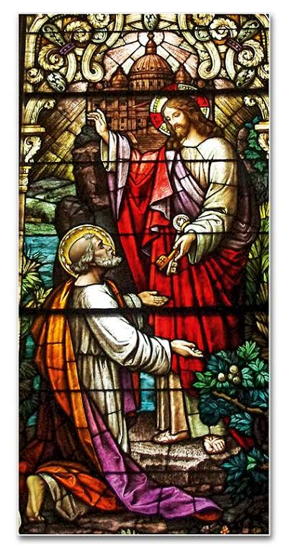

Thirteenth Sunday after Pentecost
August 23, 2026
10:30 A.M

Welcome!

St. Paul’s Anglican Church extends a warm welcome to all visitors and newcomers, whether worshiping in person or at home via livestream.

Visitors’ Guide

St. Paul’s Church is a parish in the Diocese of San Joaquin of the Anglican Church in North America, which includes both Catholic and Protestant traditions. We accept Jesus Christ as Savior, and we promise to follow him as Lord. We believe in One God,

- the Father who created us and all things,
- the Son who redeems us from sin and death,
- the Holy Spirit who renews and sanctifies us.

We believe the Holy Scriptures to be the Word of God and to contain all things necessary for salvation, and we accept the Apostles’ and Nicene Creeds as essential beliefs of the Christian faith.

Those not desiring to receive Holy Communion, and those who have not been baptized into the Christian faith, are invited to cross their arms across their chest, and a blessing will be given instead.

Visitors are invited to sign the guest book at the entrance table and introduce themselves to the clergy following the service.

The Holy Eucharist

Prelude: “Fantasy in C Major” Bach
Opening Hymn: - #438 - “Tell Out, My Soul” p. 4
Opening Acclamation p. 5
The Collect for Purity p. 5
Summary of the Law p. 5
Kyrie p. 5
Gloria p. 6
Collect of the Day p. 7
Lesson: Isaiah 51:1-6 p. 7
Gradual: Psalm 138 p. 8
Epistle: Romans 11:25-36 p. 8
Sequence Hymn: #448 – “O Love, How Deep” p. 9
Gospel: Matthew 16:13-20 p. 10
Sermon: The Rev Robert Longbottom
Nicene Creed p. 10
Prayers of the People p. 11
The Peace p. 13
Offertory: “Finlandia” - by Sibelius Organ
The Offertory p. 14
Sursum Corda p. 14
Sanctus p. 15
The Lord’s Prayer p. 17
Fraction p. 17
Prayer for Humble Access p. 18
Agnus Dei p. 18
Communion Hymn: #328 “Draw Nigh and Taste the Body of the Lord” p. 19
Post Communion Prayer p. 20
Blessing p. 20
Closing Hymn: # “Glorius Things of The Are Spoken” p. 21
Dismissal p. 22
Postlude: “Postlude in G Major” Handel

Opening Hymn: Tell Out, My Soul
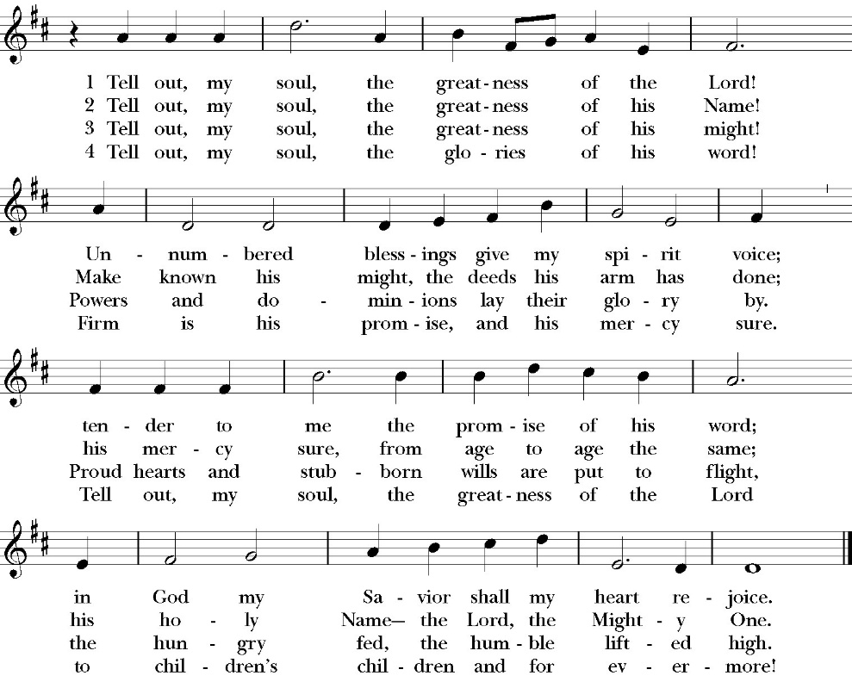

Opening Acclamation

Celebrant Blessed be God, the Father, the Son and the Holy Spirit. People And blessed be his kingdom, now and forever. Amen.

Collect for Purity

Almighty God, to you all hearts are open, all desires
known, and from you no secrets are hid: Cleanse the thoughts
of our hearts by the inspiration of your Holy Spirit, that we
may perfectly love you, and worthily magnify your holy Name;
through Christ our Lord. Amen.

Summary of the law

Hear what our Lord Jesus Christ says: You shall love
the Lord your God with all your heart and with all your soul
and with all your mind. This is the first and great
commandment. And the second is like it: You shall love your
neighbor as yourself. On these two commandments depend all
the Law and the Prophets.

Kyrie
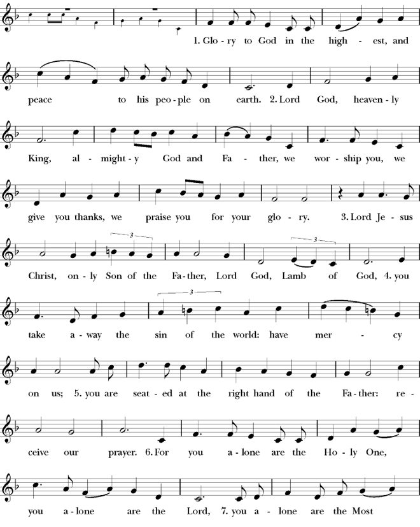
Gloria

Celebrant The Lord be with you.
People And with your spirit.
Celebrant Let us pray.

The Collect of the Day
Let your continual mercy, O Lord, cleanse and defend your Church; and, because it cannot continue in safety without your help, protect and govern it always by your goodness; through Jesus Christ our Lord, who lives and reigns with you and the Holy Spirit, one God, for ever and ever. Amen.

Lesson: Isaiah 51:1-6
“Listen to me, you who pursue righteousness, you who seek the LORD: look to the rock from which you were hewn, and to the quarry from which you were dug. 2 Look to Abraham your father and to Sarah who bore you; for he was but one when I called him, that I might bless him and multiply him. 3 For the LORD comforts Zion; he comforts all her waste places and makes her wilderness like Eden, her desert like the garden of the LORD; joy and gladness will be found in her, thanksgiving and the voice of song.
4 “Give attention to me, my people, and give ear to me, my nation; for a law will go out from me, and I will set my justice for a light to the peoples. 5 My righteousness draws near, my salvation has gone out, and my arms will judge the peoples; the coastlands hope for me, and for my arm they wait. 6 Lift up your eyes to the heavens, and look at the earth beneath; for the heavens vanish like smoke, the earth will wear out like a garment, and they who dwell in it will die in like manner; but my salvation will be forever, and my righteousness will never be dismayed.

Reader: The Word of the Lord
People: Thanks be to God

Gradual: : Psalm 138
1.I will give thanks to you, O LORD, with my whole heart; *
even before the gods will I sing praises to you.
2 I will worship toward your holy temple and praise your Name, because of your loving-kindness and truth, *
for you have magnified your Name and your word above all things.
3 When I called upon you, you heard me *
and gave me increase of strength.
4 All the kings of the earth shall praise you, O LORD, *
for they have heard the words of your mouth.
5 They shall sing of the ways of the LORD, *
that great is the glory of the LORD.
6 For though the LORD be high, yet he has respect for the lowly;*
as for the proud, he beholds them from afar.
7 Though I walk in the midst of trouble, yet shall you refresh me;* you shall stretch forth your hand upon the furiousness of my enemies, and your right hand shall save me.
8 The LORD shall make good his loving-kindness toward me; *
your mercy, O LORD, endures for ever; despise not the works of your own hands.

Glory be to the Father, and to the Son, and to the Holy Spirit;
as it was in the beginning, is now, and ever shall be, world
without end. Amen

Epistle: Romans 11:25-36
Lest you be wise in your own sight, I do not want you to be unaware of this mystery, brothers: a partial hardening has come upon Israel, until the fullness of the Gentiles has come in. 26 And in this way all Israel will be saved, as it is written, “The Deliverer will come from Zion, he will banish ungodliness from Jacob”; 27 “and this will be my covenant with them when I take away their sins.”
28 As regards the gospel, they are enemies for your sake. But as regards election, they are beloved for the sake of their forefathers.
29 For the gifts and the calling of God are irrevocable. 30 For just as you were at one time disobedient to God but now have received mercy because of their disobedience, 31 so they too have now been disobedient in order that by the mercy shown to you they also may
now receive mercy. 32 For God has consigned all to disobedience, that he may have mercy on all.
33 Oh, the depth of the riches and wisdom and knowledge of God! How unsearchable are his judgments and how inscrutable his ways! 34 “For who has known the mind of the Lord, or who has been his counselor?” 35 “Or who has given a gift to him that he might be repaid?” 36 For from him and through him and to him are all things. To him be glory forever. Amen.

Reader: The Word of the Lord
People: Thanks be to God

Sequence Hymn: O Love, How Deep
(verse 1&2 before Gospel, verse 3 after)
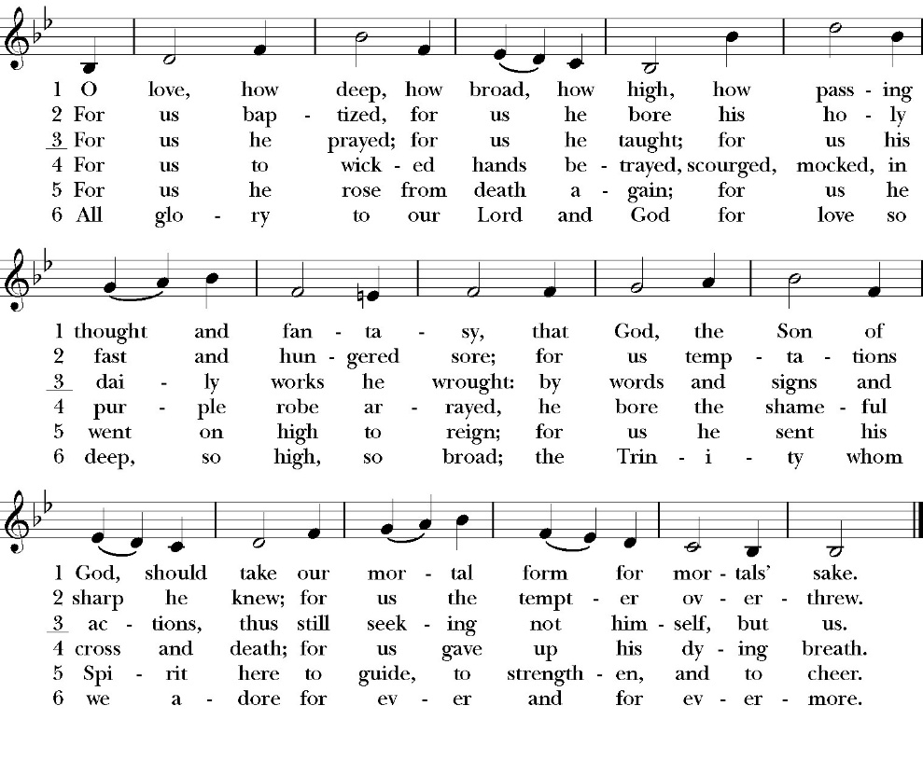

Clergy: The Holy Gospel of Our Lord Jesus Christ,
according to St. Matthew
People: Glory to you, Lord Christ.

Gospel: Matthew 16:13-20
Now when Jesus came into the district of Caesarea Philippi, he asked his disciples, “Who do people say that the Son of Man is?”
14 And they said, “Some say John the Baptist, others say Elijah, and others Jeremiah or one of the prophets.” 15 He said to them, “But who do you say that I am?” 16 Simon Peter replied, “You are the Christ, the Son of the living God.” 17 And Jesus answered him, “Blessed are you, Simon Bar-Jonah! For flesh and blood has not revealed this to you, but my Father who is in heaven. 18 And I tell you, you are Peter, and on this rock I will build my church, and the gates of hell shall not prevail against it. 19 I will give you the keys of the kingdom of heaven, and whatever you bind on earth shall be bound in heaven, and whatever you loose on earth shall be loosed in heaven.” 20 Then he strictly charged the disciples to tell no one that he was the Christ.
Clergy: The Gospel of the Lord
People: Praise to you, Lord Christ

Sermon
The Rev. Robert Longbottom

The Nicene Creed

We believe in one God,
the Father, the Almighty,
maker of heaven and earth,
of all that is, visible and invisible.

We believe in one Lord, Jesus Christ,
the only-begotten Son of God,
eternally begotten of the Father,
God from God, Light from Light,
true God from true God,
begotten, not made,
of one Being with the Father.
through him all things were made.
For us and for our salvation he came down from heaven:
was incarnate from the Holy Spirit and the Virgin Mary,
and was made man.
For our sake he was crucified under Pontius Pilate;
he suffered death and was buried.
On the third day he rose again in accordance with the
Scriptures;
he ascended into heaven
and is seated at the right hand of the Father.
He will come again in glory to judge the living and the dead,
and his kingdom will have no end.
We believe in the Holy Spirit, the Lord, the giver of life,
who proceeds from the Father and the Son,
who with the Father and the Son is worshiped and glorified. who has spoken through the Prophets.
We believe in one holy catholic and apostolic Church.
We acknowledge one Baptism for the forgiveness of sins.
We look for the resurrection of the dead,
and the life of the world to come. Amen.

The Prayers of the People

Leader Let us pray for the Church and for the world, saying, “hear our prayer.”
For the peace of the whole world, and for the well-being and unity of the people of God.
Lord, in your mercy:
People Hear our prayer.

Leader For Stephen our archbishop, Julian our provincial dean, and Eric our bishop. For Fr. Rob, Deacon John, Deacon Kashy, and for all the clergy and people of our diocese and congregation and for the worldwide Anglican Communion.
Lord, in your mercy:
People Hear our prayer.

Leader For all those who proclaim the Gospel at home and abroad; and for all who teach and disciple others.
Lord, in your mercy:
People Hear our prayer.

Leader For our brothers and sisters in Christ who are persecuted for their faith.
Lord, in your mercy:
People Hear our prayer.

Leader For our nation, for those in authority, and for all in public service especially Donald our president and Gavin our governor.
Lord, in your mercy:
People Hear our prayer.

Leader In the St. Paul’s cycle of prayer, we lift up the ministries of pastoral care, all our members who are in the hospital, care facilities, or who are shut into their own homes. We pray for those who are recovering from recent surgeries and for those who are in crisis.
Lord, in your mercy:
People Hear our prayer.

Leader In the ACNA Cycle of Prayer, today we pray for the Fellowship of Confessing Anglicans, the Confessing Anglican Diocese in New Zealand, and The Rt. Rev. Jay Behan, Bishop, and his wife, Jaimee.
Lord, in your mercy:
People Hear our prayer.

Leader For all those who are in trouble, sorrow, need, sickness, or
any other adversity [especially ____________]. We also
pray for all who are currently serving in our armed forces
and serving as first responders.
Lord, in your mercy:
People Hear our prayer.

Leader For all those who have departed this life in the certain hope
of the resurrection, (we pray especially for ____________),
in Thanksgiving let us pray.
Lord, in your mercy:
People Hear our prayer.

Celebrant will add a concluding prayer

Heavenly Father, grant these our prayers for the sake of Jesus Christ,
our only Mediator and Advocate, who lives and reigns with you in
the unity of the Holy Spirit, one God, now and for ever. Amen.

The Confession and Absolution

Celebrant Let us humbly confess our sins to Almighty God.

Most merciful God,
we confess that we have sinned against you
in thought, word and deed,
by what we have done, and by what we have left undone.
We have not loved you with our whole heart;
we have not loved our neighbors as ourselves.
We are truly sorry and we humbly repent.
For the sake of your Son Jesus Christ,
have mercy on us and forgive us;
that we may delight in your will, and walk in your ways,
to the glory of your Name. Amen.

Almighty God, our heavenly Father, who in his great mercy has
promised forgiveness of sins to all those who sincerely repent and
with true faith turn to him, have mercy upon you, pardon and deliver
you from all your sins, confirm and strengthen you in all goodness,
and bring you to everlasting life; through Jesus Christ our Lord.
Amen.

Hear the Word of God to all who truly turn to him.

God so loved the world, that he gave his only-begotten Son, that
whoever believes in him should not perish but have eternal life.
John 3:16
Celebrant The Peace of the Lord be always with you.
People And with your spirit.

offertory
“Finlandia” - by Sibelius
marguerite crownover - organ

The Doxology
(Verse 3 only)

Offertory

Celebrant All things come from you, O Lord,
People And of your own have we given you.

The Eucharistic Liturgy
Celebrant The Lord be with you.
People And with your spirit.
Celebrant Lift up your hearts.
People We lift them up to the Lord.
Celebrant Let us give thanks to the Lord our God.
People It is right to give him thanks and praise.

It is right, our duty and our joy, always and everywhere to give thanks to you, Father Almighty, Creator of heaven and earth.

Through Jesus Christ our Lord, who on the first day of the week overcame death and the grave, and by his glorious resurrection opened to us the way of everlasting life.

Therefore we praise you, joining our voices with Angels and Archangels and with all the company of heaven, who for ever sing this hymn to proclaim the glory of your Name:

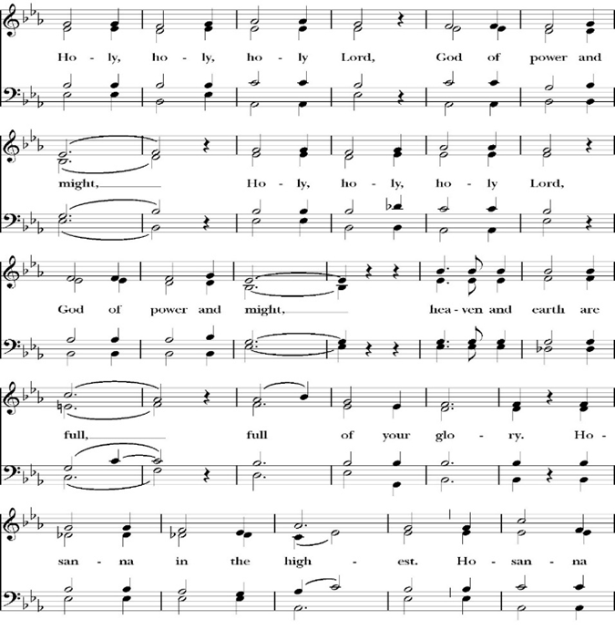
Sanctus

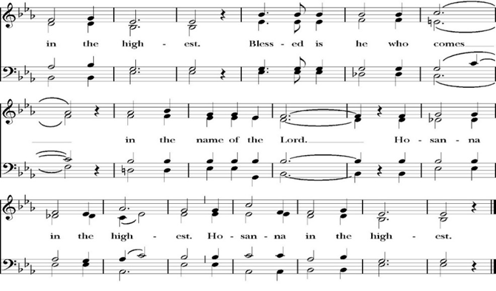
Holy and gracious Father: In your infinite love you made us for yourself; and when we had sinned against you and become subject to evil and death, you, in your mercy, sent your only Son Jesus Christ into the world for our salvation. By the Holy Spirit and the Virgin Mary he became flesh and dwelt among us. In obedience to your will, he stretched out his arms upon the Cross and offered himself once for all, that by his suffering and death we might be saved. By his resurrection he broke the bonds of death, trampling Hell and Satan under his feet. As our great high priest, he ascended to your right hand in glory, that we might come with confidence before the throne of grace.

On the night that he was betrayed, our Lord Jesus Christ took bread; and when he had given thanks, he broke it,* and gave it to his disciples, saying, “Take, eat; this is my Body, which is given for you: Do this in remembrance of me.”

Likewise, after supper, Jesus took the cup, and when he had given thanks, he gave it to them, saying, “Drink this, all of you; for this is my Blood of the New Covenant, which is shed for you, and for many, for the forgiveness of sins: Whenever you drink it, do this in remembrance of me.”

Therefore we proclaim the mystery of faith:

Christ has died.
Christ is risen.
Christ will come again.

We celebrate the memorial of our redemption, O Father, in this sacrifice of praise and thanksgiving, and we offer you these gifts.

Sanctify them by your Word and Holy Spirit to be for your people the Body and Blood of your Son Jesus Christ. Sanctify us also, that we may worthily receive this holy Sacrament, and be made one body with him, that he may dwell in us and we in him. In the fullness of time, put all things in subjection under your Christ, and bring us with all your saints into the joy of your heavenly kingdom, where we shall see our Lord face to face.

All this we ask through your Son Jesus Christ: By him, and with him, and in him, in the unity of the Holy Spirit, all honor and glory is yours, Almighty Father, now and for ever. Amen.

And now, as our Savior Christ has taught us, we are bold to pray,

Our Father, who art in heaven,
hallowed be thy Name,
thy kingdom come,
thy will be done,
on earth as it is in heaven.
Give us this day our daily bread.
And forgive us our trespasses,
as we
forgive those
who trespass against us.
And lead us not into temptation,
but deliver us from evil.
For thine is the kingdom,
and the power, and the glory,
for ever and ever. Amen.

Fraction

Celebrant Alleluia! Christ our Passover is sacrificed for us.
People Therefore let us keep the feast. Alleluia!
The Prayer for Humble Access

We do not presume to come to this your table, O merciful Lord,
trusting in our own righteousness,
but in your abundant and great mercies.
We are not worthy so much as to gather up
the crumbs under your table;
but you are the same Lord
whose character is always to have mercy.
Grant us, therefore, gracious Lord,
so to eat the flesh of your dear Son Jesus Christ,
and to drink his blood,
that our sinful bodies may be made clean by his body,
and our souls washed through his most precious blood,
and that we may evermore dwell in him, and he in us.
Amen.

Agnus Dei

The Ministration of Communion

The gifts of God for the People of God. Take them in remembrance that Christ died for you and feed on him in your hearts by faith, with thanksgiving.

Communion Hymn: Draw Nigh and Take the Body of the Lord
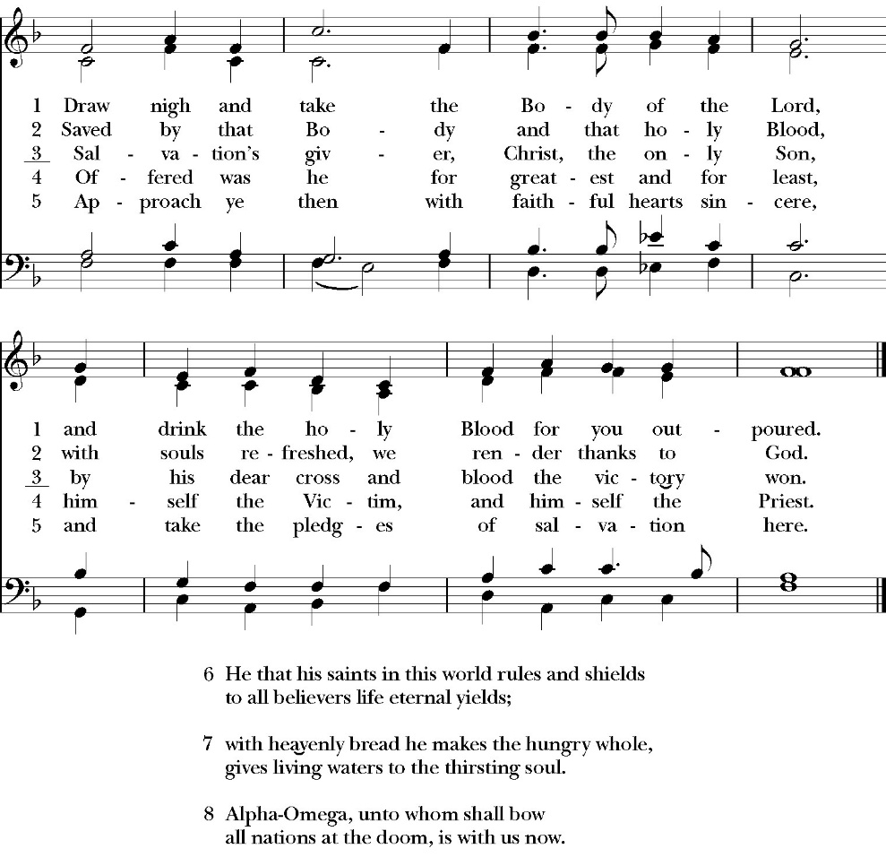

The Post Communion Prayer
Let us pray.

Heavenly Father,
We thank you for feeding us with the spiritual food
of the most precious Body and Blood
of your Son our Savior Jesus Christ;
and for assuring us in these holy mysteries
that we are living members of the body of your Son,
and heirs of your eternal Kingdom.
And now, Father, send us out to do the work you have
given us to do,
to love and serve you as faithful witnesses of Christ our
Lord.
To him, to you, and to the Holy Spirit,
be honor and glory, now and for ever. Amen.

The Blessing

The peace of God, which passes all understanding, keep your hearts and minds in the knowledge and love of God, and of his Son Jesus Christ our Lord; and the blessing of God Almighty, the Father, the Son, and the Holy Spirit, be among you, and remain with you always. Amen.

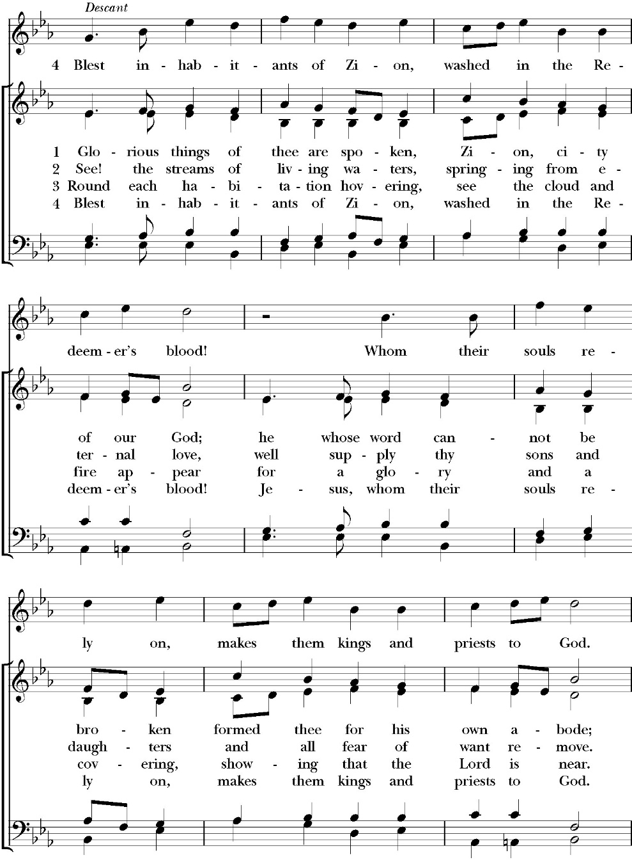
Closing Hymn: Glorious Things of Thee Are Spoken

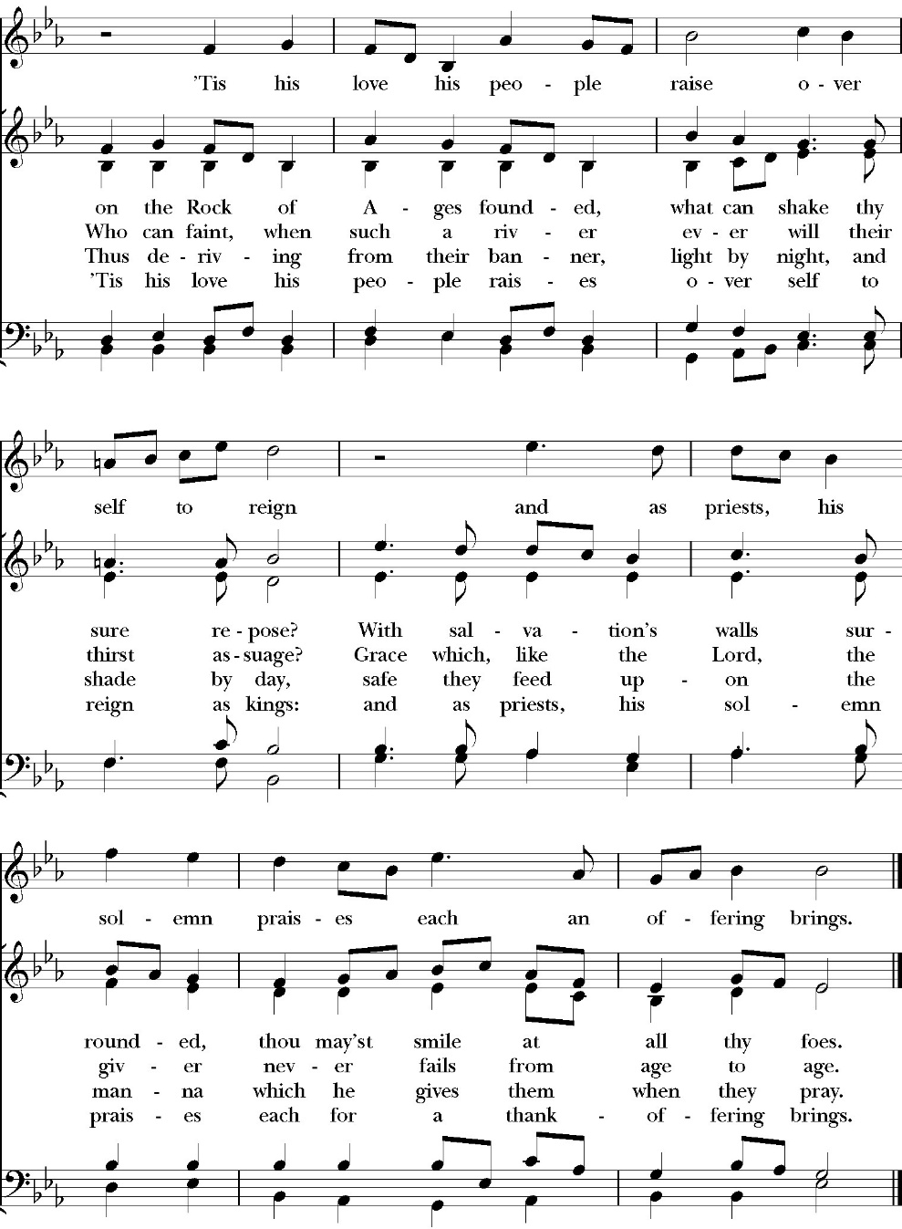

Dismissal
Deacon Alleluia, Alleluia. Let us go forth into the world,
rejoicing in the power of the Holy Spirit.
People Thanks be to God Alleluia, Alleluia.

St. Paul’s Parish Calendar
Sunday August 23 – Sunday August 30

SUNDAY, August 23 – Thirteenth Sunday after Pentecost
9:15 AM Sunday Funday, Youth Room
9:15 AM Gospel of John Bible Study, Conference Room
10:30 AM Children’s Sunday School, Chapel
Pre-K –2nd Grade, Sunday School Room
3rd -5th Grade, Youth Room
10:30 AM Holy Eucharist, Church

MONDAY, August 24

TUESDAY, August 25
6:00 PM Bell Choir Rehearsal, Music Room

WEDNESDAY, August 26
9:30 AM Holy Eucharist with healing prayer, Chapel
10:15 AM Bible Study, Conference Room
7:00 PM Choir Rehearsal, Chapel

THURSDAY, August 27

FRIDAY, August 28
6:30 AM Men’s Bible Study, Valhalla Restaurant

SATURDAY, August 29

SUNDAY, August 30 – Fourteenth Sunday after Pentecost
9:15 AM Sunday Funday, Youth Room
9:15 AM Gospel of John Bible Study, Conference Room
10:30 AM Children’s Sunday School, Chapel
Pre-K –2nd Grade, Sunday School Room
3rd -5th Grade, Youth Room
10:30 AM Holy Eucharist, Church

Church Office Hours
Monday-Thursday 8:00 AM-4:00 PM

Mid-Year Financial Update, Sunday, August 30, after Church
Every year at the annual meeting the year-end financial accounting is presented. A mid-year financial update will be presented simply to be informative and allow our members to have an update twice a year.

Bell Choir and Vocal Choir rehearsals are back, and all are invited from veterans to newcomers

Vocal Choir
Vocal choir rehearsals begin Sunday, August 23, at 9:30 AM. The first Wednesday evening rehearsal will be Wednesday, August 26, 7:00-8:00 PM.

Bell Choir
Bell Choir rehearsals have begun and are on Tuesday evenings from
6:00-7:00 PM.

The Gospel of John Sunday morning Bible study, 9:15-10:00AM
The Sunday morning Gospel of John Bible study has resumed and is working through chapter 8 in August. Fr. Rob will be our leader through August. Deacon John will lead the class in September.
No Gospel of John Class September 6 due to Labor Day weekend.

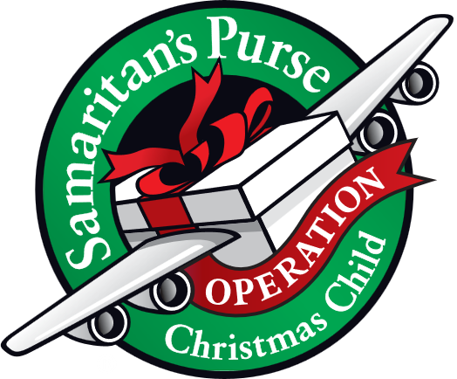
Operation Christmas Child donations begin in August
August Donations: School Supplies

Operation Christmas Child is a ministry of Samaritan’s Purse. The mission of Operation Christmas Child is to demonstrate God’s love in a tangible way to children in need around the world through partnering with the local church worldwide to provide shoebox size containers filled with school supplies, hygiene products, and a small gift to share the Good News of Jesus Christ and make disciples of the nations.

St. Paul’s Anglican Church is committed to providing 100 boxes to children throughout the world and will do this by having monthly themed donations from August through November. We will then have a ‘Filling the Box” party when we will gather together and fill 100 boxes with school supplies, hygiene products and small toys.

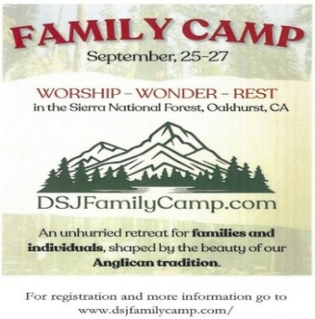
Anglican Diocese of San Joaquin Family Camp, Out of the Noise and Into the Wonder, September 25-27, Calvin Crest Sherwood Forest, Oakhurst, CA
Join your friends from St. Paul’s for an unhurried retreat for families and individuals, shaped by the beauty of our Anglican tradition. Calvin Crest Sherwood Forest is outside Oakhurst, CA near Yosemite. Each day flows from Morning Prayer to Compline. The family camp will feature tent and rustic cabin accommodations and will feel very much like the old Camp San Joaquin. The camp will be led by our friend Rev. Paul Gibbons, so we know that it will be a wonderful time.

The cost cannot be beat:
Bring your own Tent or RV: $75 for the whole family
Rustic Cabin Accommodations: $150 for the whole family

Accommodations and bathroom facilities

Tent & RV Sites: Pitch a tent or park your rig in the scenic Sherwood Forest area.
Rustic Cabins: Each cabin features 10 bunks with mattresses. Cabins are non-electric.
Bathrooms and Showers: Clean, private bathrooms and hot showers are available throughout camp.

What is included for this price:

The flat rate covers lodging, firewood, a sub sandwich dinner on Friday evening, breakfast on Saturday morning and a BBQ on Saturday evening.
How do I sign up or find out more?
Talk with Fr. Rob Longbottom or go to the Family Camp website at:
dsjfamilycamp.com





St. Paul’s Anglican Church
6436 W Hurley Ave
Visalia, CA


Friday October 2, 8:00 AM to 4:00 PM
Saturday October 3, 8:00 AM to 2:00 PM
Drop Off Donated Items in James Hall on:
Wednesday, September 30, and Thursday, October 1
Between 9:00 AM – 4:00 PM
Items need to be in Good Condition: clean,
gently worn clothing, household items, toys in
working order gladly accepted!
Volunteers Needed for Set Up:
Wednesday, September 30 and Thursday, October 1
Between 9:00 AM – 4:00 PM
If you have any questions, Contact: Mary Murray at 799-6973

St. Paul’s Anglican Church
Parish Office
6436 W. Hurley Ave
Visalia, California 93291
559-732-4821
Office Hours: 8:00 – 4:00
Monday – Thursday

Worship: Sundays at 10:30AM
Livestream: Link at spvisalia.com
and on our Facebook page
Please be advised that this service is being recorded for broadcast
and/or archival purposes. By attending, you consent
to the inclusion of your likeness in these recordings.

St. Paul’s Clergy and Staff
The Rev. Robert Longbottom, Rector
rector@spvisalia.com
(559)802-2928
The Rev. John Iseman, Pastoral Associate for Family Ministries
family@spvisalia.com
The Rev. Kashy Rowland-Smith, Deacon
kashyrs@aol.com
Antoinette Horsting, Parish Administrator
bookkeeper@spvisalia.com
Marguerite Crownover, Organist and Accompanist
organist@spvisalia.com
Ellen Daniels, Choral Director
choirdirector@spvisalia.com
Jackie Iseman, Nursery Coordinator
nursery@spvisalia.com
Shane Motl, Sexton

St. Paul’s is a member church of the
Anglican Diocese of San Joaquin
The Rt. Rev. Eric V. Menees, Bishop

Next Week’s Lessons
Jeremiah 15:15-21
Psalm 26
Romans 12:1-8
Matthew 16:21-27

