ST. PAUL’S
ANGLICAN CHURCH
VISALIA, CALIFORNIA

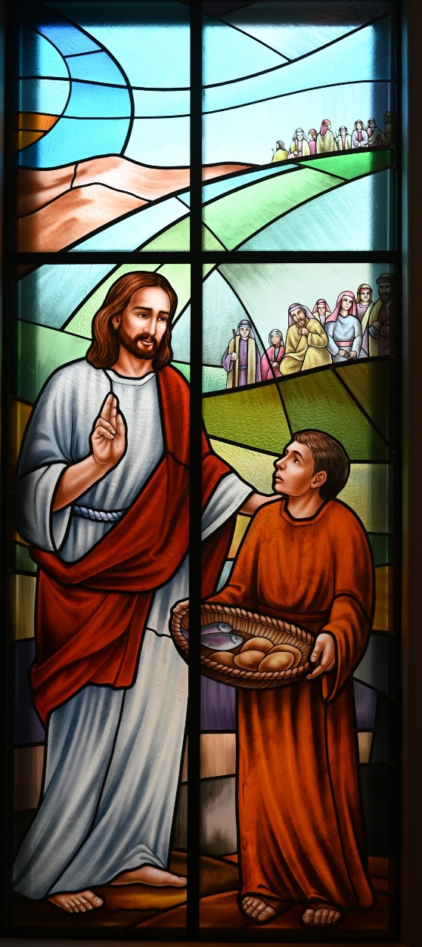

Tenth Sunday after Pentecost
August 2, 2026
10:30 A.M

Welcome!

St. Paul’s Anglican Church extends a warm welcome to all visitors and newcomers, whether worshiping in person or at home via livestream.

Visitors’ Guide

St. Paul’s Church is a parish in the Diocese of San Joaquin of the Anglican Church in North America, which includes both Catholic and Protestant traditions. We accept Jesus Christ as Savior, and we promise to follow him as Lord. We believe in One God,

- the Father who created us and all things,
- the Son who redeems us from sin and death,
- the Holy Spirit who renews and sanctifies us.

We believe the Holy Scriptures to be the Word of God and to contain all things necessary for salvation, and we accept the Apostles’ and Nicene Creeds as essential beliefs of the Christian faith.

Those not desiring to receive Holy Communion, and those who have not been baptized into the Christian faith, are invited to cross their arms across their chest, and a blessing will be given instead.

Visitors are invited to sign the guest book at the entrance table and introduce themselves to the clergy following the service.

The Holy Eucharist

Opening Hymn: # 657 – “Love Divine, All Loves Excelling” p. 4
Opening Acclamation p. 5
The Collect for Purity p. 5
Summary of the Law p. 5
Kyrie p. 5
Gloria p. 6
Collect of the Day p. 7
Lesson: Nehemiah 9:16-21 p. 7
Gradual: Psalm 78 p. 7
Epistle: Romans 14:13-21 p. 9
Sequence Hymn: #488 “Be Thou My Vision” p. 10
Gospel: Matthew 13:24-30, 34-43 p. 10
Sermon: The Rev Robert Longbottom
Nicene Creed p. 11
Prayers of the People p. 12
The Peace p. 14
Offertory: “In Christ Alone”
The Offertory p. 16
Sursum Corda p. 16
Sanctus p. 17
The Lord’s Prayer p. 19
Fraction p. 19
Prayer for Humble Access p. 20
Agnus Dei p. 20
Communion Hymn: “One Bread, One Body” p. 21
Post Communion Prayer p. 24
Blessing p. 24
Closing Hymn: #542 – “Christ is the World’s True Light” p. 25
Dismissal p. 25

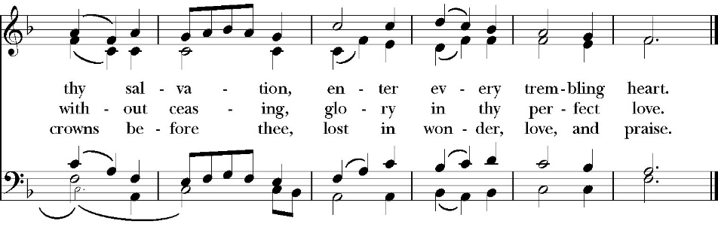
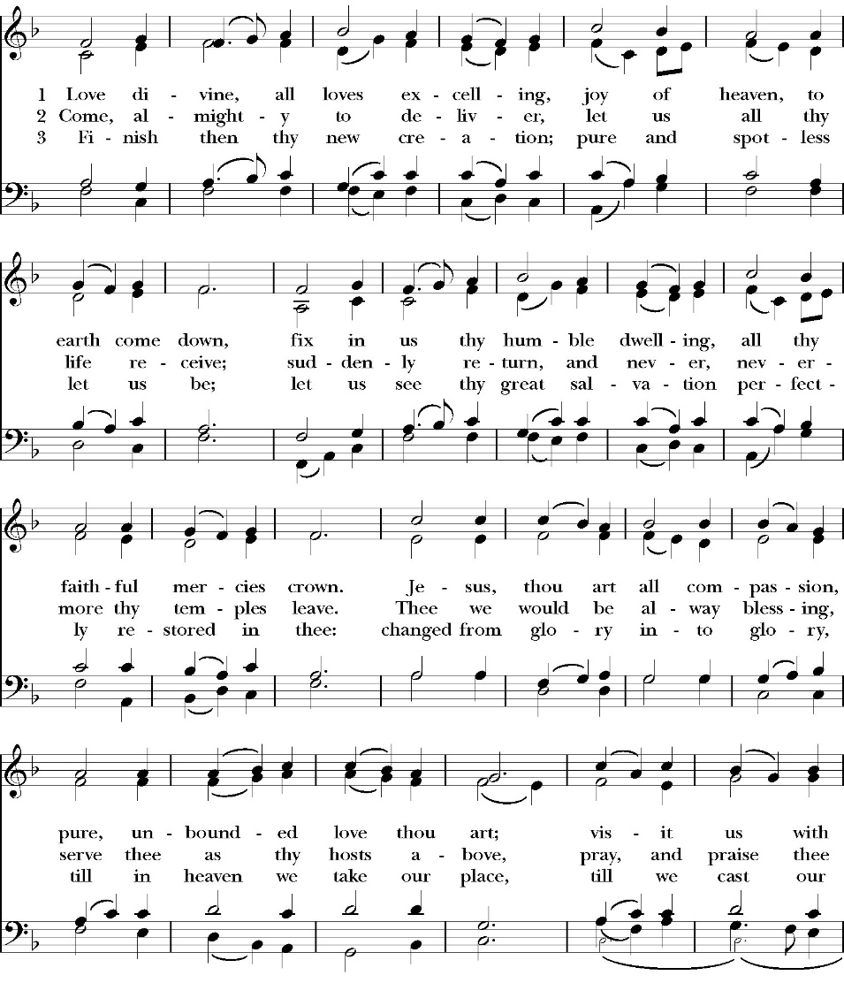
Opening Hymn: Love Divine, All Loves Excelling

Opening Acclamation

Celebrant Blessed be God, the Father, the Son and the Holy Spirit. People And blessed be his kingdom, now and forever. Amen.

Collect for Purity

Almighty God, to you all hearts are open, all desires
known, and from you no secrets are hid: Cleanse the thoughts
of our hearts by the inspiration of your Holy Spirit, that we
may perfectly love you, and worthily magnify your holy Name;
through Christ our Lord. Amen.

Summary of the law

Hear what our Lord Jesus Christ says: You shall love
the Lord your God with all your heart and with all your soul
and with all your mind. This is the first and great
commandment. And the second is like it: You shall love your
neighbor as yourself. On these two commandments depend all
the Law and the Prophets.

Kyrie
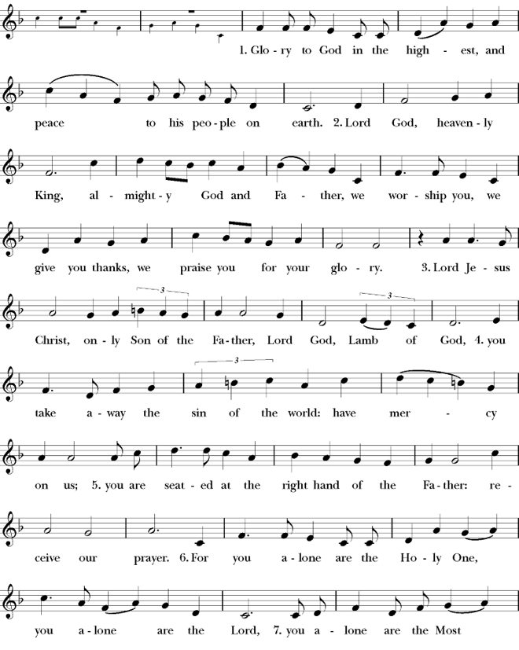
Gloria

Celebrant The Lord be with you.
People And with your spirit.
Celebrant Let us pray.

The Collect of the Day

Almighty and merciful God, it is only by your grace that your faithful people offer you true and laudable service: Grant that we may run without stumbling to obtain your heavenly promises; through Jesus Christ our Lord, who lives and reigns with you and the Holy Spirit, one God, now and for ever. Amen.

Lesson: Nehemiah 9:16-21
“But they and our fathers acted presumptuously and stiffened their neck and did not obey your commandments. 17 They refused to obey and were not mindful of the wonders that you performed among them, but they stiffened their neck and appointed a leader to return to their slavery in Egypt. But you are a God ready to forgive, gracious and merciful, slow to anger and abounding in steadfast love, and did not forsake them. 18 Even when they had made for themselves a golden calf and said, ‘This is your God who brought you up out of Egypt,’ and had committed great blasphemies, 19 you in your great mercies did not forsake them in the wilderness. The pillar of cloud to lead them in the way did not depart from them by day, nor the pillar of fire by night to light for them the way by which they should go. 20 You gave your good Spirit to instruct them and did not withhold your manna from their mouth and gave them water for their thirst. 21 Forty years you sustained them in the wilderness, and they lacked nothing. Their clothes did not wear out and their feet did not swell.

Reader: The Word of the Lord
People: Thanks be to God

Gradual: 78
1 Hear my teaching, O my people; *
incline your ears to the words of my mouth.
2 I will open my mouth in a parable; *
I will utter dark sayings of old,
3 Which we have heard and known, *
and such as our forefathers have told us,
4 That we should not hide them from the children of the generations to come, *
but show the honor of the LORD, his mighty and wonderful works that he has done.
5 He made a covenant with Jacob, and gave Israel a law, *
which he commanded our forefathers to teach their children,
6 That their posterity might know it, *
and the children which were yet unborn;
7 With the intent that when they came up *
they might show it to their children,
8 That they might put their trust in God, *
and not forget the works of God, but keep his commandments;
9 And not be as their forefathers, a faithless and stubborn generation, *
a generation that did not set their heart aright, and whose spirit did not cleave steadfastly to God,
10 Like the children of Ephraim, archers carrying bows, *
who turned back in the day of battle.
11 They did not keep the covenant of God, *
and would not walk in his law,
12 But forgot what he had done, *
and the wonderful works that he had shown them.
13 Marvelous things he did in the sight of our forefathers, *
in the land of Egypt, even in the field of Zoan. )
14 He divided the sea and let them go through; *
he made the waters to stand in a heap.
15 In the daytime he led them with a cloud, *
and all the night through with a light of fire.
16 He split the hard rocks in the wilderness *
and gave them drink in abundance, as out of the great deep.
17 He brought waters out of the stony rock, *
so that it gushed out like the rivers.
18 Yet for all this they sinned more against him, *
and provoked the Most High in the wilderness.
19 They tested God in their hearts *
and demanded food for their craving.
20 They spoke against God, saying, *
“Can God prepare a table in the wilderness?
21 Indeed, he smote the stony rock, so that water gushed out, and the streams overflowed; *
but can he give bread also, or provide meat for his people?”
22 When the LORD heard this, he was full of wrath; *
so a fire was kindled against Jacob, and there flared up fierce anger against Israel,
23 Because they did not believe in God, *
and did not put their trust in his help.
24 So he commanded the clouds above *
and opened the doors of heaven.
25 He rained down manna upon them to eat *
and gave them food from heaven.
26 So mortals ate the bread of angels; *
for he sent them food enough.

Glory be to the Father, and to the Son, and to the Holy Spirit;
as it was in the beginning, is now, and ever shall be, world
without end. Amen

Epistle: Romans 8:35-39
Who shall separate us from the love of Christ? Shall tribulation, or distress, or persecution, or famine, or nakedness, or danger, or sword? 36 As it is written,
“For your sake we are being killed all the day long; we are regarded as sheep to be slaughtered.”
37 No, in all these things we are more than conquerors through him who loved us. 38 For I am sure that neither death nor life, nor angels nor rulers, nor things present nor things to come, nor powers, 39 nor height nor depth, nor anything else in all creation, will be able to separate us from the love of God in Christ Jesus our Lord.

Reader: The Word of the Lord
People: Thanks be to God

Sequence Hymn: Be Thou My Vision
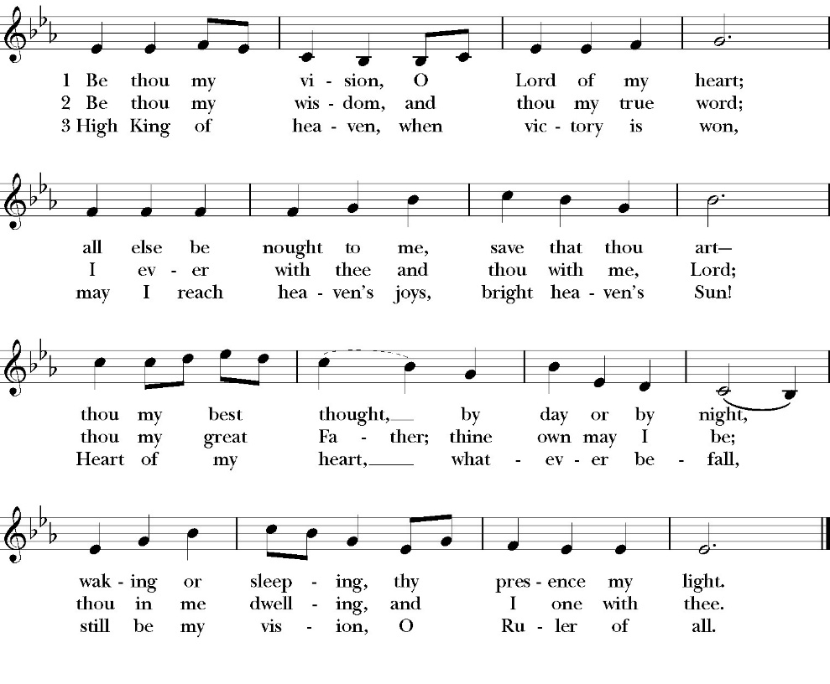
(Verses 1&2 before gospel verse 3 after gospel)

Clergy: The Holy Gospel of Our Lord Jesus Christ,
according to St. Matthew
People: Glory to you, Lord Christ.

Gospel: Matthew 14:13-21
Now when Jesus heard this, he withdrew from there in a boat to a desolate place by himself. But when the crowds heard it, they followed him on foot from the towns. 14 When he went ashore he saw a great crowd, and he had compassion on them and healed their sick. 15 Now when it was evening, the disciples came to him and said, “This is a desolate place, and the day is now over; send the crowds away to go into the villages and buy food for themselves.” 16 But Jesus said, “They need not go away; you give them something to eat.” 17 They said to him, “We have only five loaves here and two fish.” 18And he said, “Bring them here to me.” 19 Then he ordered the crowds to sit down on the grass, and taking the five loaves and the two fish, he looked up to heaven and said a blessing. Then he broke the loaves and gave them to the disciples, and the disciples gave them to the crowds. 20 And they all ate and were satisfied. And they took up twelve baskets full of the broken pieces left over. 21 And those who ate were about five thousand men, besides women and children.

Clergy: The Gospel of the Lord
People: Praise to you, Lord Christ

Sermon
The Rev. Robert Longbottom

The Nicene Creed

We believe in one God,
the Father, the Almighty,
maker of heaven and earth,
of all that is, visible and invisible.

We believe in one Lord, Jesus Christ,
the only-begotten Son of God,
eternally begotten of the Father,
God from God, Light from Light,
true God from true God,
begotten, not made,
of one Being with the Father.
through him all things were made.

For us and for our salvation he came down from heaven:
was incarnate from the Holy Spirit and the Virgin Mary,
and was made man.
For our sake he was crucified under Pontius Pilate;
he suffered death and was buried.
On the third day he rose again in accordance with the
Scriptures;
he ascended into heaven
and is seated at the right hand of the Father.
He will come again in glory to judge the living and the dead,
and his kingdom will have no end.
We believe in the Holy Spirit, the Lord, the giver of life,
who proceeds from the Father and the Son,
who with the Father and the Son is worshiped and glorified. who has spoken through the Prophets.
We believe in one holy catholic and apostolic Church.
We acknowledge one Baptism for the forgiveness of sins.
We look for the resurrection of the dead,
and the life of the world to come. Amen.

The Prayers of the People

Leader Let us pray for the Church and for the world, saying, “hear our prayer.”
For the peace of the whole world, and for the well-being and unity of the people of God.
Lord, in your mercy:
People Hear our prayer.

Leader For Stephen our archbishop, Julian our provincial dean, and Eric our bishop. For Fr. Rob, Deacon John, Deacon Kashy, and for all the clergy and people of our diocese and congregation and for the worldwide Anglican Communion.
Lord, in your mercy:
People Hear our prayer.

Leader For all those who proclaim the Gospel at home and abroad; and for all who teach and disciple others.
Lord, in your mercy:
People Hear our prayer.

Leader For our brothers and sisters in Christ who are persecuted for their faith.
Lord, in your mercy:
People Hear our prayer.

Leader For our nation, for those in authority, and for all in public service especially Donald our president and Gavin our governor.
Lord, in your mercy:
People Hear our prayer.

Leader In the St. Paul’s cycle of prayer, we pray for all ministries of mission and outreach to our community and in the world. We pray specifically for the medical mission to Honduras, St. Paul’s School, Visalia Senior Housing, Turning Point ministries and all ministries which we support as a parish. We pray for Fr. Frank and Ann Bernardi and Millagro Menees.
Lord, in your mercy:
People Hear our prayer.

Leader In the ACNA Cycle of Prayer, today we pray for the Anglican Diocese of the Living Word, for Bishop Julian Dobbs, and his wife, Brenda; Bishop William Love and his wife, Karen; Bishop David Bena and his wife, Mary Ellen; and Bishop Daniel Herzog and his wife, Carol.
Lord, in your mercy:
People Hear our prayer.

Leader For all those who are in trouble, sorrow, need, sickness, or
any other adversity [especially ____________]. We also
pray for all who are currently serving in our armed forces
and serving as first responders.
Lord, in your mercy:
People Hear our prayer.

Leader For all those who have departed this life in the certain hope
of the resurrection, (we pray especially for ____________),
in Thanksgiving let us pray.
Lord, in your mercy:
People Hear our prayer.

Celebrant will add a concluding prayer

Celebrant: A Prayer for a spirit of evangelism (BCP page 652)

Almighty God our Savior, you desire that none should perish, and
you have taught us through your Son that there is great joy in heaven
over every sinner who repents: Grant that our hearts may ache for a
lost and broken world. May your Holy Spirit work through our
words, deeds, and prayers, that the lost may be found and the dead
made alive, and that all your redeemed may rejoice around your
throne; through Jesus Christ our Lord. Amen.

Heavenly Father, grant these our prayers for the sake of Jesus Christ,
our only Mediator and Advocate, who lives and reigns with you in
the unity of the Holy Spirit, one God, now and for ever. Amen.

The Confession and Absolution

Celebrant Let us humbly confess our sins to Almighty God.

Most merciful God,
we confess that we have sinned against you
in thought, word and deed,
by what we have done, and by what we have left undone.
We have not loved you with our whole heart;
we have not loved our neighbors as ourselves.
We are truly sorry and we humbly repent.
For the sake of your Son Jesus Christ,
have mercy on us and forgive us;
that we may delight in your will, and walk in your ways,
to the glory of your Name. Amen.

Almighty God, our heavenly Father, who in his great mercy has
promised forgiveness of sins to all those who sincerely repent and
with true faith turn to him, have mercy upon you, pardon and deliver
you from all your sins, confirm and strengthen you in all goodness,
and bring you to everlasting life; through Jesus Christ our Lord.
Amen.

Hear the Word of God to all who truly turn to him.

God so loved the world, that he gave his only-begotten Son, that
whoever believes in him should not perish but have eternal life.
John 3:16
Celebrant The Peace of the Lord be always with you.
People And with your spirit.

offertory
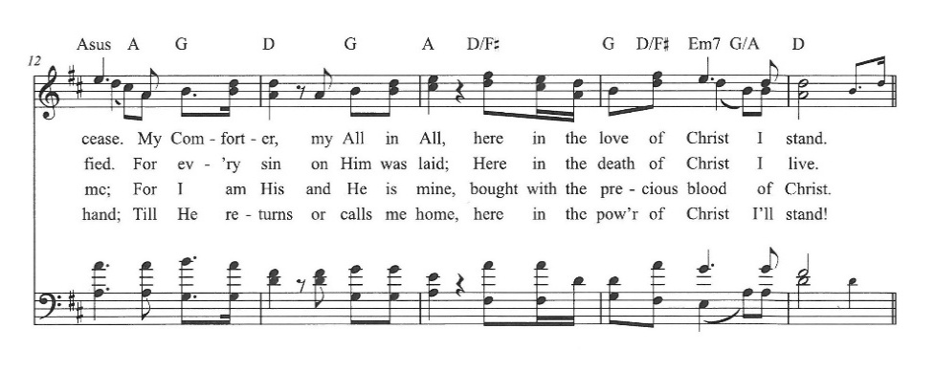
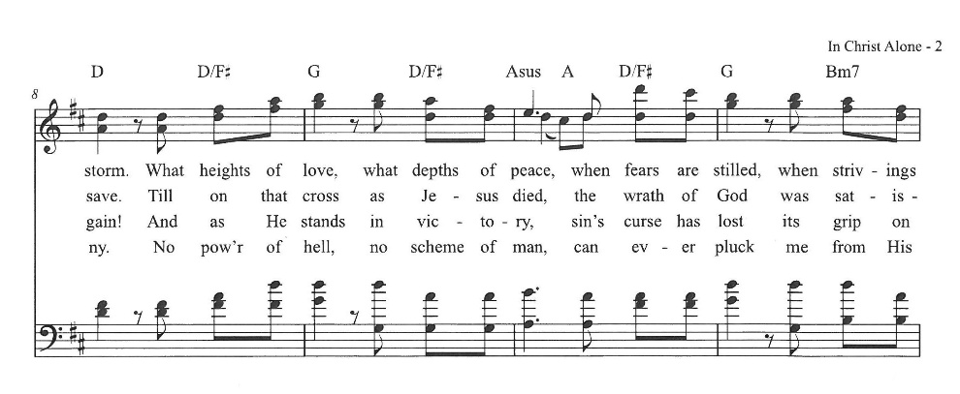
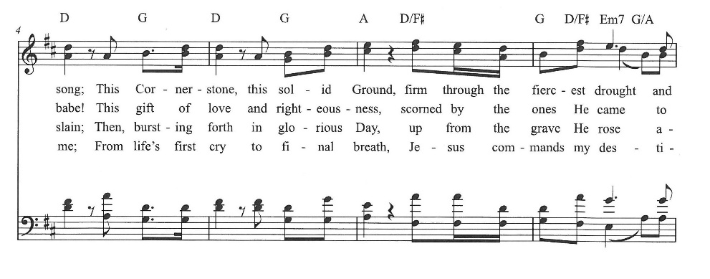
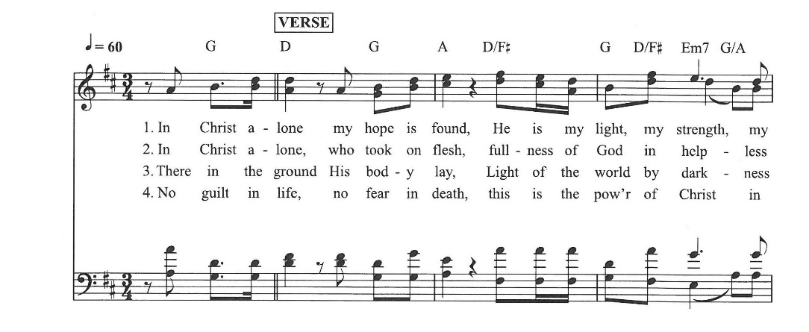
In Christ Alone
The Doxology
(Verse 3 only)

Offertory
Celebrant All things come from you, O Lord,
People And of your own have we given you.

The Eucharistic Liturgy

Celebrant The Lord be with you.
People And with your spirit.
Celebrant Lift up your hearts.
People We lift them up to the Lord.
Celebrant Let us give thanks to the Lord our God.
People It is right to give him thanks and praise.

It is right, our duty and our joy, always and everywhere to give thanks to you, Father Almighty, Creator of heaven and earth.

Through Jesus Christ our Lord, who on the first day of the week overcame death and the grave, and by his glorious resurrection opened to us the way of everlasting life.

Therefore we praise you, joining our voices with Angels and Archangels and with all the company of heaven, who for ever sing this hymn to proclaim the glory of your Name:

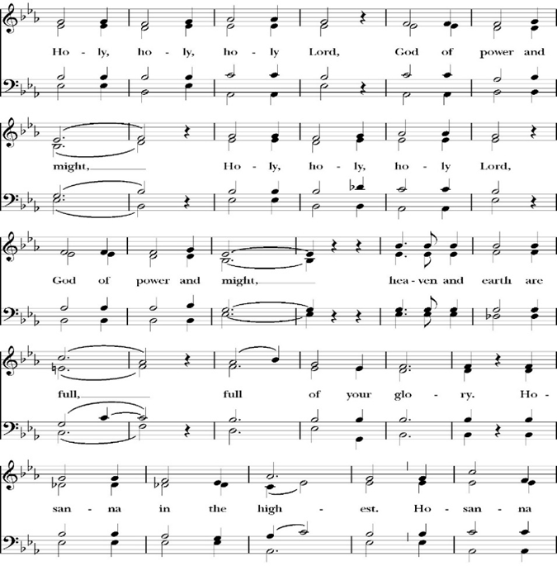
Sanctus

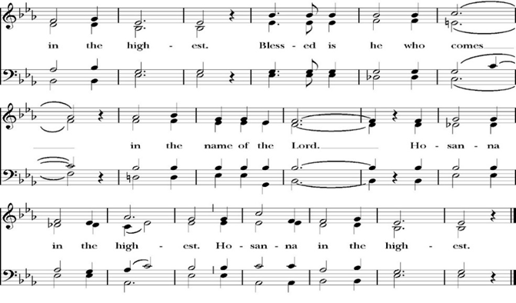
Holy and gracious Father: In your infinite love you made us for yourself; and when we had sinned against you and become subject to evil and death, you, in your mercy, sent your only Son Jesus Christ into the world for our salvation. By the Holy Spirit and the Virgin Mary he became flesh and dwelt among us. In obedience to your will, he stretched out his arms upon the Cross and offered himself once for all, that by his suffering and death we might be saved. By his resurrection he broke the bonds of death, trampling Hell and Satan under his feet. As our great high priest, he ascended to your right hand in glory, that we might come with confidence before the throne of grace.

On the night that he was betrayed, our Lord Jesus Christ took bread; and when he had given thanks, he broke it,* and gave it to his disciples, saying, “Take, eat; this is my Body, which is given for you: Do this in remembrance of me.”

Likewise, after supper, Jesus took the cup, and when he had given thanks, he gave it to them, saying, “Drink this, all of you; for this is my Blood of the New Covenant, which is shed for you, and for many, for the forgiveness of sins: Whenever you drink it, do this in remembrance of me.”

Therefore we proclaim the mystery of faith:

Christ has died.
Christ is risen.
Christ will come again.

We celebrate the memorial of our redemption, O Father, in this sacrifice of praise and thanksgiving, and we offer you these gifts.

Sanctify them by your Word and Holy Spirit to be for your people the Body and Blood of your Son Jesus Christ. Sanctify us also, that we may worthily receive this holy Sacrament, and be made one body with him, that he may dwell in us and we in him. In the fullness of time, put all things in subjection under your Christ, and bring us with all your saints into the joy of your heavenly kingdom, where we shall see our Lord face to face.

All this we ask through your Son Jesus Christ: By him, and with him, and in him, in the unity of the Holy Spirit, all honor and glory is yours, Almighty Father, now and for ever. Amen.

And now, as our Savior Christ has taught us, we are bold to pray,

Our Father, who art in heaven,
hallowed be thy Name,
thy kingdom come,
thy will be done,
on earth as it is in heaven.
Give us this day our daily bread.
And forgive us our trespasses,
as we
forgive those
who trespass against us.
And lead us not into temptation,
but deliver us from evil.
For thine is the kingdom,
and the power, and the glory,
for ever and ever. Amen.

Fraction

Celebrant Alleluia! Christ our Passover is sacrificed for us.
People Therefore let us keep the feast. Alleluia!

The Prayer for Humble Access

We do not presume to come to this your table, O merciful Lord,
trusting in our own righteousness,
but in your abundant and great mercies.
We are not worthy so much as to gather up
the crumbs under your table;
but you are the same Lord
whose character is always to have mercy.
Grant us, therefore, gracious Lord,
so to eat the flesh of your dear Son Jesus Christ,
and to drink his blood,
that our sinful bodies may be made clean by his body,
and our souls washed through his most precious blood,
and that we may evermore dwell in him, and he in us.
Amen.

Agnus Dei

The Ministration of Communion

The gifts of God for the People of God. Take them in remembrance that Christ died for you and feed on him in your hearts by faith, with thanksgiving.

Communion Hymn: One Bread One Body

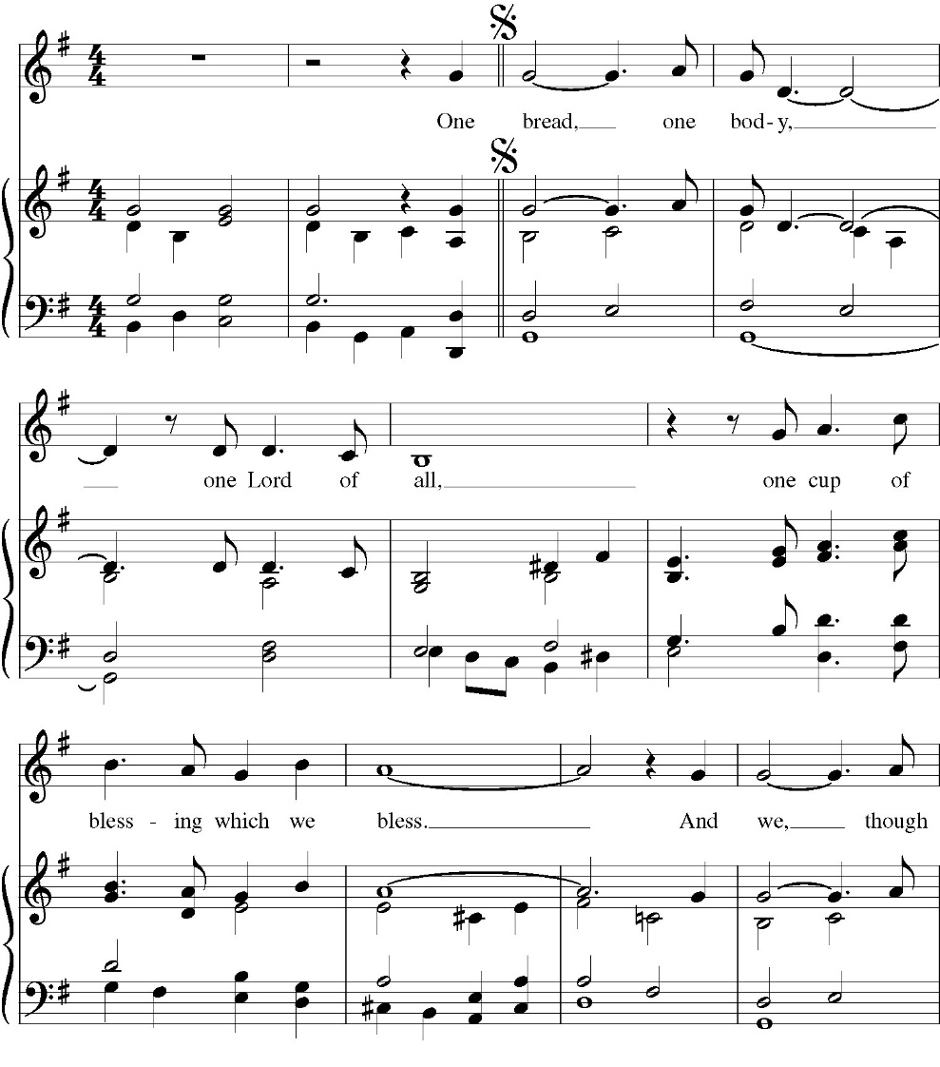

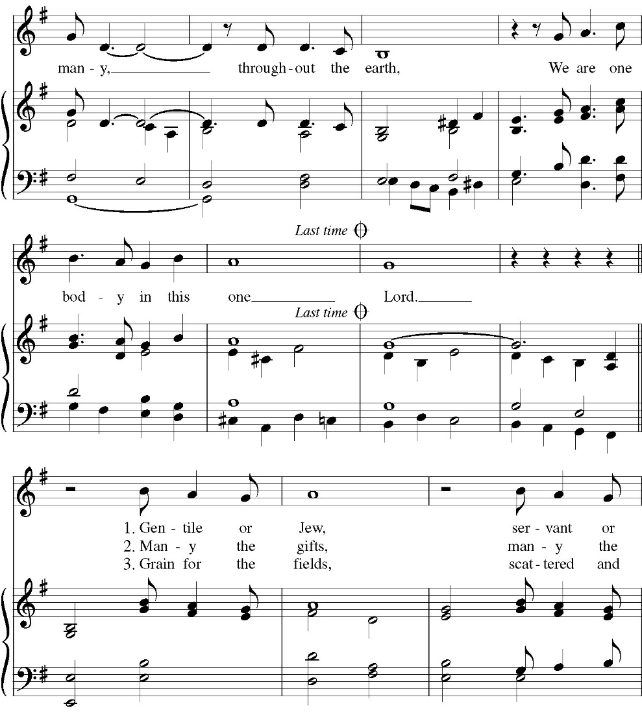

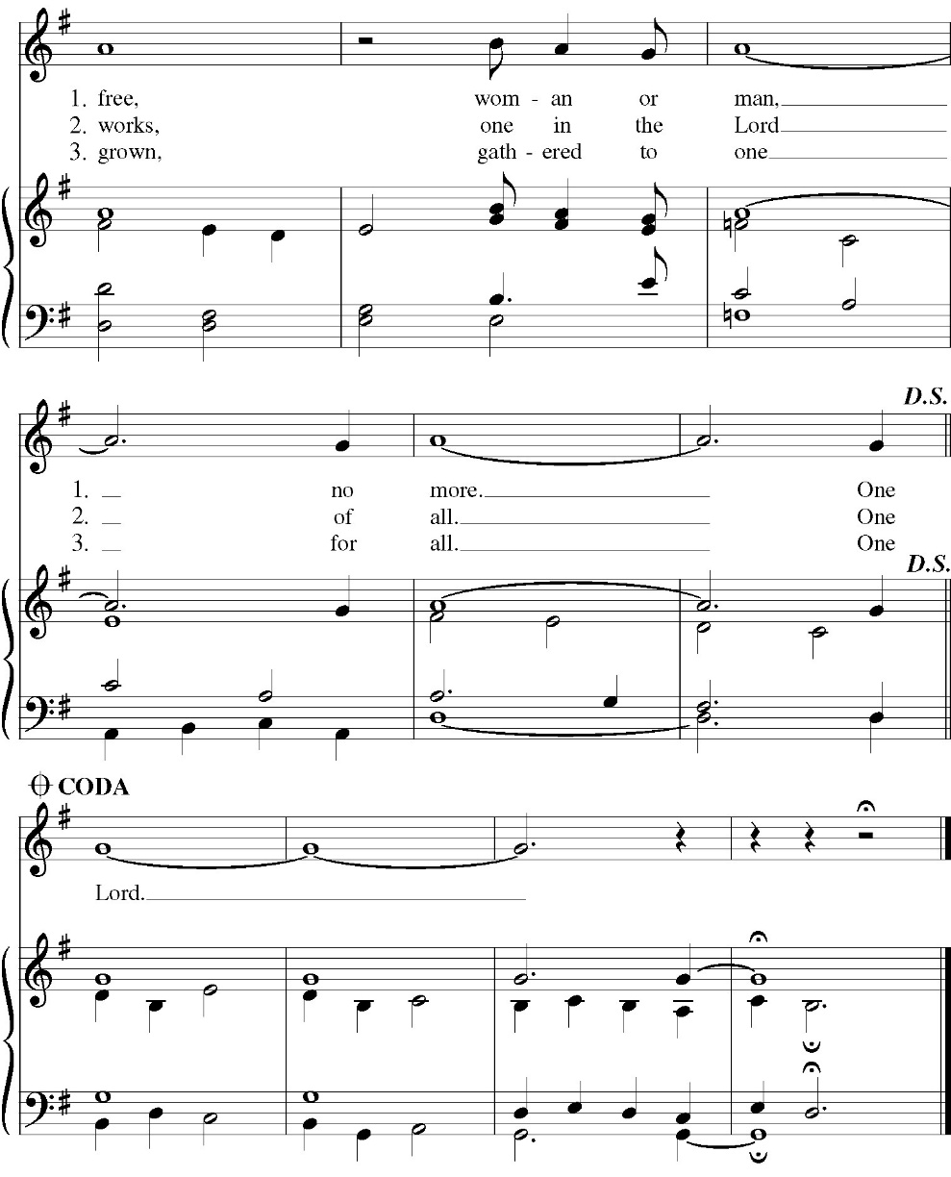

The Post Communion Prayer
Let us pray.

Heavenly Father,
We thank you for feeding us with the spiritual food
of the most precious Body and Blood
of your Son our Savior Jesus Christ;
and for assuring us in these holy mysteries
that we are living members of the body of your Son,
and heirs of your eternal Kingdom.
And now, Father, send us out to do the work you have
given us to do,
to love and serve you as faithful witnesses of Christ our
Lord.
To him, to you, and to the Holy Spirit,
be honor and glory, now and for ever. Amen.

The Blessing

The peace of God, which passes all understanding, keep your hearts and minds in the knowledge and love of God, and of his Son Jesus Christ our Lord; and the blessing of God Almighty, the Father, the Son, and the Holy Spirit, be among you, and remain with you always. Amen.

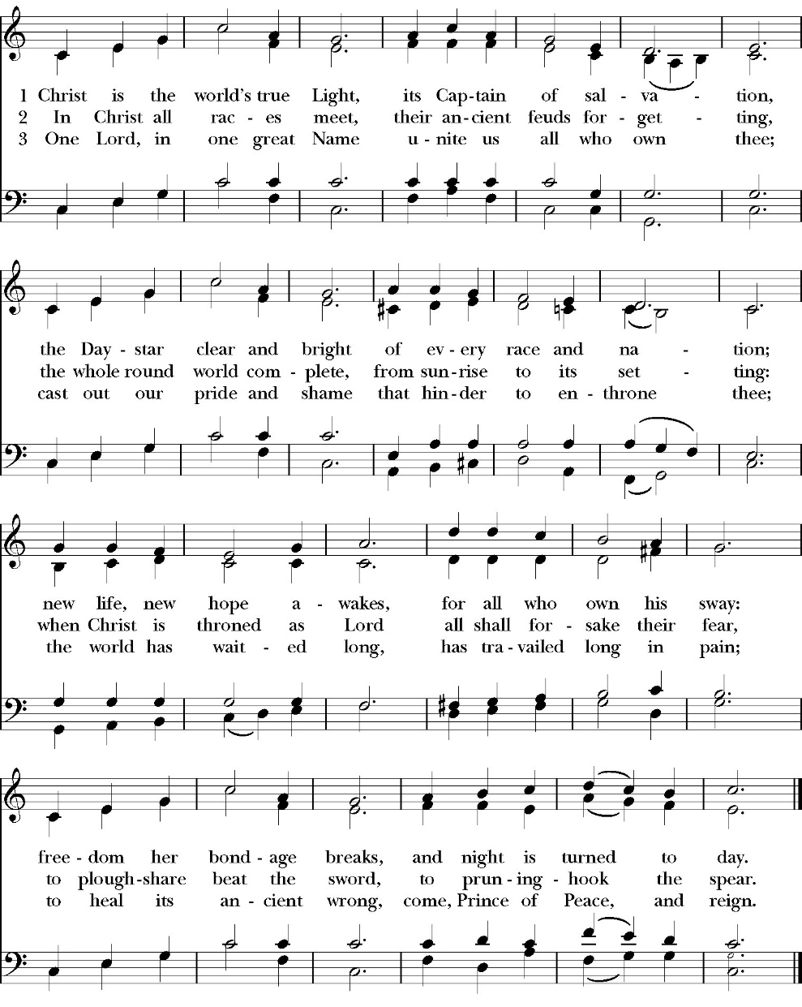
Closing Hymn: Christ is the World’s True Light

Dismissal
Deacon Alleluia, Alleluia. Let us go forth into the world, rejoicing
in the power of the Holy Spirit.
People Thanks be to God. Alleluia, alleluia.
St. Paul’s Parish Calendar
Sunday August 2 – Sunday August 9

SUNDAY, August 2 – Tenth Sunday after Pentecost
9:15 AM Sunday Funday, Youth Room
9:15 AM Gospel of John Bible Study, Conference Room
10:30 AM Children’s Sunday School, Chapel
Pre-K –2nd Grade, Sunday School Room
3rd -5th Grade, Youth Room
10:30 AM Holy Eucharist, Church

MONDAY, August 3

TUESDAY, August 4

WEDNESDAY, August 5
9:30 AM Holy Eucharist with healing prayer, Chapel
10:15 AM Bible Study, Conference Room

THURSDAY, August 6

FRIDAY, August 7
6:30 AM Men’s Bible Study, Valhalla Restaurant

SATURDAY, August 8

SUNDAY, August 9 – Eleventh Sunday after Pentecost
9:15 AM Sunday Funday, Youth Room
9:15 AM Gospel of John Bible Study, Conference Room
10:30 AM Children’s Sunday School, Chapel
Pre-K –2nd Grade, Sunday School Room
3rd -5th Grade, Youth Room
10:30 AM Holy Eucharist, Church

Church Office Hours
Monday-Thursday 8:00 AM-4:00 PM

Fr. Rob Longbottom will be on vacation August 6-10
In Case of Pastoral emergencies here are the cell phone numbers of our pastors Dcn. John Iseman (518)222-6722 Dcn. Kashy Rosland-Smith (559)733-1229
The Gospel of John Sunday morning Bible study, 9:15-10:00AM Resumes Sunday August 2
The Sunday morning Gospel of John bible study resumes Sunday, August 2 from 9:15am-10:00am. The Class finished through chapter 7 in June and is currently working through chapter 8.

School Supply drive for Hurley Elementary
Begins now and runs through Sunday, August 9
Did you know that 1/3 of all students at Hurley elementary are from low-income households? Help us serve these students with a school supply drive to help teachers make sure all their students have the supplies they need for a great school year. School supplies can be brought to Church on Sundays or to the church office Monday-Thursday 8am-4pm.
List of School Supplies needed are:

Backpacks, Crayons, Pencils Erasers, Glue Sticks, Scissors, Composition books, 1-inch binders, Expo markers, Lined paper, Pencil pouch.

A Food Bank for Hurley Families
The next Neighborhood Market to benefit students at Hurley School will be Tuesday August 11, 2:30 PM to 3:30 PM at St Paul’s Church parking lot. If you are interested in helping that day, please contact Sue Nyberg. My home phone number is 559-733-8244.

Due to the heat, we are in need of more volunteers for
the months of August and September. This will allow volunteers to work in shifts during these hot months.

PROVIDED BY VISALIA EMERGENCY AID
AND ST. PAUL’S CHURCH
Tuesday, August 11, 2026
From 2:30 PM to 3:30 PM
LOCATION:
ST. PAUL'S CHURCH PARKING LOT
ACROSS THE STREET FROM HURLEY
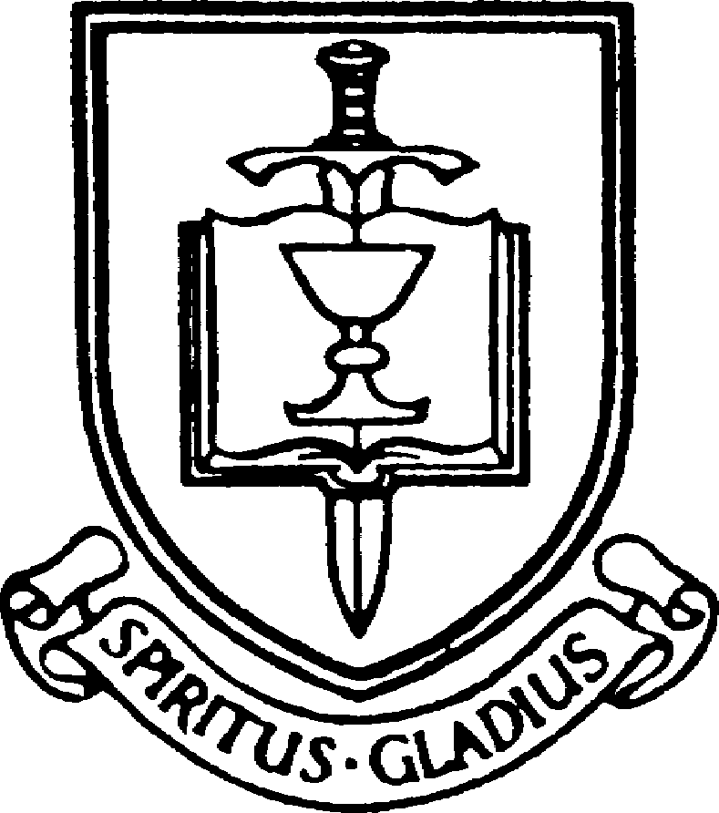



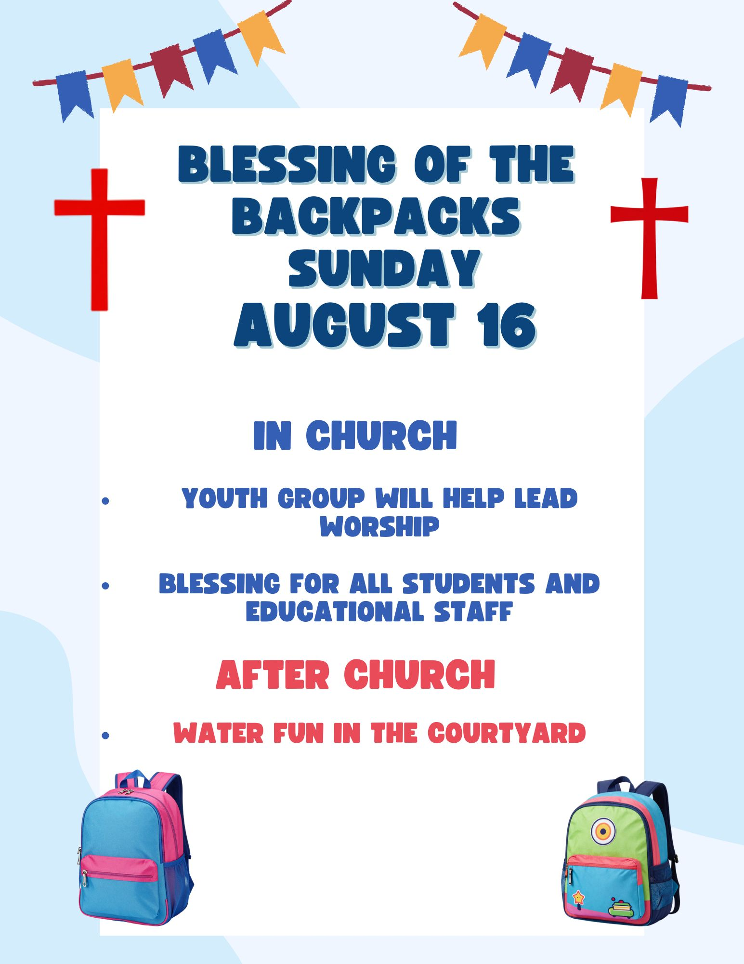

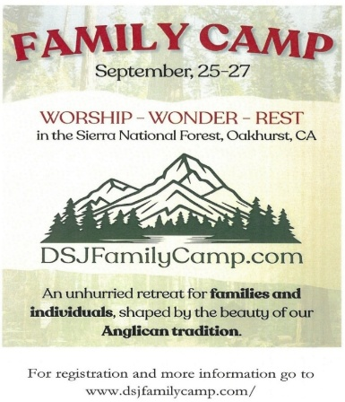
Anglican Diocese of San Joaquin Family Camp, Out of the Noise and Into the Wonder, September 25-27, Calvin Crest Sherwood Forest, Oakhurst, CA
Join your friends from St. Paul’s for an unhurried retreat for families and individuals, shaped by the beauty of our Anglican tradition. Calvin Crest Sherwood Forest is outside Oakhurst, CA near Yosemite. Each day flows from Morning Prayer to Compline. The family camp will feature tent and rustic cabin accommodations and will feel very much like the old Camp San Joaquin. The camp will be led by our friend Rev. Paul Gibbons, so we know that it will be a wonderful time.

The cost cannot be beat:
Bring your own Tent or RV: $75 for the whole family
Rustic Cabin Accommodations: $150 for the whole family

Accommodations and bathroom facilities

Tent & RV Sites: Pitch a tent or park your rig in the scenic Sherwood Forest area.
Rustic Cabins: Each cabin features 10 bunks with mattresses. Cabins are non-electric.
Bathrooms and Showers: Clean, private bathrooms and hot showers are available throughout camp.

What is included for this price:

The flat rate covers lodging, firewood, a sub sandwich dinner on Friday evening, breakfast on Saturday morning and a BBQ on Saturday evening.
How do I sign up or find out more?
Talk with Fr. Rob Longbottom or go to the Family Camp website at:
dsjfamilycamp.com


St. Paul’s Anglican Church
6436 W Hurley Ave
Visalia, CA


Friday October 2, 8:00 AM to 4:00 PM
Saturday October 3, 8:00 AM to 2:00 PM
Drop Off Donated Items in James Hall on:
Wednesday, September 30, and Thursday, October 1
Between 9:00 AM – 4:00 PM
Items need to be in Good Condition: clean, gently worn clothing, household items, toys in working order gladly accepted!
Volunteers Needed for Set Up:
Wednesday, September 30 and Thursday, October 1
Between 9:00 AM – 4:00 PM
If you have any questions,
Contact: Mary Murray at 799-6973

St. Paul’s Anglican Church
Parish Office
6436 W. Hurley Ave
Visalia, California 93291
559-732-4821
Office Hours: 8:00 – 4:00
Monday – Thursday

Worship: Sundays at 10:30AM
Livestream: Link at spvisalia.com
and on our Facebook page
Please be advised that this service is being recorded for broadcast
and/or archival purposes. By attending, you consent
to the inclusion of your likeness in these recordings.

St. Paul’s Clergy and Staff
The Rev. Robert Longbottom, Rector
rector@spvisalia.com
(559)802-2928
The Rev. John Iseman, Pastoral Associate for Family Ministries
family@spvisalia.com
The Rev. Kashy Rowland-Smith, Deacon
kashyrs@aol.com
Antoinette Horsting, Parish Administrator
bookkeeper@spvisalia.com
Marguerite Crownover, Organist and Accompanist
Ellen Daniels, Choral Director
Jackie Iseman, Nursery Coordinator
Shane Motl, Sexton

St. Paul’s is a member church of the
Anglican Diocese of San Joaquin
The Rt. Rev. Eric V. Menees, Bishop

Next Week’s Lessons
Jonah 2:1-10
Psalm 29
Romans 9:1-5
Matthew 14:22-33

