ST. PAUL’S
ANGLICAN CHURCH
VISALIA, CALIFORNIA

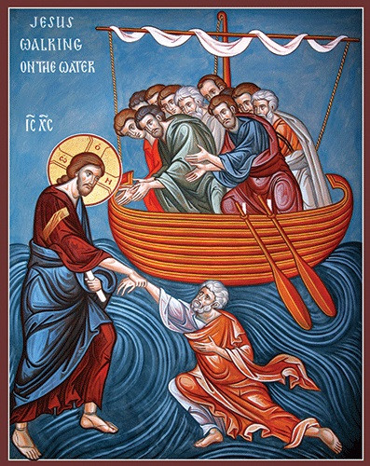

Eleventh Sunday after Pentecost
August 9, 2026
10:30 A.M

Welcome!

St. Paul’s Anglican Church extends a warm welcome to all visitors and newcomers, whether worshiping in person or at home via livestream.

Visitors’ Guide

St. Paul’s Church is a parish in the Diocese of San Joaquin of the Anglican Church in North America, which includes both Catholic and Protestant traditions. We accept Jesus Christ as Savior, and we promise to follow him as Lord. We believe in One God,

- the Father who created us and all things,
- the Son who redeems us from sin and death,
- the Holy Spirit who renews and sanctifies us.

We believe the Holy Scriptures to be the Word of God and to contain all things necessary for salvation, and we accept the Apostles’ and Nicene Creeds as essential beliefs of the Christian faith.

Those not desiring to receive Holy Communion, and those who have not been baptized into the Christian faith, are invited to cross their arms across their chest, and a blessing will be given instead.

Visitors are invited to sign the guest book at the entrance table and introduce themselves to the clergy following the service.

The Holy Eucharist

Prelude: “Andante” Handel
Opening Hymn: #411 – “O Bless the Lord My Soul!” p. 4
Opening Acclamation p. 5
The Collect for Purity p. 5
Summary of the Law p. 5
Kyrie p. 5
Gloria p. 6
Collect of the Day p. 7
Lesson: Jonah 2:1-10 p. 7
Gradual: Psalm 29 p. 7
Epistle: Romans 9:1-5 p. 8
Sequence Hymn: #414 – “God, My King Thy Might Confessing” p. 9
Gospel: Matthew 14:22-33 p. 10
Sermon: Rev John Iseman
Nicene Creed p. 10
Prayers of the People p. 11
The Peace p. 14
Offertory: Marguerite Organ
The Offertory p. 15
Sursum Corda p. 15
Sanctus p. 16
The Lord’s Prayer p. 17
Prayer for Humble Access p. 18
Agnus Dei p. 18
Communion Hymn: #435 – “At the Name of Jesus” p. 19
Post Communion Prayer p. 20
Blessing p. 20
Closing Hymn: #658 – “Eternal Father Strong to Save” p. 21
Dismissal p. 21
Postlude: “Trumpet Voluntary” Purcell

Opening Hymn: O Bless the Lord My Soul!
(All Verses)
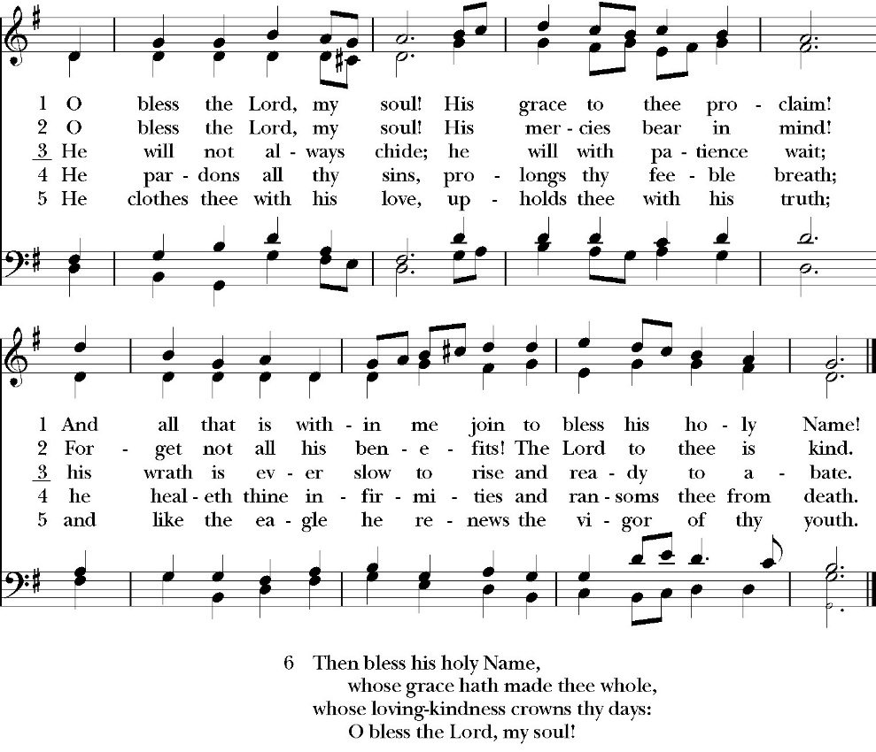

Opening Acclamation

Celebrant Blessed be God, the Father, the Son and the Holy Spirit. People And blessed be his kingdom, now and forever. Amen.

Collect for Purity

Almighty God, to you all hearts are open, all desires
known, and from you no secrets are hid: Cleanse the thoughts
of our hearts by the inspiration of your Holy Spirit, that we
may perfectly love you, and worthily magnify your holy Name;
through Christ our Lord. Amen.

Summary of the law

Hear what our Lord Jesus Christ says: You shall love
the Lord your God with all your heart and with all your soul
and with all your mind. This is the first and great
commandment. And the second is like it: You shall love your
neighbor as yourself. On these two commandments depend all
the Law and the Prophets.

Kyrie
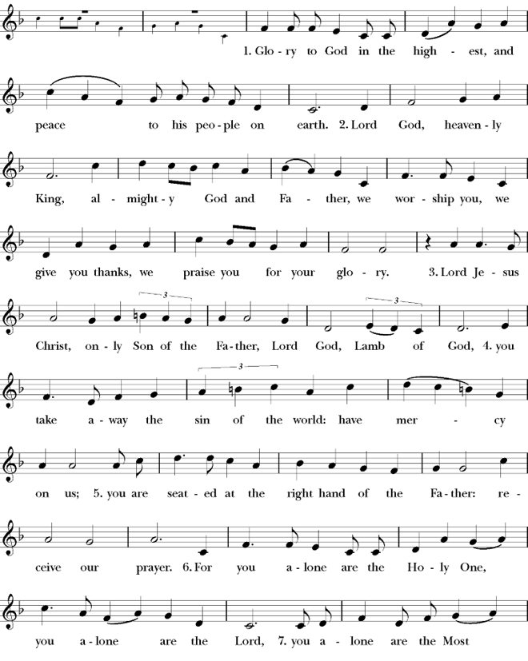
Gloria

Celebrant The Lord be with you.
People And with your spirit.
Celebrant Let us pray.

The Collect of the Day

Almighty God, give us the increase of faith, hope, and love; and, that we may obtain what you have promised, make us love what you command; through Jesus Christ our Lord, who lives and reigns with you and the Holy Spirit, one God, for ever and ever. Amen.

Lesson: Jonah 2:1-10
Then Jonah prayed to the LORD his God from the belly of the fish,

2 saying,

“I called out to the LORD, out of my distress, and he answered me; out of the belly of Sheol I cried, and you heard my voice.

3 For you cast me into the deep, into the heart of the seas, and the flood surrounded me; all your waves and your billows passed over me. 4 Then I said, ‘I am driven away from your sight; yet I shall again look upon your holy temple.’5 The waters closed in over me to take my life; the deep surrounded me; weeds were wrapped about my head 6 at the roots of the mountains. I went down to the land whose bars closed upon me forever; yet you brought up my life from the pit, O LORD my God. 7 When my life was fainting away, I remembered the LORD, and my prayer cameto you, into your holy temple. 8 Those who pay regard to vain idols forsake their hope of steadfast love. 9 But I with the voice of thanksgiving will sacrifice to you; what I have vowed I will pay. Salvation belongs to the LORD!”

10 And the LORD spoke to the fish, and it vomited Jonah out upon the dry land.

Reader: The Word of the Lord
People: Thanks be to God

Gradual: Psalm 29
1 Ascribe unto the LORD, O you mighty, *
ascribe unto the LORD worship and strength.
2 Give the LORD the honor due unto his Name; *
worship the LORD with holy worship.
3 It is the LORD that commands the waters; *
it is the glorious God that makes the thunder.
4 It is the LORD that rules the sea; the voice of the LORD is mighty in its working; *
the voice of the LORD is a glorious voice.
5 The voice of the LORD breaks the cedar trees; *
indeed, the LORD breaks the cedars of Lebanon.
6 He makes them also to skip like a calf, *
Lebanon also, and Sirion, like a young ox.
7 The voice of the LORD divides the flames of fire; the voice of the LORD shakes the wilderness; *
indeed, the LORD shakes the wilderness of Kadesh.
8 The voice of the LORD makes the deer to bring forth young, and strips the forests bare; *
in his temple all cry, “Glory.”
9 The LORD sits above the floodwaters, *
and the LORD remains King for ever.
10 The LORD shall give strength to his people; *
the LORD shall give his people the blessing of peace.

Glory be to the Father, and to the Son, and to the Holy Spirit;
as it was in the beginning, is now, and ever shall be, world
without end. Amen

Epistle: Romans 9:1-5
I am speaking the truth in Christ—I am not lying; my conscience bears me witness in the Holy Spirit— 2 that I have great sorrow and unceasing anguish in my heart. 3 For I could wish that I myself were accursed and cut off from Christ for the sake of my brothers, my kinsmen according to the flesh. 4 They are Israelites, and to them belong the adoption, the glory, the covenants, the giving of the law, the worship, and the promises. 5 To them belong the patriarchs, and from their race, according to the flesh, is the Christ, who is God over all, blessed forever. Amen.

Reader: The Word of the Lord
People: Thanks be to God

Sequence Hymn: God, My King Thy Might Confessing
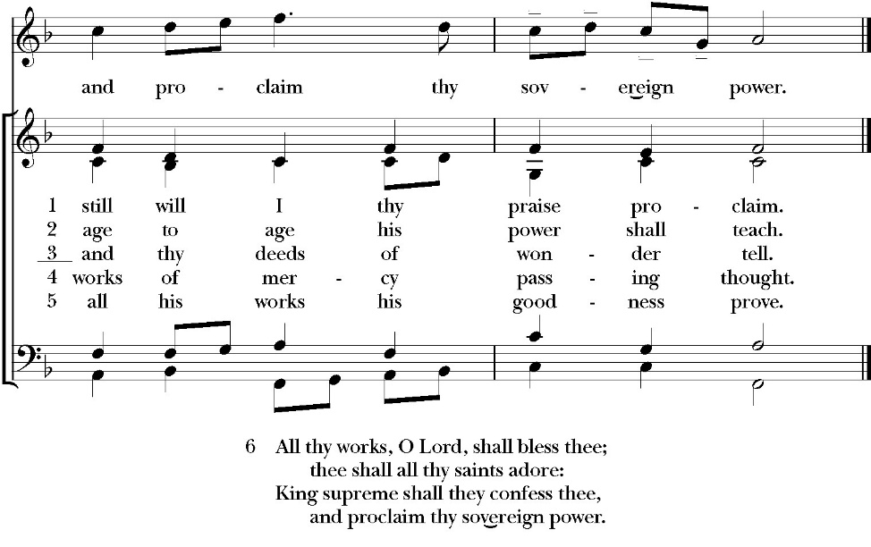
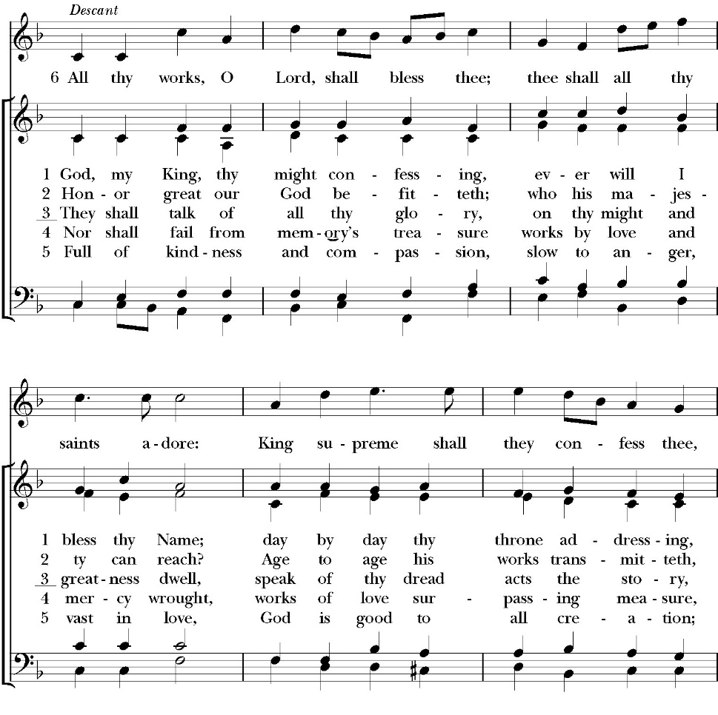
(Verses 1&2 before gospel verse 3 after gospel)
Clergy: The Holy Gospel of Our Lord Jesus Christ,
according to St. Matthew
People: Glory to you, Lord Christ.

Gospel: Matthew 14:22-33
Immediately he made the disciples get into the boat and go before him to the other side, while he dismissed the crowds. 23 And after he had dismissed the crowds, he went up on the mountain by himself to pray. When evening came, he was there alone, 24 but the boat by this time was a long way from the land, beaten by the waves, for the wind was against them. 25 And in the fourth watchof the night he came to them, walking on the sea. 26 But when the disciples saw him walking on the sea, they were terrified, and said, “It is a ghost!” and they cried out in fear. 27 But immediately Jesus spoke to them, saying, “Take heart; it is I. Do not be afraid.”

28 And Peter answered him, “Lord, if it is you, command me to come to you on the water.” 29 He said, “Come.” So Peter got out of the boat and walked on the water and came to Jesus. 30 But when he saw the wind, he was afraid, and beginning to sink he cried out, “Lord, save me.” 31 Jesus immediately reached out his hand and took hold of him, saying to him, “O you of little faith, why did you doubt?” 32 And when they got into the boat, the wind ceased. 33 And those in the boat worshiped him, saying, “Truly you are the Son of God.”

Clergy: The Gospel of the Lord
People: Praise to you, Lord Christ
Sermon

Rev. John Iseman

The Nicene Creed

We believe in one God,
the Father, the Almighty,
maker of heaven and earth,
of all that is, visible and invisible.

We believe in one Lord, Jesus Christ,
the only-begotten Son of God,
eternally begotten of the Father,
God from God, Light from Light,
true God from true God,
begotten, not made,
of one Being with the Father.
through him all things were made.

For us and for our salvation he came down from heaven:
was incarnate from the Holy Spirit and the Virgin Mary,
and was made man.
For our sake he was crucified under Pontius Pilate;
he suffered death and was buried.
On the third day he rose again in accordance with the
Scriptures;

he ascended into heaven
and is seated at the right hand of the Father.
He will come again in glory to judge the living and the dead,
and his kingdom will have no end.
We believe in the Holy Spirit, the Lord, the giver of life,
who proceeds from the Father and the Son,
who with the Father and the Son is worshiped and glorified.
who has spoken through the Prophets.
We believe in one holy catholic and apostolic Church.
We acknowledge one Baptism for the forgiveness of sins.
We look for the resurrection of the dead,
and the life of the world to come. Amen.

The Prayers of the People

Leader Let us pray for the Church and for the world, saying, “hear our prayer.”
For the peace of the whole world, and for the well-being and unity of the people of God.
Lord, in your mercy:
People Hear our prayer.

Leader For Stephen our archbishop, Julian our provincial dean, and Eric our bishop. For Fr. Rob, Deacon John, Deacon Kashy, and for all the clergy and people of our diocese and congregation and for the worldwide Anglican Communion.
Lord, in your mercy:
People Hear our prayer.

Leader For all those who proclaim the Gospel at home and abroad; and for all who teach and disciple others.
Lord, in your mercy:
People Hear our prayer.

Leader For our brothers and sisters in Christ who are persecuted for their faith.
Lord, in your mercy:
People Hear our prayer.

Leader For our nation, for those in authority, and for all in public service especially Donald our president and Gavin our governor.
Lord, in your mercy:
People Hear our prayer.

Leader: In the St. Paul’s cycle of prayer, we pray for the for our Sunday morning worship and welcoming ministries. We pray for the Altar Guild, our Lay Eucharistic Ministers, our Lectors, and our Acolytes. We pray for our music ministry and the musicians and vocalists. We pray for our ushers, greeters, and prayer table ministries.

Lord, in your mercy:
People Hear our prayer.

Leader In the ACNA Cycle of Prayer, today we pray for the Anglican Province of Rwanda and The Most Rev. Laurent Mbanda, Archbishop, and his wife, Chantal.
Lord, in your mercy:
People Hear our prayer.

Leader For all those who are in trouble, sorrow, need, sickness, or
any other adversity [especially ____________]. We also
pray for all who are currently serving in our armed forces
and serving as first responders.
Lord, in your mercy:
People Hear our prayer.

Leader For all those who have departed this life in the certain hope
of the resurrection, (we pray especially for ____________),
in Thanksgiving let us pray.
Lord, in your mercy:
People Hear our prayer.

Celebrant will add a concluding prayer

Heavenly Father, grant these our prayers for the sake of Jesus Christ,
our only Mediator and Advocate, who lives and reigns with you in
the unity of the Holy Spirit, one God, now and for ever. Amen.

The Confession and Absolution

Celebrant Let us humbly confess our sins to Almighty God.

Most merciful God,
we confess that we have sinned against you
in thought, word and deed,
by what we have done, and by what we have left undone.
We have not loved you with our whole heart;
we have not loved our neighbors as ourselves.
We are truly sorry and we humbly repent.
For the sake of your Son Jesus Christ,
have mercy on us and forgive us;
that we may delight in your will, and walk in your ways,
to the glory of your Name. Amen.
The Deacon leads the congregation is saying together a prayer to receive
God’s forgiveness.

Almighty God, our heavenly Father, who in his great mercy has
promised forgiveness of sins to all those who sincerely repent
and with true faith turn to him, have mercy upon us, pardon
and deliver us from all our sins, confirm and strengthen us in all
goodness, and bring us to everlasting life; through Jesus Christ our
Lord. Amen.

The comfortable words

The Deacon may then say one or more of the following sentences,

Come to me, all who labor and are heavy laden, and I will give you
rest.
-Matthew 11:28

God so loved the world, that he gave his only-begotten Son, that
whoever believes in him should not perish but have eternal life.
-John 3:16

The saying is trustworthy and deserving of full acceptance, that
Christ Jesus came into the world to save sinners.
-1 Timothy 1:15

If anyone sins, we have an advocate with the Father, Jesus Christ the
righteous. He is the propitiation for our sins, and not for ours only,
but also for the sins of the whole world.
-1 John 2:1-2t

Celebrant The Peace of the Lord be always with you.
People And with your spirit.

offertory
marguerite - organ

The Doxology
(Verse 3 only)

Offertory
Celebrant All things come from you, O Lord,
People And of your own have we given you.

The Eucharistic Liturgy

Celebrant The Lord be with you.
People And with your spirit.
Celebrant Lift up your hearts.
People We lift them up to the Lord.
Celebrant Let us give thanks to the Lord our God.
People It is right to give him thanks and praise.

It is right, our duty and our joy, always and everywhere to give thanks to you, Father Almighty, Creator of heaven and earth.

Through Jesus Christ our Lord, who on the first day of the week overcame death and the grave, and by his glorious resurrection opened to us the way of everlasting life.

Therefore we praise you, joining our voices with Angels and Archangels and with all the company of heaven, who for ever sing this hymn to proclaim the glory of your Name:

Sanctus
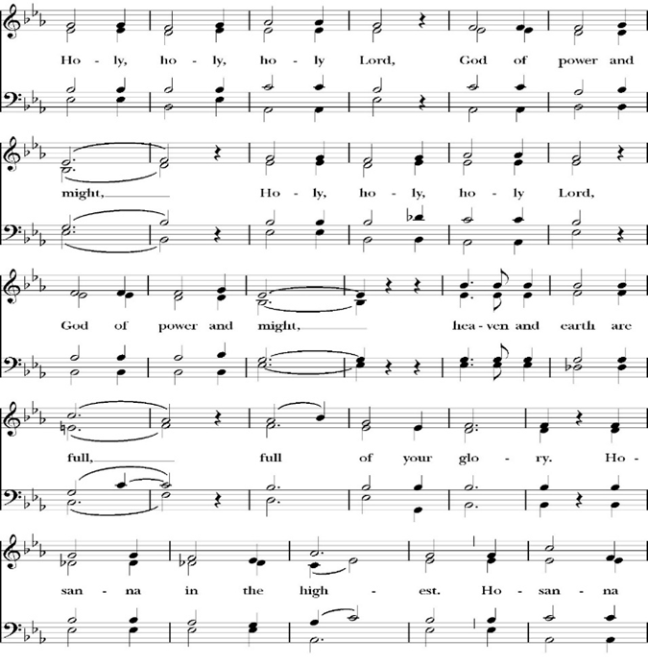

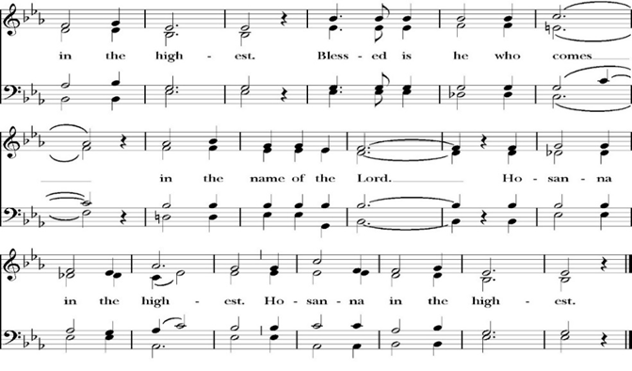
And now, as our Savior Christ has taught us, we are bold to pray,

Our Father, who art in heaven,
hallowed be thy Name,
thy kingdom come,
thy will be done,
on earth as it is in heaven.
Give us this day our daily bread.
And forgive us our trespasses,
as we
forgive those
who trespass against us.
And lead us not into temptation,
but deliver us from evil.
For thine is the kingdom,
and the power, and the glory,
for ever and ever. Amen.

The Prayer for Humble Access

We do not presume to come to this your table, O merciful Lord,
trusting in our own righteousness,
but in your abundant and great mercies.
We are not worthy so much as to gather up
the crumbs under your table;
but you are the same Lord
whose character is always to have mercy.
Grant us, therefore, gracious Lord,
so to eat the flesh of your dear Son Jesus Christ,
and to drink his blood,
that our sinful bodies may be made clean by his body,
and our souls washed through his most precious blood,
and that we may evermore dwell in him, and he in us.
Amen.

Agnus Dei

The Ministration of Communion

The gifts of God for the People of God. Take them in remembrance that Christ died for you and feed on him in your hearts by faith, with thanksgiving.

Communion Hymn: At the Name of Jesus

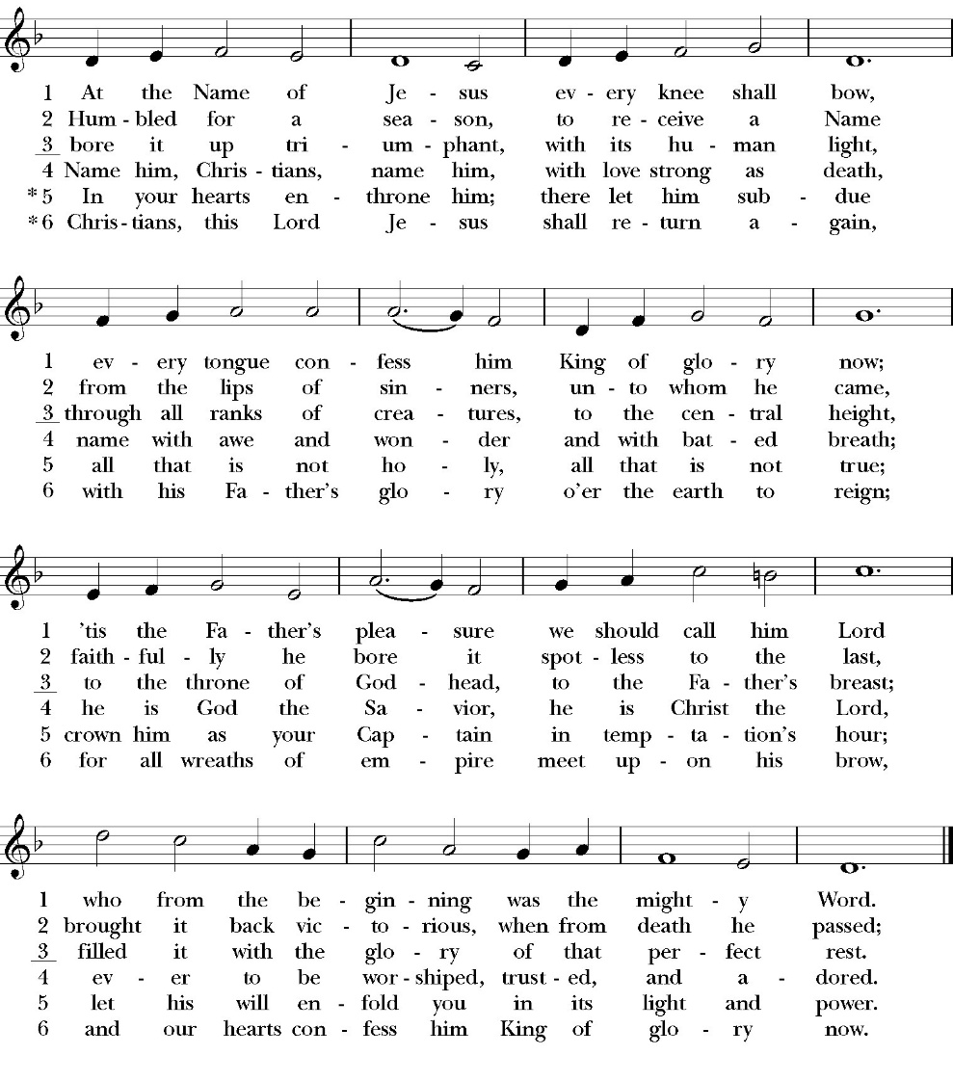

The Post Communion Prayer
Let us pray.

Heavenly Father,
We thank you for feeding us with the spiritual food
of the most precious Body and Blood
of your Son our Savior Jesus Christ;
and for assuring us in these holy mysteries
that we are living members of the body of your Son,
and heirs of your eternal Kingdom.
And now, Father, send us out to do the work you have
given us to do,
to love and serve you as faithful witnesses of Christ our
Lord.
To him, to you, and to the Holy Spirit,
be honor and glory, now and for ever. Amen.

The Blessing

The blessing of God Almighty, the Father, the Son, and the Holy
Spirit, be upon us, and remain with us always. Amen.

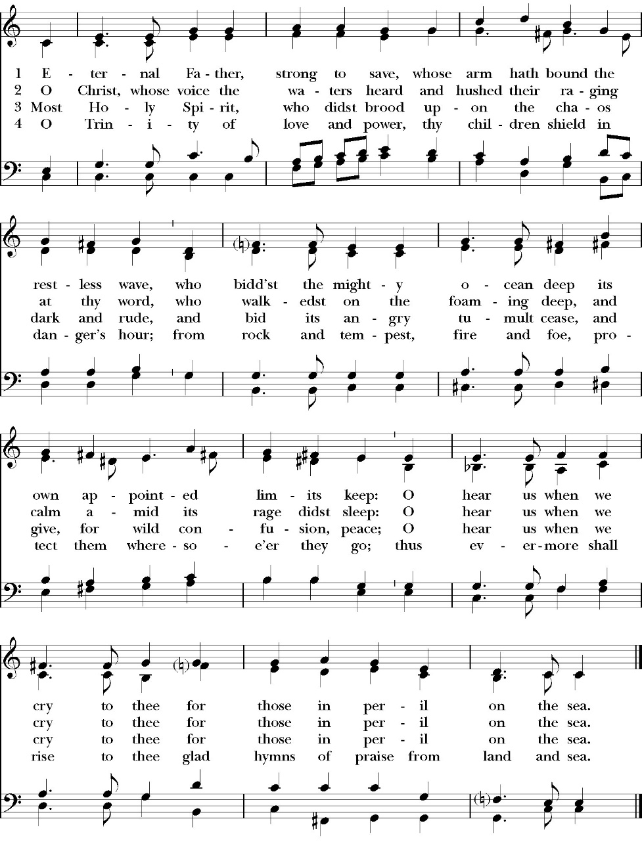
Closing Hymn: Eternal Father Strong to Save

Dismissal
Deacon Alleluia, Alleluia. Let us go forth into the world, rejoicing in the power of the Holy Spirit.
People Thanks be to God Alleluia, Alleluia.

Paul’s Parish Calendar
Sunday August 9 – Sunday August 16

SUNDAY, August 9 – Eleventh Sunday after Pentecost
9:15 AM Sunday Funday, Youth Room
9:15 AM Gospel of John Bible Study, Conference Room
10:30 AM Children’s Sunday School, Chapel
Pre-K –2nd Grade, Sunday School Room
3rd -5th Grade, Youth Room
10:30 AM Holy Eucharist, Church

MONDAY, August 10

TUESDAY, August 11
2:30 to 3:30 PM Neighborhood Market, Parking Lot
6:30 PM Bell Choir Rehearsals, Music Room

WEDNESDAY, August 12
9:30 AM Holy Eucharist with healing prayer, Chapel
10:15 AM Bible Study, Conference Room

THURSDAY, August 13

FRIDAY, August 14
6:30 AM Men’s Bible Study, Valhalla Restaurant

SATURDAY, August 15

SUNDAY, August 16 – Eleventh Sunday after Pentecost
9:15 AM Sunday Funday, Youth Room
9:15 AM Gospel of John Bible Study, Conference Room
10:30 AM Children’s Sunday School, Chapel
Pre-K –2nd Grade, Sunday School Room
3rd -5th Grade, Youth Room
10:30 AM Holy Eucharist, Church
Blessing of the Backpacks

Church Office Hours
Monday-Thursday 8:00 AM-4:00 PM
Fr. Rob Longbottom is on vacation August6-10
In Case of Pastoral emergencies here are the cell phone numbers of our pastors. Dcn. John Iseman (518)222-6722 Dcn. Kashy Rosland-Smith (559)733-1229
The Gospel of John Sunday morning Bible study, 9:15-10:00AM
The Sunday morning Gospel of John bible study has resumed and is working through chapter 8 in August. Fr. Rob will be our leader through August. Deacon John will lead the class in September.
No Gospel of John Class September 6 due to Labor Day weekend.

School Supply drive for Hurley Elementary Concludes Today Did you know that 1/3 of all students at Hurley elementary are from low-income households? Help us serve these students with a school supply drive to help teachers make sure all their students have the supplies they need for a great school year. School supplies can be brought to Church on Sundays or to the church office Monday-Thursday 8am-4pm.
List of School Supplies needed are:

Backpacks, Crayons, Pencils Erasers, Glue Sticks, Scissors, Composition books, 1-inch binders, Expo markers, Lined paper, Pencil pouch.

A Food Bank for Hurley Families
The next Neighborhood Market to benefit students at Hurley School will be Tuesday August 11, 2:30 PM to 3:30 PM at St Paul’s Church parking lot. If you are interested in helping that day, please contact Sue Nyberg. My home phone number is 559-733-8244.

Due to the heat, we are in need of more volunteers for
the months of August and September. This will allow volunteers to work in shifts during these hot months.

PROVIDED BY VISALIA EMERGENCY AID
AND ST. PAUL’S CHURCH
Tuesday, August 11, 2026
From 2:30 PM to 3:30 PM
LOCATION:
ST. PAUL'S CHURCH PARKING LOT
ACROSS THE STREET FROM HURLEY
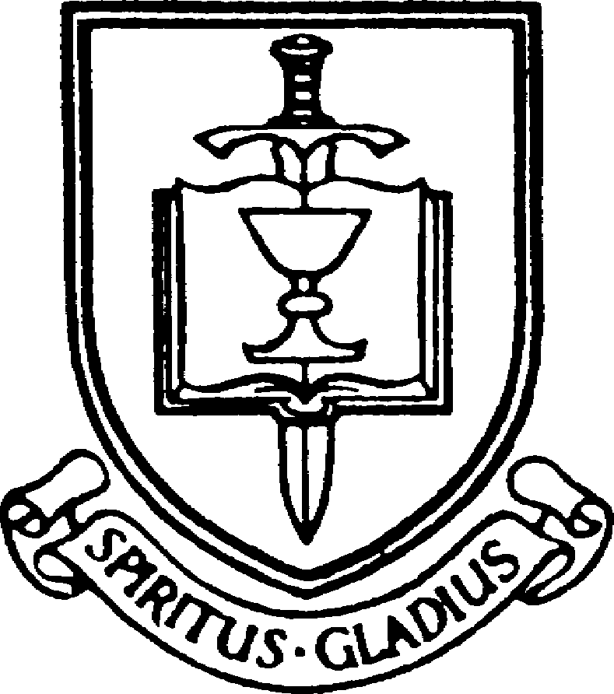



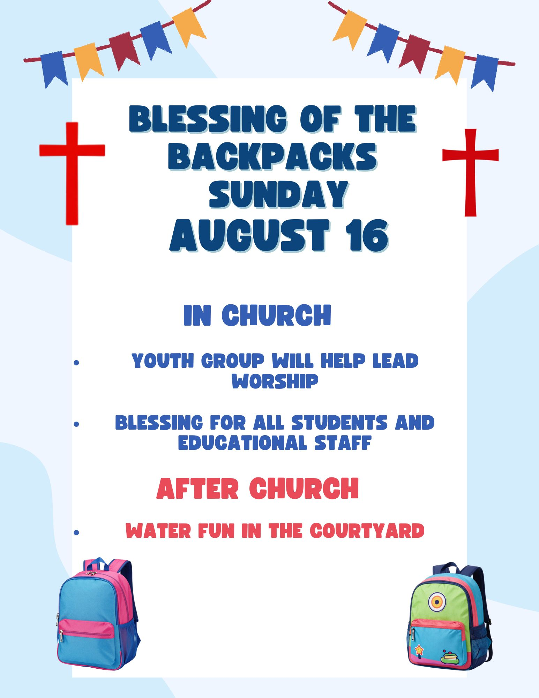

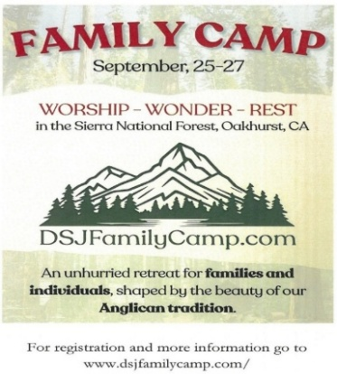
Diocese of San Joaquin Family Camp, Out of the Noise and Into the Wonder, September 25-27, Calvin Crest Sherwood Forest, Oakhurst, CA
Join your friends from St. Paul’s for an unhurried retreat for families and individuals, shaped by the beauty of our Anglican tradition. Calvin Crest Sherwood Forest is outside Oakhurst, CA near Yosemite. Each day flows from Morning Prayer to Compline. The family camp will feature tent and rustic cabin accommodations and will feel very much like the old Camp San Joaquin. The camp will be led by our friend Rev. Paul Gibbons, so we know that it will be a wonderful time.

The cost cannot be beat:
Bring your own Tent or RV: $75 for the whole family
Rustic Cabin Accommodations: $150 for the whole family

Accommodations and bathroom facilities

Tent & RV Sites: Pitch a tent or park your rig in the scenic Sherwood Forest area.
Rustic Cabins: Each cabin features 10 bunks with mattresses. Cabins are non-electric.
Bathrooms and Showers: Clean, private bathrooms and hot showers are available throughout camp.

What is included for this price:

The flat rate covers lodging, firewood, a sub sandwich dinner on Friday evening, breakfast on Saturday morning and a BBQ on Saturday evening.
How do I sign up or find out more?
Talk with Fr. Rob Longbottom or go to the Family Camp website at:
dsjfamilycamp.com


St. Paul’s Anglican Church
6436 W Hurley Ave
Visalia, CA


Friday October 2, 8:00 AM to 4:00 PM
Saturday October 3, 8:00 AM to 2:00 PM
Drop Off Donated Items in James Hall on:
Wednesday, September 30, and Thursday, October 1
Between 9:00 AM – 4:00 PM
Items need to be in Good Condition: clean, gently worn clothing, household items, toys in working order gladly accepted!
Volunteers Needed for Set Up:
Wednesday, September 30 and Thursday, October 1
Between 9:00 AM – 4:00 PM
If you have any questions,
Contact: Mary Murray at 799-6973

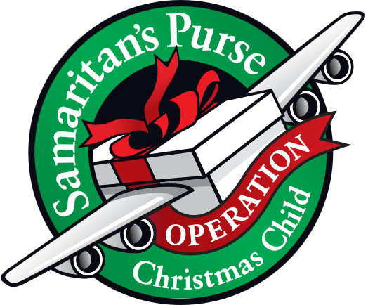
Operation Christmas Child donations begin in August
August Donations: School Supplies

Operation Christmas Child is a ministry of Samaritan’s Purse. The mission of Operation Christmas Child is to demonstrate God’s love in a tangible way to children in need around the world through partnering with the local church worldwide to provide shoe box size containers fill with school supplies, hygiene products and a small gift so to share the Good News of Jesus Christ and make disciples of the nations.

St. Paul’s Anglican Church is committed to providing 100 boxes to children throughout the world and will do this through monthly themed donations from August through November. We will then have a ‘Filling the box” party when we will gather together and fill 100 boxes with school supplies, hygiene products and small toys.

August Donations: School Supplies
Preferred donations: Pencils, colored pencils, crayons, paper, small ruler, items that can fit in a shoe box. All donations can be dropped off in the church Narthex at the display or in the church office.

St. Paul’s Anglican Church
Parish Office
6436 W. Hurley Ave
Visalia, California 93291
559-732-4821
Office Hours: 8:00 – 4:00
Monday – Thursday

Worship: Sundays at 10:30AM
Livestream: Link at spvisalia.com
and on our Facebook page
Please be advised that this service is being recorded for broadcast
and/or archival purposes. By attending, you consent
to the inclusion of your likeness in these recordings.

St. Paul’s Clergy and Staff
The Rev. Robert Longbottom, Rector
rector@spvisalia.com
(559)802-2928
The Rev. John Iseman, Pastoral Associate for Family Ministries
family@spvisalia.com
The Rev. Kashy Rowland-Smith, Deacon
kashyrs@aol.com
Antoinette Horsting, Parish Administrator
bookkeeper@spvisalia.com
Marguerite Crownover, Organist and Accompanist
Ellen Daniels, Choral Director
Jackie Iseman, Nursery Coordinator
Shane Motl, Sexton

St. Paul’s is a member church of the
Anglican Diocese of San Joaquin
The Rt. Rev. Eric V. Menees, Bishop

Next Week’s Lessons
Isaiah 56:1-8
Psalm 67
Romans 11:13-24
Matthew 15:21-28

