ST. PAUL’S
ANGLICAN CHURCH
VISALIA, CALIFORNIA

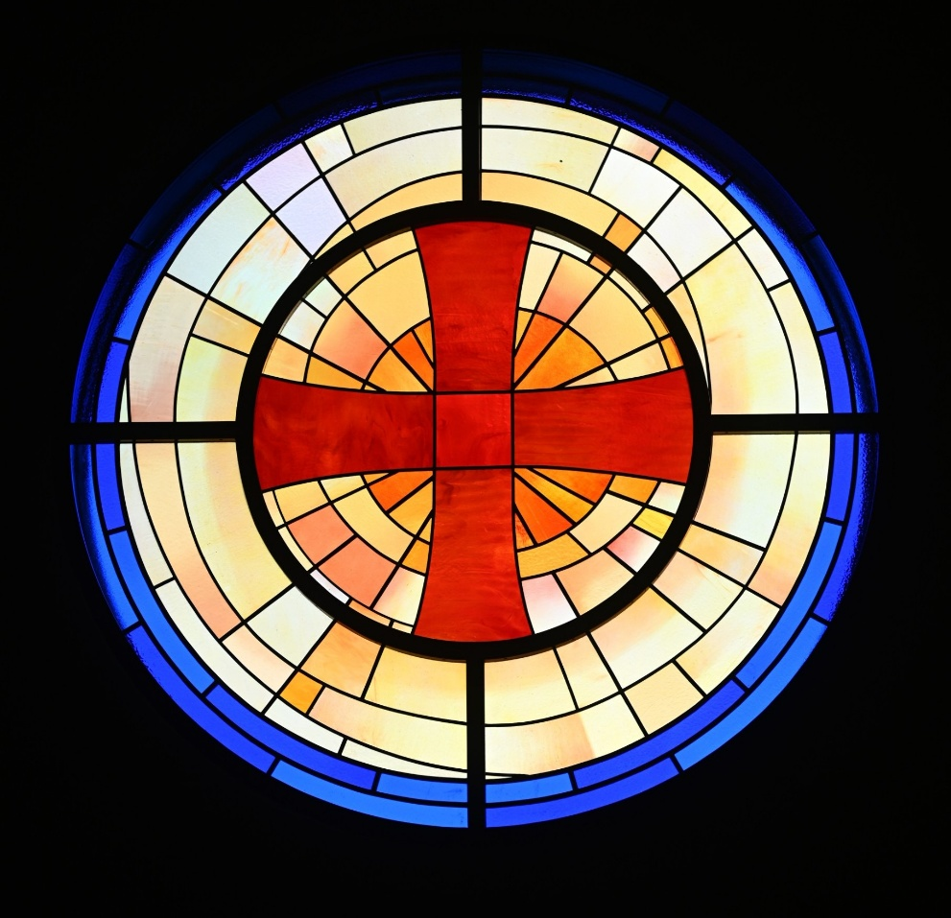

Seventeenth Sunday after Pentecost
September 20, 2026
10:30 A.M

Welcome!

St. Paul’s Anglican Church extends a warm welcome to all visitors and newcomers, whether worshiping in person or at home via livestream.

Visitors’ Guide

St. Paul’s Church is a parish in the Diocese of San Joaquin of the Anglican Church in North America, which includes both Catholic and Protestant traditions. We accept Jesus Christ as Savior, and we promise to follow him as Lord. We believe in One God,

- the Father who created us and all things,
- the Son who redeems us from sin and death,
- the Holy Spirit who renews and sanctifies us.

We believe the Holy Scriptures to be the Word of God and to contain all things necessary for salvation, and we accept the Apostles’ and Nicene Creeds as essential beliefs of the Christian faith.

Those not desiring to receive Holy Communion, and those who have not been baptized into the Christian faith, are invited to cross their arms across their chest, and a blessing will be given instead.

Visitors are invited to sign the guest book at the entrance table and introduce themselves to the clergy following the service.

The Holy Eucharist

Prelude: “Prelude and Fugue in E Minor” Bach
Opening Hymn: - #411 – “O Bless the Lord My Soul” p. 4
Opening Acclamation p. 4
The Collect for Purity p. 4
Summary of the Law p. 5
Kyrie p. 5
Gloria p. 6
Collect of the Day p. 7
Lesson: Jonah 3:10-4:11 p. 7
Gradual: Psalm 145 p. 8
Epistle: Philippians 1:21-27 p. 8
Sequence Hymn: #686 – “Come Thou Font of Every Blessing” p. 9
Gospel: Matthew 20:1-16 p. 10
Sermon: The Rev. Robert Longbottom
Nicene Creed p. 11
Prayers of the People p. 11
The Peace p. 14
Offertory: “Holy, Holy, Holy” Bells
The Offertory p. 15
Sursum Corda p. 15
Sanctus p. 16
The Lord’s Prayer p. 18
Fraction p. 18
Prayer for Humble Access p. 18
Agnus Dei p. 19
Communion Hymn: #325 – Let Us Brake Bread Together” p. 20
Post Communion Prayer p. 21
Blessing p. 21
Closing Hymn: #690 – Guide Me Thour, O Great Jehovah” p. 22
Dismissal p. 22
Postlude: “Jerusalem” Welch

Opening Hymn: O Bless the Lord My Soul

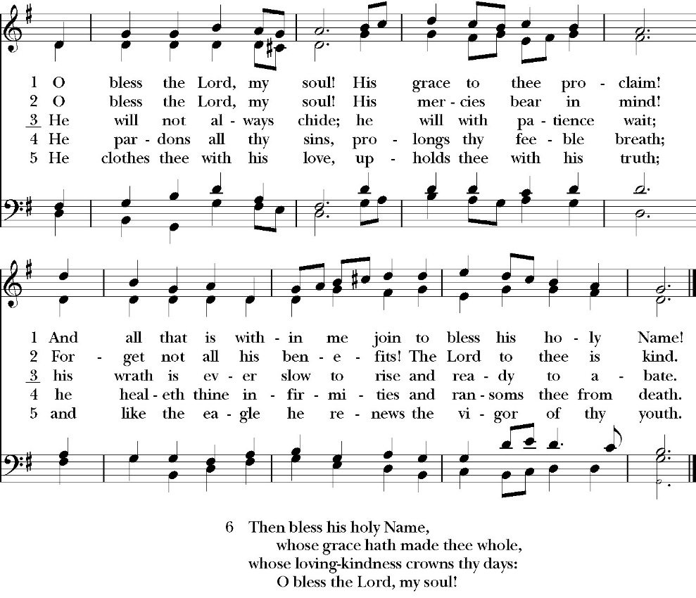

Opening Acclamation

Celebrant Blessed be God, the Father, the Son and the Holy Spirit. People And blessed be his kingdom, now and forever. Amen.

Collect for Purity

Almighty God, to you all hearts are open, all desires
known, and from you no secrets are hid: Cleanse the thoughts
of our hearts by the inspiration of your Holy Spirit, that we
may perfectly love you, and worthily magnify your holy Name;
through Christ our Lord. Amen.

Summary of the law

Hear what our Lord Jesus Christ says: You shall love
the Lord your God with all your heart and with all your soul
and with all your mind. This is the first and great
commandment. And the second is like it: You shall love your
neighbor as yourself. On these two commandments depend all
the Law and the Prophets.

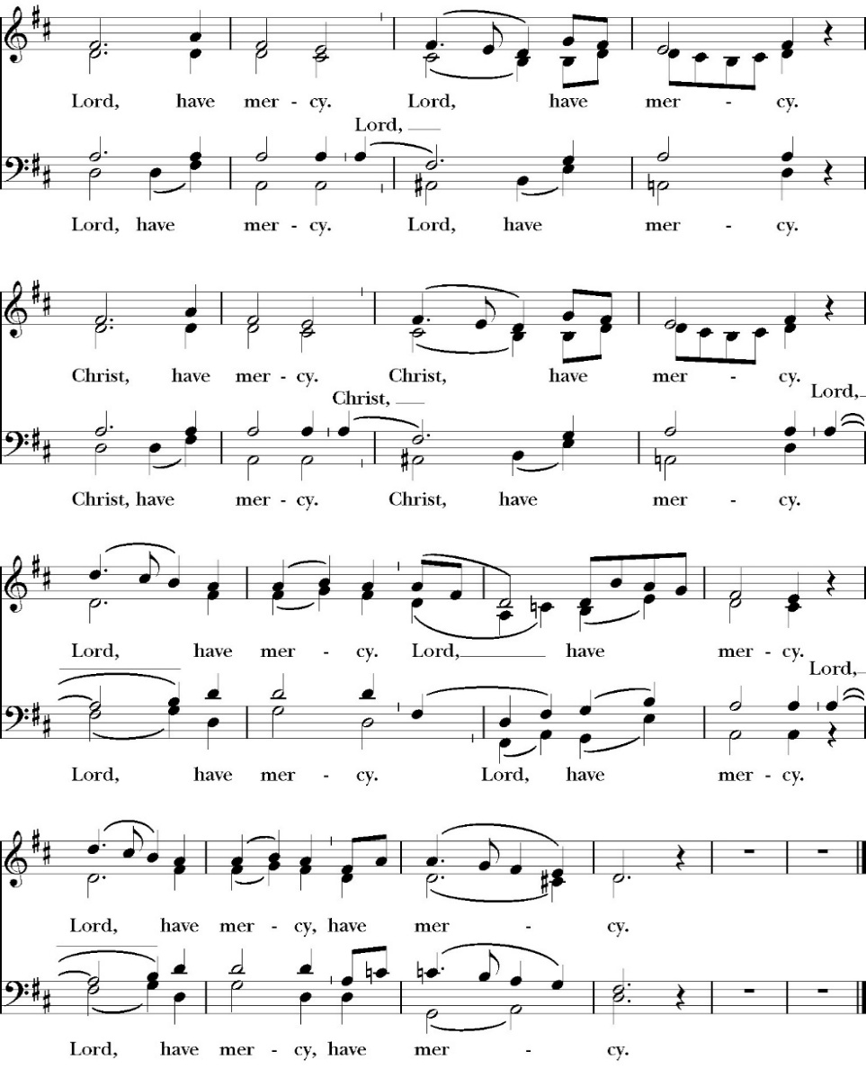
Kyrie

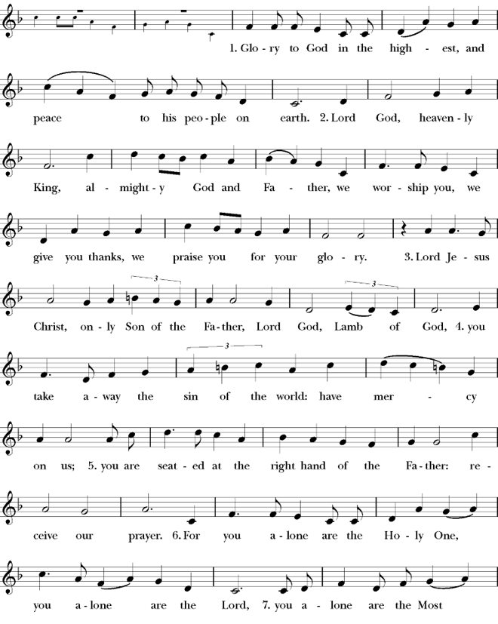
Gloria

Celebrant The Lord be with you.
People And with your spirit.
Celebrant Let us pray.

The Collect of the Day

O Lord, you have taught us that without love, all our deeds are worth nothing: Send your Holy Spirit and pour into our hearts that most excellent gift of charity, the true bond of peace and of all virtues, without which whoever lives is counted dead before you; grant this for the sake of your Son Jesus Christ, who lives and reigns with you and the Holy Spirit, one God, for ever and ever. Amen.

Lesson: Jonah 3:10-4:11
When God saw what they did, how they turned from their evil way, God relented of the disaster that he had said he would do to them, and he did not do it.

4 But it displeased Jonah exceedingly, and he was angry. 2 And he prayed to the LORD and said, “O LORD, is not this what I said when I was yet in my country? That is why I made haste to flee to Tarshish; for I knew that you are a gracious God and merciful, slow to anger and abounding in steadfast love, and relenting from disaster. 3 Therefore now, O LORD, please take my life from me, for it is better for me to die than to live.” 4 And the LORD said, “Do you do well to be angry?”

5 Jonah went out of the city and sat to the east of the city and made a booth for himself there. He sat under it in the shade, till he should see what would become of the city. 6 Now the LORD God appointed a plant and made it come up over Jonah, that it might be a shade over his head, to save him from his discomfort. So Jonah was exceedingly glad because of the plant. 7 But when dawn came up the next day, God appointed a worm that attacked the plant, so that it withered. 8 When the sun rose, God appointed a scorching east wind, and the sun beat down on the head of Jonah so that he was faint. And he asked that he might die and said, “It is better for me to die than to live.” 9 But God said to Jonah, “Do you do well to be angry for the plant?” And he said, “Yes, I do well
to be angry, angry enough to die.” 10 And the LORD said, “You pity the plant, for which you did not labor, nor did you make it grow, which came into being in a night and perished in a night. 11 And should not I pity Nineveh, that great city, in which there are more than 120,000 persons who do not know their right hand from their left, and also much cattle?”

Reader: The Word of the Lord
People: Thanks be to God

Gradual: Psalm 145: 14-21

14 The LORD upholds all those who fall *
and lifts up all those who are bowed down.
15 The eyes of all wait upon you, O Lord, *
and you give them their food in due season.
16 You open wide your hand, *
and fill all things living with plenteousness.
17 The LORD is righteous in all his ways *
and merciful in all his works.
18 The LORD is near to all those who call upon him, *
to all who call upon him faithfully.
19 He will fulfill the desire of those who fear him; *
he also will hear their cry and will help them.
20 The LORD preserves all those who love him, *
but he will destroy all the ungodly.
21 My mouth shall speak the praise of the LORD; *
and let all flesh give thanks unto his holy Name for ever and ever.

Glory be to the Father, and to the Son, and to the Holy Spirit;
as it was in the beginning, is now, and ever shall be, world
without end. Amen

Epistle: Philippians 1:21-27
For to me to live is Christ, and to die is gain. 22 If I am to live in the flesh, that means fruitful labor for me. Yet which I shall choose I cannot tell. 23 I am hard pressed between the two. My desire is to depart and be with Christ, for that is far better. 24 But to remain in the flesh is more necessary on your account.

25 Convinced of this, I know that I will remain and continue with you all, for your progress and joy in the faith, 26 so that in me you may have ample cause to glory in Christ Jesus, because of my coming to you again.

27 Only let your manner of life be worthy of the gospel of Christ, so that whether I come and see you or am absent, I may hear of you that you are standing firm in one spirit, with one mind striving side by side for the faith of the gospel,

Reader: The Word of the Lord
People: Thanks be to God

Sequence Hymn: Come Thou Font of Every Blessing
(verse 1&2 before Gospel, verse 3 after)
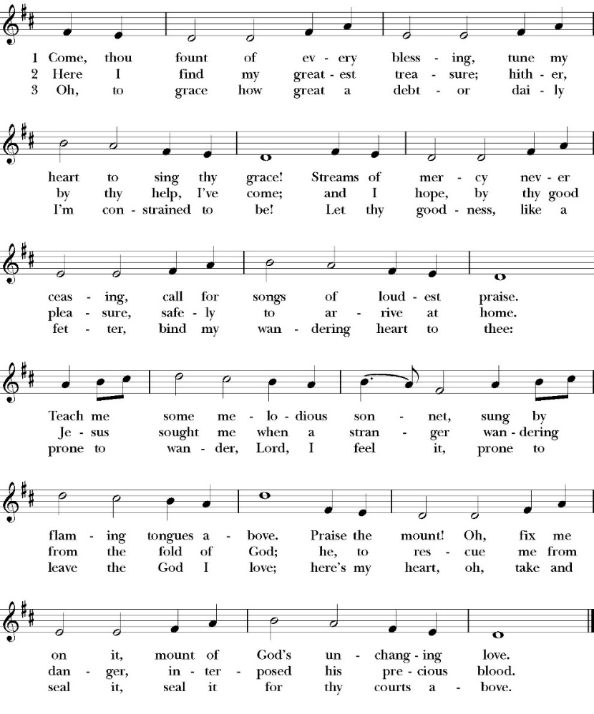

Clergy: The Holy Gospel of Our Lord Jesus Christ,
according to St. Matthew
People: Glory to you, Lord Christ.

Gospel Matthew 20:1-16
“For the kingdom of heaven is like a master of a house who went out early in the morning to hire laborers for his vineyard. 2 After agreeing with the laborers for a denarius a day, he sent them into his vineyard. 3 And going out about the third hour he saw others standing idle in the marketplace, 4 and to them he said, ‘You go into the vineyard too, and whatever is right I will give you.’ 5 So they went. Going out again about the sixth hour and the ninth hour, he did the same. 6 And about the eleventh hour he went out and found others standing. And he said to them, ‘Why do you stand here idle all day?’ 7 They said to him, ‘Because no one has hired us.’ He said to them, ‘You go into the vineyard too.’

8 And when evening came, the owner of the vineyard said to his foreman, ‘Call the laborers and pay them their wages, beginning with the last, up to the first.’

9 And when those hired about the eleventh hour came, each of them received a denarius. 10 Now when those hired first came, they thought they would receive more, but each of them also received a denarius. 11 And on receiving it they grumbled at the master of the house, 12 saying, ‘These last worked only one hour, and you have made them equal to us who have borne the burden of the day and the scorching heat.’ 13 But he replied to one of them, ‘Friend, I am doing you no wrong. Did you not agree with me for a denarius? 14 Take what belongs to you and go. I choose to give to this last worker as I give to you. 15 Am I not allowed to do what I choose with what belongs to me? Or do you begrudge my generosity?’ 16 So the last will be first, and the first last.”

Clergy: The Gospel of the Lord
People: Praise to you, Lord Christ

Sermon
The Rev. Robert Longbottom

The Nicene Creed

We believe in one God,
the Father, the Almighty,
maker of heaven and earth,
of all that is, visible and invisible.
We believe in one Lord, Jesus Christ,
the only-begotten Son of God,
eternally begotten of the Father,
God from God, Light from Light,
true God from true God,
begotten, not made,
of one Being with the Father.
through him all things were made.
For us and for our salvation he came down from heaven:
was incarnate from the Holy Spirit and the Virgin Mary,
and was made man.
For our sake he was crucified under Pontius Pilate;
he suffered death and was buried.
On the third day he rose again in accordance with the
Scriptures;
he ascended into heaven
and is seated at the right hand of the Father.
He will come again in glory to judge the living and the dead,
and his kingdom will have no end.
We believe in the Holy Spirit, the Lord, the giver of life,
who proceeds from the Father and the Son,
who with the Father and the Son is worshiped and glorified. who has spoken through the Prophets.
We believe in one holy catholic and apostolic Church.
We acknowledge one Baptism for the forgiveness of sins.
We look for the resurrection of the dead,
and the life of the world to come. Amen.

The Prayers of the People

Leader Let us pray for the Church and for the world, saying, “hear our prayer.”
For the peace of the whole world, and for the well-being and unity of the people of God.
Lord, in your mercy:
People Hear our prayer.

Leader For Stephen our archbishop, Julian our provincial dean, and Eric our bishop. For Fr. Rob, Deacon John, Deacon Kashy, and for all the clergy and people of our diocese and congregation and for the worldwide Anglican Communion.
Lord, in your mercy:
People Hear our prayer.

Leader For all those who proclaim the Gospel at home and abroad; and for all who teach and disciple others.
Lord, in your mercy:
People Hear our prayer.

Leader For our brothers and sisters in Christ who are persecuted for their faith.
Lord, in your mercy:
People Hear our prayer.

Leader For our nation, for those in authority, and for all in public service especially Donald our president and Gavin our governor.
Lord, in your mercy:
People Hear our prayer.

Leader In the St. Paul’s cycle of prayer will pray for all ministries of mission and outreach to our community and in the world. We pray specifically for the medical mission to Honduras, St. Paul’s School, Visalia Senior Housing, Turning Point ministries and all ministries which, we support as a parish. We pray for Fr. Frank and Ann Bernardi and Millagro Menees.
Lord, in your mercy:
People Hear our prayer.

Leader In the ACNA Cycle of Prayer, today we pray for the Anglican Province of Myanmar and The Most Rev. Stephen Than Myint Oo, Archbishop, and his wife, Nan.
Lord, in your mercy:
People Hear our prayer.

Leader For all those who are in trouble, sorrow, need, sickness, or
any other adversity [especially ____________]. We also
pray for all who are currently serving in our armed forces
and serving as first responders.
Lord, in your mercy:
People Hear our prayer.

Leader For all those who have departed this life in the certain hope
of the resurrection, (we pray especially for ____________),
in Thanksgiving let us pray.
Lord, in your mercy:
People Hear our prayer.

The Celebrant concludes with this or some other appropriate Collect.
Heavenly Father, grant these our prayers for the sake of Jesus Christ,
our only Mediator and Advocate, who lives and reigns with you in
the unity of the Holy Spirit, one God, now and for ever. Amen.

The Confession and Absolution

Celebrant Let us humbly confess our sins to Almighty God.

Most merciful God,
we confess that we have sinned against you
in thought, word and deed,
by what we have done, and by what we have left undone.
We have not loved you with our whole heart;
we have not loved our neighbors as ourselves.
We are truly sorry and we humbly repent.
For the sake of your Son Jesus Christ,
have mercy on us and forgive us;
that we may delight in your will, and walk in your ways,
to the glory of your Name. Amen.

Almighty God, our heavenly Father, who in his great mercy has
promised forgiveness of sins to all those who sincerely repent and
with true faith turn to him, have mercy upon you, pardon and deliver
you from all your sins, confirm and strengthen you in all goodness,
and bring you to everlasting life; through Jesus Christ our Lord.
Amen.
The Comfortable Words

Hear the Word of God to all who truly turn to him. Come to me, all
who labor and are heavy laden, and I will give you rest.
-Matthew 11:28

God so loved the world, that he gave his only-begotten Son, that
whoever believes in him should not perish but have eternal life.
-John 3:16t

Celebrant The Peace of the Lord be always with you.
People And with your spirit.

offertory
bell choir - holy, holy, holy
arranged by Sandra eithun

The Doxology
(Verse 3 only)

Offertory

Celebrant All things come from you, O Lord,
People And of your own have we given you.

The Eucharistic Liturgy
Celebrant The Lord be with you.
People And with your spirit.
Celebrant Lift up your hearts.
People We lift them up to the Lord.
Celebrant Let us give thanks to the Lord our God.
People It is right to give him thanks and praise.

It is right, our duty and our joy, always and everywhere to give thanks to you, Father Almighty, Creator of heaven and earth.
Through Jesus Christ our Lord, who on the first day of the week overcame death and the grave, and by his glorious resurrection opened to us the way of everlasting life.

Therefore we praise you, joining our voices with Angels and Archangels and with all the company of heaven, who for ever sing this hymn to proclaim the glory of your Name:

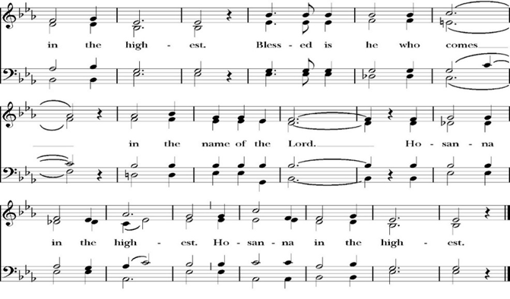
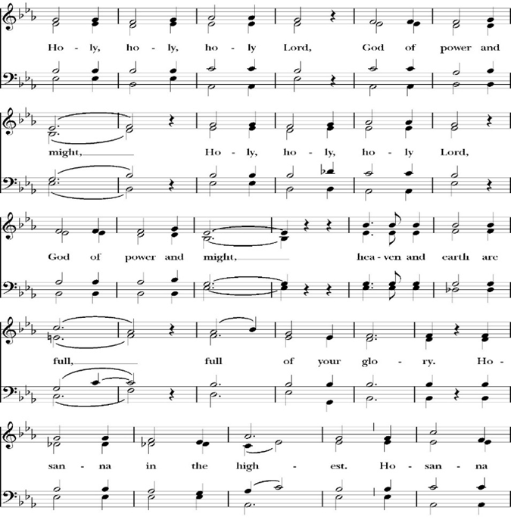
Sanctus
Holy and gracious Father: In your infinite love you made us for yourself; and when we had sinned against you and become subject to evil and death, you, in your mercy, sent your only Son Jesus Christ into the world for our salvation. By the Holy Spirit and the Virgin Mary he became flesh and dwelt among us. In obedience to your will, he stretched out his arms upon the Cross and offered himself once for all, that by his suffering and death we might be saved. By his resurrection he broke the bonds of death, trampling Hell and Satan under his feet. As our great high priest, he ascended to your right hand in glory, that we might come with confidence before the throne of grace.

On the night that he was betrayed, our Lord Jesus Christ took bread; and when he had given thanks, he broke it,* and gave it to his disciples, saying, “Take, eat; this is my Body, which is given for you: Do this in remembrance of me.”

Likewise, after supper, Jesus took the cup, and when he had given thanks, he gave it to them, saying, “Drink this, all of you; for this is my Blood of the New Covenant, which is shed for you, and for many, for the forgiveness of sins: Whenever you drink it, do this in remembrance of me.”

Therefore, we proclaim the mystery of faith:

Christ has died.
Christ is risen.
Christ will come again.

We celebrate the memorial of our redemption, O Father, in this sacrifice of praise and thanksgiving, and we offer you these gifts.

Sanctify them by your Word and Holy Spirit to be for your people the Body and Blood of your Son Jesus Christ. Sanctify us also, that we may worthily receive this holy Sacrament, and be made one body with him, that he may dwell in us and we in him. In the fullness of time, put all things in subjection under your Christ, and bring us with all your saints into the joy of your heavenly kingdom, where we shall see our Lord face to face.

All this we ask through your Son Jesus Christ: By him, and with him, and in him, in the unity of the Holy Spirit, all honor and glory is yours, Almighty Father, now and for ever. Amen.

And now, as our Savior Christ has taught us, we are bold to pray,

Our Father, who art in heaven,
hallowed be thy Name,
thy kingdom come,
thy will be done,
on earth as it is in heaven.
Give us this day our daily bread.
And forgive us our trespasses,
as we
forgive those
who trespass against us.
And lead us not into temptation,
but deliver us from evil.
For thine is the kingdom,
and the power, and the glory,
for ever and ever. Amen.

Fraction

Celebrant Alleluia! Christ our Passover is sacrificed for us.
People Therefore let us keep the feast. Alleluia!

The Prayer for Humble Access

We do not presume to come to this your table, O merciful Lord,
trusting in our own righteousness,
but in your abundant and great mercies.
We are not worthy so much as to gather up
the crumbs under your table;
but you are the same Lord
whose character is always to have mercy.
Grant us, therefore, gracious Lord,
so to eat the flesh of your dear Son Jesus Christ,
and to drink his blood,
that our sinful bodies may be made clean by his body,
and our souls washed through his most precious blood,
and that we may evermore dwell in him, and he in us.
Amen.
Agnus Dei

The Ministration of Communion

The gifts of God for the People of God. Take them in remembrance that Christ died for you and feed on him in your hearts by faith, with thanksgiving.

Communion Hymn: Let Us Break Bread Together

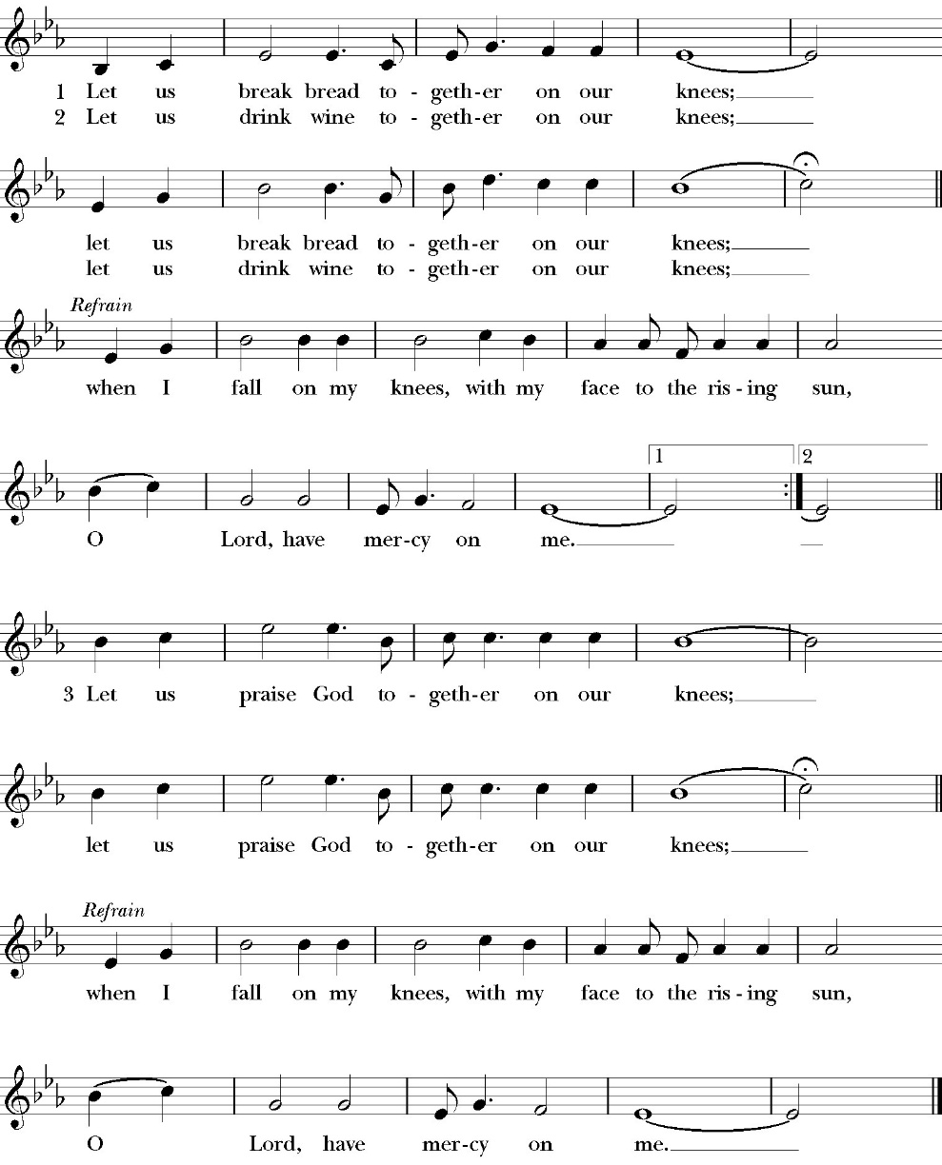

The Post Communion Prayer
Let us pray.

Heavenly Father,
We thank you for feeding us with the spiritual food
of the most precious Body and Blood
of your Son our Savior Jesus Christ;
and for assuring us in these holy mysteries
that we are living members of the body of your Son,
and heirs of your eternal Kingdom.
And now, Father, send us out to do the work you have
given us to do,
to love and serve you as faithful witnesses of Christ our
Lord.
To him, to you, and to the Holy Spirit,
be honor and glory, now and for ever. Amen.

The Blessing

The peace of God, which passes all understanding, keep your hearts and minds in the knowledge and love of God, and of his Son Jesus Christ our Lord; and the blessing of God Almighty, the Father, the Son, and the Holy Spirit, be among you, and remain with you always. Amen.

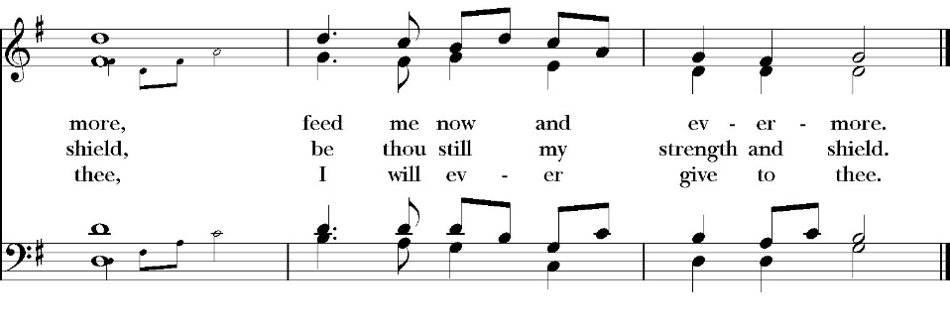
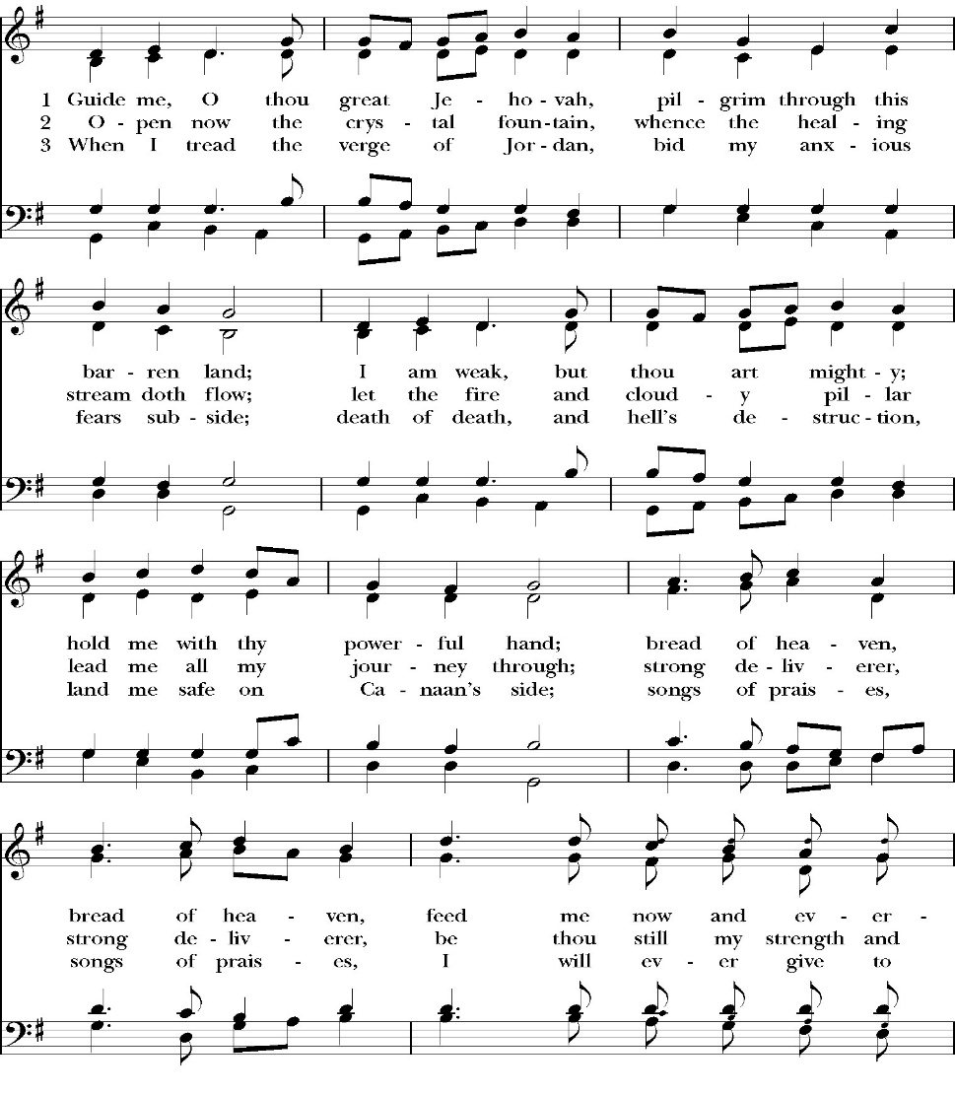
Closing Hymn: Guide Me, Thou O Great Jehovah
Dismissal
Deacon Alleluia, Alleluia. Let us go forth into the world,
rejoicing in the power of the Holy Spirit.
People Thanks be to God Alleluia, Alleluia.
St. Paul’s Parish Calendar
Sunday September 20– Sunday September 27

SUNDAY, September 20 –Seventeenth Sunday after Pentecost
9:15 AM Sunday Funday, Youth Room
9:15 AM Gospel of John Bible Study, Conference Room
10:30 AM Children’s Sunday School, Chapel
Pre-K –2nd Grade, Sunday School Room
3rd -5th Grade, Youth Room
10:30 AM Holy Eucharist, Church

MONDAY, September 21

TUESDAY, September 22
6:30 PM Bell Choir Rehearsal, Music Room

WEDNESDAY, September 23
9:30 AM Holy Eucharist with healing prayer, Chapel
10:15 AM Bible Study, Conference Room
5:00 – 6 PM Practicing the Way: Witness
5:30 – 6:30 PM Dinner, James Hall
6:30 – 7:15 PM Parenting Group
6:30-7:15 PM Children’s Program
7:00 PM Choir Rehearsal, Chapel

THURSDAY, September 24

FRIDAY, September 25
6:30 AM Men’s Bible Study, Valhalla Restaurant

SATURDAY, September 26

SUNDAY, September 27 –Eighteenth Sunday after Pentecost
9:15 AM Sunday Funday, Youth Room
9:15 AM Gospel of John Bible Study, Conference Room
10:30 AM Children’s Sunday School, Chapel
Pre-K –2nd Grade, Sunday School Room
3rd -5th Grade, Youth Room
10:30 AM Holy Eucharist, Church

Church Office Hours
Monday-Thursday 8:00 AM-4:00 PM

The Gospel of John Sunday morning Bible study, 9:15-10:00AM
The Sunday morning Gospel of John Bible study has resumed and is working through chapter 8 in August. Fr. Rob will be our leader through August. Deacon John will lead the class in September.
No Gospel of John Class September 6 due to Labor Day weekend.

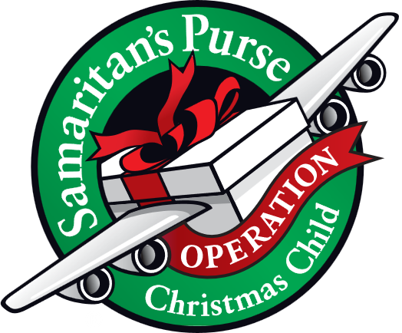
Operation Christmas Child donations begin in September
September Donations: Personal Care Item and Clothing & Accessories.

Operation Christmas Child is a ministry of Samaritan’s Purse. The mission of Operation Christmas Child is to demonstrate God’s love in a tangible way to children in need around the world through partnering with the local church worldwide to provide shoebox size containers filled with school supplies, hygiene products, and a small gift to share the Good News of Jesus Christ and make disciples of the nations.

St. Paul’s Anglican Church is committed to providing 100 boxes to children throughout the world and will do this by having monthly themed donations from August through November. We will then have a ‘Filling the Box” party when we will gather together and fill 100 boxes with school supplies, hygiene products and small toys.

Letters for Fr. Jim Rouse upon his homecoming from his Honor Flight to Washington D.C.
Fr. Jim Rouse is priest in charge at St. John’s Porterville and is an Army veteran. He just completed an honor flight to Washington D.C. with many other local veterans. This is a very special trip and there is a mail call at the end of the trip. Unfortunately, we missed the opportunity to give Fr. Jim letters of support, thanks and encouragement for his years of service to our country that he would have received on the way home. Yet we can still show Fr. Jim our support and thanks with letters. All members of the church are invited to write a letter of support and thanks and return the letter to church or the church office We will hand deliver the letters to Fr. Jim in one large envelope. Please return as soon as possible. If you have any questions please talk with Fr. Rob.
Blessing of the Animals
Sunday, October 4, 4:00PM
Join us in the church courtyard on Sunday October 4 at 4:00PM with your pets for a blessing of the animals. Please have dogs on leashes, cats secured in carriers and pets of all kinds as long as they are secure. We will have water, treats and pup cups of whipped cream for all our dogs and cats.

Trunk or Treat, Sunday October 25, 4:00-6:00PM
Trunk or treat is a wonderful event for a safe and fun trick or treating and harvest fun activities. All families both inside and outside the church are welcome to join us. Our annual Trunk or treat is coming up. Trunk or treat keeps growing and so our need for trunks and help with activities continues to grow as well. A sign-up sheet is in the Narthex of the church and in the office. Please reach out to Deacon John for any questions

Chairs for Sale
Due to a generous donation, new folding chairs with cloth backing have been donated for James Hall. Because of this the Church has approximately 50 metal folding chairs and 15 old blue cloth back chairs for sale to church members. The cost is $4 for a metal folding chair and $5 for an old blue cloth backed chair. If any of our church members would like to purchase chairs please speak with Fr. Rob, Mary Murray or call the church office. Any chairs not sold to church members by Sunday, October 27 will be placed in the church rummage sale. (The metal chairs currently sitting around the round tables in James Hall are not for sale.)

Convention of the Anglican Diocese of San Joaquin
Thursday evening and Friday, October 29 & 30
Trinity Anglican Church, Bakersfield, CA
The annual convention of the Anglican Diocese of San Joaquin will take place the evening of Thursday and all day Friday, October 29 & 30. Convention is not just the annual business meeting of the church. It is a time gather together as a Diocesan family with Anglican churches in the central valley of California and Neveda, hear from our bishop on his plans and vision for the diocese, learn more about the many ministries occurring in Anglican churches in our area and have fellowship with our brothers and sisters. If you are interested in attending, please reach out to Fr. Rob and he will help you register.
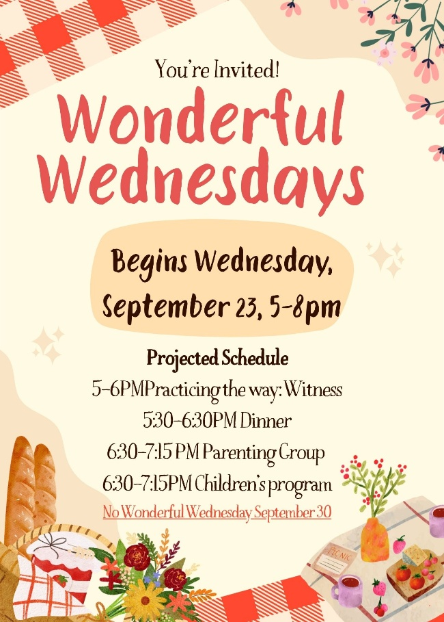

Wonderful Wednesdays Begin This Fall
Wonderful Wednesdays will look a little different this fall, but will continue to have discipleship opportunities both before dinner and after dinner. Please read through our program information to understand how our program itinerary will shift in order to accommodate special programs this year.

Wonderful Wednesday Dinners
5:30-6:30PM Wonderful Wednesday Dinner
The dinner start time is the big change this year for Wonderful Wednesdays. The reason for this is because, after dinner, there will be a parenting group that will meet from 6:30-7:15pm This will help the group to be finished in time to get young kids home and to bed at an appropriate time.

Wonderful Wednesday Kick-Off BBQ September 23
5:00-6:00 PM Practicing the Way Witness
5:30-6:30 PM Dinner
6:30-7:15 PM Parenting Group
6:30-7:15 PM Children’s Program

Wednesday’s September Kick-off BBQ Dinner Menu
Hamburgers
Cheeseburgers
Hot Dogs
Chips
Condiments: Mustard, ketchup, mayo, lettuce,
tomatoes, onions, pickles, peppers

Drinks: Iced Tea
Lemonade
Water

No Wonderful Wednesday Dinner or Programs on September 30 Due to Rummage Sale
The regular WWD's will start on October 7 and will end on November 18th. The WWD menus will be printed in the October and November Newsletters. The WWD menus will also be printed in the Sunday Bulletins. RSVP's are always welcomed to make sure there are meals for all.



St. Paul’s Anglican Church
6436 W Hurley Ave
Visalia, CA


Friday October 2, 8:00 AM to 4:00 PM
Saturday October 3, 8:00 AM to 2:00 PM
Drop Off Donated Items in James Hall on:
Wednesday, September 30, and Thursday, October 1
Between 9:00 AM – 4:00 PM
Items need to be in Good Condition: clean,
gently worn clothing, household items, toys in
working order gladly accepted!
Volunteers Needed for Set Up:
Wednesday, September 30 and Thursday, October 1
Between 9:00 AM – 4:00 PM
If you have any questions, Contact: Mary Murray at 799-6973

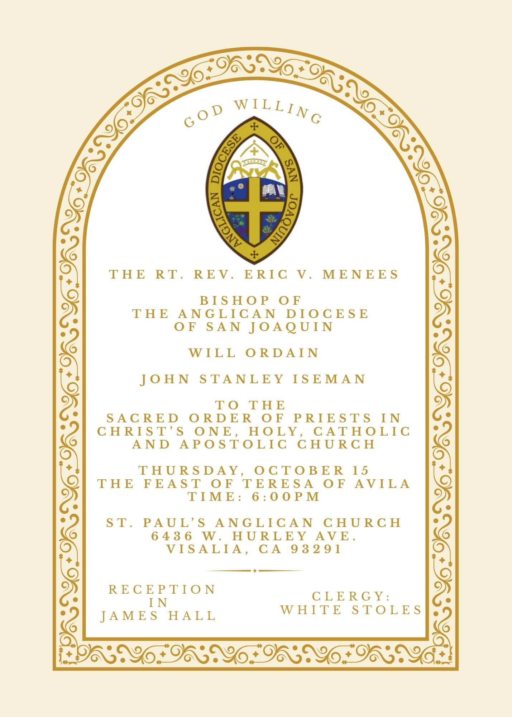


St. Paul’s Anglican Church
Friendship and Fellowship Gathering
Celebrating Rev. John Iseman’s
ordination to the Priesthood
Saturday October 17th
5:30 PM
at the home of
Jerry and Darlene Hallberg
1926 S. Savannah
Visalia, Ca 93277
BBQ Dinner
Please! Call or Text Darlene
to see what side dishes are needed.
Bring your favorite beverage.
RSVP by calling or texting Darlene at 559-280-2313
by Monday October 12


St. Paul's School has an exchange program with a school in Germany. Every fall, students from Germany come and spend two weeks with us, and every spring we send a group of 8th graders to spend two weeks in Germany. This is a truly wonderful program which enriches the educational experience for all of our students.

St. Paul’s School is in need of several more host families and households. This is a wonderful opportunity to support St. Paul’s School, share our area and culture with an 8th grade student from Germany and have a transformative time. If you would like more information, Deacon John would love to talk with you about hosting a student and what would be expected. He guarantees it is less daunting and more fun than you might imagine. Deacon John can be contacted at family@spvisalia.com or (518)222-6722
St. Paul’s Anglican Church
Parish Office
6436 W. Hurley Ave
Visalia, California 93291
559-732-4821
Office Hours: 8:00 – 4:00
Monday – Thursday

Worship: Sundays at 10:30AM
Livestream: Link at spvisalia.com
and on our Facebook page
Please be advised that this service is being recorded for broadcast
and/or archival purposes. By attending, you consent
to the inclusion of your likeness in these recordings.

St. Paul’s Clergy and Staff
The Rev. Robert Longbottom, Rector
rector@spvisalia.com, (559)802-2928
The Rev. John Iseman, Pastoral Associate for Family Ministries
family@spvisalia.com, (518)222-6722
The Rev. Kashy Rowland-Smith, Deacon
kashyrs@aol.com
Antoinette Horsting, Parish Administrator
bookkeeper@spvisalia.com
Marguerite Crownover, Organist and Accompanist
organist@spvisalia.com
Ellen Daniels, Choral Director
choirdirector@spvisalia.com
Jackie Iseman, Nursery Coordinator
nursery@spvisalia.com
Shane Motl, Sexton

St. Paul’s is a member church of the
Anglican Diocese of San Joaquin
The Rt. Rev. Eric V. Menees, Bishop

Next Week’s Lessons
Ezekiel 18:1-4, 25-32
Psalm 25
Philippians 2:1-13
Matthew 21:28-32

