ST. PAUL’S
ANGLICAN CHURCH
VISALIA, CALIFORNIA

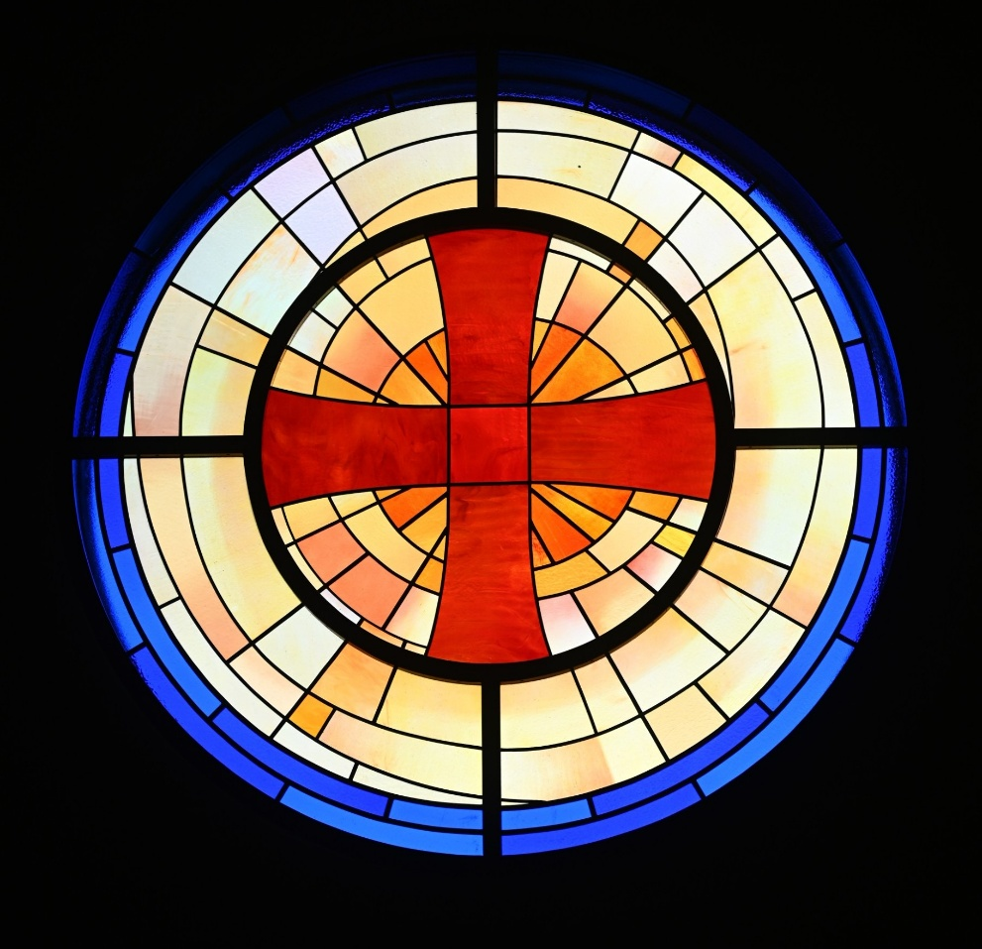

Eighteenth Sunday after Pentecost
September 27, 2026
10:30 A.M

Welcome!

St. Paul’s Anglican Church extends a warm welcome to all visitors and newcomers, whether worshiping in person or at home via livestream.

Visitors’ Guide

St. Paul’s Church is a parish in the Diocese of San Joaquin of the Anglican Church in North America, which includes both Catholic and Protestant traditions. We accept Jesus Christ as Savior, and we promise to follow him as Lord. We believe in One God,

- the Father who created us and all things,
- the Son who redeems us from sin and death,
- the Holy Spirit who renews and sanctifies us.

We believe the Holy Scriptures to be the Word of God and to contain all things necessary for salvation, and we accept the Apostles’ and Nicene Creeds as essential beliefs of the Christian faith.

Those not desiring to receive Holy Communion, and those who have not been baptized into the Christian faith, are invited to cross their arms across their chest, and a blessing will be given instead.

Visitors are invited to sign the guest book at the entrance table and introduce themselves to the clergy following the service.

The Altar Flowers
The flowers at the altar are given to the Glory of God,
by Glen and Christine Catalina, in memory of
Larry Peter Catalina.

The Holy Eucharist

Prelude: “Menuet Gothique” Boẽllmann
Opening Hymn: #473 - “Lift High the Cross” p. 4
Opening Acclamation p. 5
The Collect for Purity p. 5
Summary of the Law p. 5
Kyrie p. 6
Gloria p. 7
Collect of the Day p. 8
Lesson: Ezekiel 18:1-4, 25-32 p. 8
Gradual: Psalm 25:1-14 p. 9
Epistle: Philippians 2:1-13 p. 10
Sequence Hymn: #435 – “At the Name of Jesus” p. 11
Gospel: Matthew 21:28-32 p. 12
Sermon: Rev John Iseman
Nicene Creed p. 12
Prayers of the People p. 13
The Peace p. 15
Offertory Anthem “Ye Watchers and Ye Holy Ones” Choir
The Offertory p. 16
Sursum Corda p. 16
Sanctus p. 17
The Lord’s Prayer p. 18
Prayer for Humble Access p. 19
Agnus Dei p. 19
Communion Celebration Hymn: - “Come Just as You Are” p. 20
Post Communion Prayer p. 21
Blessing p. 21
Closing Hymn: #376 - “Here I am, Lord” p. 22
Dismissal p. 23
Postlude: “Onward Christian Soldiers” Young

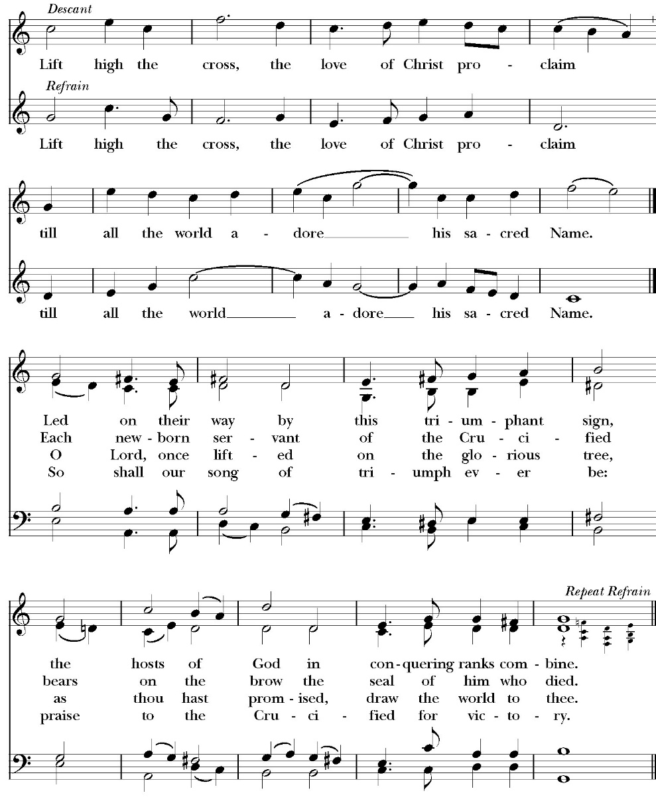
Opening Hymn: Lift High the Cross

Opening Acclamation

Celebrant Blessed be God, the Father, the Son and the Holy Spirit. People And blessed be his kingdom, now and forever. Amen.

Collect for Purity

Almighty God, to you all hearts are open, all desires
known, and from you no secrets are hid: Cleanse the thoughts
of our hearts by the inspiration of your Holy Spirit, that we
may perfectly love you, and worthily magnify your holy Name;
through Christ our Lord. Amen.

Summary of the law

Hear what our Lord Jesus Christ says: You shall love
the Lord your God with all your heart and with all your soul
and with all your mind. This is the first and great
commandment. And the second is like it: You shall love your
neighbor as yourself. On these two commandments depend all
the Law and the Prophets.

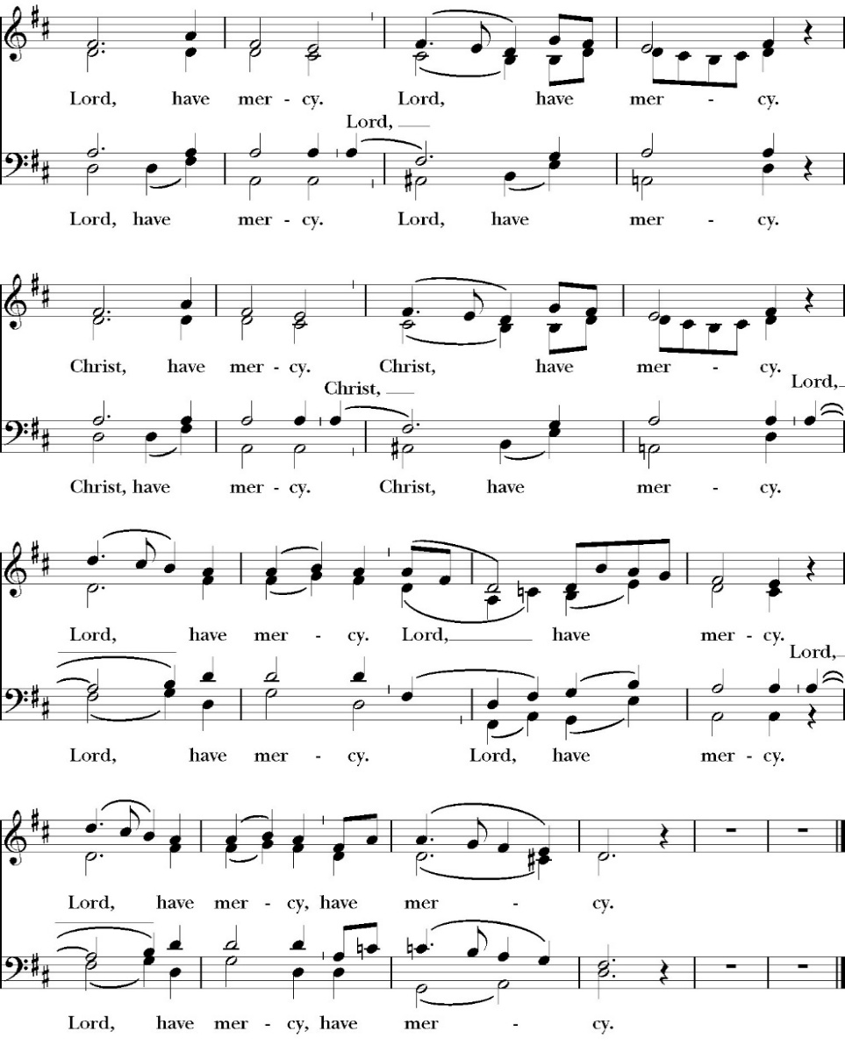
Kyrie

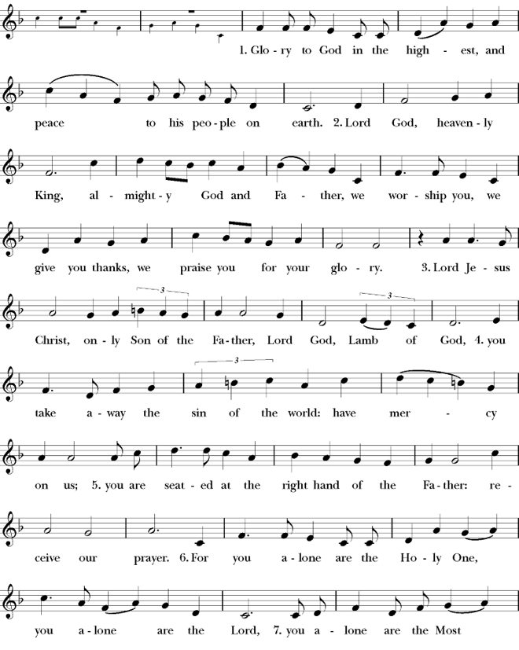
Gloria

Celebrant The Lord be with you.
People And with your spirit.
Celebrant Let us pray.

The Collect of the Day

O merciful Lord, grant to your faithful people pardon and peace, that we may be cleansed from all our sins and serve you with a quiet mind; through Jesus Christ our Lord, who lives and reigns with you and the Holy Spirit, one God, now and for ever. Amen.

Lesson: Ezekiel 18:1-4,25-32
The word of the LORD came to me: 2 “What do you mean by repeating this proverb concerning the land of Israel, ‘The fathers have eaten sour grapes, and the children's teeth are set on edge’? 3 As I live, declares the Lord God, this proverb shall no more be used by you in Israel. 4 Behold, all souls are mine; the soul of the father as well as the soul of the son is mine: the soul who sins shall die.
25 “Yet you say, ‘The way of the Lord is not just.’ Hear now, O house of Israel: Is my way not just? Is it not your ways that are not just? 26 When a righteous person turns away from his righteousness and does injustice, he shall die for it; for the injustice that he has done he shall die. 27 Again, when a wicked person turns away from the wickedness he has committed and does what is just and right, he shall save his life. 28 Because he considered and turned away from all the transgressions that he had committed, he shall surely live; he shall not die. 29 Yet the house of Israel says, ‘The way of the Lord is not just.’ O house of Israel, are my ways not just? Is it not your ways that are not just?

30 “Therefore I will judge you, O house of Israel, everyone according to his ways, declares the Lord God. Repent and turn from all your transgressions, lest iniquity be your ruin. 31 Cast away from you all the transgressions that you have committed and make yourselves a new heart and a new spirit! 2 Why will you die, O house of Israel? 32 For I have no pleasure in the death of anyone, declares the Lord God; so, turn, and live.”

Reader: The Word of the Lord
People: Thanks be to God
Gradual: Psalm 25:1-14
1 Unto you, O LORD, will I lift up my soul; my God, I have put my trust in you; *
O let me not be ashamed, neither let my enemies triumph over me.
2 For all those who hope in you shall not be ashamed, *
but those who deal untruly shall be put to confusion.
3 Show me your ways, O LORD, *
and teach me your paths.
4 Lead me forth in your truth and teach me, *
for you are the God of my salvation; in you has been my hope all the day long.
5 Call to remembrance, O LORD, your tender mercies, *
and your loving-kindnesses, which have been from of old.
6 O remember not the sins and offenses of my youth, *
but according to your mercy think on me, O LORD, in your goodness.
7 Gracious and righteous is the LORD; *
therefore will he teach sinners in the way.
8 Those who are meek shall he guide in judgment, *
and those who are gentle shall he teach his way.
9 All the paths of the LORD are mercy and truth *
to those who keep his covenant and his testimonies.
10 For your Name’s sake, O LORD, *
forgive my sin, for it is great.
11 Who is the one who fears the LORD? *
He shall teach him in the way that he shall choose.
12 He shall dwell at ease, *
and his seed shall inherit the land.
13 The LORD reveals his secret counsel to those who fear him,* and he will show them his covenant.
14 My eyes are ever looking to the LORD, *
for he shall pluck my feet out of the net.

Glory be to the Father, and to the Son, and to the Holy Spirit;
as it was in the beginning, is now, and ever shall be, world
without end. Amen

Epistle: Philippians 2:1-13
So, if there is any encouragement in Christ, any comfort from love, any participation in the Spirit, any affection and sympathy, 2 complete my joy by being of the same mind, having the same love, being in full accord and of one mind. 3 Do nothing from selfish ambition or conceit, but in humility count others more significant than yourselves. 4 Let each of you look not only to his own interests, but also to the interests of others. 5 Have this mind among yourselves, which is yours in Christ Jesus, 6 who, though he was in the form of God, did not count equality with God a thing to be grasped, 7 but emptied himself, by taking the form of a servant, being born in the likeness of men. 8 And being found in human form, he humbled himself by becoming obedient to the point of death, even death on a cross. 9Therefore God has highly exalted him and bestowed on him the name that is above every name, 10 so that at the name of Jesus every knee should bow, in heaven and on earth and under the earth, 11 and every tongue confess that Jesus Christ is Lord, to the glory of God the Father. 12 Therefore, my beloved, as you have always obeyed, so now, not only as in my presence but much more in my absence, work out your own salvation with fear and trembling, 13 for it is God who works in you, both to will and to work for his good pleasure.

Reader: The Word of the Lord
People: Thanks be to God

Sequence Hymn: At the Name of Jesus
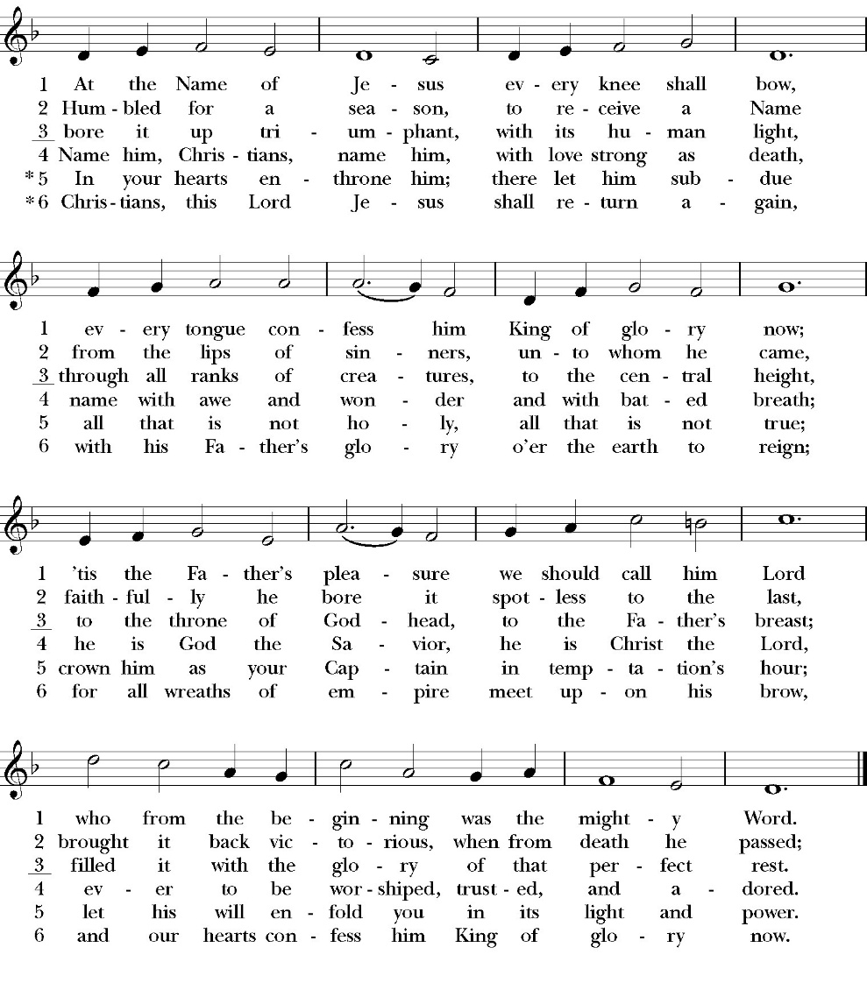
(verse 1&2 before Gospel, verse 3after)

Clergy: The Holy Gospel of Our Lord Jesus Christ,
according to St. Matthew
People: Glory to you, Lord Christ.

Gospel: Matthew 21:28-32
“What do you think? A man had two sons. And he went to the first and said, ‘Son, go and work in the vineyard today.’ 29 And he answered, ‘I will not,’ but afterward he changed his mind and went. 30 And he went to the other son and said the same. And he answered, ‘I go, sir,’ but did not go. 31 Which of the two did the will of his father?” They said, “The first.” Jesus said to them, “Truly, I say to you, the tax collectors and the prostitutes go into the kingdom of God before you. 32 For John came to you in the way of righteousness, and you did not believe him, but the tax collectors and the prostitutes believed him. And even when you saw it, you did not change your minds and believe him.

Clergy: The Gospel of the Lord
People: Praise to you, Lord Christ

Sermon
Rev. John Iseman

The Nicene Creed

We believe in one God,
the Father, the Almighty,
maker of heaven and earth,
of all that is, visible and invisible.

We believe in one Lord, Jesus Christ,
the only-begotten Son of God,
eternally begotten of the Father,
God from God, Light from Light,
true God from true God,
begotten, not made,
of one Being with the Father.
through him all things were made.
For us and for our salvation he came down from heaven:
was incarnate from the Holy Spirit and the Virgin Mary,
and was made man.
For our sake he was crucified under Pontius Pilate;
he suffered death and was buried.
On the third day he rose again in accordance with the
Scriptures;
he ascended into heaven
and is seated at the right hand of the Father.
He will come again in glory to judge the living and the dead,
and his kingdom will have no end.

We believe in the Holy Spirit, the Lord, the giver of life,
who proceeds from the Father and the Son,
who with the Father and the Son is worshiped and glorified. who has spoken through the Prophets.
We believe in one holy catholic and apostolic Church.
We acknowledge one Baptism for the forgiveness of sins.
We look for the resurrection of the dead,
and the life of the world to come. Amen.

The Prayers of the People

Leader Let us pray for the Church and for the world, saying, “hear our prayer.”
For the peace of the whole world, and for the well-being and unity of the people of God.
Lord, in your mercy:
People Hear our prayer.

Leader For Stephen our archbishop, Julian our provincial dean, and Eric our bishop. For Fr. Rob, Deacon John, Deacon Kashy, and for all the clergy and people of our diocese and congregation and for the worldwide Anglican Communion.
Lord, in your mercy:
People Hear our prayer.

Leader For all those who proclaim the Gospel at home and abroad; and for all who teach and disciple others.
Lord, in your mercy:
People Hear our prayer.

Leader For our brothers and sisters in Christ who are persecuted for their faith.
Lord, in your mercy:
People Hear our prayer.

Leader For our nation, for those in authority, and for all in public service especially Donald our president and Gavin our governor.
Lord, in your mercy:
People Hear our prayer.

Leader In the St. Paul’s cycle of prayer, we pray for our Sunday morning worship and welcoming ministries. We pray for the Altar Guild, our Lay Eucharistic Ministers, our Lectors, and our Acolytes. We pray for our music ministry and the musicians and vocalists. We pray for our ushers, greeters, and prayer table ministries.
Lord, in your mercy:
People Hear our prayer.

Leader In the ACNA Cycle of Prayer, today we pray for the Anglican Province of Uganda and The Most Rev. Dr. Samuel Stephen Kazimba Mugalu, Archbishop, and his wife, Margaret.
Lord, in your mercy:
People Hear our prayer.

Leader For all those who are in trouble, sorrow, need, sickness, or
any other adversity [especially ____________]. We also
pray for all who are currently serving in our armed forces
and serving as first responders.
Lord, in your mercy:
People Hear our prayer.

Leader For all those who have departed this life in the certain hope
of the resurrection, (we pray especially for ____________),
in Thanksgiving let us pray.
Lord, in your mercy:
People Hear our prayer.

Celebrant will add a concluding prayer

Heavenly Father, grant these our prayers for the sake of Jesus Christ,
our only Mediator and Advocate, who lives and reigns with you in
the unity of the Holy Spirit, one God, now and for ever. Amen.

The Confession and Absolution

Celebrant Let us humbly confess our sins to Almighty God.

Most merciful God,
we confess that we have sinned against you
in thought, word and deed,
by what we have done, and by what we have left undone.
We have not loved you with our whole heart;
we have not loved our neighbors as ourselves.
We are truly sorry and we humbly repent.
For the sake of your Son Jesus Christ,
have mercy on us and forgive us;
that we may delight in your will, and walk in your ways,
to the glory of your Name. Amen.

Almighty God, our heavenly Father, who in his great mercy has
promised forgiveness of sins to all those who sincerely repent and
with true faith turn to him, have mercy upon you, pardon and deliver
you from all your sins, confirm and strengthen you in all goodness,
and bring you to everlasting life; through Jesus Christ our Lord.
Amen.

Hear the Word of God to all who truly turn to him.

God so loved the world, that he gave his only-begotten Son, that
whoever believes in him should not perish but have eternal life.
John 3:16

Celebrant The Peace of the Lord be always with you.
People And with your spirit.

offertory
Choir – ye watchers and ye holy ones
for michaelmas

The Doxology
(Verse 3 only)

Offertory

Celebrant All things come from you, O Lord,
People And of your own have we given you.

The Eucharistic Liturgy
Celebrant The Lord be with you.
People And with your spirit.
Celebrant Lift up your hearts.
People We lift them up to the Lord.
Celebrant Let us give thanks to the Lord our God.
People It is right to give him thanks and praise.

It is right, our duty and our joy, always and everywhere to give thanks to you, Father Almighty, Creator of heaven and earth.
Through Jesus Christ our Lord, who on the first day of the week overcame death and the grave, and by his glorious resurrection opened to us the way of everlasting life.

Therefore we praise you, joining our voices with Angels and Archangels and with all the company of heaven, who for ever sing this hymn to proclaim the glory of your Name:

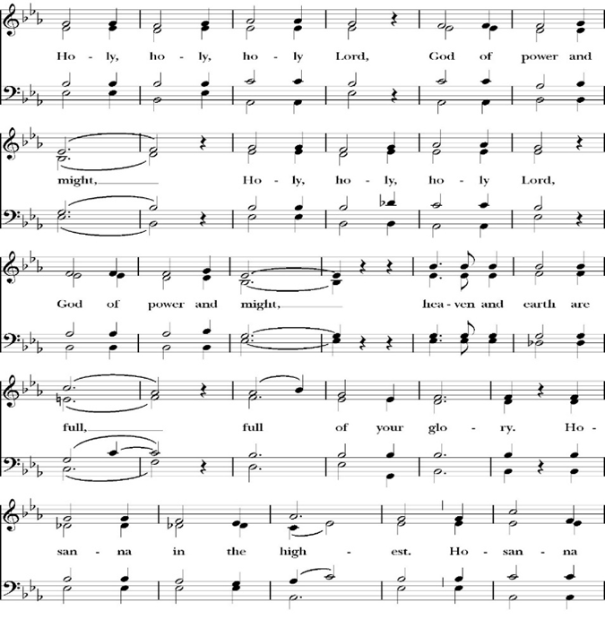
Sanctus

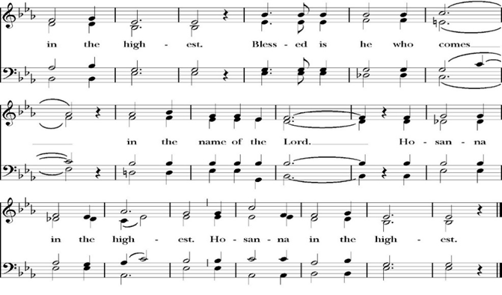

And now, as our Savior Christ has taught us, we are bold to pray,

Our Father, who art in heaven,
hallowed be thy Name,
thy kingdom come,
thy will be done,
on earth as it is in heaven.
Give us this day our daily bread.
And forgive us our trespasses,
as we
forgive those
who trespass against us.
And lead us not into temptation,
but deliver us from evil.
For thine is the kingdom,
and the power, and the glory,
for ever and ever. Amen.

The Prayer for Humble Access

We do not presume to come to this your table, O merciful Lord,
trusting in our own righteousness,
but in your abundant and great mercies.
We are not worthy so much as to gather up
the crumbs under your table;
but you are the same Lord
whose character is always to have mercy.
Grant us, therefore, gracious Lord,
so to eat the flesh of your dear Son Jesus Christ,
and to drink his blood,
that our sinful bodies may be made clean by his body,
and our souls washed through his most precious blood,
and that we may evermore dwell in him, and he in us.
Amen.

Agnus Dei

The Ministration of Communion

The gifts of God for the People of God. Take them in remembrance that Christ died for you and feed on him in your hearts by faith, with thanksgiving.

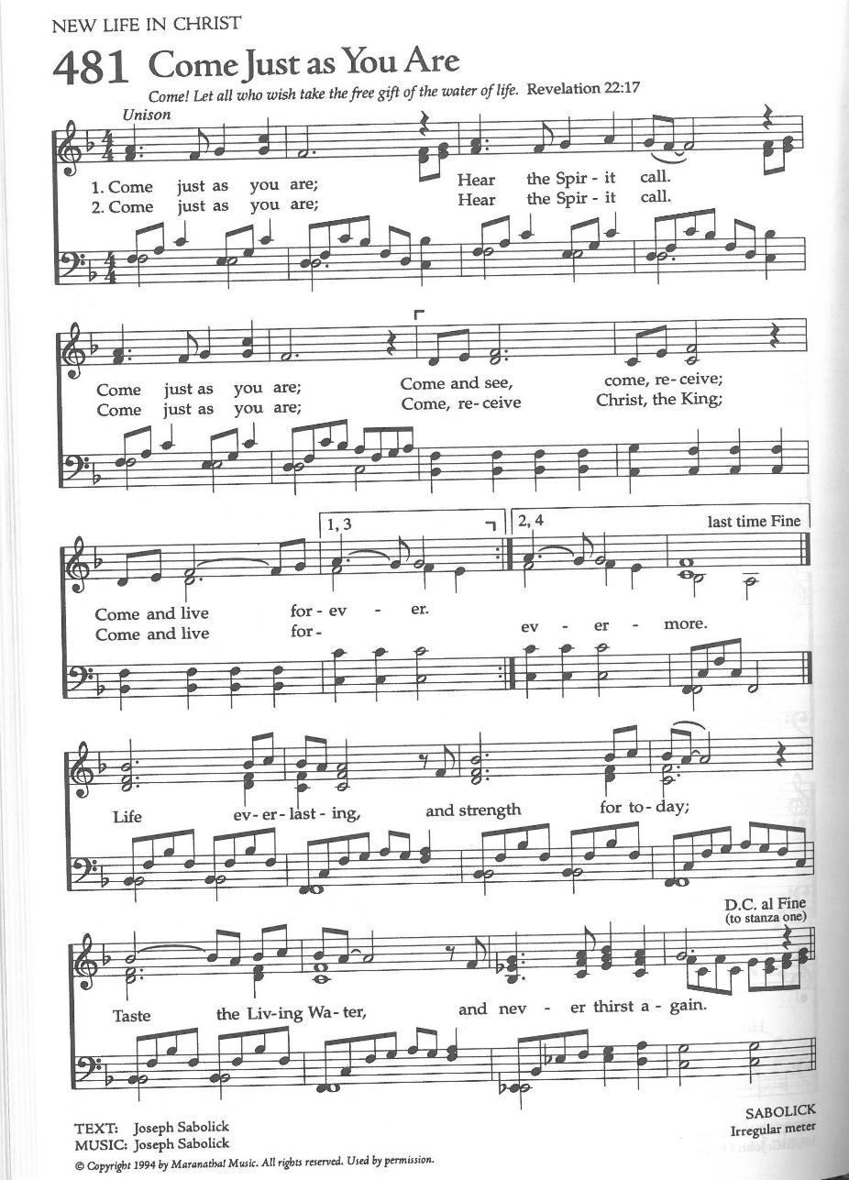
Communion Celebration Hymn: Come Just as You Are

The Post Communion Prayer
Let us pray.

Heavenly Father,
We thank you for feeding us with the spiritual food
of the most precious Body and Blood
of your Son our Savior Jesus Christ;
and for assuring us in these holy mysteries
that we are living members of the body of your Son,
and heirs of your eternal Kingdom.
And now, Father, send us out to do the work you have
given us to do,
to love and serve you as faithful witnesses of Christ our
Lord.
To him, to you, and to the Holy Spirit,
be honor and glory, now and for ever. Amen.

The Blessing

The peace of God, which passes all understanding, keep your hearts and minds in the knowledge and love of God, and of his Son Jesus Christ our Lord; and the blessing of God Almighty, the Father, the Son, and the Holy Spirit, be among you, and remain with you always. Amen.

Closing Hymn: Here I Am, Lord
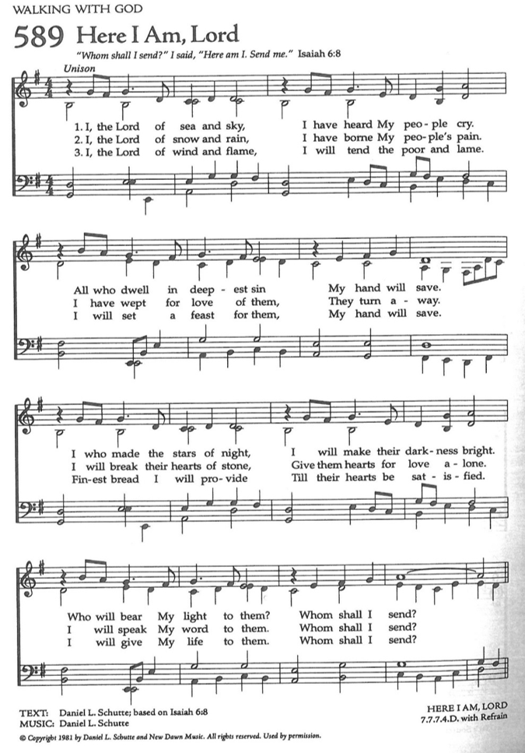

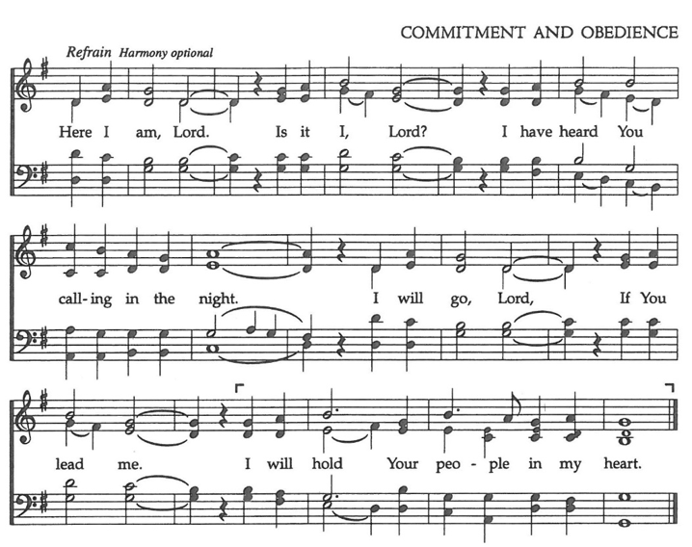

Dismissal
Deacon Alleluia, Alleluia. Let us go forth into the world,
rejoicing in the power of the Holy Spirit.
People Thanks be to God Alleluia, Alleluia.

St. Paul’s Parish Calendar
Sunday September 27– Sunday October 4

SUNDAY, September 27 –Eighteenth Sunday after Pentecost
9:15 AM Sunday Funday, Youth Room
9:15 AM Gospel of John Bible Study, Conference Room
10:30 AM Children’s Sunday School, Chapel
Pre-K –2nd Grade, Sunday School Room
3rd -5th Grade, Youth Room
10:30 AM Holy Eucharist, Church

MONDAY, September 28

TUESDAY, September 29
6:30 PM Bell Choir Rehearsal, Music Room

WEDNESDAY, September 30
9 AM to 4 PM Rummage Sale Drop-Off, James Hall
9:30 AM Holy Eucharist with healing prayer, Chapel
10:15 AM Bible Study, Conference Room
No Wonderful Wednesday
7:00 PM Choir Rehearsal

THURSDAY, October 1
9AM to 4PM Rummage Sale Drop-Off, James Hall

FRIDAY, October 2
6:30 AM Men’s Bible Study, Valhalla Restaurant
8AM to 4PM Rummage Sale, James Hall

SATURDAY, October 3
8AM to 2PM Rummage Sale, James Hall

SUNDAY, October 4 –Nineteenth Sunday after Pentecost
9:15 AM Sunday Funday, Youth Room
9:15 AM Gospel of John Bible Study, Conference Room
10:30 AM Children’s Sunday School, Chapel
Pre-K –2nd Grade, Sunday School Room
3rd -5th Grade, Youth Room
10:30 AM Holy Eucharist, Church

Church Office Hours
Monday-Thursday 8:00 AM-4:00 PM

Announcements

Blessings of the Animals
Sunday, October 4, 4:00PM
Join us in the church courtyard on Sunday, October 4 at 4:00PM with your pets for a blessing of the animals. Please have dogs on leashes, cats secured in carriers and pets of all kinds as long as they are secure. We will have water, treats, and pup cups of whipped cream for all our dogs and cats.

St. Paul’s Church is Sponsoring
St. Paul’s School Carnival Cakewalk
Cakes Needed for St. Paul’s School Carnival Cakewalk
Friday, October 16, 3-6PM
St. Paul’s Church sponsors the cakewalk at St. Paul’s School fall carnival and every year members of the church are invited to make baked goods for the event. Smaller cakes are preferable, or cutting cakes in halves or quarters, are the perfect size to for the event. Cakes, brownies, cookies, and all kinds of baked goods are welcome. Please deliver cakes to the church office on Wednesday-Friday, October 14 and 15 during regular business hours, or on Friday October 16 before 2PM. .

Trunk or Treat, Sunday October 25, 4:00-6:00PM
Trunk or Treat is a wonderful event for a safe and fun trick or treating and harvest fun activities. All families, both inside and outside the church, are welcome to join us. Our annual Trunk or Treat is coming up. Trunk or Treat keeps growing and so our need for trunks and help with activities continues to grow as well. A sign-up sheet is in the Narthex of the church and in the office. Please reach out to Deacon John for any questions

Convention of the Anglican Diocese of San Joaquin
Thursday Evening and Friday, October 29 & 30
Trinity Anglican Church, Bakersfield, CA
The annual convention of the Anglican Diocese of San Joaquin will take place the evening of Thursday and all day Friday, October 29 & 30. Convention is not just the annual business meeting of the church. It is a time gather together as a Diocesan family with Anglican churches in the central valley of California and Neveda, hear from our bishop on his plans and vision for the diocese, learn more about the many ministries occurring in Anglican churches in our area and enjoy fellowship with our brothers and sisters. If you are interested in attending, please reach out to Fr. Rob and he will help you register.

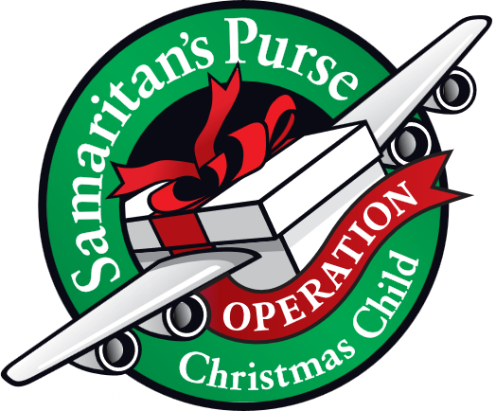
Operation Christmas Child Donations Begin in September
September Donations: Personal Care Items and Clothing & Accessories.

Operation Christmas Child is a ministry of Samaritan’s Purse. The mission of Operation Christmas Child is to demonstrate God’s love in a tangible way to children in need around the world through partnering with the local church worldwide to provide shoebox size containers filled with school supplies, hygiene products, and a small gift to share the Good News of Jesus Christ and make disciples of the nations.

St. Paul’s Anglican Church is committed to providing 100 boxes to children throughout the world and will do this by having monthly themed donations from August through November. We will then have a “Filling the Box” party when we will gather together and fill 100 boxes with school supplies, hygiene products and small toys.

Letters for Fr. Jim Rouse Upon His Homecoming from His Honor Flight to Washington D.C.
Fr. Jim Rouse is the priest-in-charge at St. John’s Porterville and is an Army veteran. He just completed an honor flight to Washington D.C. with many other local veterans. This is a very special trip and there is a mail call at the end of the trip. Unfortunately, we missed the opportunity to give Fr. Jim letters of support, thanks and encouragement for his years of service to our country that he would have received on the way home. Yet we can still show Fr. Jim our support and thanks with letters. All members of the church are invited to write a letter of support and thanks and return the letter to the church or the church office We will hand-deliver the letters to Fr. Jim in one large envelope. Please return as soon as possible. If you have any questions, please talk with Fr. Rob.

No Wonderful Wednesday Dinner or Programs on September 30 Due to Rummage Sale
The regular WWD's will start on October 7 and will end on November 18th. The WWD menus will be printed in the October and November Newsletters. The WWD menus will also be printed in the Sunday Bulletins. RSVPs are always welcomed to make sure there are meals for all.

Wonderful Wednesdays Classes Begin Wednesday, October 7
Wonderful Wednesdays will look a little different this fall but will continue to have discipleship opportunities both before dinner and after dinner. Please read through our program information to understand how our program itinerary will shift in order to accommodate special programs this year.

Wonderful Wednesday Dinners
5:30-6:30PM Wonderful Wednesday Dinner
The dinner start time is the big change this year for Wonderful

Practicing The Way: Our Call to Witness
5:00-6:00PM
This small group will continue in the spiritual practice of witness outlined in John Mark Comer’s work Practicing the Way. We will gather as a small group in the conference room and learn more about witnessing the resurrection in the world around us or as we might traditionally know it Evangelism.

In a post-Christian culture, the idea of “sharing the gospel” seems intimidating — even offensive. But the Spirit in us seeks to draw near those who are far from God; and we embody his heart by inviting people to our table, listening deeply, and testifying simply to the good news of Jesus. This class will be led by Fr. Rob Longbottom. For more info on the content of this class please scan the QR code to go to class website.

Habits Of the Household: Practicing the story of God in everyday family rhythms
6:30-7:15PM:
Parenting is not easy. For anyone. And most of us who are currently parenting children and teens need opportunities to receive healthy, Christ-centered teaching and discussion on parenting.
Habits of the Household by Justin Whitmel Earley is a practical guide for parents that emphasizes the importance of daily family rhythms in spiritual formation. The book outlines how ordinary routines, from waking up to bedtime, can be transformed into meaningful moments of worship and connection, helping families grow closer together and fostering a deeper relationship with God.

All Parents are invited to join us no matter if you have a newborn or kids in college.
For more info on the content of this class please scan the QR code to go to class website.

Habits of the Household for kids
6:30-7:15pm
This program will run concurrently with the Habits of the Household group and will help our kids to work towards the same habits as parents for continuity and common understanding. This class will be led by Fr. Rob and Deacon Kashy, and all kids are welcome from age 4 through middle school.

Wednesday night Nursery
6:30-7:30PM
The Nursery will be open every Wonderful Wednesday so that parents can have a safe and fun place for their little one’s age 0-3 while they are participating in the Habits of the household class or other Wednesday evening activities.

The Gospel of John Sunday Morning Bible Study, 9:15-10:00AM
The Sunday morning Gospel of John Bible study has resumed. Deacon John is leading the class in September.



St. Paul’s Anglican Church
6436 W Hurley Ave
Visalia, CA


Friday October 2, 8:00 AM to 4:00 PM
Saturday October 3, 8:00 AM to 2:00 PM
Drop Off Donated Items in James Hall on:
Wednesday, September 30, and Thursday, October 1
Between 9:00 AM – 4:00 PM
Items need to be in Good Condition: clean,
gently worn clothing, household items, toys in
working order gladly accepted!
Volunteers Needed for Set Up:
Wednesday, September 30 and Thursday, October 1
Between 9:00 AM – 4:00 PM
If you have any questions, Contact: Mary Murray at 799-6973

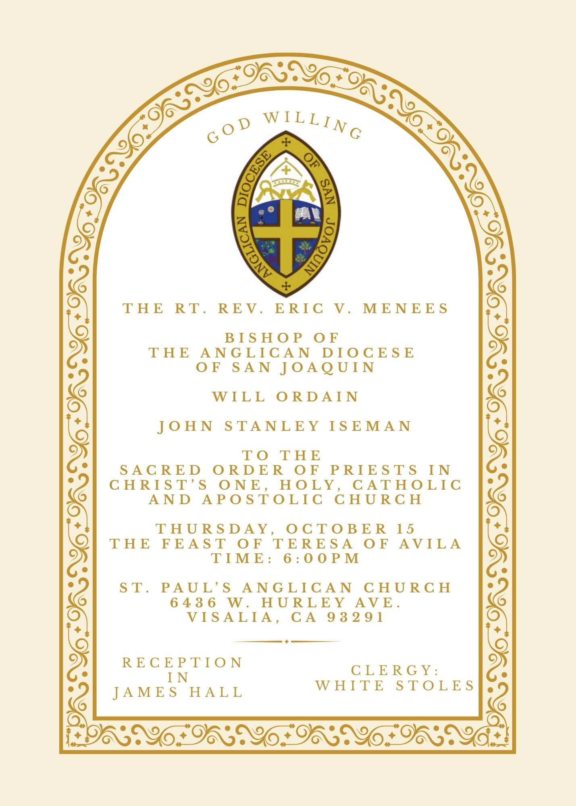


St. Paul’s Anglican Church
Friendship and Fellowship Gathering
Celebrating Rev. John Iseman’s
ordination to the Priesthood
Saturday October 17
5:30 PM
at the home of
Jerry and Darlene Hallberg
1926 S. Savannah
Visalia, Ca 93277
BBQ Dinner
Please! Call or Text Darlene
to see what side dishes are needed.
Bring your favorite beverage.
RSVP by calling or texting Darlene at 559-280-2313
by Monday October 12

St. Paul’s Anglican Church
Parish Office
6436 W. Hurley Ave
Visalia, California 93291
559-732-4821
Office Hours: 8:00 – 4:00
Monday – Thursday

Worship: Sundays at 10:30AM
Livestream: Link at spvisalia.com
and on our Facebook page
Please be advised that this service is being recorded for broadcast
and/or archival purposes. By attending, you consent
to the inclusion of your likeness in these recordings.

St. Paul’s Clergy and Staff
The Rev. Robert Longbottom, Rector
rector@spvisalia.com
(559)802-2928
The Rev. John Iseman, Pastoral Associate for Family Ministries
family@spvisalia.com
The Rev. Kashy Rowland-Smith, Deacon
kashyrs@aol.com
Antoinette Horsting, Parish Administrator
bookkeeper@spvisalia.com
Marguerite Crownover, Organist and Accompanist
organist@spvisalia.com
Ellen Daniels, Choral Director
choirdirector@spvisalia.com
Jackie Iseman, Nursery Coordinator
nursery@spvisalia.com
Shane Motl, Sexton

St. Paul’s is a member church of the
Anglican Diocese of San Joaquin
The Rt. Rev. Eric V. Menees, Bishop

Next Week’s Lessons
Isaiah 5:1-7
Psalm 80: (1-6) or 7:19
Philippians 3:14-21
Matthew 21:33-44

