ST. PAUL’S
ANGLICAN CHURCH
VISALIA, CALIFORNIA

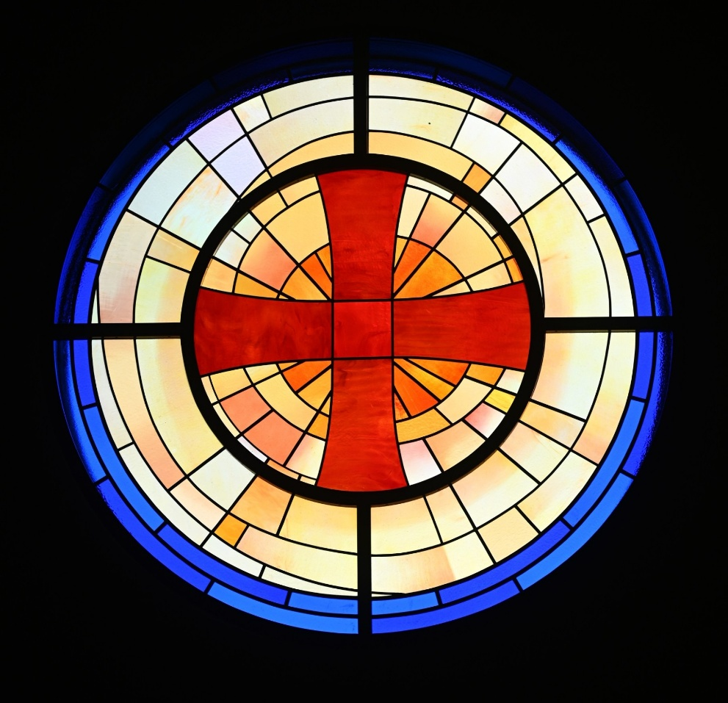

Fifteenth Sunday after Pentecost
September 6, 2026
10:30 A.M

Welcome!

St. Paul’s Anglican Church extends a warm welcome to all visitors and newcomers, whether worshiping in person or at home via livestream.

Visitors’ Guide

St. Paul’s Church is a parish in the Diocese of San Joaquin of the Anglican Church in North America, which includes both Catholic and Protestant traditions. We accept Jesus Christ as Savior, and we promise to follow him as Lord. We believe in One God,

- the Father who created us and all things,
- the Son who redeems us from sin and death,
- the Holy Spirit who renews and sanctifies us.

We believe the Holy Scriptures to be the Word of God and to contain all things necessary for salvation, and we accept the Apostles’ and Nicene Creeds as essential beliefs of the Christian faith.

Those not desiring to receive Holy Communion, and those who have not been baptized into the Christian faith, are invited to cross their arms across their chest, and a blessing will be given instead.

Visitors are invited to sign the guest book at the entrance table and introduce themselves to the clergy following the service.

The Holy Eucharist

Prelude: “Prelude in Classic Style” Young
Opening Hymn: - #657- “Love Divine, All Love Excelling” p. 4
Opening Acclamation p. 5
The Collect for Purity p. 5
Summary of the Law p. 5
Kyrie p. 5
Gloria p. 6
Collect of the Day p. 7
Lesson: Ezekiel 33:1-11 p. 7
Gradual: Psalm 119:33-48 p. 8
Epistle: Romans 12:9-21 p. 9
Sequence Hymn: #602 – “Jesu, Jesu” p. 10
Gospel: Matthew 18:15-20 p. 10
Sermon: Rev John Iseman
Nicene Creed p. 11
Prayers of the People p. 12
The Peace p. 14
Offertory Anthem Organ: “Prières à Notre – Dame” by Boellman
The Offertory p. 15
Sursum Corda p. 15
Sanctus p. 16
The Lord’s Prayer p. 17
Prayer for Humble Access p. 17
Agnus Dei p. 18
Communion Celebrations Hymn: - “We Remember You” p. 19
Post Communion Prayer p. 20
Blessing p. 20
Closing Hymn: #376 - “Joyful, Joyful We Adore Thee” p. 21
Dismissal p. 21
Postlude: “Fanfare and Cannon on Lobe Den Herren” Blanchard

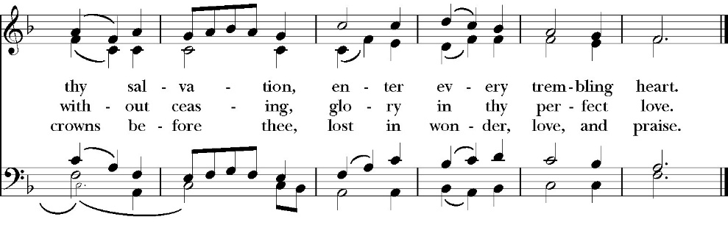
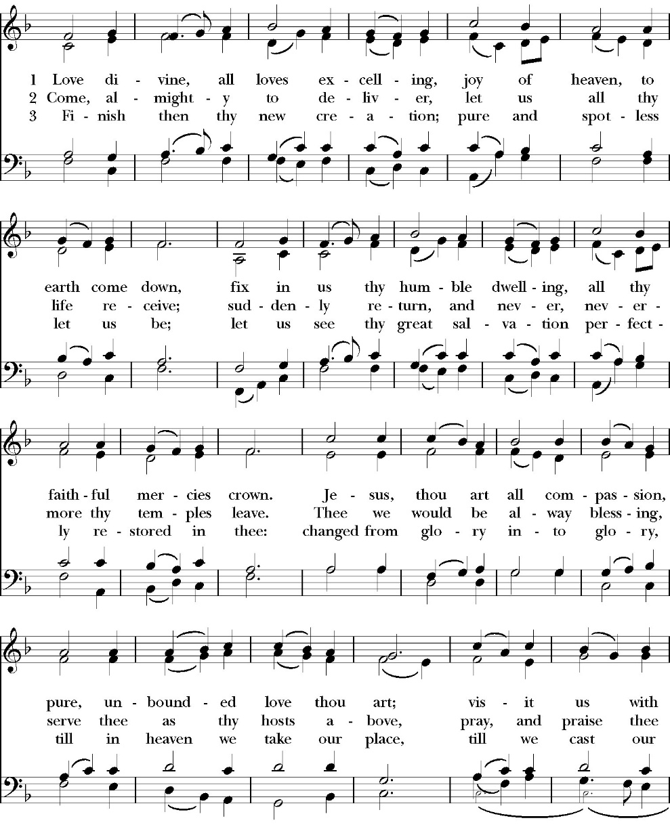
Opening Hymn: Love Divine, All Love Excelling

Opening Acclamation

Celebrant Blessed be God, the Father, the Son and the Holy Spirit. People And blessed be his kingdom, now and forever. Amen.

Collect for Purity

Almighty God, to you all hearts are open, all desires
known, and from you no secrets are hid: Cleanse the thoughts
of our hearts by the inspiration of your Holy Spirit, that we
may perfectly love you, and worthily magnify your holy Name;
through Christ our Lord. Amen.

Summary of the law

Hear what our Lord Jesus Christ says: You shall love
the Lord your God with all your heart and with all your soul
and with all your mind. This is the first and great
commandment. And the second is like it: You shall love your
neighbor as yourself. On these two commandments depend all
the Law and the Prophets.

Kyrie
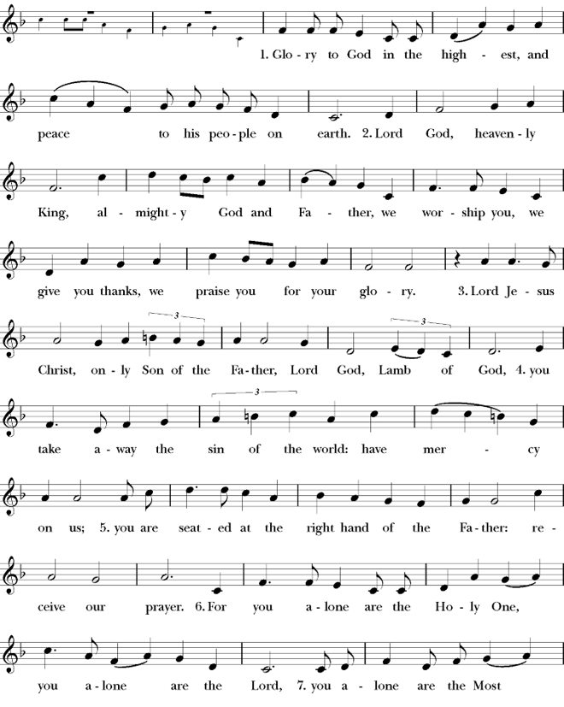
Gloria

Celebrant The Lord be with you.
People And with your spirit.
Celebrant Let us pray.

The Collect of the Day

O Lord God, grant your people grace to withstand the temptations of the world, the flesh, and the devil, and with pure hearts and minds to follow you, the only God; through Jesus Christ our Lord, who lives and reigns with you and the Holy Spirit, one God, now and for ever. Amen.

Lesson: Ezekiel 33:1-11
The word of the LORD came to me: 2 “Son of man, speak to your people and say to them, If I bring the sword upon a land, and the people of the land take a man from among them, and make him their watchman,

3 and if he sees the sword coming upon the land and blows the trumpet and warns the people, 4 then if anyone who hears the sound of the trumpet does not take warning, and the sword comes and takes him away, his blood shall be upon his own head. 5 He heard the sound of the trumpet and did not take warning; his blood shall be upon himself. But if he had taken warning, he would have saved his life. 6 But if the watchman sees the sword coming and does not blow the trumpet, so that the people are not warned, and the sword comes and takes any one of them, that person is taken away in his iniquity, but his blood I will require at the watchman's hand.

7 “So you, son of man, I have made a watchman for the house of Israel. Whenever you hear a word from my mouth, you shall give them warning from me. 8 If I say to the wicked, O wicked one, you shall surely die, and you do not speak to warn the wicked to turn from his way, that wicked person shall die in his iniquity, but his blood I will require at your hand. 9 But if you warn the wicked to turn from his way, andhe does not turn from his way, that person shall die in his iniquity, but you will have delivered your soul.

10 “And you, son of man, say to the house of Israel, Thus have you said: ‘Surely our transgressions and our sins are upon us, and we rot away because of them. How then can we live?’ 11 Say to them, As I live, declares the Lord God, I have no pleasure in the death of the wicked, but that the wicked turn from his way and live; turn back, turn back from your evil ways, for why will you die, O house of Israel?

Reader: The Word of the Lord
People: Thanks be to God

Gradual: Psalm 119:33-48
33 Teach me, O LORD, the way of your statutes, *
and I shall keep it to the end.
34 Give me understanding, and I shall keep your law; *
indeed, I shall keep it with my whole heart.
35 Make me go in the path of your commandments, *
for therein is my desire.
36 Incline my heart to your testimonies, *
and not to covetous desires.
37 O turn away my eyes, lest they behold vanity, *
and revive me in your ways.
38 Confirm your word to your servant, *
and to all those who fear you.
39 Take away the reproach that I am afraid of, *
for your judgments are good.
40 Behold, my delight is in your precepts; *
O revive me in your righteousness.
41 Let your loving mercy come to me, O LORD, *
even your salvation, according to your word.
42 So shall I answer those who taunt me, *
for my trust is in your word.
43 O do not take the word of your truth utterly out of my mouth, * for my hope is in your judgments.
44 So shall I always keep your law, *
even for ever and ever;
45 And I will walk at liberty, *
for I seek your commandments.
46 I will speak of your testimonies also, even before kings, *
and will not be ashamed;
47 And my delight shall be in your commandments, *
which I have loved exceedingly.
48 My hands also will I lift up to your commandments, *
and I will meditate on your statutes.

Glory be to the Father, and to the Son, and to the Holy Spirit;
as it was in the beginning, is now, and ever shall be, world
without end. Amen

Epistle: Romans 12:9-21
Let love be genuine. Abhor what is evil; hold fast to what is good. 10 Love one another with brotherly affection. Outdo one another in showing honor. 11 Do not be slothful in zeal, be fervent in spirit, serve the Lord. 12 Rejoice in hope, be patient in tribulation, be constant in prayer. 13 Contribute to the needs of the saints and seek to show hospitality.

14 Bless those who persecute you; bless and do not curse them. 15 Rejoice with those who rejoice, weep with those who weep. 16 Live in harmony with one another. Do not be haughty, but associate with the lowly. Never be wise in your own sight. 17 Repay no one evil for evil, but give thought to do what is honorable in the sight of all. 18 If possible, so far as it depends on you, live peaceably with all. 19 Beloved, never avenge yourselves, but leave it to the wrath of God, for it is written, “Vengeance is mine, I will repay, says the Lord.” 20 To the contrary, “if your enemy is hungry, feed him; if he is thirsty, give him something to drink; for by so doing you will heap burning coals on his head.” 21 Do not be overcome by evil, but overcome evil with good.

Reader: The Word of the Lord
People: Thanks be to God

Sequence Hymn: Jesu, Jesu
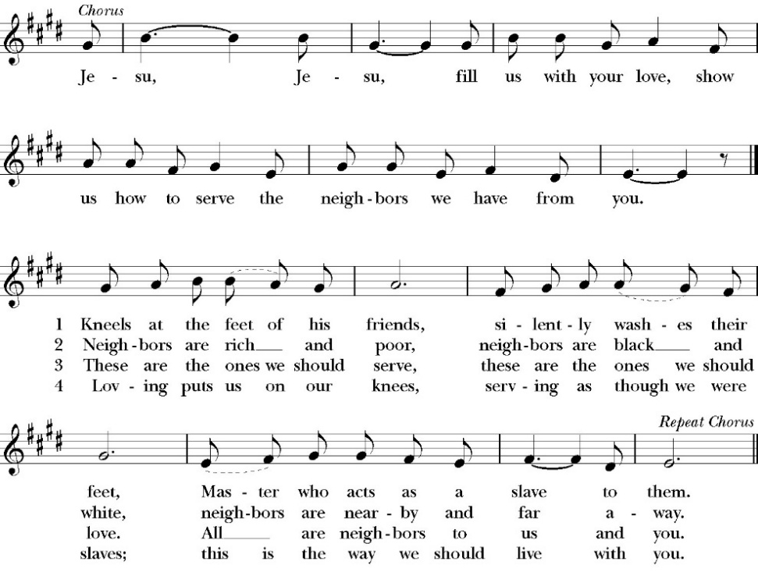
(verse 1&2 before Gospel, verse 3&4after)

Clergy: The Holy Gospel of Our Lord Jesus Christ,
according to St. Matthew
People: Glory to you, Lord Christ.

Gospel: Matthew 18:15-20
“If your brother sins against you, go and tell him his fault, between you and him alone. If he listens to you, you have gained your brother.

16 But if he does not listen, take one or two others along with you, that every charge may be established by the evidence of two or three witnesses. 17 If he refuses to listen to them, tell it to the church. And if he refuses to listen even to the church, let him be to you as a Gentile and a tax collector. 18 Truly, I say to you, whatever you bind on earth shall be bound in heaven, and whatever you loose on earth shall be loosed in heaven. 19 Again I say to you, if two of you agree on earth about anything they ask, it will be done for them by my Father in heaven. 20 For where two or three are gathered in my name, there am I among them.”
Clergy: The Gospel of the Lord
People: Praise to you, Lord Christ

Sermon
Rev. John Iseman

The Nicene Creed

We believe in one God,
the Father, the Almighty,
maker of heaven and earth,
of all that is, visible and invisible.

We believe in one Lord, Jesus Christ,
the only-begotten Son of God,
eternally begotten of the Father,
God from God, Light from Light,
true God from true God,
begotten, not made,
of one Being with the Father.
through him all things were made.
For us and for our salvation he came down from heaven:
was incarnate from the Holy Spirit and the Virgin Mary,
and was made man.
For our sake he was crucified under Pontius Pilate;
he suffered death and was buried.
On the third day he rose again in accordance with the
Scriptures;
he ascended into heaven
and is seated at the right hand of the Father.
He will come again in glory to judge the living and the dead,
and his kingdom will have no end.

We believe in the Holy Spirit, the Lord, the giver of life,
who proceeds from the Father and the Son,
who with the Father and the Son is worshiped and glorified. who has spoken through the Prophets.
We believe in one holy catholic and apostolic Church.
We acknowledge one Baptism for the forgiveness of sins.
We look for the resurrection of the dead,
and the life of the world to come. Amen.
The Prayers of the People

Leader Let us pray for the Church and for the world, saying, “hear our prayer.”
For the peace of the whole world, and for the well-being and unity of the people of God.
Lord, in your mercy:
People Hear our prayer.

Leader For Stephen our archbishop, Julian our provincial dean, and Eric our bishop. For Fr. Rob, Deacon John, Deacon Kashy, and for all the clergy and people of our diocese and congregation and for the worldwide Anglican Communion.
Lord, in your mercy:
People Hear our prayer.

Leader For all those who proclaim the Gospel at home and abroad; and for all who teach and disciple others.
Lord, in your mercy:
People Hear our prayer.

Leader For our brothers and sisters in Christ who are persecuted for their faith.
Lord, in your mercy:
People Hear our prayer.

Leader For our nation, for those in authority, and for all in public service especially Donald our president and Gavin our governor.
Lord, in your mercy:
People Hear our prayer.

Leader In the St. Paul’s cycle of prayer, we pray for our Bishop Eric Menees, the Ministries of the Anglican Diocese of San Joaquin and its churches, for the Anglican Church in North America and its dioceses, for the Global Anglican Futures Conference, for the Worldwide Anglican Communion and all their provinces, diocese and churches.
Lord, in your mercy:
People Hear our prayer.

Leader In the ACNA Cycle of Prayer, today we pray for the Diocese of the Southeast (REC), Bishop William White and his wife, Gail; and Bishop Willie Hill and his wife and his wife, Gale.
Lord, in your mercy:
People Hear our prayer.

Leader For all those who are in trouble, sorrow, need, sickness, or
any other adversity [especially ____________]. We also
pray for all who are currently serving in our armed forces
and serving as first responders.
Lord, in your mercy:
People Hear our prayer.

Leader For all those who have departed this life in the certain hope
of the resurrection, (we pray especially for ____________),
in Thanksgiving let us pray.
Lord, in your mercy:
People Hear our prayer.

Celebrant will add a concluding prayer

Heavenly Father, grant these our prayers for the sake of Jesus Christ,
our only Mediator and Advocate, who lives and reigns with you in
the unity of the Holy Spirit, one God, now and for ever. Amen.

The Confession and Absolution

Celebrant Let us humbly confess our sins to Almighty God.

Most merciful God,
we confess that we have sinned against you
in thought, word and deed,
by what we have done, and by what we have left undone.
We have not loved you with our whole heart;
we have not loved our neighbors as ourselves.
We are truly sorry and we humbly repent.
For the sake of your Son Jesus Christ,
have mercy on us and forgive us;
that we may delight in your will, and walk in your ways,
to the glory of your Name. Amen.
Almighty God, our heavenly Father, who in his great mercy has
promised forgiveness of sins to all those who sincerely repent and
with true faith turn to him, have mercy upon you, pardon and deliver
you from all your sins, confirm and strengthen you in all goodness,
and bring you to everlasting life; through Jesus Christ our Lord.
Amen.

Hear the Word of God to all who truly turn to him.

God so loved the world, that he gave his only-begotten Son, that
whoever believes in him should not perish but have eternal life.
John 3:16

Celebrant The Peace of the Lord be always with you.
People And with your spirit.

offertory
marguerite Crownover - organ
Prières à Notre – Dame” by Boellman

The Doxology
(Verse 3 only)

Offertory

Celebrant All things come from you, O Lord,
People And of your own have we given you.

The Eucharistic Liturgy
Celebrant The Lord be with you.
People And with your spirit.
Celebrant Lift up your hearts.
People We lift them up to the Lord.
Celebrant Let us give thanks to the Lord our God.
People It is right to give him thanks and praise.

It is right, our duty and our joy, always and everywhere to give thanks to you, Father Almighty, Creator of heaven and earth.
Through Jesus Christ our Lord, who on the first day of the week overcame death and the grave, and by his glorious resurrection opened to us the way of everlasting life.

Therefore we praise you, joining our voices with Angels and Archangels and with all the company of heaven, who for ever sing this hymn to proclaim the glory of your Name:

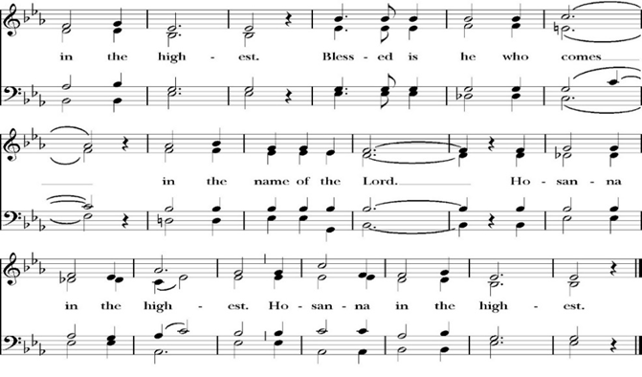
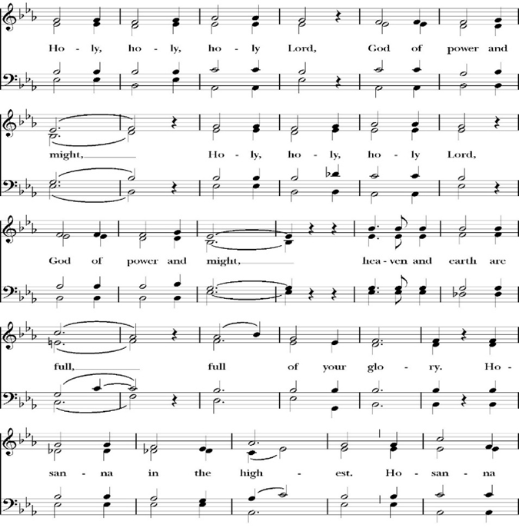
Sanctus

And now, as our Savior Christ has taught us, we are bold to pray,

Our Father, who art in heaven,
hallowed be thy Name,
thy kingdom come,
thy will be done,
on earth as it is in heaven.
Give us this day our daily bread.
And forgive us our trespasses,
as we
forgive those
who trespass against us.
And lead us not into temptation,
but deliver us from evil.
For thine is the kingdom,
and the power, and the glory,
for ever and ever. Amen.

The Prayer for Humble Access

We do not presume to come to this your table, O merciful Lord,
trusting in our own righteousness,
but in your abundant and great mercies.
We are not worthy so much as to gather up
the crumbs under your table;
but you are the same Lord
whose character is always to have mercy.
Grant us, therefore, gracious Lord,
so to eat the flesh of your dear Son Jesus Christ,
and to drink his blood,
that our sinful bodies may be made clean by his body,
and our souls washed through his most precious blood,
and that we may evermore dwell in him, and he in us.
Amen.

Agnus Dei

The Ministration of Communion

The gifts of God for the People of God. Take them in remembrance that Christ died for you and feed on him in your hearts by faith, with thanksgiving.

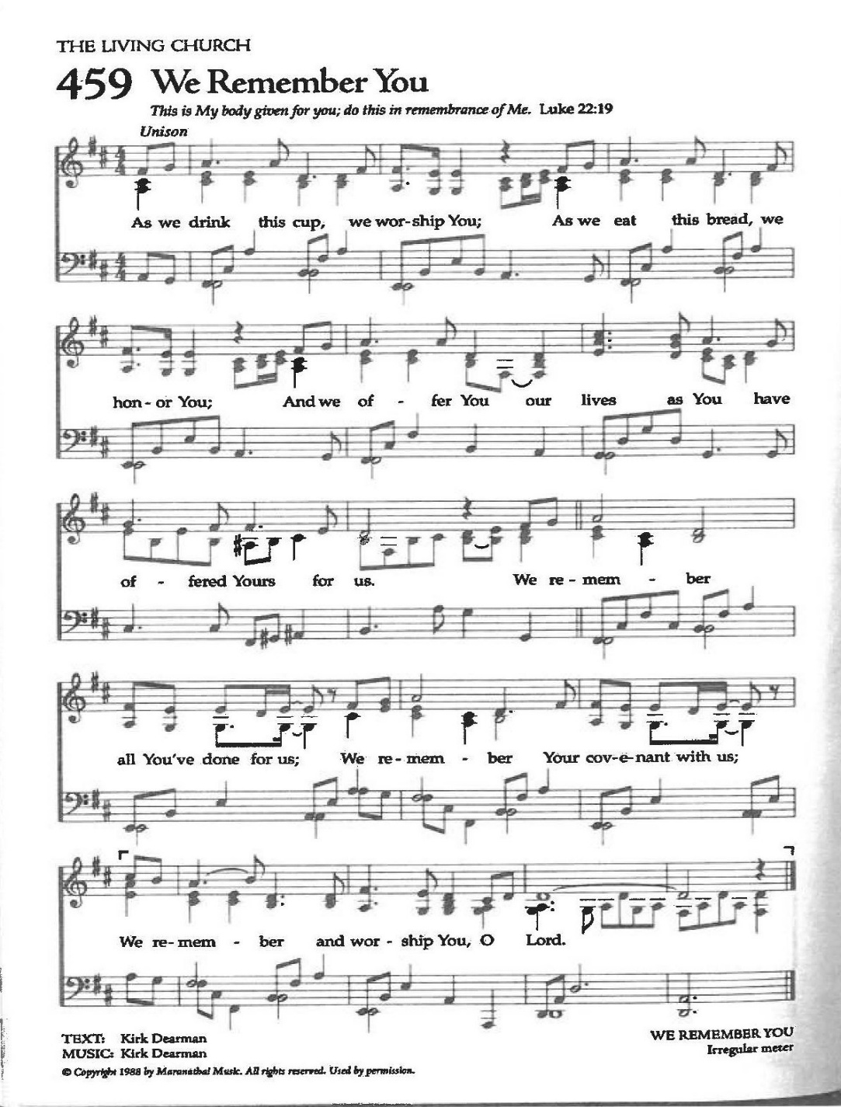
Communion Celebration Hymn: We Remember You

The Post Communion Prayer
Let us pray.

Heavenly Father,
We thank you for feeding us with the spiritual food
of the most precious Body and Blood
of your Son our Savior Jesus Christ;
and for assuring us in these holy mysteries
that we are living members of the body of your Son,
and heirs of your eternal Kingdom.
And now, Father, send us out to do the work you have
given us to do,
to love and serve you as faithful witnesses of Christ our
Lord.
To him, to you, and to the Holy Spirit,
be honor and glory, now and for ever. Amen.

The Blessing

The peace of God, which passes all understanding, keep your hearts and minds in the knowledge and love of God, and of his Son Jesus Christ our Lord; and the blessing of God Almighty, the Father, the Son, and the Holy Spirit, be among you, and remain with you always. Amen.

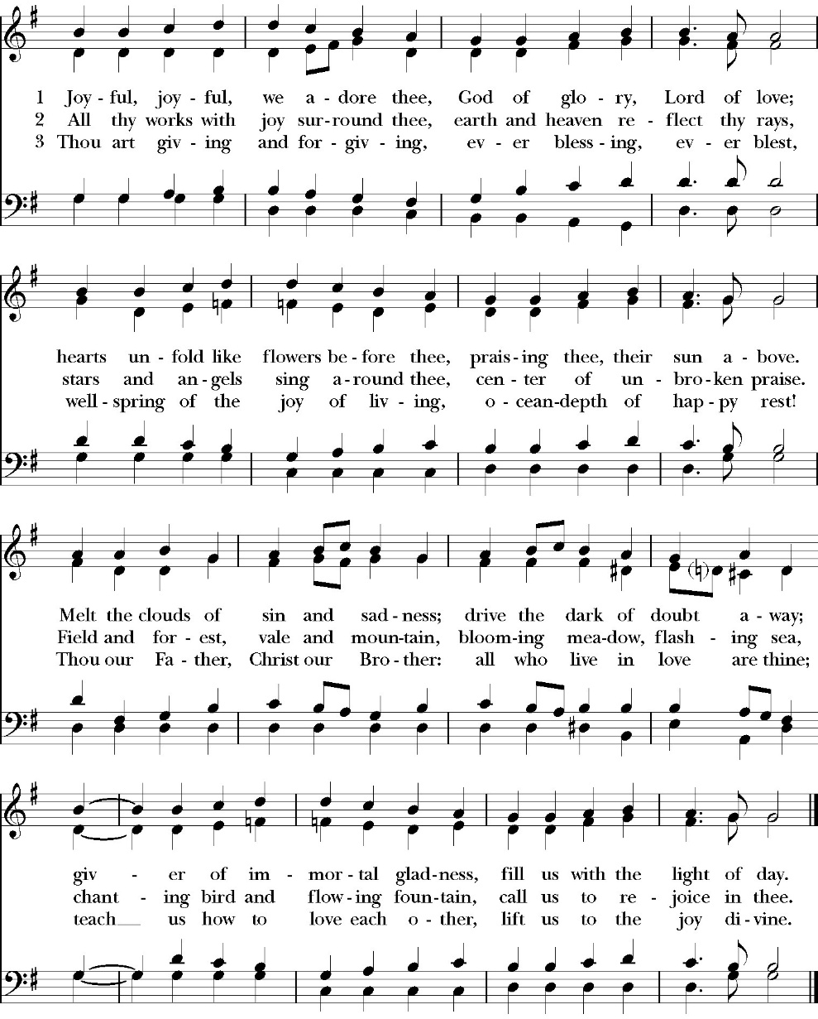
Closing Hymn: Joyful, Joyful We Adore Thee

Dismissal
Deacon Alleluia, Alleluia. Let us go forth into the world,
rejoicing in the power of the Holy Spirit.
People Thanks be to God Alleluia, Alleluia.

St. Paul’s Parish Calendar
Sunday September 6 – Sunday September 13

SUNDAY, September 6 – Fifteenth Sunday after Pentecost
9:15 AM Sunday Funday, Youth Room
9:15 AM Gospel of John Bible Study, Conference Room
10:30 AM Children’s Sunday School, Chapel
Pre-K –2nd Grade, Sunday School Room
3rd -5th Grade, Youth Room
10:30 AM Holy Eucharist, Church

MONDAY, September 7 – Labor Day - Office Closed

TUESDAY, September 8
6:00 PM Bell Choir Rehearsal, Music Room

WEDNESDAY, September 9
9:30 AM Holy Eucharist with healing prayer, Chapel
10:15 AM Bible Study, Conference Room
7:00 PM Choir Rehearsal, Chapel

THURSDAY, September 10

FRIDAY, September 11
6:30 AM Men’s Bible Study, Valhalla Restaurant

SATURDAY, September 12

SUNDAY, September 13 –Sixteenth Sunday after Pentecost
9:15 AM Sunday Funday, Youth Room
9:15 AM Gospel of John Bible Study, Conference Room
10:30 AM Children’s Sunday School, Chapel
Pre-K –2nd Grade, Sunday School Room
3rd -5th Grade, Youth Room
10:30 AM Holy Eucharist, Church

Church Office Hours
Monday-Thursday 8:00 AM-4:00 PM

Gospel of John Sunday morning Bible study, 9:15-10:00AM
The Sunday morning Gospel of John Bible study is working through chapter 9 & 10 in August. Fr. Rob will be our leader through September 20 and Deacon John will begin leading on September 27 and teach through November.

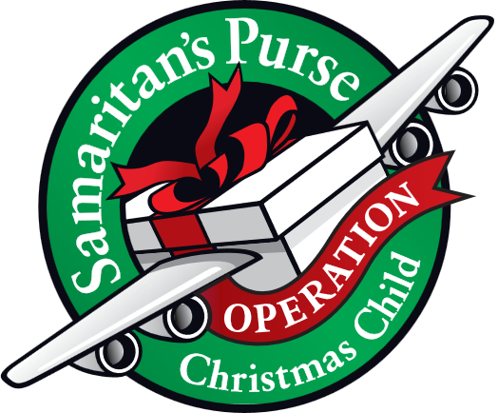
Operation Christmas Child donations begin in August
August Donations: School Supplies

Operation Christmas Child is a ministry of Samaritan’s Purse. The mission of Operation Christmas Child is to demonstrate God’s love in a tangible way to children in need around the world through partnering with the local church worldwide to provide shoebox size containers filled with school supplies, hygiene products, and a small gift to share the Good News of Jesus Christ and make disciples of the nations.

St. Paul’s Anglican Church is committed to providing 100 boxes to children throughout the world and will do this by having monthly themed donations from August through November. We will then have a ‘Filling the Box” party when we will gather together and fill 100 boxes with school supplies, hygiene products and small toys.

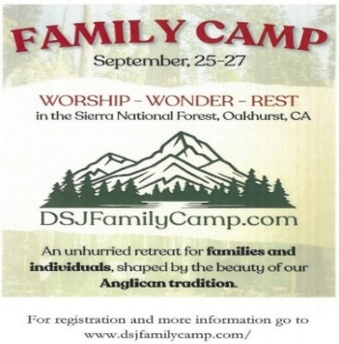
Anglican Diocese of San Joaquin Family Camp, Out of the Noise and Into the Wonder, September 25-27, Calvin Crest Sherwood Forest, Oakhurst, CA
Join your friends from St. Paul’s for an unhurried retreat for families and individuals, shaped by the beauty of our Anglican tradition. Calvin Crest Sherwood Forest is outside Oakhurst, CA near Yosemite. Each day flows from Morning Prayer to Compline. The family camp will feature tent and rustic cabin accommodations and will feel very much like the old Camp San Joaquin. The camp will be led by our friend Rev. Paul Gibbons, so we know that it will be a wonderful time.

The cost cannot be beat:
Bring your own Tent or RV: $75 for the whole family
Rustic Cabin Accommodations: $150 for the whole family

Accommodations and bathroom facilities

Tent & RV Sites: Pitch a tent or park your rig in the scenic Sherwood Forest area.
Rustic Cabins: Each cabin features 10 bunks with mattresses. Cabins are non-electric.
Bathrooms and Showers: Clean, private bathrooms and hot showers are available throughout camp.

What is included for this price:

The flat rate covers lodging, firewood, a sub sandwich dinner on Friday evening, breakfast on Saturday morning and a BBQ on Saturday evening.
How do I sign up or find out more?
Talk with Fr. Rob Longbottom or go to the Family Camp website at:
dsjfamilycamp.com

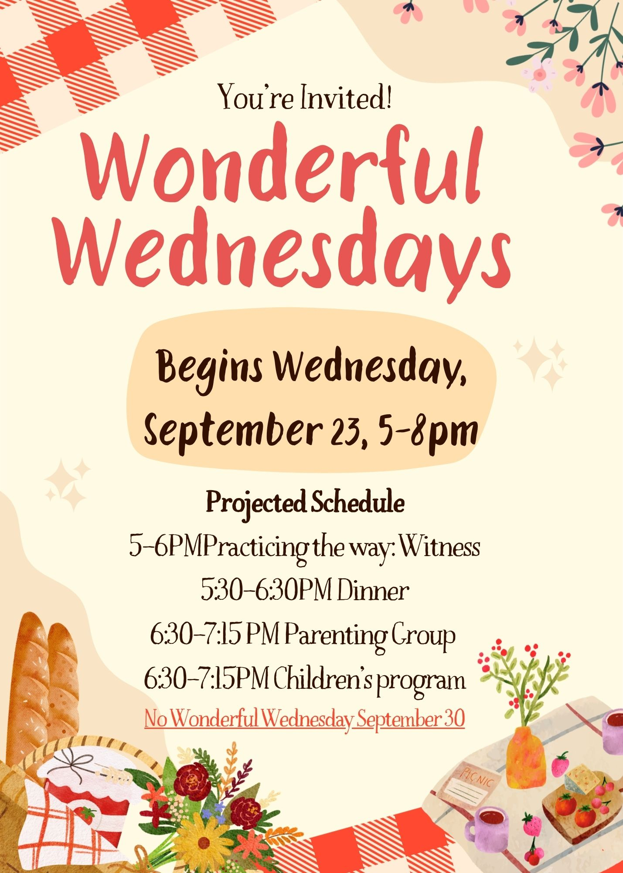

Wonderful Wednesdays Begin This Fall
Wonderful Wednesdays will look a little different this fall, but will continue to have discipleship opportunities both before dinner and after dinner. Please read through our program information to understand how our program itinerary will shift in order to accommodate special programs this year.

Wonderful Wednesday Dinners
5:30-6:30PM Wonderful Wednesday Dinner
The dinner start time is the big change this year for Wonderful Wednesdays. The reason for this is because, after dinner, there will be a parenting group that will meet from 6:30-7:15pm This will help the group to be finished in time to get young kids home and to bed at an appropriate time.

Wonderful Wednesday Kick-Off BBQ September 23
5:00-6:00 PM Practicing the Way Witness
5:30-6:30 PM Dinner
6:30-7:15 PM Parenting Group
6:30-7:15 PM Children’s Program

Wednesday’s September Kick-off BBQ Dinner Menu
Hamburgers
Cheeseburgers
Hot Dogs
Chips
Condiments: Mustard, ketchup, mayo, lettuce,
tomatoes, onions, pickles, peppers

Drinks: Iced Tea
Lemonade
Water

No Wonderful Wednesday Dinner or Programs on September 30 Due to Rummage Sale
The regular WWD's will start on October 7 and will end on November 18th. The WWD menus will be printed in the October and November Newsletters. The WWD menus will also be printed in the Sunday Bulletins. RSVP's are always welcomed to make sure there are meals for all.



St. Paul’s Anglican Church
6436 W Hurley Ave
Visalia, CA


Friday October 2, 8:00 AM to 4:00 PM
Saturday October 3, 8:00 AM to 2:00 PM
Drop Off Donated Items in James Hall on:
Wednesday, September 30, and Thursday, October 1
Between 9:00 AM – 4:00 PM
Items need to be in Good Condition: clean,
gently worn clothing, household items, toys in
working order gladly accepted!
Volunteers Needed for Set Up:
Wednesday, September 30 and Thursday, October 1
Between 9:00 AM – 4:00 PM
If you have any questions, Contact: Mary Murray at 799-6973

A Food Bank for Hurley Families
The next Neighborhood Market to benefit students at Hurley School will be Tuesday September 15, 2:30 PM to 3:30 PM at St Paul’s Church parking lot. If you are interested in helping that day, please contact Sue Nyberg. My home phone number is 559-733-8244. Next Market dates will be October 20 and November 10.

Due to the heat, we are in need of more volunteers for
month of September. This will allow volunteers to work
in shifts during these hot months.

PROVIDED BY VISALIA EMERGENCY AID
AND ST. PAUL’S CHURCH
Tuesday, September 15`, 2026
From 2:30 PM to 3:30 PM
LOCATION:
ST. PAUL'S CHURCH PARKING LOT
ACROSS THE STREET FROM HURLEY




The Altar Flowers
The flowers at the altar are given to the Glory of God,
by Maria Round, in thanksgiving for family.

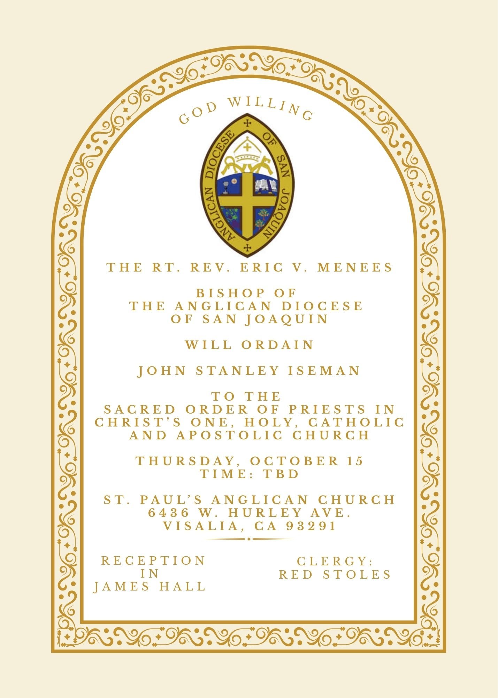


St. Paul’s Anglican Church
Friendship and Fellowship Gathering
Saturday October 17th
5:30 PM
at the home of
Jerry and Darlene Hallberg
1926 S. Savannah
Visalia, Ca 93277
BBQ Dinner
Please! Call or Text Darlene
to see what side dishes are needed.
Bring your favorite beverage.
RSVP by calling or texting Darlene at 559-280-2313
by Monday October 12

St. Paul’s Anglican Church
Parish Office
6436 W. Hurley Ave
Visalia, California 93291
559-732-4821
Office Hours: 8:00 – 4:00
Monday – Thursday

Worship: Sundays at 10:30AM
Livestream: Link at spvisalia.com
and on our Facebook page
Please be advised that this service is being recorded for broadcast
and/or archival purposes. By attending, you consent
to the inclusion of your likeness in these recordings.

St. Paul’s Clergy and Staff
The Rev. Robert Longbottom, Rector
rector@spvisalia.com
(559)802-2928
The Rev. John Iseman, Pastoral Associate for Family Ministries
family@spvisalia.com
The Rev. Kashy Rowland-Smith, Deacon
kashyrs@aol.com
Antoinette Horsting, Parish Administrator
bookkeeper@spvisalia.com
Marguerite Crownover, Organist and Accompanist
organist@spvisalia.com
Ellen Daniels, Choral Director
choirdirector@spvisalia.com
Jackie Iseman, Nursery Coordinator
nursery@spvisalia.com
Shane Motl, Sexton

St. Paul’s is a member church of the
Anglican Diocese of San Joaquin
The Rt. Rev. Eric V. Menees, Bishop

Next Week’s Lessons
Ecclesiasticus 27:30–28:7
Psalm 103
Romans 14:5-12
Matthew 18:21-35

