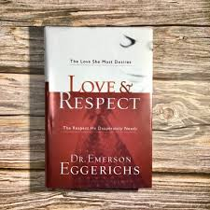
Registration Form

What: Circle of Love Bible Study with Ministers Rod and Chaun Pinkston
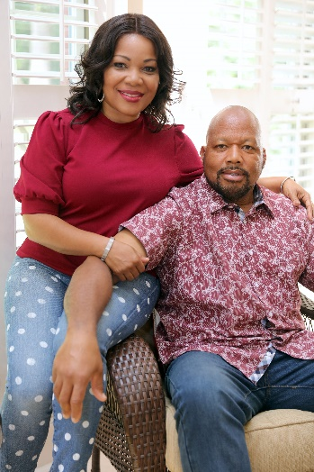
Who: Bible Study for Married Couples
When: Sundays following service at 12 Noon: September 12th & 26th, October 10th, 24th, November 14th and December 12th
How: Bible Study Sessions include six meetings where couples are led through the book “Love and Respect” with active conversations and inspiring illustrations.
What: Book: Love & Respect by Dr. Emerson Eggerichs – purchase from Amazon
Where: Springfield Baptist Church – Brinson, Roberson, Wilson Nutritional Center – 614 Martin Luther King Jr. St., Thomson, GA 30824

Complete the information listed below:

Name: ____________________________________________________

Address: __________________________________________________

City, State, Zip Code: _________________________________________

Email address: ______________________________________________

Phone number: _____________________________________________

