2026-2027 Calendar
Monday/Wednesday Program
Wednesday, August 12th | 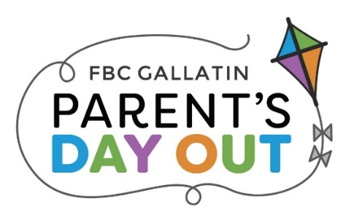  Open House
Monday, August 17th | First Day of Parent’s Day Out
Monday, September 7th | Labor Day—No PDO
Monday, September 21st | SCS Closed—No PDO
Monday & Wednesday, October 5th & 7th &12th | Fall Break—No PDO
Monday & Wednesday, November 23rd & 25th | Thanksgiving Break—No PDO
Wednesday, December 16th | Last day of semester
December 17th – January 4th | Winter Break—No PDO
Wednesday, January 6th | Return from Winter Break
Monday, January 18th | MLK, Jr. Day—No PDO
Monday, February 15th | President’s Day—No PDO
Monday & Wednesday, March 22nd & 24th & 29th | Spring Break—No PDO
Wednesday, May 19th TBD | Last day of PDO
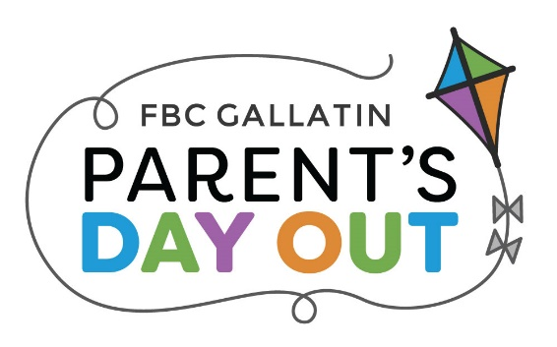

2026-2027 Calendar
Tuesday/Thursday Program

Thursday, August 13th | Open House
Tuesday, August 18th | First Day of Parent’s Day Out
Tuesday & Thursday, October 6th & 8th | Fall Break—No PDO
Tuesday, November 3rd | Election Day—No PDO
Tuesday & Thursday, November 24th & 26th | Thanksgiving Break—No PDO
Thursday, December 17th | Last day for semester
December 21st - January 4th | Winter Break—No PDO
Tuesday , January 5th | Return from Winter Break
Tuesday & Thursday, March 23rd & 25th | Spring Break—No PDO
Thursday, May 20th TBD | Last day of PDO

