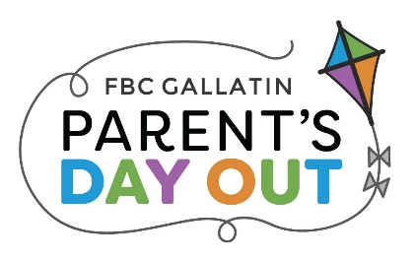
2022-2023
FOR OFFICE USE ONLY:
Date Form Received _______ Materials Fee $70 paid _____
Age Group _________
Monday & Wednesday
Program ______

OR

Tuesday & Thursday
Program ______

205 East Main Street, PO Box 369
Gallatin, TN 37066

Child’s Full Name: ________________________________________ Child Goes By: ________________________

Male Female Age: _______ Child’s Birthdate (mm/dd/yy): ______________

Address: ________________________________________ City: _______________________ Zip: _______________
Mom cell: __________________ Dad cell: __________________ Email: _________________________________

Father’s Name: ________________________________ Occupation: _________________________
Place of Employment: __________________________ Work Phone: ________________________

Mother’s Name: _______________________________ Occupation: _________________________
Place of Employment: __________________________ Work Phone: ________________________
Custody: _____Both _____Dad _____Mom _____Other:_______________________

Siblings: Name: ______________________ Age: ______ Birthdate (mm/dd/yy): _____________
Name: ______________________ Age: ______ Birthdate (mm/dd/yy): _____________
Name: ______________________ Age: ______ Birthdate (mm/dd/yy): _____________

Name of person to make PDO payments: ________________________________________________________
Birthdate of person who will be making payments (for online account) (mm/dd/yy):________________
Do you currently attend a church? Yes No If yes, where? __________________________________

Please list below people, OTHER THAN PARENTS, to be called in case of illness/emergency or that have permission to pick up your child:

Name & Relationship to Child: __________________________________ Phone Number: _________________
Name & Relationship to Child: __________________________________ Phone Number: _________________
Any person picking up your child must show a valid driver’s license or your child’s security card.

Medical Information
Child’s Physician: _________________________ Phone: __________________
Emergency Instructions: __________________________________________________________________________

Please list any medication, medical treatment, health problems, or allergies that your child may have: ___________________________________________________________________________________________
Please list any evidence of hearing, vision, or speech difficulties that you are aware of: ______________
_________________________________________________________________________________________________
Any other special information or areas of concern: _________________________________________________
- I authorize a representative of First Baptist Gallatin Parent’s Day Out Program to give consent for any and all necessary medical care for my child while he/she is in our care.
- I give permission for my child’s image to be used in any PDO publications and programs.
- I have read and understand the policies of the First Baptist Gallatin Parent’s Day Out Program.
- I understand that the PDO program at First Baptist Gallatin is not licensed and is not required to be licensed by the State of Tennessee as a child care agency.
X_________________________________________ Date: ______________________________
(Signature of Parent or Guardian)

