
CROSSOVER UNIVERSITY
STUDENT HANDBOOK
Certificate in Christian Studies

WELCOME
Welcome to Crossover University. We are excited that you have chosen to invest in your spiritual growth and biblical education.
MISSION
Crossover University exists to equip believers to know God's Word, grow in Christlikeness, defend the faith, and serve faithfully in the local church for the glory of God.
PROGRAM OVERVIEW
The Certificate in Christian Studies is designed to provide believers with a solid foundation in biblical knowledge, theology, Christian living, and ministry.
XP POINT SYSTEM
Students earn 10 XP points for each successfully completed course.
CERTIFICATE PROGRAM
Students who successfully complete all ten required courses will earn 100 XP points and receive:
• A Certificate in Christian Studies from Crossover University
• Free Bible Commentary Set
• An official Crossover University Graduation Ring
RECOGNITION
Students who complete the Certificate Program may choose to be recognized before the church during a Sunday morning worship service.
CONTINUING EDUCATION
Additional courses may be offered throughout the year and may be completed to earn additional XP points.
MILESTONE AWARD
Students who earn 150 XP points will receive:
• A 3-Year Subscription to Logos Bible Software
• A Crossover University T-Shirt
• A Crossover University Sweatshirt
• A Replica of an ancient manuscript. The Epistle of Jude-Early Papyrus 78 Replica

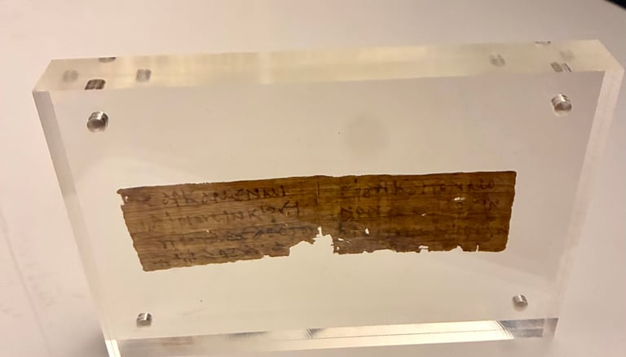
This high-quality replica brings you one of the earliest surviving pieces of the Epistle of Jude — a powerful New Testament warning against false teachers who pervert the grace of God. Key Content Preserved: Jude verse 4, “For certain people have crept in unnoticed… ungodly people who pervert the grace of our God into sensuality and deny our only Master and Lord, Jesus Christ.”
Dated to the second half of the 3rd century, this small but significant papyrus was discovered at Oxyrhynchus, Egypt.
Contains Strong Warnings Against False Teachers
• Jude 1:4 — “For certain people have crept in unnoticed… ungodly people who pervert the grace of our God into sensuality and deny our only Master and Lord, Jesus Christ.”
• Jude 1:5, 7–8 — References to God’s judgment, Sodom and Gomorrah, and those who “defile the flesh and reject authority.”
Displayed in an acrylic standing frame (4" x 6")
___________________________________________________________________________________

If you have any questions about Crossover University you may direct all your questions to Pastor Kyle Hogg at khogg@crossover-rosedale.org

“Do your best to present yourself to God as one approved, a worker who has no need to be ashamed, rightly handling the word of truth.” — 2 Timothy 2:15

