The Challenge: The Virginia Department of Corrections launches more people into Virginia’s workforce annually than our largest graduating university. With new federal Pell grant eligibility, we have the chance to prepare our returning neighbors to contribute at their highest level--a boon to individuals, families, and the commonwealth.
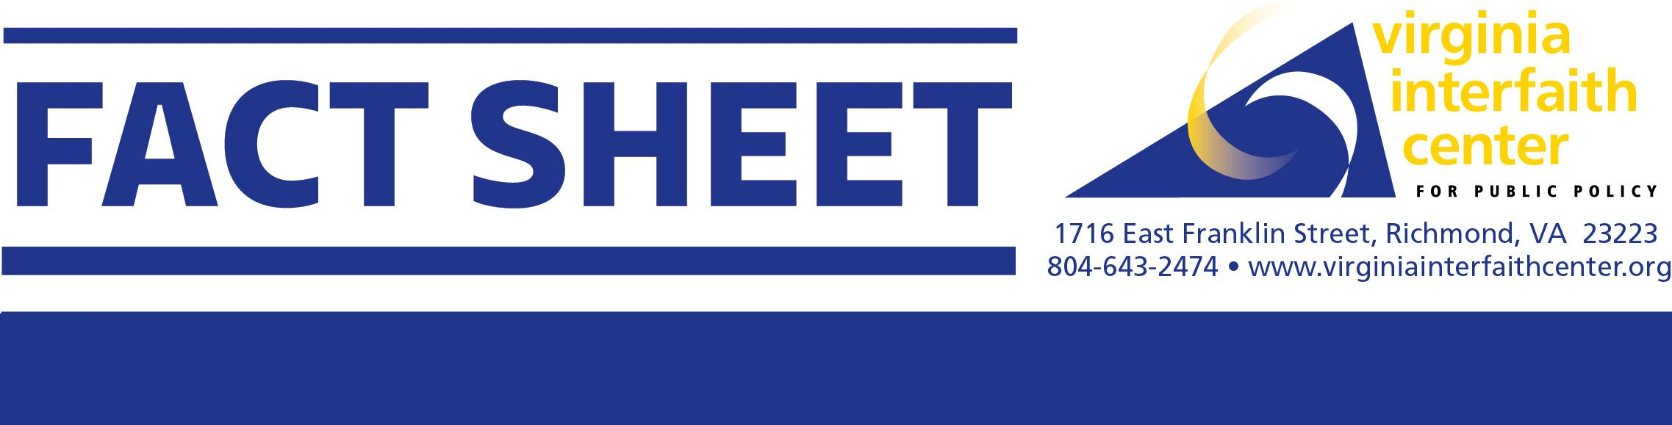
Background: For decades, colleges operated degree programs in prisons and jails, enrolling and graduating students who possessed a desire to learn and a Pell grant for tuition. By the early nineties, there were 772 colleges with degree programs in 1,287 prisons and jails across the U.S. Almost universally, incarcerated college students, even with the best prison jobs, met the low-income criteria for Pell grants.
Expand Access to Higher Education in Prisons
Colleges pursued a business model that worked for everybody—it generated enrollment revenue, while contributing to individual transformations, reduced recidivism, increased safety inside prisons, and greater employability for graduates upon reentry.
But the model collapsed on a dime in 1994, when the federal Violent Crime Bill made incarceration a disqualifier for Pell grants, and tuition monies evaporated. Regardless of classroom location, student financial wherewithal drives college access in the U.S., as this natural experiment made clear. Almost overnight, 765 programs closed, leaving only seven college prison programs in operation by 1997.
Leadership in Virginia: In 2015, the U.S. Department of Education launched a Second Chance Pell pilot in 67 colleges, growing it to 200 schools by 2023. In Virginia, Danville Community College, Rappahannock Community College, Southside Community College, and Piedmont Virginia Community College entered the pilot, several already having long histories of pre-1994 and/or charity-funded prison programs. Today, these schools offer Pell-funded associate degrees and CTEs in ten VADOC facilities, serving about 600 students. These partnerships represent a significant reservoir of experience and thought leadership in Virginia, as does national model, Resilience Education, launched at UVA’s Darden School.
Benefits of College Programs in Prisons: Research evidence of positive outcomes has won support across the political spectrum. Reduction of recidivism, which improves with each advancing degree, appeals for public safety reasons, taxpayer savings and restored life potentials. Prison culture shifts, like fewer violent misconducts, make both staff and residents safer. College degrees and credentials promote socioeconomic mobility, employment opportunities and higher wages, along with increased self-esteem and educational role modeling for children.
Pell Reinstatement & New Opportunities: July 2023 marked full reestablishment of Pell eligibility, yet Virginia lags in taking advantage of the federal dollars now available. Our existing Second Chance Pell programs are massively underscaled, given research that 65% of prison residents academically qualify for college. Multi-year wait lists show demand is strong.
VICPP is committed to involving stakeholders across education, corrections, justice-impacted, employers and legislators in a consensus-building process to expand access to higher education in Virginia prisons.

