Where does a Christian go when they die?
(The Rapture)
7.26.26

Observations:
I’m trying really hard to stick with the original question but we may have to wade into end times stuff some.
The purpose of this series is to comfort and inform!
I Thess 4:13 We do not want you to be uninformed, brothers and sisters, concerning those who are asleep, so that you will not grieve like the rest, who have no hope. 18 Therefore encourage^{[a]} one another with these words.
I. A timeline of events

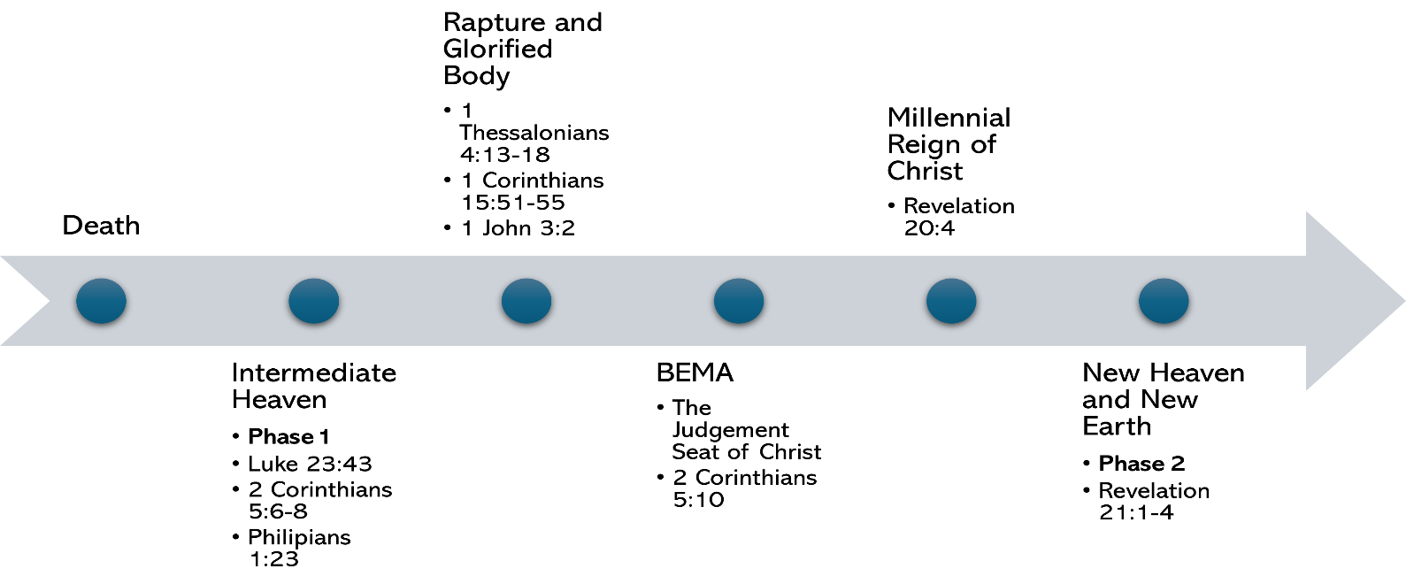

Church age to
Rapture to
Tribulation to (7 years)
Second Coming to
Millennial Reign to (1000 years)
New Heaven and Earth
II. What is the rapture?
A. 1 Thessalonians 4:13–5:6
And now, dear brothers and sisters, we want you to know what will happen to the believers who have died^{[a]} so you will not grieve like people who have no hope. ¹⁴ For since we believe that Jesus died and was raised to life again, we also believe that when Jesus returns, God will bring back with him the believers who have died.
¹⁵ We tell you this directly from the Lord: We who are still living when the Lord returns will not meet him ahead of those who have died.^{[b]} ¹⁶ For the Lord himself will come down from heaven with a commanding shout, with the voice of the archangel, and with the trumpet call of God. First, the believers who have died^{[c]} will rise from their graves. ¹⁷ Then, together with them, we who are still alive and remain on the earth will be caught up in the clouds to meet the Lord in the air. Then we will be with the Lord forever. ¹⁸ So encourage each other with these words.
B The word “rapture” comes from the phrase “caught up”. The Greek word is harpadzō. It means to snatch aggressively
thecripplegate.com/rapture-vs-second-coming-back-to-the-future-part-4/

C. At the Rapture, Christians are physically removed from the earth, together with all those who are dead in Christ, and we all get our immortal, glorified bodies.
1 Corinthians 15:50–54What I am saying, dear brothers and sisters, is that our physical bodies cannot inherit the Kingdom of God. These dying bodies cannot inherit what will last forever.
⁵¹ But let me reveal to you a wonderful secret. We will not all die, but we will all be transformed! ⁵² It will happen in a moment, in the blink of an eye, when the last trumpet is blown. For when the trumpet sounds, those who have died will be raised to live forever. And we who are living will also be transformed. ⁵³ For our dying bodies must be transformed into bodies that will never die; our mortal bodies must be transformed into immortal bodies.
⁵⁴ Then, when our dying bodies have been transformed into bodies that will never die,^{[a]} this Scripture will be fulfilled:
“Death is swallowed up in victory.^{[b]}

D. In a nutshell
The deceased believers will go first and then believers who are alive will be caught up secondly.
The deceased believers will reunite with their earthly bodies in some manner .
All believers will get a glorified body at the rapture.

III. Four questions to ponder.

A. --What will our gloried bodies look like?
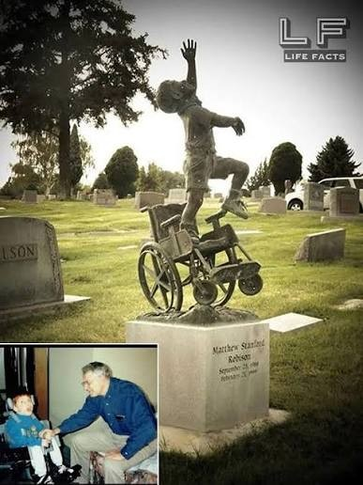

1 Corinthians 15:42–53 ⁴² So will it be with the resurrection of the dead. The body that is sown is perishable, it is raised imperishable; ⁴³ it is sown in dishonor, it is raised in glory; it is sown in weakness, it is raised in power; ⁴⁴ it is sown a natural body, it is raised a spiritual body.
If there is a natural body, there is also a spiritual body. ⁴⁵ So it is written: “The first man Adam became a living being”^{[a]}; the last Adam, a life-giving spirit. ⁴⁶ The spiritual did not come first, but the natural, and after that the spiritual. ⁴⁷ The first man was of the dust of the earth; the second man is of heaven. ⁴⁸ As was the earthly man, so are those who are of the earth; and as is the heavenly man, so also are those who are of heaven. ⁴⁹ And just as we have borne the image of the earthly man, so shall we^{[b]} bear the image of the heavenly man.
⁵⁰ I declare to you, brothers and sisters, that flesh and blood cannot inherit the kingdom of God, nor does the perishable inherit the imperishable. ⁵¹ Listen, I tell you a mystery: We will not all sleep, but we will all be changed— ⁵² in a flash, in the twinkling of an eye, at the last trumpet. For the trumpet will sound, the dead will be raised imperishable, and we will be changed. ⁵³ For the perishable must clothe itself with the imperishable, and the mortal with immortality
B. --What happens to deceased believer, at the rapture, who was cremated?
If God created us from dust can he not do it again?
C. --When will the rapture take place?
---In general nobody knows!
I Thess 5 Now, brothers and sisters, about times and dates we do not need to write to you, ² for you know very well that the day of the Lord will come like a thief in the night.
---What is the time context for the rapture as it relates to the tribulation?
All Christians believe in a rapture, but not all Christians agree on the timing of the Rapture.
The three views
1. pre-Trib – that the Rapture takes place before the 7-year Tribulation
2. mid-Trib – that the Rapture takes place before the mid-way through the 7-year Tribulation
3. post-Trib – that the Rapture takes place after the 7-year Tribulation (i.e. with the Return of Christ).

D. --What is the difference between the rapture and the second coming of Christ?
Matt 25:31–34 “When the Son of Man comes in his glory, and all the angels with him, then he will sit on his glorious throne. Before him will be gathered all the nations, and he will separate people one from another as a shepherd separates the sheep from the goats. And he will place the sheep on his right, but the goats on the left. Then the King will say to those on his right, ‘Come, you who are blessed by my Father, inherit the kingdom prepared for you from the foundation of the world. [i.e. the Millennial Kingdom]
A. With Rapture Christ comes for us in the air and takes us with him, in his Glorious Coming (the Matthew passage) – Jesus comes to dwell with us;
B. With Rapture – Jesus gathers his people himself; at his Glorious Coming, his angels do the gathering;
C. With Rapture, Jesus comes to reward (1 Thess 4:17); in is Glorious Coming – he comes to judge (Mat 25:31-46);
D. With Rapture the believers depart the earth and only unbelievers remain to usher in the Tribulation, but with Jesus’ Glorious Coming – the unbelievers are taken away and the believers (saved in the Rapture) remain to populate the Millennial Kingdom;
E. With Rapture there is no mention of the Kingdom, but the Kingdom begins with Jesus’ Glorious Coming.

Close:
“ He who is the faithful witness to all these things says, “Yes, I am coming soon!”
Rev 22:20

