Sermon Text: Luke 16:19–31 Date: March 15, 2026
Sermon Title: Looking Beyond Today
Sermon Notes:
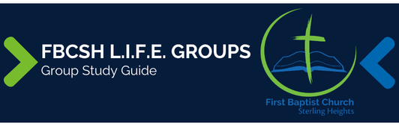

Sermon Text: Luke 16:19–31 Date: March 15, 2026
Sermon Title: Looking Beyond Today
Main Idea: Today’s riches will distort eternal realities unless we look beyond them.
Breaking the Ice
- Share an example of a time when you realized in hindsight that your perception of something was distorted.

Excavating the Truth
- Reread Luke 16:19–31
- Describe how this parable concludes Jesus’ discussion on riches.

- Based on what the rich man says in verse 30, what realization does the man have about riches?

Applying the Truth Personally
- In what ways am I like the rich man acting as if others exist to serve me? What can I do to change my attitude and actions?

- How have I demonstrated a lack of confidence in the sufficiency of Scripture and how can this parable strengthen my confidence in it?

Applying the Truth Congregationally
- In what ways do we allow riches to distort our perceptions? How can we help each other look beyond the economic situations we observe toward eternity?

- What might we try to utilize beyond the sufficiency of Scripture to move people to believe? How can we resist this temptation in our church?

Digging Deeper
- The verb in verse 26 is literally, “a great chasm has been fixed.” What does the picture formed by this phrase imply?

- Consider the other nine uses of “Hades” in the NT: Matt 11:23; 16:18; Luke 10:15; Acts 2:27, 31; Rev 1:18; 6:8; 20:13, 14. From these verses, what can you conclude about this place?

Looking Ahead
- Read Luke 17:1–10 daily.

