Sermon Text: Luke 17:11–19 Date: March 29, 2026
Sermon Title: A Thankful Heart
Sermon Notes:
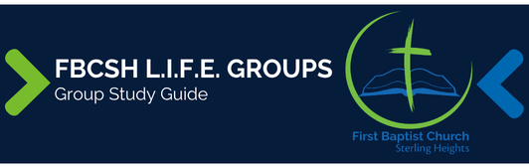

Sermon Text: Luke 17:11–19 Date: March 29, 2026
Sermon Title: A Thankful Heart
Main Idea: Experiencing salvation should produce elated thanksgiving.
Breaking the Ice
- Describe a time when you found yourself giving elated thanks to someone.

Excavating the Truth
- Reread Luke 17:11–19
- What is the significance of the Samaritan’s “loud voice” in verse 15?

- Accordign to our text, why might Jesus ask a Samaritan to follow the requirements of Leviticus 14:2-32 and show himself to a Jewish priest?

Applying the Truth Personally
- What is one specific blessing in my life that I failed to thank God for? What causes me to neglect giving Him praise?

- When am I most thankful for my salvation? What can I do to maintain my thankfulness?

- When have I failed to act according to faith’s demands? What can I do to overcome such failure in the future?

Applying the Truth Congregationally
- How can our church help others understand that God’s grace and mercy do not automatically equate to salvation.

- What can our church do to help us maintain and publicly express elated thankfulness over our salvation?

Digging Deeper
- The NT uses the particular Greek word translated as “Master” in verse 13 only seven times: Luke 5:5; 8:24 (2X); 8:45; 9:33; 9:49; 17:13. From these occurrences, what do you conclude the word means?

- Explain how the miracles of Luke 11:14; 13:12; 14:4; 17:14; and 18:42 serve to emphasize the teaching that follows.

Looking Ahead
- Read Mark 15:1–16:7 daily in preparation for Good Friday and Easter Sunday.

