Sermon Text: Luke 18:1–8 Date: April 19, 2026
Sermon Title: Persistent Prayer
Sermon Notes:
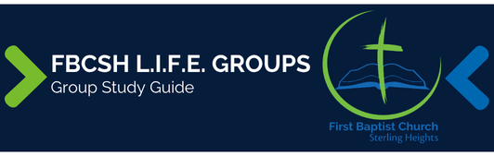

Sermon Text: Luke 18:1–8 Date: April 19, 2026
Sermon Title: Persistent Prayer
Main Idea: Strong faith requires that we persist in prayer.
Breaking the Ice
- What is one example where yourpersistence has benefited you?

Excavating the Truth
- Reread Luke 18:1–8
- The context (Luke 17:22–37) of our parable deals with the delay of the second coming. How does this context affect its interpretation?

- Compare verses 2 and 4 with Luke 10:27. How does the judge fail to meet the fundamental requirements of the Mosaic Law?

Applying the Truth Personally
- What are some reasons that I fail to persist in prayer as I wait for Christ’s return? What can I do to remove or mitigate these reasons?

- How does persistence in prayer strengthen my faith?

- What is one thing I can do this week to make my prayers more about justice and righteousness and less about personal comfort?

Applying the Truth Congregationally
- Why are prayer times so poorly attended in our church? What can we do to improve persistence in prayer as a church?

- How can we increase our church’s prayer concerns for justice and righteousness?

Digging Deeper
- Based on OT passages such as Exod 22:22–24; Deut 24:17–18; Ps 68:5; 82:2–7; and 146:9; how does the judge serve as a classic example of an unrighteous person? What sort of behavior might portray such a person in our NT era?

- The last clause of verse 7 can be translated as either “and will He delay long over them” or “though He bear long with them.” How does the translation choice affect the meaning of the passage?

Looking Ahead
- Read Luke 18:9–14 daily.

