Sermon Text: Luke 19:1–10 Date: May 31, 2026
Sermon Title: Responsive Faith
Sermon Notes:
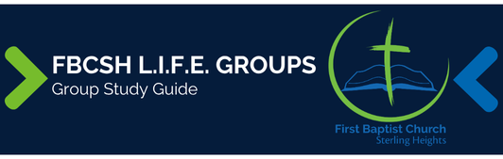

Sermon Text: Luke 19:1–10 Date: May 31, 2026
Sermon Title: Responsive Faith
Main Idea: God’s unexpected salvation brings visible transformation to our lives.
Breaking the Ice
- What is a personal characteristic, such as Zaccheus’ height, that has challenged me and how have I coped with the challenge?

Excavating the Truth
- Reread Luke 19:1–10
- What is the significance of the way the crowd described Zaccheus in verse 7?

- Verse 8 begins with a contrasting “but” (untranslated in some English versions). What contrast is Luke suggesting with this word?

Applying the Truth Personally
- How has salvation produced joyful generosity in my life?

- How does the fact that Jesus “sought” me while I was lost impact in my life?

Applying the Truth Congregationally
- What can we do as a Life Group to ensure that we see people as God does rather than as “sinners” like the crowd of verse 7?

- How can this Life Group help me rectify past wrongs in my life?

Digging Deeper
- Taking Luke 19:10 as the “key verse” of Luke (as many do), write a paragraph summarizing how the previous 18 chapters have lead up to this verse.

- Luke 12:33 and 18:22 do not require every believer to sell all possessions. Yet, combined Luke 19:8, write a brief philosophy of money that reflects faithful, godly stewardship.

Looking Ahead
- Read Psalm 145 daily.

