Sermon Text: Luke 19:41–48 Date: June 28, 2026
Sermon Title: The Hardships of Holiness
Sermon Notes:
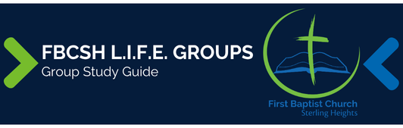

Sermon Text: Luke 19:41–48 Date: June 28, 2026
Sermon Title: The Hardships of Holiness
Main Idea: We must remain prepared for the hardships of holiness.
Breaking the Ice
- What is something that I have chosen to do even though I know it will bring hardship into my life?

Excavating the Truth
- Reread Luke 19:41–48
- Count the number of times “you” or “your” is repeated in verses 43–44. What is Jesus trying to emphasize?

- In verse 46, how does Jesus combined citation from Isaiah 56:7 and Jeremiah 7:11 strengthen His point?

Applying the Truth Personally
- What tempts me to avoid full-on holy living because of the hardship that might arise? What can I do to overcome this fear?

- What hardship do I warn others about most often? Why am I passionate about this? What can I learn from this passion that applies to warning people about the eternal hardship of hell?

Applying the Truth Congregationally
- How can we more effectively help someone accept the personal hardships of holiness? What am I going to do to strengthen our church in this area this week?

- What Scripture can we use to comfort a fellow church member suffering the loss of relationships because of choosing to live a holy life?

Digging Deeper
- Luke is the only Gospel writer to include Jesus’ lament over Jerusalem in verses 41–44. How does this section affect Luke’s climax of Jesus’ final trip?

- All four Gospels record a Temple cleansing: Matt 21:12–13; Mark 11:15–17, Luke 19:45–46, and John 2:13–17. John places the event at the beginning of Jesus’ ministry while the others place it at the end. How might you harmonize the four accounts?

Looking Ahead
- Read Matthew 6:9–13, 1 Timothy 2:8, and Galatians 1:10 daily.

