

PO Box 509
Cisco, TX 76437
(254) 643-1534
www.HalleluYah.org

Name of Principal

Name of School

Address of School

City State Zip

Dear School Administrator:

Each week, members of the Assembly of Yahweh drop their work activities for the purpose of observing the Biblical Sabbath from Friday sunset to Saturday sunset (Genesis 2:2-3 & Exodus 20:8-11). Assembly of Yahweh - What We Believe (halleluyah.org)

Additionally, each year members of the Assembly of Yahweh drop their work and school activities for the purpose of observing the Biblical Holy Days as set forth in Leviticus, Chapter 23. These annual Holy Days are Sabbath Days in which no work is to be done. We must meet and worship our Heavenly Father. Therefore, we request excused absences (non-truant) for the student named below for religious reasons so they can make up missed school work upon their return. Your cooperation is truly appreciated.

Thank you for your continuing support of the many freedoms which we, as United States citizens, enjoy in our great nation. Again, we truly appreciate your courtesy.

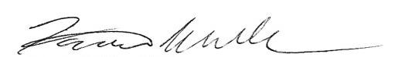
Sincerely,

Farris Wilks, Pastor

Student’s name

Parent’s name

Date(s) Absent

Occasion ____ Feast of Unleavened Bread
____ Feast of Trumpets
____ Day of Atonement
____ Feast of Tabernacles
____ Feast of Pentecost
____ Weekly Sabbath (Friday sunset to Saturday sunset)

