
PO Box 509
Cisco, TX 76437
(254) 643-1534
www.HalleluYah.org

Supervisor

Employer

Address of Employer

City State Zip

Dear Sir / Madam:

Each week, members of the Assembly of Yahweh drop their work activities for the purpose of observing the Biblical Sabbath from Friday sunset to Saturday sunset (Genesis 2:2-3 & Exodus 20:8-11). Assembly of Yahweh - What We Believe (halleluyah.org)

Additionally, we also observe the Holy Days as set forth in Leviticus, Chapter 23. These annual Holy Days include Sabbath Days in which no work is to be done. We must meet and worship the Most High. Therefore, we request excused absences for the employee named below per religious rights and observances. Your cooperation is truly appreciated.

Thank you for your continuing support of the many freedoms which we, as United States citizens, enjoy in our great nation. Again, we truly appreciate your courtesy.

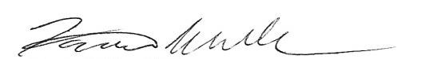
Sincerely,

Farris Wilks, Pastor

Employee

Date(s) Absent

Occasion ____ Feast of Unleavened Bread
____ Feast of Trumpets
____ Day of Atonement
____ Feast of Tabernacles
____ Feast of Pentecost
____ Weekly Sabbath (Friday sunset to Saturday sunset)

