Medical Release and Permission Form
(Please print in ink)
Activity Effective dates: September 1, 2026 – August 31, 2027
Name: ____________________________________________________________________
LAST FIRST MIDDLE
Age: ____ DOB: ________ Year in school:________________  Male  Female
Physical Address: ___________________________________________________
Mailing Address: ___________________________________________________
City:_________________ State: ______ Zip: ___________
Student Cell: (___)____________ E-mail:__________________
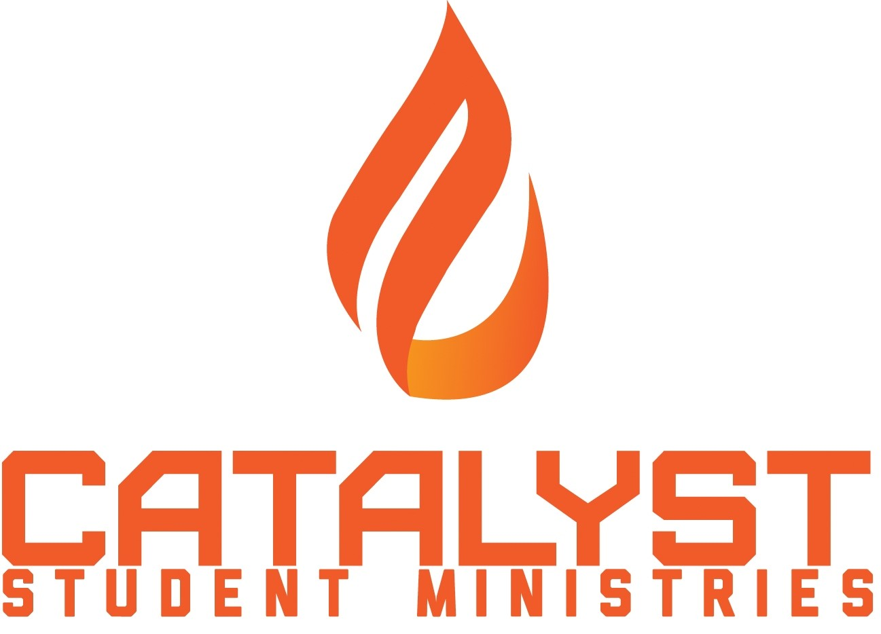
Medical insurance company:_____________________________Policy#:______________
Parent/Guardian Name: _____________________________________________
Phone: Home/Cell: (___)__________ Work: (___)______________
Emergency contact:__________________________________________
Phone: Home/Cell: (___)__________ Work: (___)______________
Physician: _______________________________ Office phone:_______________
Medical History
If necessary, describe in detail the nature and severity of any physical and/or psychological ailment, illness, propensity, weakness, limitation, handicap, disability, or condition to which your child is subject and of which the staff should be aware, and what, if any action of protection is required on account thereof. Submit this notification in writing and attach it to this form. Include names of medications and dosages that must be taken.
Check the following areas of concern for this student. If necessary, add another page with details:

- For your child’s safety and our knowledge, is your student a:
 good swimmer  fair swimmer  non-swimmer

- Does your child have allergies to:
 pollens  medications  food  insect bites
If so, please list which ones, and if the student carries an epi-pen: ___________________________________________________________________________
___________________________________________________________________________
- Does your child suffer from, or has ever experienced, or is being treated currently for any of the following:
 asthma  epilepsy/seizure disorder  heart trouble  diabetes
 physical handicap
- Date of last tetanus shot: ______________________________
- Please list and explain any major illnesses the child experienced during the last year:____________________________________________________________________________
________________________________________________________________________________

Additional comments:_______________________________________________________________
________________________________________________________________________________

Should this child’s activities be restricted for any reason? Please explain:______________________
________________________________________________________________________________

For your information, we expect each student to conform to these rules of conduct ----
-No possession or use of alcohol, drugs, tobacco, or vaping products
-No fighting, weapons, fireworks, lighters, or explosives.
-No offensive or immodest clothing.
-If there is an event outside of Pomeroy, students are not allowed to drive there independently.
-During any overnight event, no boys in girls’ sleeping areas and no girls in boys’ sleeping
areas.
-Participation with the group is expected.
-Students are not to leave events early.
-Parents will be notified if students leave an event early.
-Respect property, one another, staff, and adult leaders and comply with event schedules. Students who fail to comply with these expectations may be sent home at their parents’ expense.
I, the student, have read the rules of conduct, the above evaluation of my health, and permission to participate in youth group activities. I agree to abide by the stated guidelines and code of conduct.
Student signature: ___________________________________ Date: ______
This consent form gives permission to seek whatever medical attention is deemed necessary, and releases the Catalyst Student Ministries and its staff of any liability against personal losses of named child.
I/We the undersigned have legal custody of the student named above, a minor, and have given our consent for him/her to participate in events being organized by Catalyst Student Ministries. I/We understand that there are inherent risks involved in any ministry or athletic event, and I/we hereby release Catalyst Student Ministries, its directors, employees, counselors, and other volunteer workers from any and all liability for any injury, loss, or damage to person or property that may occur during the course of my/our child’s involvement. In the event that he/she is injured and requires the attention of a doctor, I/we consent to any reasonable medical treatment as deemed necessary by a licensed physician. In the event treatment is required from a physician and/or hospital personnel designated by the Catalyst Student Ministries, I/we agree to hold such person free and harmless of any claims, demands, or suits for damages arising from the giving of such consent. I/We also acknowledge that we will be ultimately responsible for the cost of any medical care should the cost of that medical care not be reimbursed by the health insurance provider. Further, I/we affirm that the health insurance information provided above is accurate at this date and will, to the best of my/our knowledge, still be in force for the student named above. I/we also agree to bring my/our child home at my/our own expense should they become ill or if deemed necessary by the student ministries staff member.

Parent/guardian signature:________________________________________ Date:__________
MINOR MEDIA RELEASE & PARENT/GUARDIAN CONSENT FORM

1. PERMISSION TO USE PHOTOGRAPHS, VIDEO, AND AUDIO
I am the parent or legal guardian of the minor named above. I hereby grant Catalyst Student Ministries, including its authorized staff, volunteers, representatives, and ministry partners, permission to photograph, videotape, record audio of, and otherwise capture the likeness and/or voice of the minor named above during Catalyst Student Ministries activities, events, programs, trips, services, and other ministry-related activities.
I understand that these recordings may be used for legitimate ministry and promotional purposes, including but not limited to:
- Catalyst Student Ministries’ website and social media accounts
- Church or ministry newsletters and publications
- Promotional materials, flyers, brochures, and advertisements
- Ministry presentations and videos
- Printed or digital ministry materials
- Online streaming or recorded ministry content
- Other communications intended to promote or document the ministry’s activities

2. GRANT OF RIGHTS
I grant Catalyst Student Ministries permission to use, reproduce, edit, display, publish, distribute, and otherwise utilize photographs, video recordings, audio recordings, and other media containing the minor’s image, likeness, or voice for the purposes described above.
I understand that such media may be viewed by members of the public when published through publicly accessible websites, social media platforms, or other promotional channels.

3. NO COMPENSATION
I understand that neither the minor nor I will receive payment, royalties, or other compensation for the use of photographs, video, audio, or other media as authorized by this release.

4. RELEASE OF LIABILITY
To the extent permitted by law, I release and hold harmless Catalyst Student Ministries, its staff, volunteers, representatives, and affiliated organizations from claims arising solely from the authorized use of the minor’s photograph, likeness, or voice in accordance with this release.
I understand that Catalyst Student Ministries will make reasonable efforts to use media in an appropriate and respectful manner consistent with its ministry purposes.

5. DURATION OF RELEASE
This authorization shall remain in effect unless and until I revoke it in writing.
I understand that revocation will apply to future use of media and may not be reasonably possible for materials that have already been printed, published, distributed, or posted online.

6. PARENT/GUARDIAN ACKNOWLEDGMENT
By signing below, I affirm that:
- I am the parent or legal guardian of the minor identified above.
- I have read and understand this Media Release and Consent Form.
- I voluntarily provide the permissions described in this form.
- I understand that I may revoke this authorization in writing for future use.
- I understand that Catalyst Student Ministries may use the minor’s photograph, likeness, or voice for legitimate ministry and promotional purposes as described above.
Parent/Guardian Signature: ____________________________________________
Printed Name: _______________________________________________________
Date: ______________________
The church uses an app that has a variety of resources in it (e.g. ride request, calendar, bible studies, etc.), and for communication. Here is the QR code for the app:
Apple: 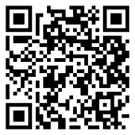 Android: 