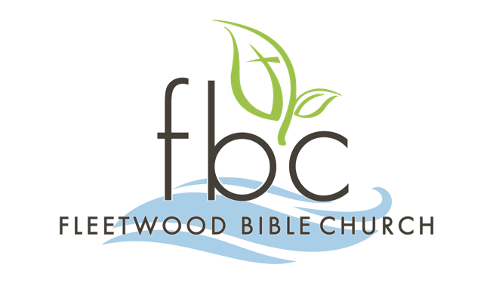 | Membership  Class  Schedule

Thank you for expressing interest in becoming a member of Fleetwood Bible Church. The process includes attending four (4) membership classes during the Sunday School hour that are offered during the Spring and Fall Sunday School quarters or one (1) three-hour class on a scheduled Saturday morning during the Summer and Winter quarters. See the Upcoming Calendar Dates listed below.

Please return two (2) pages (Application and Covenant) from this packet to the Office Mail Slot in the Coat Room by the application due date listed below and send a digital photo to office@fleetwoodbible.org
OR complete the FBC Church Membership Application form online at
https://fleetwoodbible.ccbchurch.com/goto/forms/200/responses/new
and return only the signed Covenant to the Office Mail Slot in the Coat Room.

You will receive notification from an Elder or the FBC Office concerning Elder interviews and membership approval along with a request for a digital photo if not yet received, Please send your digital photo to office@fleetwoodbible.org ASAP. This photo will be used for the power point presentation during the Sunday morning services on the scheduled presentation Sunday listed below and might also be used to update your fbcLINK profile page for subsequent directory printings.

UPCOMING CALENDAR DATES – 2025 Winter/Spring

Saturday Three-Hour Session
February 8 (snow date: February 22) from 9am-12pm

Sunday School Sessions
March 2, 9, 16, 23 from 9:15-10:15am (snow date: March 30)

Application Due Date
Sunday, March 30

Baptism Dates
Sundays, May 25, July 6, August 31, & December 28
during 10:30am combined services

Elder Interview Dates (scheduled after App is received)
Sundays during the Sunday School hour or Tuesdays at 6:30pm

New Member Presentation
Sunday, May 4, during both services

Ministry Fair
Sunday, October 19, 2023

Please contact the church office if you have any questions or need additional information. Office Hours are Tuesdays – Fridays at 9:00am – 4:00pm.

FLEETWOOD BIBLE CHURCH
2847 Moselem Springs Road (Route 662)
Fleetwood, Pennsylvania 19522
(610) 944-9235 ext. 201
office@fleetwoodbible.org • www.fleetwoodbible.org

