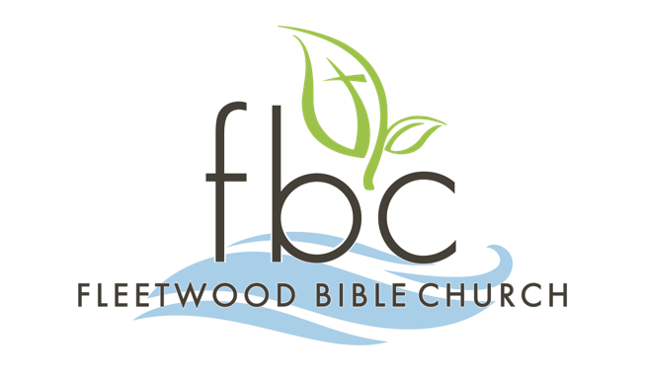 | Membership  Class  Schedule

Thank you for expressing interest in becoming a member of Fleetwood Bible Church. The process includes attending four (4) membership classes during the Sunday School hour that are offered during the Spring and Fall Sunday School quarters or one (1) three-hour class on a scheduled Saturday morning during the Summer and Winter quarters. See the upcoming calendar dates listed below.

Please return three (3) pages (Application, Covenant, and Ministry Team Opportunities) from this packet to the church office or submit the Covenant
to the Office and complete the online form located in the fbcLINK at https://fleetwoodbible.ccbchurch.com/goto/forms/200/responses/new
by the application due date listed below.

You will receive notification from the FBC Office concerning Elder interview schedules. If you submit the paper application, please send a digital photo to office@fleetwoodbible.org. This photo will be used for the power point presentation during the Sunday morning services on the scheduled presentation to the congregation and might also be used to update your fbcLINK profile page.

UPCOMING CALENDAR DATES – 2025 Summer/Fall

Saturday Three-Hour Session
August 23 from 9 am-12 pm

Sunday School Sessions
September 7, 14, 21, & 28 from 9:15-10:15

Application Due Date
Sunday, October 5

Baptism Dates
Sundays, August 31, & December 28
during 10:30am combined services

Elder Interview Dates (scheduled after App is received)
Sundays during the Sunday School hour or Tuesdays at 6:30pm

New Member Presentation
Sunday, November 9, during both services

Ministry Fair
Sunday, October 19 during Sunday School hour

Please contact the church office if you have any questions or need additional information. Office Hours are Tuesdays – Fridays at 9:00am – 4:00pm

FLEETWOOD BIBLE CHURCH
2847 Moselem Springs Road (Route 662)
Fleetwood, Pennsylvania 19522
(610) 944-9235 ext. 201
office@fleetwoodbible.org • www.fleetwoodbible.org

