

Women 3:18 will be meeting September 8th this month. Come find belonging. We dive into God’s word and apply it to our lives together and surround each other in prayer. Our next meeting will be in the fellowship hall on 11.10..26 @ 11:00 AM.



Proverbs 31 Women is an opportunity for all women to come and experience the grace of God and community. This women's group focuses primarily on young women with families; but, all are invited. This month we will help with OCC packing instead of meeting – 11.15.26.



Men, we have a chance to gather together for a great breakfast and great message. We hope you can join us. We are not meant to do this life alone. Come find community with other men who are on the journey of following Christ. Our next meeting will be 11.15.26 @ 8:30 AM.

OPPORTUNITIES FOR SERVICE:

Global



11.15.26

Operation Christmas Child packing night: We will pack all supplies that have been donated throughout this year and shoeboxes will be mailed the following week. We will start packing at 5:00 PM. Come help start the Christmas season with blessing others.

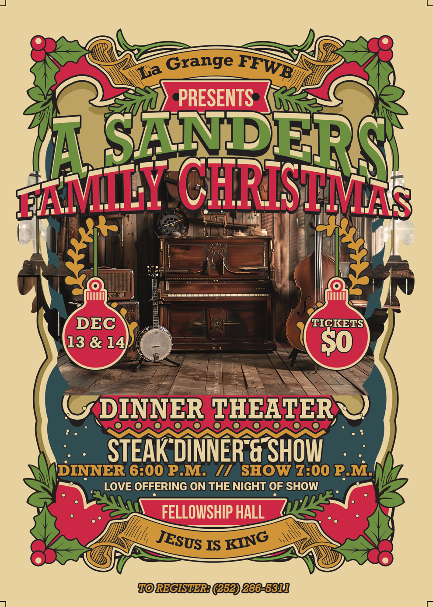

Our dinner theater this year will be

A Sander's Family Christmas.

Prepare to come and receive a blessing this season. Tickets available by contacting

Tiffany Creech – see above flyer.



The CRIB provides a safe place for Students to encounter Jesus week in and week out, and some for the very first time accept Him as Lord of their lives, which is nothing short of miraculous. We have food, games, and a whole lot of Jesus every Sunday night!

11.1.26 – NO CRIB (Homecoming Sunday)

11.15.26 – CRIBSGIVING CELEBRATION (5:00 – 7:30 PM)

11.21.26 – Christmas shopping trip to Southpoint Mall

(please contact David Ginn by November 14th if you plan to go)



The CRIB has a MIDWEEK opportunity every week for students to dive further into God’s word in a small group Bible Study setting. These moments take our faith further into what God has for our lives. We hope you or you student can come experience community in Jesus name!

11.4.26 @ 6:00p – MIDWEEK

11.11.26 @ 6:00p – MIDWEEK

11.18.26 @ 6:00p – MIDWEEK

11.25.26 – NO MIDWEEK



We all have battles we face. They can feel impossible. Join us as we take a deep dive into the moment where God defeated Goliath and accomplished His purposes in Israel’s story. He will do the same for us!



Leviticus is a book most of us avoid if we’re honest. It’s a beautiful book that points us to Jesus. We are called to be holy because God is Holy. Through the cross what was began in Leviticus is brought to completion in our lives.



Each Sunday morning, the children have an introduction to the children's message in morning worship. They are dismissed prior to the sermon for children's church coordinated by Vicki Bannister. Kids meet each Sunday night for Bible study, games, recreation, refreshments and just a lot of fun! Our LGS Kids coordinator is Sheila Harrison assisted by Vicki Bannister, Marian Kennedy, Josh Hobgood and other parents.

10.25.26 – Family Fun Night (5:00p)

11.1.26 – NO Kids Ministry (Homecoming Sunday)

11.8.26 – Kids Ministry @ 6:00p

11.15.26 – OCC Packing Night

OPPORTUNITIES FOR SERVICE:

Local/Community


Lantern Lighting Ceremony for the Town of La Grange We will be collecting empty gallon cartons to light the town this Christmas season. If you want to contribute containers, OR help with distribution, please contact Bruce and Vicki Bannister for information and time/location for event.

12.23.26/12.24.26



Who: Ages 18 - 25 (High School Seniors - College)
When: February 5-7
Link for More Info: www.passion2027.com
Schedule:
Friday (5th):
6:00a // Depart for Passion
12:00p // Lunch on the Road
3:00p // Arrive at Hotel & Check-In
4:00p // Depart for Stadium
6:00p // Session 1
8:30p // Session 2
Saturday (6th):
8:15a // Depart for Stadium
10:00a // Session 3 (Lunch Provided)
1:00p // Session 4

3:00p // Session 5
4:30p // Break
7:30p // Session 6
Sunday (7th):
9:00a // Depart for Home
12:30p // Lunch on Road
5:00p // Arrive Home



In 2 Corinthians 8, Paul tells of the Macedonian churches who, "in a severe test of affliction," gave "beyond their ability," not because they had plenty, but because grace had taken hold of them. Verse 5 says it best: "they gave themselves first to the Lord." That's the heart of Beyond Sunday. Before it's about a gift, it's about ourselves — given fully to Him. Let that same grace move you to go beyond: beyond your comfort in prayer, seeking Him for what's next for our church; beyond your routine in giving, trusting Him with your finances the way the Macedonians did, out of joy rather than obligation; and beyond your schedule in time, showing up to serve where He's placed you. Paul reminds us in verse 9 that Christ, "though he was rich, yet for your sakes he became poor, so that you by his poverty might become rich." Everything we give beyond is simply a response to what He's already given beyond measure on the cross. Where is grace calling you to go beyond today?
Take-Home Challenge: Pray for our church. Pray that Jesus would lead us as individuals into that beyond but also that we as a church could see beyond our four walls and into the future He has for us.
Giving Opportunities:
- Weekly Tithe & Offering (Tithing Boxes @ Back or Online)
- Faith Promise Giving
  - Place Faith Promise giving cards in the tithing boxes @ back of Sanctuary or give to Angela Taylor & DeeAnn Maready (Church Treasurers)
CRIB Ministry
The Lord has done incredible things through our CRIB ministry. Students encounter Jesus week in and week out, and some for the very first time accept Him as Lord of their lives, which is nothing short of miraculous. We are still in the process of paying for this facility and are so thankful that we are all partnered together to make this happen. We hope everyone will take an opportunity to visit the CRIB to see the lives being changed through this ministry. Make this ministry an item of prayer, and prayerfully a place to give from your heart. Jesus is elevated one heart at the time through our CRIB ministry!

Next Beyond Sunday: 3.28.27 (Easter)

Amount Owed: $200,703.32 (As of 9/30/26)

Week at a Glance:

Tonight 1st:

NO EVENING SERVICES

Tuesday 3rd:

7:00p // Band Practice

Wednesday 4th:

6:00p // MIDWEEK (6th – College)

7:00p // Adult Bible Study

Sunday 8th:

9:45a // Sunday School

11:00a // Morning Worship

5:00p // Choir Practice

5:30p // CRIB

6:00p // Adult Bible Study

7:00p // Sander’s Family Practice

Upcoming Events:

11.7.26 - Veteran's Breakfast

11.15.26 - Packing night for OCC Christmas boxes

(CRIBSGIVING Meal following)

11.21.26. – Christmas shopping trip for teens/youth

12.13.26 – Sanders Family Christmas Dinner Theater

12.14.26 – Sanders Family Christmas Dinner Theater

12.20.26 - Church Christmas Party



11.1 Mary Gresham
11.2 Tyler Holmes
11.3 Braxton Holland
11.5 Cooper Roddy
11.6 Johnna Stroud
11.7 Robert Maready


PRAY FOR OUR VETERANS

This month we will be recognizing and honoring our veterans – those among us and across our nation. Our veterans have answered a call that demanded your time, your comfort, and your safety. You stood in the gap to protect the freedoms we enjoy today, including the very freedom we have to gather here in worship this morning.
Scripture tells us in John 15:13: 'Greater love has no nobler expression than this: that a man lay down his life for his friends.'
We see the reflection of that sacrificial love in the ways our veterans have served our country. Whether you served in times of peace or times of conflict, at home or on foreign soil, your sacrifice was real, and your dedication was absolute.
We also acknowledge the hidden sacrifices; the missed birthdays, the long months away from family, and the heavy burdens carried home. To the families of our veterans, we thank you for your strength and your shared sacrifice.
Church, let us never take our veterans for granted. Let us commit to supporting them, praying for them, and living lives worthy of the peace they secured for us. To all who served - We see you, we appreciate you, and we thank you for your service. May God bless you, and may God bless your families."
Please join us for a special service honoring our veterans on Sunday, November 8th @ 11:00 AM.

Deacon of the Month – Jimmy Jones
November

Greeters/Ushers for Worship
 | Sanctuary | Gathering Hall
1 | Bruce Bannister | Chris Roddy Family
8 | Carolyn Massengill | Ted Harrison Family
15 | Kendrick Harrison, Jr. | Tony Parrish
22 | Laura Eason | Westbrook Family
29 | Mary Gresham | Wilbur Taylor Family

Candlelighters
1 | Finn Bannister | 8 | Hutton & Holland Smith
15 | Lela Wade | 22 | Madi Herring
29 | Anne Matchett & Fletcher Cox

Kid’s Church
1 | NO KIDS CHURCH | 8 | Carolyn Massengill/Christie Welheim
15 | Laura Eason/Christie Westbrook | 22 | Bonnie Kornegay/DeeAnn Maready
29 | Sharon Baird/Anna Baird

Church Nursery
1 | Asa & Tiffany Creech | 8 | John & Ashley Kennamer
15 | Mike & Kendra Sullivan | 22 | Guy & Janet Hines
29 | Frederick & Stacie Smith

Worship Host
1 | Anna Baird | 8 | Brad Hunter
15 | Jamie Ham | 22 | Jennifer Sutton
29 | Vicki Bannister

Pro-Presenter Sanctuary
1 | Heather Ham | 8 | Janet Hines
15 | Olivia Sutton | 22 | Maura Ham
29 | Heather Ham

Pro-Presenter CRIB
1 | NO CRIB | 8 | Heather Ham
15 | CRIBSGIVING | 22 | NO CRIB
29 | NO CRIB

Pro-Presenter Wednesday
4 | Vicki Bannister | 11 | Marian Kennedy
18 | Vicki Bannister | 25 | Marian Kennedy
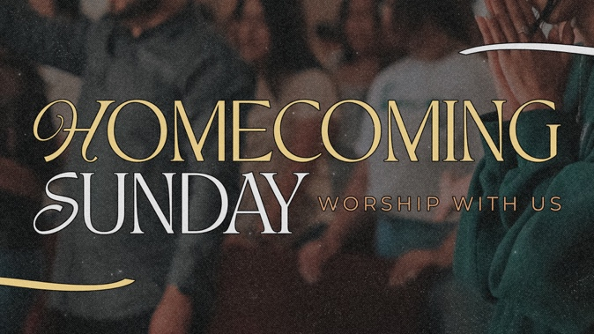
This week we celebrate a special day dedicated to looking back with gratitude and looking forward with faith. Homecoming is more than just a date on our church calendar; it is a family reunion. It is a time when we open our doors wide to welcome back old friends, former members, and those who may have been away for a season. Whether you have been a part of this church family for decades, or you are stepping through our doors for the very first time, you are a vital part of this celebration.
Scripture reminds us in Psalm 100:5, 'For the Lord is good; his steadfast love endures forever, and his faithfulness to all generations.' Our services now are a living testament to that generational faithfulness.
Homecoming isn't just about celebrating our history—it is about renewing our fellowship. It is about catching up over shared meals and strengthening the bonds of our church family.
We pray that this week’s service refreshes your spirit, restores your joy, and reminds you that no matter where life takes you, you always have a home here.

Upcoming Messages:
11.8.26 – The God Who Provides
11.15.26 – The Power of the Table
11.22.26 – Overflowing Generosity

Upcoming Scriptures:
11.8.26 – Matthew 6:25-34
11.15.26 – Hebrews 13:2. Luke 14:12-24, Romans 12:!3
11.22.26 – Proverbs 11:24-25, Malachi 3:10, Luke 6:38




La Grange 1st FWB Church LaGrange1stFWB LaGrange1stFWB

www.lagrangefwb.org
Worship & Celebration

The Lord’s Day • November 1, 2026 • Eleven O’clock

Preparation for Worship Musician

Welcome & Prayer Pastor

Worship “Holy, Holy, Holy”,“I Know A Name”

Hosting Anna Baird
Welcome
Time of Fellowship
Announcements
Scripture Reading – James 1:16-18
Giving Moment 2 Corinthians 9:7 NIV

Tithes and Offering Boxes – Back of Sanctuary

Kids Message Laity

Homecoming Remembrance Pastor

Morning Prayer Matthew 6:9-10 NIV

Special: “Angel Armies/Awesome God”

Message: John 3:1-18 “New Birth”

Altar Call: “Good, Good, Father”
Altar Prayer & Benediction: Anna Baird

Following worship today we will serve lunch in the Fellowship Hall. Please join us! Your presence matters!

Sermon Notes:

John 3:1-18 – New Birth



PRAISE…
For Jesus the Name above all other names.
SALVATION & RENEWAL…
The lost of the world and for workers in the field., Persecuted Christians, all Christians, and Revival in the church.
SYMPATHY, FAMILY OF: Trish Tanner (Fran Gibbons), Andew Brokes killed in Line of Duty, Carly Humphrey, Jason Spencer, Phyllis Harrison, Russ Prys, Martin Simonds (Marty Hobgood)
SICK…
Maverick Allen, Erika Allison (Fran Gibbons), Debbie Alston (Herring Family) Bill Armitage (Ronnie’s uncle) Bruce Bannister, Linda Block, Mark Blount, Penny Braswell, Cassie Buck (Harrison Family) Ray Brosseau (Carol Hardison), Valerie Bryan (Bannister’s), Peggy Clifton (Kendra Sullivan), Scott Cody, Ricky Cole, Karen Cook, Luke Corbett (Lucille Harrison, Ed Craig (Hobgood) Pat & Darlene Creech, Rhonda Davis, Marie Deans (Ivan Braswell Family) Gerri Deaver (Shivar) Charles Evans (Gary Taylor), Henry Edwards, Jamie Edmundson (Carl Hinson’s nephew) Anna Brook Fuller (Baird Family) Judy Gray, Heather Hardison, Mike Hardison, Neal Hardison, Chris Hardison, Cliff Hardison, Barrett Harrison (Carrie/Travis) Dennis Harrison, Frank Harrison, Lucille Harrison, Mark Hartman (Shivar family) Carol Henderson, Elvin Herring, Paul Herring (Nelson & Susie Harrison), Sherrie Herring, Danny Hill, Carl Hinson, Gracelyn Hobbs, Gerald Holmes, Elsie Holmes, Kim House (Kendra Sullivan), Dwight Howard (Brad Taylor), Megan Ingram, Dean Johnson, David Jones, Frankie Jones, Kevin Keel (Shivar Family) , Elizabeth Kenny (David Ginn), Max Killette (Killette Family), Billy Kilpatrick, Remi Lopez (Carrie Harrison) Greta Ruth MacEachern, Beal Marsden (Carrie Harrison) McGinnis Family (Mission Trip), Carolyn Massengill, Jack May (Spivey Family), Dallas Mayberry, Shirley Metts (Janet Hines), Tara Minder (Bonnie), Ginny Moody, Adelene Grace Moore, Tammy Moore, Cole Morris (Sandra Rouse) Austin Mozingo, Jimmy Newman, Angie Partin, Len Poole (Lucille Harrison) Wallace & Faye Pope, Kennedee Reimers, Emzy Rock (Sandra Rouse), Crissy Rouse, Julie Rouse, Crystal Ryan, Nancy Sauls, Joette Sessoms (Shelia Harrison), Elaine Shepherd (Rachael Thompson) Beth Shirley (KJ Harrison) Lee Spivey, Sherwood Shivar, Donald Stroud (Cleo Hinson Family) Kerri Stroud (Friend of Emily Daniels, Bailey Suggs, Dallas Sutton, Glen Stalnaker, J. J. Sutton, Gary & Jackie Taylor, Michelle Taylor, Nathan TerMeer (Jennifer Sutton) Tammy Thompson (Spivey) Tom & Kathryn Thutt (Carol Hardison), Maddison Troyer, Mike Turner, Pat Turner (Stepmother of Laura Eason),Greg Turner (Laura Eason) Tom Turner (Laura Eason), Mayor Weeks (Janet/Boo Hines), Connie Weyant (Ernie & Linda Spivey), Beverly Wiggins, Miranda Wiggins (Kendra Sullivan) Christi Wilheim, Tracy Zacharzuk (Sara Hobgood), Carol Zimmerman. An unspoken prayer.
ASSISTED LIVING & HOMEBOUND…
Barbara Corbett (Cherry Point Bay), Edna Johnson, Esther Flowers, Betty Pelt (Brookdale) Angie Herring (Magnolia)
CHURCH / DENOMINATIONAL & OUTREACH …
First Church, Pastor, Youth Director, Deacons, Sunday School Leaders/Teachers, College Students, Convention of Original FWB, CRIB Youth, Denominational Ministries, Rev. Dr. Ricky Warren (Convention President), Rev. Dr. Dustin Bannister (Director of Church Planting & Renewal), Rev. Donald Fader (Director of Church Finance), Disaster Relief (Cragmont Assembly).
SPECIAL REQUEST: E.J. and brother – complications from Covid and leukemia.
MILITARY…Rob Bittner (Service/Sara Hobgood), Nick Cornatzer (Holmes Family – deploying this week with Marines), Alex Ferrell (Bethany Jones, he is deployed to Middle East Aug 2026) Rev. Richard Holmes (OFWB Chaplain), Emily Johnson (Army), Jason Nipple (Wade family), Tyler Proctor (Navy/ Elsie Holmes), Joshua Ryan (USAF). Jami Sutton (Navy/Angela Taylor), & Austin Tyner (Navy/Elsie Holmes).
LA GRANGE/LENOIR COUNTY… Mayor Bobby Wooten, Town Commissioners, County Commissioners, County & Private Schools, and Lenoir Community College. The countries of Israel & Ukraine.
OUR COMMUNITY, NATION, & WORLD…
US: President Donald Trump, Vice-President J. D. Vance, Cabinet, Congress, and the Supreme Court NC: Governor Josh Stein, NC Senators and NC Representatives.




802 S. Caswell Street • La Grange, N.C.

Josh Hobgood - Pastor

