Worship & Celebration

The Lord’s Day • March 29, 2026 • Eleven O’clock

That which was from the beginning, which we have heard, which we have seen with our eyes, which we have looked at and our hands have touched—this we proclaim concerning the Word of life. – 1 John 1

Call To Worship Processional “Majesty”

Invocation Pastor

Worship “Come, Thou Almighty King” “Glorify Thy Name”
Time of Fellowship

Hosting Kim Hipkiss
Welcome
Scripture Reading – John 12:12-19
Announcements
Giving Moment Luke 6:38 NIV
" ³⁸ Give, and it will be given to you. A good measure, pressed down, shaken together and running over, will be poured into your lap. For with the measure you use, it will be measured to you.”

Tithes and Offering Boxes – Back of Sanctuary

Kids Message Laity

Kids Special “What A Beautiful Name”

Morning Prayer 1 John 5:14-15 NIV
^{14”} This is the confidence we have in approaching God: that if we ask anything according to his will, he hears us. ¹⁵And if we know that he hears us—whatever we ask—we know that we have what we asked of him.”

Special: “Jesus, Save Us, Lord”
(Kids Dismissed to Kids Worship)

Message: “Father, Glorify Your Name” John 12:20-36

Response/Altar Call: “King of Kings”
Benediction Pastor

Postlude Musicians
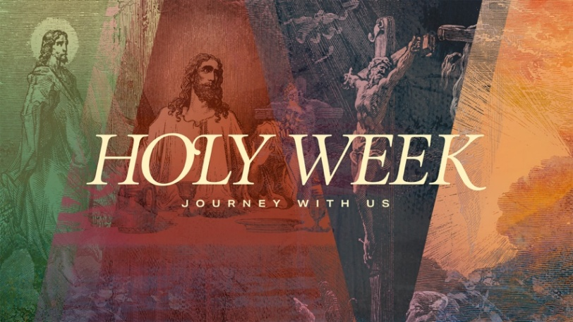

Holy week is a special time in the life of the Church around the world and has started today with Palm Sunday as Jesus entered back into Jerusalem. The cross and resurrection are the pivotal moments in our story. In this moment Jesus chose us and defeated death, defeated sin, and restored us to Himself. It is the moment that defines our lives as Christians. We want to invite you to celebrate Jesus’ week leading up to the resurrection. Each moment offers us something unique to reflect on and hopefully challenges us to draw closer to name above every name, Jesus Christ.

Series Dates:
4.2.26 – Maundy Thursday (Fellowship Hall) @ 7 PM
4.3.26 – Good Friday (Sanctuary) @ 7 PM
4.4.26 – Kids Easter Celebration & Egg Hunt (Fellowship Hall) @ 10 AM
4.5.26 – Easter Sunday Worship Service (Sanctuary)

Scriptures:
4.2.26 – John 16:16-33
4.3.26 – John 18:1-19:42
4.4.26 – Luke 24:1-12
4.5.26 – John 20:1-31



La Grange 1st FWB Church LaGrange1stFWB LaGrange1stFWB

www.lagrangefwb.org



April 2026

Deacon of the Month – Carter Daniels

Greeters for Worship
SANCTUARY | GATHERING HALL
5 – Sue Shivar | 5 – James Sutton Family
12 – Bobby Wadsworth | 12 – Jernigan Family
19 – Sue Shivar | 19 – Joey Sutton Family
26 – Brian Jones | 26 – Justin and Madison Hardy

Candlelighters
5 – Benjamin Carroll | 12 – James & Allie Wooten
19 – Griffin & Marley Daniels | 26 – Declan & Finn Bannister

Children’s Church
5 – Tara & Ryan Carroll | 12 – Tiffany & Asa Creech
19 – Vicki Bannister & Stacie Smith | 26 – Sheila & Ted Harrison

Nursery
5 - Asa & Tiffany Creech | 12 - Sharon Baird & Kim Fields
19 - Danielle & Declan Bannister | 26 - Tara & Ryan Carroll

Pro-Presenter Teams
5 – Olivia Sutton | 12 – Maura Ham
19 – Heather Ham | 26 – Janet Hines



802 S. Caswell Street • La Grange, N.C.

Josh Hobgood - Pastor

