Worship & Celebration

The Lord’s Day • March 8, 2026 • Eleven O’clock
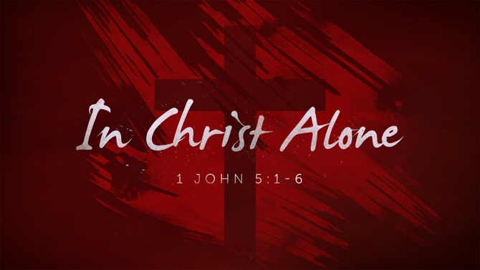

That which was from the beginning, which we have heard, which we have seen with our eyes, which we have looked at and our hands have touched—this we proclaim concerning the Word of life. – 1 John 1

Preparation For Worship Pastor

Call To Worship
" I proclaim your saving acts in the great assembly;
I do not seal my lips, Lord, as you know.” – Psalm 40:9

Invocation Pastor

Worship “Holy Forever”/”Give Me Jesus”
Time of Fellowship

Hosting Ted Harrison
Welcome
Scripture Reading – Psalm 119:36-37
Announcements
Giving Moment Luke 6:38 NIV
" ³⁸ Give, and it will be given to you. A good measure, pressed down, shaken together and running over, will be poured into your lap. For with the measure you use, it will be measured to you.”

Tithes and Offering Boxes – Back of Sanctuary

Kids Message Laity

Morning Prayer 1 John 5:14-15 NIV
^{14”} This is the confidence we have in approaching God: that if we ask anything according to his will, he hears us. ¹⁵And if we know that he hears us—whatever we ask—we know that we have what we asked of him.”

Special: “At His Name”
(Kids Dismissed to Kids Worship)

Message: “Love God, Not the World” 1 John 2:15-17

Response/Altar Call: “Turn Your Eyes Upon Jesus”
Benediction Pastor

Postlude Musicians


We HOPE you are hearing God speak to you and your family as we journey through 1 John. There is still plenty God has for us in the coming weeks. If you need to catch up or missed a week, check out past messages online on YouTube, Facebook, or our church app. Pray that the Holy Spirit would reveal to all of us the condition of our faith and the condition of hearts. Jesus alone is worthy of both! We love you!
Series Dates:
3.15.2026 - Deception & The Truth of Jesus
3.22.2026 – Matthew Grubbs: Cragmont
3.29. 2026 - Destroying Sin
Scriptures:
3.15.2026 - 1 John 2:18-29
3.22.2026 – TBD
3.29. 2026 - 1 John 2:28-3:10




La Grange 1st FWB Church LaGrange1stFWB LaGrange1stFWB

www.lagrangefwb.org

PRAISE…
For Jesus the Name above all other names.
SALVATION & RENEWAL…
The lost of the world and for workers in the field., Persecuted Christians, all Christians, and Revival in the church.
SYMPATHY…
The Family of Vernon Sorrell; The Family of Elaine Tyndall; The Family of Gary Radford.
RECOVERING…
SICK…
Maverick Allen, Erika Allison (Fran Gibbons), Jerry Barr, Shirley Bedford (Linda Spivey), Mike Bridwell (Linda Spivey), Ray Brosseau (Carol Haridson), Janice Corbett Williams, Luke Corbett, Cotton Family, Margaret Creech, Pat & Darlene Creech, Mr. Daniels (Carter’s father), Henry Edwards, Krew Ginn (Brent Herring), Judy Gray, Jay Greenway (Father of Crystal Ryan), Owen Hales (Jessica Hobgood Moss), Neal Hardison, Chris Hardison, Cliff Hardison, Donnie Harrison, Janie Beth Harrison, Carrie Harrison, Theo & Barrett Harrison, Joyce Heath, Carrol Henderson, Elvin Herring, Paul Herring (Nelson & Susie Harrison), Danny Hill, Remi Hill (Ann Burke), Gracelyn Hobbs, Gerald Holmes, Carly Humphrey, Megan Ingram, Jimmy Jones, Edna Johnson, Frankie Jones, Elizabeth Kenny (David Ginn), Ann Kennedy, Leona LeNeave (Mother of Bethany Jones), Jan-Blaise MacEachern, Christy Mobley, Tammy Moore, Larry Mann (Mary Gresham), Rod Minder (Bonnie), Ginny Moody, Austin Mozingo, Heather Myers (Cleo/Chris), Jimmy Newman, Judy Parrott, Angie Partin, Gene Roddy, Sandy Rogers, Thomas Rouse, Nancy Sauls, Bruton Sowers (Baird family), Ernie Spivery, Vicki Stafford (Linda Spivey), Rusty & K. J. Strong (Sue Shivar), Donald Stroud, Kerri Stroud (Friend of Emily Daniels), Yvonne Stroud, J. J. Sutton, Trish Tanner (Sister/Fran Gibbons), Gary Taylor, Jackie Taylor, Michelle Taylor, Tom & Kathryn Thutt (Carol Hardison), Maddison Troyer, Mike Turner, Pat Turner (Stepmother of Laura Eason), Tom Turner (Laura Eason), Blair Umphlett (Hobgood’s), Paulette Wade, Linda Watson, Connie Weyant (Ernie & Linda Spivey), Tony White, Peggy Williamson (Gary & Jackie Taylor), Worswick Family (Crystal Ryan), Tracy Zacharzuk (Sara Hobgood), Carol Zimmerman.
ASSISTED LIVING & HOMEBOUND…
Barbara Corbett (Cherry Point Bay), Esther Flowers, Betty Pelt (Brookdale)
CHURCH / DENOMINATIONAL & OUTREACH …
First Church, Pastor, Youth Pastor, Deacons, Sunday School Leaders/Teachers, College Students, Convention of Original FWB, CRIB Youth, Denominational Ministries, Rev. Dr. Ricky Warren (Convention President), Rev. Dr. Dustin Bannister (Director of Church Planting & Renewal), Rev. Donald Fader (Director of Church Finance), Disaster Relief (Cragmont Assembly), Rev. Chris Singleton, (Missions).
SPECIAL REQUESTS…
MILITARY…
Rob Bittner (Service/Sara Hobgood), Nick Cornatzer (Marines / Holmes family), Rev. Richard Holmes (OFWB Chaplain), Emily Johnson (Army), Jason Nipple (Wade family), Tyler Proctor (Navy/ Elsie Holmes), Joshua Ryan (USAF). Jami Sutton (Navy/Angela Taylor), & Austin Tyner (Navy/Elsie Holmes).
LA GRANGE/LENOIR COUNTY… Mayor Bobby Wooten, Town Commissioners, County Commissioners, County & Private Schools, and Lenoir Community College. The countries of Israel & Ukraine.
OUR COMMUNITY, NATION, & WORLD…
US: President Donald Trump, Vice-President J. D. Vance, Cabinet, Congress, and the Supreme Court NC: Governor Josh Stein, NC Senators and NC Representatives.





802 S. Caswell Street • La Grange, N.C.

Josh Hobgood - Pastor

