Worship & Celebration

The Lord’s Day • April 12, 2026 • Eleven O’clock

That which was from the beginning, which we have heard, which we have seen with our eyes, which we have looked at and our hands have touched—this we proclaim concerning the Word of life. – 1 John 1

Preparation for Worship Musician

Invocation Pastor

Call To Worship Psalm 33 Video

Worship “Victory in Jesus”/“Worthy of Your Name”
Time of Fellowship

Hosting Anna Baird
Welcome
Announcements
Scripture Reading – Romans 6:14, Galatians 5:16
Giving Moment 1 John 3:17 NIV
"If anyone has material possessions and sees a brother or sister in need but has no pity on them, how can the love of God be in that person?"

Tithes and Offering Boxes – Back of Sanctuary

Kids Message Laity

Morning Prayer 1 John 5:14 NIV
¹⁴ This is the confidence we have in approaching God: that if we ask anything according to his will, he hears us.

Special: “The Old Rugged Cross Made the Difference”

(Kids Dismissed to Kids Worship)

Message: “Destroying Sin” 1 John 2:28-3:10

Altar Call: “Welcome the Healer”
Benediction Pastor

Postlude Musicians


Wow! What an amazing Holy Week! God spoke into our lives, called dry bones to life, and reminded us of his love and power. We are diving back into 1 John this week and in the coming weeks. What does it mean to have a real faith and how can we tell? Those are the questions this book tackles. Jesus is ready to speak to us. We would love for you and your family to continue journeying through this book with us. You don’t want to miss it! We hope to see you next week! Jesus has defeated the grave!

Series Dates:
4.19.2026 – Who Do You Belong To?
4.26.2026 – Belong To Jesus
5.3.2026 – Test The Spirits
5.10.2026 - “His Love Is Ours” - 1 John 4:7-21

Scriptures:
4.19.2026 – 1 John 3:11-24
4.26.2026 – 1 John 3:18-24
5.3.2026 – 1 John 4:1-6
5.10.2026 – 1 John 4:7-21



La Grange 1st FWB Church LaGrange1stFWB LaGrange1stFWB

www.lagrangefwb.org


April 2026

Deacon of the Month – Carter Daniels

Greeters for Worship
SANCTUARY | GATHERING HALL
5 – Sue Shivar | 5 – James Sutton Family
12 – Bobby Wadsworth | 12 – Jernigan Family
19 – Sue Shivar | 19 – Joey Sutton Family
26 – Brian Jones | 26 – Justin and Madison Hardy

Candlelighters
5 – Benjamin Carroll | 12 – James & Allie Wooten
19 – Griffin & Marley Daniels | 26 – Declan & Finn Bannister

Children’s Church
5 – Tara & Ryan Carroll | 12 – Tiffany & Asa Creech
19 – Vicki Bannister & Stacie Smith | 26 – Sheila & Ted Harrison

Nursery
5 - Asa & Tiffany Creech | 12 - Sharon Baird & Kim Fields
19 - Danielle & Declan Bannister | 26 - Tara & Ryan Carroll

Pro-Presenter Teams
5 – Olivia Sutton | 12 – Maura Ham
19 – Heather Ham | 26 – Janet Hines

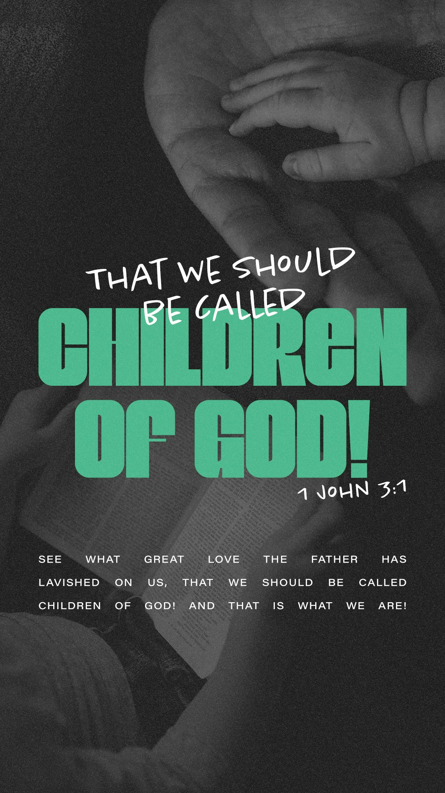



802 S. Caswell Street • La Grange, N.C.

Josh Hobgood - Pastor

