Worship & Celebration

The Lord’s Day • April 19, 2026 • Eleven O’clock

That which was from the beginning, which we have heard, which we have seen with our eyes, which we have looked at and our hands have touched—this we proclaim concerning the Word of life. – 1 John 1

Preparation for Worship Musician

Invocation Pastor

Call To Worship Colossians 3:16
"Let the word of Christ dwell in you richly, teaching and admonishing one another in all wisdom, singing psalms and hymns and spiritual songs, with thankfulness in your hearts to God."

Worship “Trust & Obey”/“Good Good Father”
Time of Fellowship

Hosting David Letchworth
Welcome
Announcements
Scripture Reading – John 13:34-35
Giving Moment 1 John 3:17 NIV
"If anyone has material possessions and sees a brother or sister in need but has no pity on them, how can the love of God be in that person?"

Tithes and Offering Boxes – Back of Sanctuary

Kids Message Laity

Morning Prayer 1 John 5:14 NIV
¹⁴ This is the confidence we have in approaching God: that if we ask anything according to his will, he hears us.

Special: “In the Name of Love”
(Kids Dismissed to Kids Worship)

Message: “Love In Action” - 1 John 3:11-24

Altar Call: “They’ll Know We’re Christians By Our Love”
Benediction Pastor

Postlude Musicians
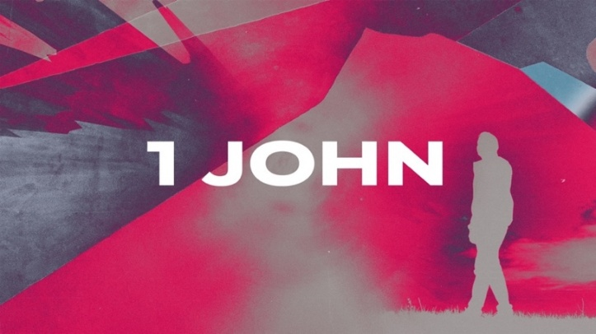

Loving like Jesus takes courage. We all know sometimes people can do things that tempt us to drop love and adopt hate. 1 John is calling us this week to put our love into action, even when it’s hard. For us to love, we must draw close to the source of that love, Jesus Himself. We pray our house at La Grange Free Will Baptist would be a house marked by the love of Christ in our community.

Series Dates:
4.26.2026 – Belong To Jesus
5.3.2026 – Test The Spirits
5.10.2026 – Mother’s Day
5.17.2026 - His Love Is Ours
Scriptures:
4.26.2026 – 1 John 3:18-24
5.3.2026 – 1 John 4:1-6
5.10.2026 – TBD
5.17.2026 - 1 John 4:7-21



La Grange 1st FWB Church LaGrange1stFWB LaGrange1stFWB

www.lagrangefwb.org


April 2026

Deacon of the Month – Carter Daniels

Greeters for Worship
SANCTUARY | GATHERING HALL
5 – Sue Shivar | 5 – James Sutton Family
12 – Bobby Wadsworth | 12 – Jernigan Family
19 – Sue Shivar | 19 – Joey Sutton Family
26 – Brian Jones | 26 – Justin and Madison Hardy

Candlelighters
5 – Benjamin Carroll | 12 – James & Allie Wooten
19 – Griffin & Marley Daniels | 26 – Declan & Finn Bannister

Children’s Church
5 – Tara & Ryan Carroll | 12 – Tiffany & Asa Creech
19 – Vicki Bannister & Stacie Smith | 26 – Sheila & Ted Harrison

Nursery
5 - Asa & Tiffany Creech | 12 - Sharon Baird & Kim Fields
19 - Danielle & Declan Bannister | 26 - Tara & Ryan Carroll

Pro-Presenter Teams
5 – Olivia Sutton | 12 – Maura Ham
19 – Heather Ham | 26 – Janet Hines

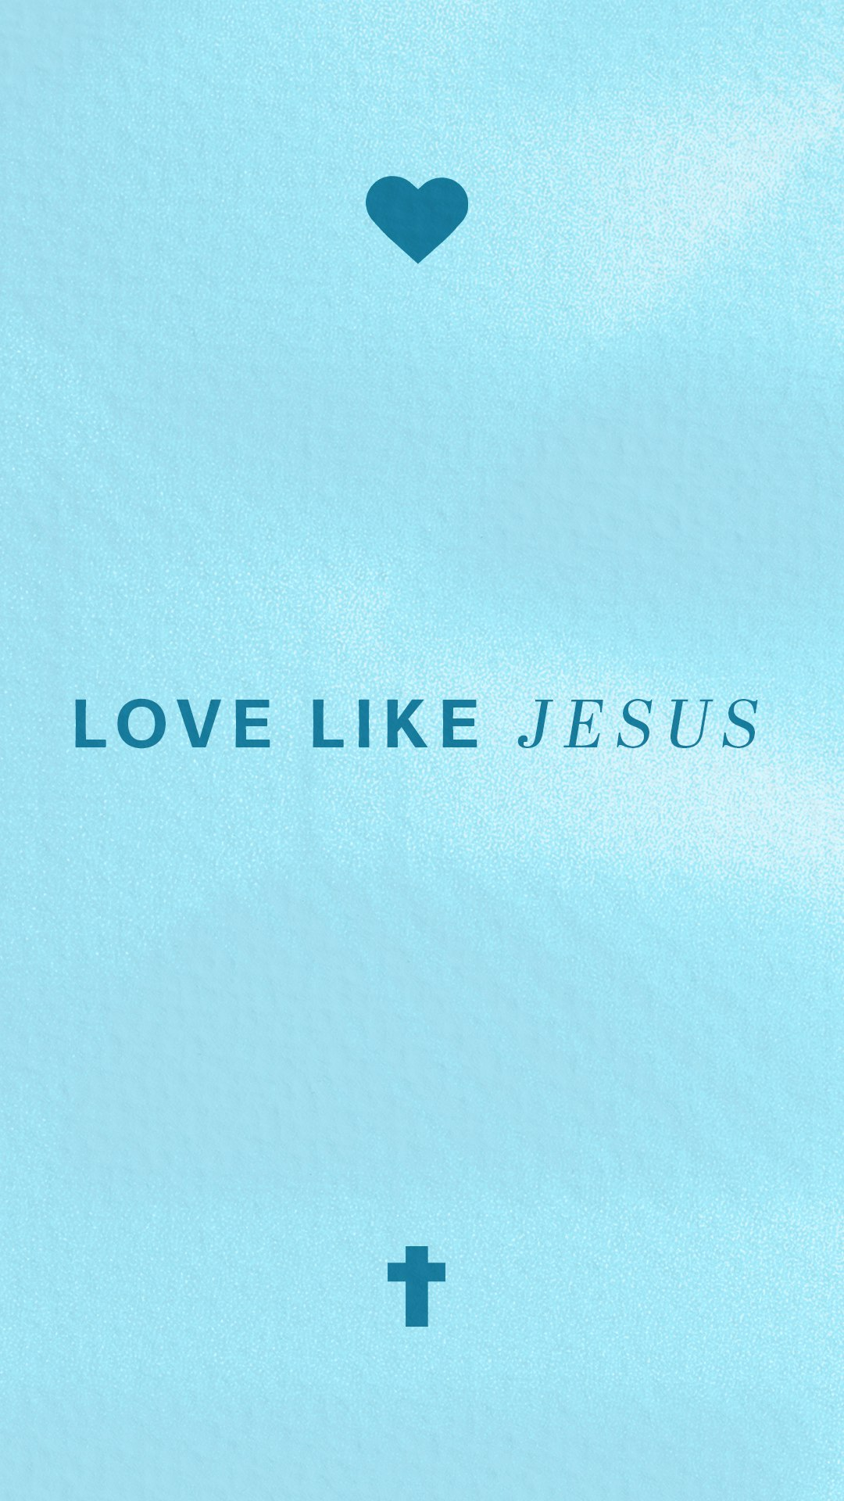



802 S. Caswell Street • La Grange, N.C.

Josh Hobgood - Pastor

