Worship & Celebration

The Lord’s Day • April 26, 2026 • Eleven O’clock
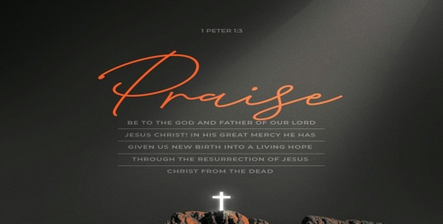
Dear children, let us not love with words or speech but with actions and in truth.– 1 John 3:18

Preparation for Worship Musician

Invocation Pastor

Call To Worship Psalm 63:1-5

Worship “Amazing Grace” “One Thing”
Time of Fellowship

Hosting Jamie Ham
Welcome
Announcements
Scripture Reading – 2 Corinthians 5:17
Giving Moment 1 John 3:17 NIV
"If anyone has material possessions and sees a brother or sister in need but has no pity on them, how can the love of God be in that person?"

Tithes and Offering Boxes – Back of Sanctuary

Kids Message Laity

Morning Prayer 1 John 5:14 NIV
^{14 "}This is the confidence we have in approaching God: that if we ask anything according to his will, he hears us."

Special: Sara Hobgood
(Kids Dismissed to Kids Worship)

Message: “Know You’re His” - 1 John 3:18-24

Altar Call: “Made for More”
Benediction Pastor

Postlude Musicians


Praise Jesus we are made for more. Jesus doesn’t leave us where we are. He calls us constantly to Himself and is always at work in our hearts making us a new creation. Jesus gives us His Spirit to live out lives that glorify His name. We are seeing God move in the hearts of His people at La Grange First Free Will Baptist. You have a role in the story of God. We are excited to see all that God will do in and through His people. Know we are praying for you. Live courageously, in Jesus name, for His glory!

Series Dates:
5.3.2026 – Test The Spirits
5.10.2026 – Mother’s Day
5.17.2026 - His Love Is Ours
5.24.2026 – Real Faith

Scriptures:
5.3.2026 – 1 John 4:1-6
5.10.2026 – TBD
5.17.2026 - 1 John 4:7-21
5.24.2026 – 1 John 5:1-12



La Grange 1st FWB Church LaGrange1stFWB LaGrange1stFWB

www.lagrangefwb.org


May 2026

Deacon of the Month – Randy Westbrook

Greeters for Worship
SANCTUARY | GATHERING HALL
3 - Bruce Bannister | 3 - Mike Sullivan Family
10 - Carolyn Massengill | 10 - Robie & Eloise Killette
17 - Kendrick Harrison, Jr. | 17 - Chris Roddy Family
24 - Laura Eason | 24 - Ted Harrison Family
31 - Mary Gresham | 31 - Tony Parrish

Candlelighters
3 - Hutton & Holland Smith | 10 - Lela Wade
17 - Madi Herring | 24 - Anne Matchett & Fletcher Cox
31 - Stella Killette

Children’s Church
3 - Carolyn Massengill/Christie Welheim | 10 - Laura Eason/Christie Westbrook
17 - Bonnie Kornegay/DeeAnn Maready | 24 - Kendra Sullivan/Anna Baird
31 - Emily Daniels/Katie Wooten

Nursery
3 - Guy & Janet Hines | 10 - Asa & Tiffany Creech
17 - Jennifer & Olivia Sutton | 24 - Mary Gresham/Bonnie Kornegay
31 - Sara Hobgood/Anna Baird

Pro-Presenter Teams
3 - Olivia Sutton | 10 – Maura Ham
17 – Heather Ham | 24 – Janet Hines
31 - Oliva Sutton

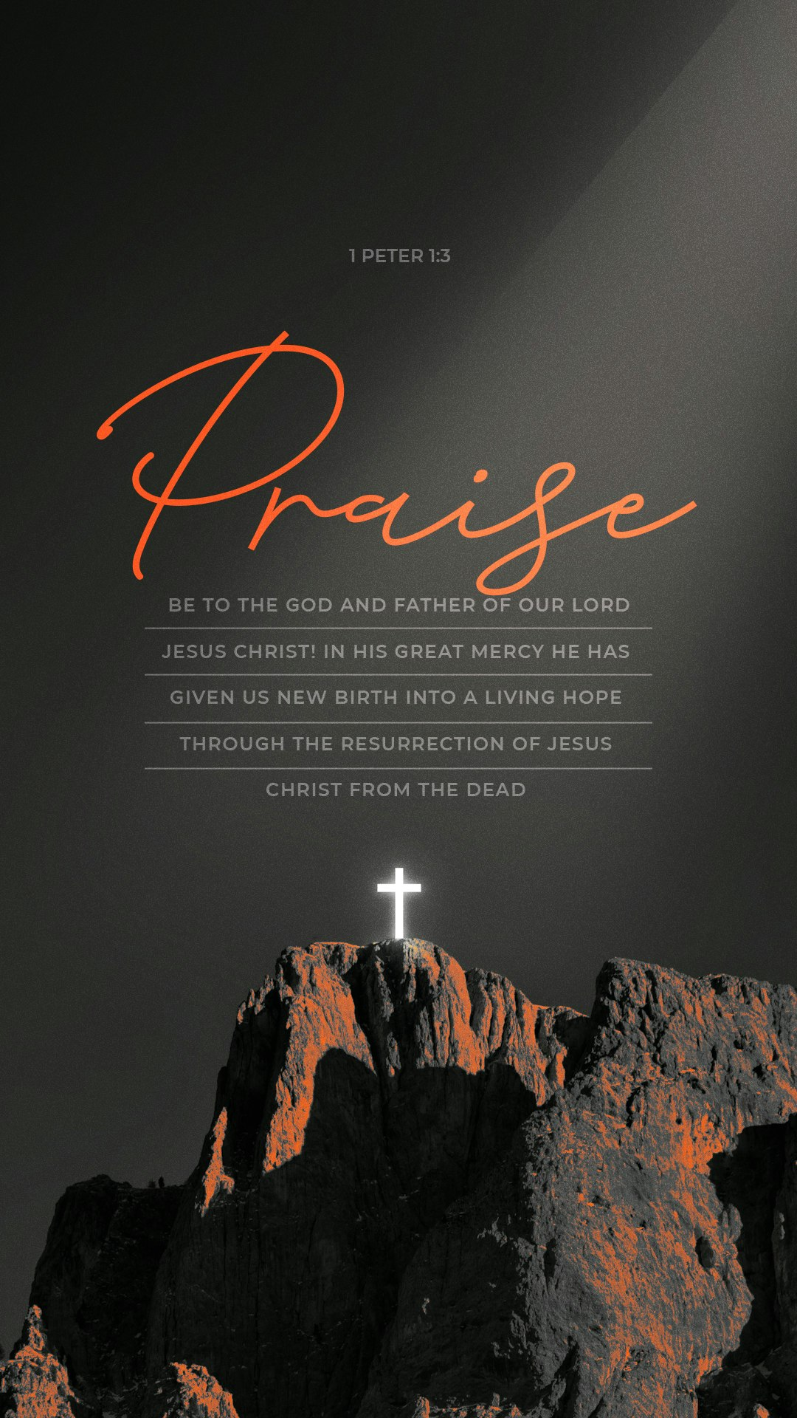



802 S. Caswell Street ~ La Grange, N.C. ~ Josh Hobgood, Pastor

