Worship & Celebration

The Lord’s Day • April 5, 2026 • Eleven O’clock
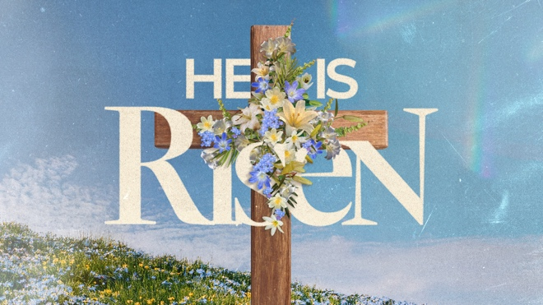
That which was from the beginning, which we have heard, which we have seen with our eyes, which we have looked at and our hands have touched—this we proclaim concerning the Word of life. – 1 John 1

Preparation for Worship Musician

Call To Worship “Christ the Lord Is Risen Today”

Invocation Pastor

Worship “He Lives” “I Know a Name”
Time of Fellowship

Hosting Ted Harrison
Welcome
Scripture Reading – Luke 24:1-12
Announcements
Giving Moment Mark 12:43-44 NIV
⁴³ Calling his disciples to him, Jesus said, “Truly I tell you, this poor widow has put more into the treasury than all the others.⁴⁴ They all gave out of their wealth; but she, out of her poverty, put in everything—all she had to live on.”

Tithes and Offering Boxes – Back of Sanctuary

Kids Message Laity

Morning Prayer John 17:1 NIV
After Jesus said this, he looked toward heaven and prayed:
“Father, the hour has come. Glorify your Son, that your Son may glorify
you.

Special: “Cornerstone”
(Kids Dismissed to Kids Worship)

Message: “That You May Believe” - John 20:1-31

Celebration: “Glorious Day”
Benediction Pastor

Postlude Musicians


We HOPE you have had an amazing week and time of worship this morning celebrating that we are redeemed through the finished work of Jesus Christ! We will be picking our 1 John series back up next Sunday. There is no better time to continue 1 John as we have just heard his account of Jesus’ Passion week. Now we have the opportunity to grow in our faith in a REAL relationship with Jesus. We hope to see you and your family next week! Jesus is King.

Series Dates:
4.12.2026 – Destroying Sin
4.19.2026 – Who Do You Belong To?
4.26.2026 – Belong To Jesus
5.3.2026 – Test The Spirits

Scriptures:
4.12.2026 – 1 John 2:28-3:10
4.19.2026 – 1 John 3:11-24
4.26.2026 – 1 John 4:1-16
5.3.2026 – 1 John 4:7-21



La Grange 1st FWB Church LaGrange1stFWB LaGrange1stFWB

www.lagrangefwb.org


April 2026

Deacon of the Month – Carter Daniels

Greeters for Worship
SANCTUARY | GATHERING HALL
5 – Sue Shivar | 5 – James Sutton Family
12 – Bobby Wadsworth | 12 – Jernigan Family
19 – Sue Shivar | 19 – Joey Sutton Family
26 – Brian Jones | 26 – Justin and Madison Hardy

Candlelighters
5 – Benjamin Carroll | 12 – James & Allie Wooten
19 – Griffin & Marley Daniels | 26 – Declan & Finn Bannister

Children’s Church
5 – Tara & Ryan Carroll | 12 – Tiffany & Asa Creech
19 – Vicki Bannister & Stacie Smith | 26 – Sheila & Ted Harrison

Nursery
5 - Asa & Tiffany Creech | 12 - Sharon Baird & Kim Fields
19 - Danielle & Declan Bannister | 26 - Tara & Ryan Carroll

Pro-Presenter Teams
5 – Olivia Sutton | 12 – Maura Ham
19 – Heather Ham | 26 – Janet Hines





802 S. Caswell Street • La Grange, N.C.

Josh Hobgood - Pastor

