Worship & Celebration

The Lord’s Day • May 17, 2026 • Eleven O’clock


Dear children, let us not love with words or speech but with actions and in truth. – 1 John 3:18

Preparation for Worship Musician

Invocation Pastor

Call To Worship
¹⁷ The Lord your God is with you, the Mighty Warrior who saves. He will take great delight in you; in his love he will no longer rebuke you, but will rejoice over you with singing.” – Zephaniah 3:17

Worship “My Jesus I Love Thee”/“Your Love Never Fails”
Hosting Anna Baird
Welcome
Time of Fellowship
Announcements
Mother’s Day Moment
Scripture Reading – Romans 8:38-39
Giving Moment Proverbs 11:24-25 NIV
""One person gives freely, yet gains even more; another withholds unduly, but comes to poverty. A generous person will prosper; whoever refreshes others will be refreshed."

Tithes and Offering Boxes – Back of Sanctuary

Kids Message Laity

Morning Prayer 1 Samuel 12:23 NIV
“As for me, far be it from me that I should sin against the Lord by failing to pray for you."

Special: "How Great is Our God"
(Kids Dismissed to Kids Worship)

Message: “Love Like No Other” – 1 John 4:7-21

Altar Call: “Amazing Love”
Closing/Benediction: Anna Baird

Postlude Musicians
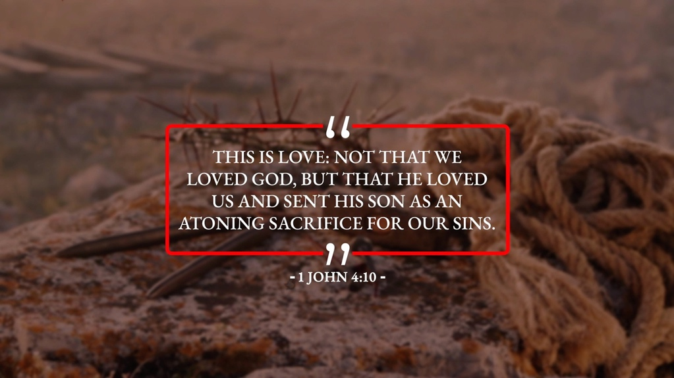

God IS love! Live it out! Enough said. We love you!

Series Dates:
5.24.2026 – Real Faith, 1 John 5:1-12
5.31.2026 - Finding Life, 1 John 5:11-13
6.7.2026 – Fighting Lies, 2 John 1
6.14.2026 – Do Some Good, 3 John 1




La Grange 1st FWB Church LaGrange1stFWB LaGrange1stFWB

www.lagrangefwb.org

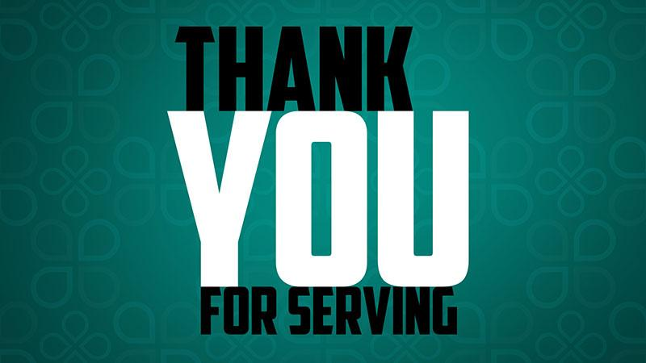
May 2026

Deacon of the Month – Randy Westbrook

Greeters for Worship
SANCTUARY | GATHERING HALL
17 - Kendrick Harrison, Jr. | 17 - Chris Roddy Family
24 - Laura Eason | 24 - Ted Harrison Family
31 - Mary Gresham | 31 - Tony Parrish

Candlelighters
10 - Lela Wade | 17 - Madi Herring
24 - Anne Matchett & Fletcher Cox | 31 - Stella Killette

Children’s Church
10 - Laura Eason/Christie Westbrook | 17 - Bonnie Kornegay/DeeAnn Maready
24 - Kendra Sullivan/Anna Baird | 31 - Emily Daniels/Katie Wooten

Nursery
10 - Asa & Tiffany Creech | 17 - Jennifer & Olivia Sutton
24 - Mary Gresham/Bonnie Kornegay | 31 - Sara Hobgood/Anna Baird

Pro-Presenter Teams
10 - Maura Ham | 17 - Heather Ham
24 - Janet Hines | 31 - Olivia Sutton

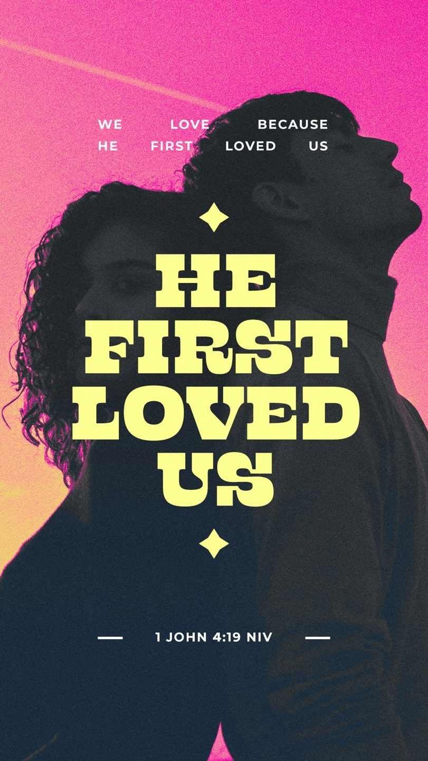

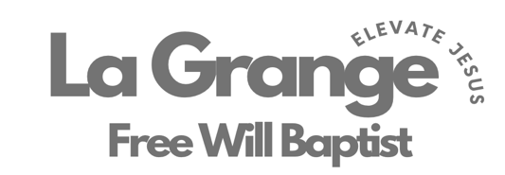

802 S. Caswell Street • La Grange, N.C.

Josh Hobgood - Pastor

