Worship & Celebration

The Lord’s Day • May 24, 2026 • Eleven O’clock

Dear children, let us not love with words or speech but with actions and in truth.– 1 John 3:18

Preparation for Worship Musician

Invocation Pastor

Call To Worship

Worship The Lord Will Provide, Bigger Than I Thought
Hosting Ted Harrison
Welcome
Time of Fellowship
Announcements
Scripture Reading – John 4:13-14
Giving Moment Proverbs 11:24-25 NIV
"One person gives freely, yet gains even more; another withholds unduly, but comes to poverty. A generous person will prosper; whoever refreshes others will be refreshed."

Tithes and Offering Boxes – Back of Sanctuary

Kids Message Laity

Morning Prayer 1 Samuel 12:23 NIV
“As for me, far be it from me that I should sin against the Lord by failing to pray for you."

Special: Goodness of God/Great is Thy Faithfulness
(Kids Dismissed To Kids Worship)

Message: Real Faith – 1 John 5:1-12

Altar Call: Turn Your Eyes Upon Jesus
Closing/Benediction: Ted Harrison

Postlude Musicians

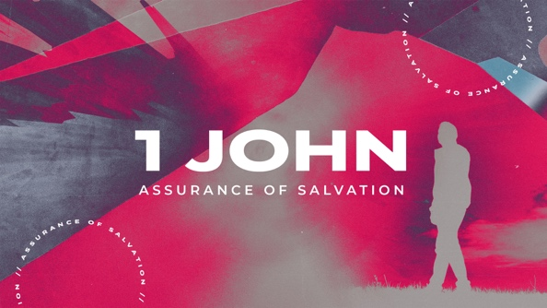

Series Dates:
5.31.2026 - Finding Life, 1 John 5:11-13
6.7.2026 – Fighting Lies, 2 John 1
6.14.2026 – Do Some Good, 3 John 1



Jesus didn’t just call disciples to Himself—He sent them out into the world. SENT is a 4-week series that explores what it means to be commissioned by Christ to carry His message, empowered by His Spirit, and compelled by His love. From the original twelve to the Church today, every believer is called to live on mission. La Grange needs God’s people on mission in this community. We are sent for the name and fame of JESUS.

Series Dates:
June 21, 2026 – Father's Day
June 28, 2026 – Sent 1
July 5, 2026 – Sent 2
July 12, 2026 – Sent 3
July 19, 2026 – Sent 4




La Grange 1st FWB Church LaGrange1stFWB LaGrange1stFWB

www.lagrangefwb.org



May 2026

Deacon of the Month – Randy Westbrook

Greeters for Worship
SANCTUARY | GATHERING HALL
24 - Laura Eason | 24 - Ted Harrison Family
31 - Mary Gresham | 31 - Tony Parrish

Candlelighters
24 - Anne Matchett & Fletcher Cox | 31 - Stella Killette

Children’s Church
24 - Kendra Sullivan/Anna Baird | 31 - Emily Daniels/Katie Wooten

Nursery
24 - Mary Gresham/Bonnie Kornegay | 31 - Sara Hobgood/Anna Baird

Pro-Presenter Teams
24 - Janet Hines | 31 - Olivia Sutton

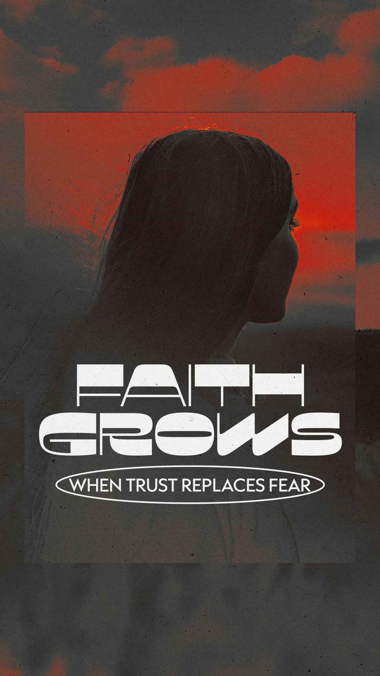



802 S. Caswell Street • La Grange, N.C.

Josh Hobgood - Pastor

