Worship & Celebration

The Lord’s Day • May 3, 2026 • Eleven O’clock
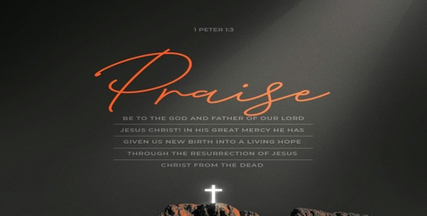
Dear children, let us not love with words or speech but with actions and in truth. – 1 John 3:18

Preparation for Worship Musician

Invocation Pastor

Call To Worship
"I am the bread of life. Whoever comes to me will never go hungry, and whoever believes in me will never be thirsty." – John 6:35

Worship “Holy, Holy, Holy”/“Goodness of God”
Hosting Kim Hipkiss
Welcome
Time of Fellowship
Announcements
Scripture Reading - Matthew 7:15-20
Giving Moment 1 John 3:17 NIV
"If anyone has material possessions and sees a brother or sister in need but has no pity on them, how can the love of God be in that person?"

Tithes and Offering Boxes – Back of Sanctuary

Kids Message Laity

Morning Prayer 1 John 5:14 NIV
¹⁴ This is the confidence we have in approaching God: that if we ask anything according to his will, he hears us.

Special: “Thy Word”
(Kids Dismissed to Kids Worship)

Message: “Test the Spirits” - 1 John 4:1-6

Altar Call: “I Speak Jesus”
Closing/Benediction: Kim Hipkiss

Postlude Musicians


God has been challenging us to take a close look at our hearts — to examine whether we truly believe Jesus Christ is who He says He is. And we are here to say: He is! As we near the end of 1 John, pray with us that Jesus would receive all the glory in our lives. He is worthy of our praise, our adoration, our work, our study, our marriages, our relationships, and everything in between. Jesus, we pray that You receive all the glory in La Grange First Free Will Baptist Church. Move in the hearts of Your people. Send us out as Your light in the darkness. Send us to live in freedom from sin. Send us to love our neighbors as ourselves. We trust You. You are enough. Amen!

Series Dates:
5.10.2026 – Mother’s Day
5.17.2026 - His Love Is Ours
5.24.2026 – Real Faith
5.31.2026 - Finding Life

Scriptures:
5.10.2026 – TBD
5.17.2026 - 1 John 4:7-21
5.24.2026 – 1 John 5:1-12
5.31.2026 – 1 John 5:11-13



La Grange 1st FWB Church LaGrange1stFWB LaGrange1stFWB

www.lagrangefwb.org


May 2026

Deacon of the Month – Randy Westbrook

Greeters for Worship
SANCTUARY | GATHERING HALL
3 - Bruce Bannister | 3 - Mike Sullivan Family
10 - Carolyn Massengill | 10 - Robie & Eloise Killette
17 - Kendrick Harrison, Jr. | 17 - Chris Roddy Family
24 - Laura Eason | 24 - Ted Harrison Family
31 - Mary Gresham | 31 - Tony Parrish

Candlelighters
3 - Hutton & Holland Smith | 10 - Lela Wade
17 - Madi Herring | 24 - Anne Matchett & Fletcher Cox
31 - Stella Killette

Children’s Church
3 - Carolyn Massengill/Christie Welheim | 10 - Laura Eason/Christie Westbrook
17 - Bonnie Kornegay/DeeAnn Maready | 24 - Kendra Sullivan/Anna Baird
31 - Emily Daniels/Katie Wooten

Nursery
3 - Guy & Janet Hines | 10 - Asa & Tiffany Creech
17 - Jennifer & Olivia Sutton | 24 - Mary Gresham/Bonnie Kornegay
31 - Sara Hobgood/Anna Baird

Pro-Presenter Teams
3 - Olivia Sutton | 10 – Maura Ham
17 – Heather Ham | 24 – Janet Hines
31 - Oliva Sutton





802 S. Caswell Street • La Grange, N.C.

Josh Hobgood - Pastor

