Worship & Celebration

The Lord’s Day • June 14, 2026 • Eleven O’clock
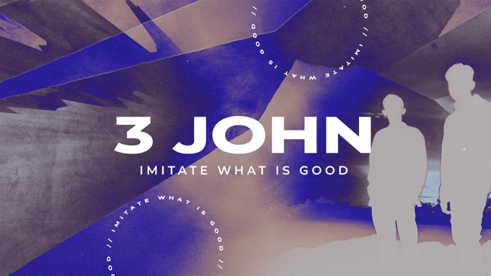
Preparation for Worship Musician

Welcome Pastor

Invocation Pastor

Call To Worship 3 John 1:4
"I have no greater joy than to hear that my children are walking in the truth."

Worship “Worthy of Your Name”/“I Know a Name”
Hosting Jennifer Sutton
Welcome
Time of Fellowship
Announcements
Scripture Reading – Ephesians 3:20-21
Giving Moment 2 Corinthians 9:7 NIV

"Each one must give as he has decided in his heart, not reluctantly or under compulsion, for God loves a cheerful giver."

Tithes and Offering Boxes – Back of Sanctuary

Kids Message Laity

Morning Prayer Lamentations 3:23-24 NIV
²² Because of the Lord’s great love we are not consumed, for his compassions never fail. ²³ They are new every morning; great is your faithfulness.

Special: "Go Light Your World"
(Kids Dismissed to Kids Worship)

Message: “Imitate What Is Good” - 3 John 1

Altar Call: “Way Maker”
Closing/Benediction: Jennifer Sutton
Postlude Musicians

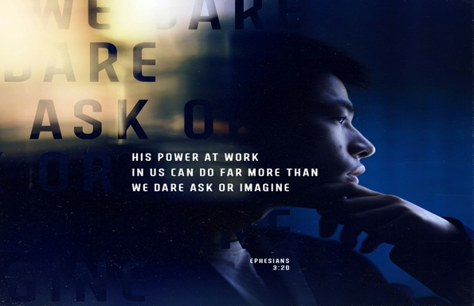
John wrote this brief letter to his friend Gaius, and its encouragement is timeless. He opens with a beautiful prayer: "I pray that you may prosper in all things and be in health, just as your soul prospers" (v. 2). God cares about your whole life, not just your spiritual health. At the heart of the letter is a simple call: walk in truth. John says there is no greater joy than hearing his children are doing exactly that (v. 4). Faithfulness in ordinary, daily things — serving, showing up, welcoming others — is what spiritual maturity looks like. Gaius is praised for his generous hospitality to traveling missionaries. By supporting them, he became a fellow worker in the gospel. Your faithfulness has a reach you may never fully see. Diotrephes stands as a warning: self-promotion and refusing to welcome others chokes out love. John's counsel is simple — "Do not imitate what is evil, but what is good" (v. 11). The takeaway: Be a Gaius. Walk in truth. Show up with open hands. The small acts of faithfulness that no one notices? God sees them — and they matter more than you know.

Series Dates:
6.21.2026 – No Longer Slaves
6.28.2026 – The Father’s Heart

Series Scriptures:
6.21.2026 – Philemon 1
6.28.2026 – John 3




La Grange 1st FWB Church LaGrange1stFWB LaGrange1stFWB

www.lagrangefwb.org



Vacation Bible School starts this Sunday night and continues until Thursday, June 18th. Register with link provided above. Supper is served at 5:30 PM and Bible School starts at 6:15 PM. We can’t wait to explore what God has in store for our week of Rainforest Falls fun!



Our Father’s Day celebration will be June 21st. Please come and help us celebrate the important men in the lives of our church family.

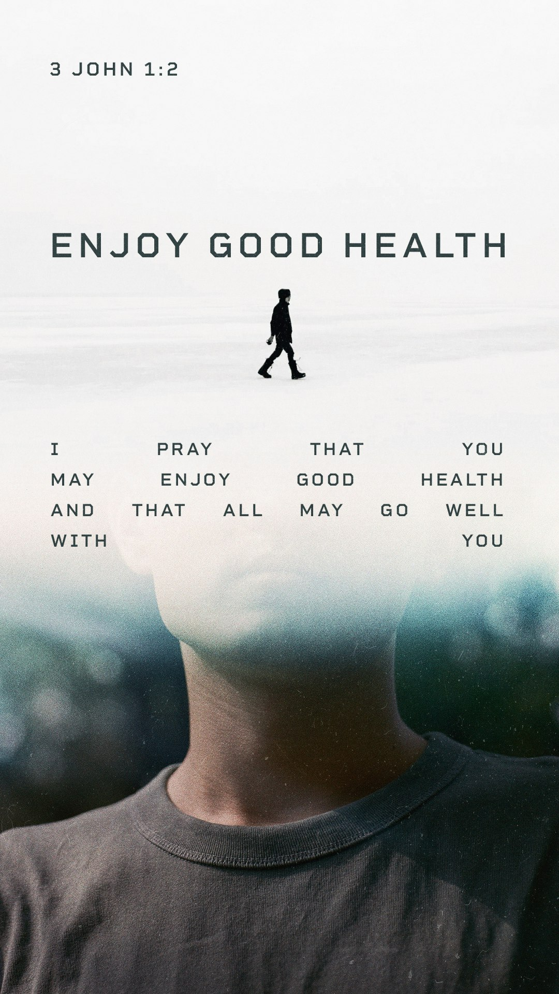



802 S. Caswell Street • La Grange, N.C.

Josh Hobgood - Pastor

