Worship & Celebration

The Lord’s Day • June 21, 2026 • Eleven O’clock

Preparation for Worship Musician

Welcome Pastor

Invocation Pastor

Call To Worship Psalm 103:13
"As a father has compassion on his children, so the Lord has compassion on those who fear him."

Worship “Faith of Our Fathers,”/“Firm Foundation”
Hosting Vicki Bannister
Welcome
Time of Fellowship
Father’s Day Moment
Announcements
Scripture Reading – Luke 15:21-24
Giving Moment 2 Corinthians 9:7 NIV

"Each one must give as he has decided in his heart, not reluctantly or under compulsion, for God loves a cheerful giver."

Tithes and Offering Boxes – Back of Sanctuary

Kids Message Laity

Morning Prayer Lamentations 3:23-24 NIV
²² Because of the Lord’s great love we are not consumed, for his compassions never fail. ²³ They are new every morning; great is your faithfulness.

Special: “Leaning on the Everlasting Arms”
(Kids Dismissed to Kids Worship)

Message: “The Father’s Heart” - Hosea 11:1-11

Altar Call: “Good, Good, Father”
Closing/Benediction: Vicki Bannister
Postlude Musicians
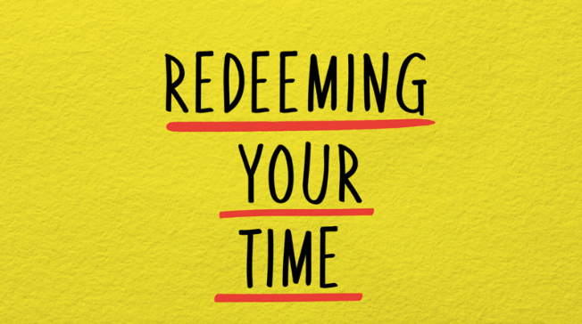
You don't need another app. You don't need a better planner. You don't need to wake up earlier or squeeze one more thing into a schedule that's already full. What you need is what the Bible has been offering all along — a completely different way of thinking about time itself. Here's the honest truth: most of us are tired. Not just physically tired, but the deeper kind — the kind that comes from pouring yourself into a hundred good things and still feeling like you're falling behind. We live in a world that celebrates busyness as a virtue, and somewhere along the way we absorbed the idea that if we could just find the right system, the right rhythm, the right routine, we'd finally feel like we had it together. But productivity systems can only rearrange your hours. They can't redeem them. That's a word only God can speak over your life. Redeeming Your Time is a 5-week series built on the conviction that how you spend your days is a spiritual issue — not just a practical one. Scripture has more to say about time, rest, work, and purpose than most of us have ever been taught. And when we bring our calendars under the lordship of Christ, something shifts. Not just in our schedules, but in us. We can’t wait to see how God speaks to us at La Grange Free Will Baptist Church!

Series Dates:
6.28.26 – 5 Biblical Truths About Time and Productivity
7.5.26 – Let Your Yes Be Yes
7.12.26 – Prioritize Your yes
7.19.26 – Embrace Productive Rest
7.26.26 – Eliminate All Hurry




La Grange 1st FWB Church LaGrange1stFWB LaGrange1stFWB

www.lagrangefwb.org



Join our church family and community on July 5th for a celebration of America and our faith. It will be held at La Grange Community Park, starting at 6 PM.





802 S. Caswell Street • La Grange, N.C.

Josh Hobgood - Pastor

