Worship & Celebration

The Lord’s Day • June 28, 2026 • Eleven O’clock
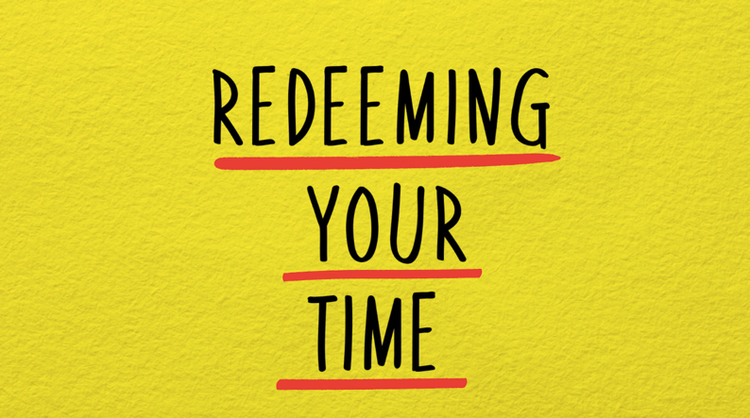
Preparation for Worship Musician

Welcome Pastor

Invocation Pastor

Call To Worship Psalm 118:24
"This is the day the Lord has made; let us rejoice and be glad in it.”

Worship “I Worship You Almighty God” “How Great Thou Art”
Hosting Ted Harrison
Welcome
Time of Fellowship
Announcements
Scripture Reading – 1 Corinthians 15:58
Giving Moment 2 Corinthians 9:7 NIV

"Each one must give as he has decided in his heart, not reluctantly or under compulsion, for God loves a cheerful giver."

Tithes and Offering Boxes – Back of Sanctuary

Kids Message Laity

Morning Prayer Lamentations 3:23-24 NIV
²² Because of the Lord’s great love we are not consumed, for his compassions never fail. ²³ They are new every morning; great is your faithfulness.

Special: “My Shepherd”
(Kids Dismissed to Kids Worship)

Message: “5 Biblical Truths About Time”
Luke 8:22-23, Ephesians 5:15-17

Altar Call: “Take Time to Be Holy”
Closing/Benediction: Ted Harrison
Postlude Musicians

Throughout the rest of this series, we are going to walk through seven principles the gospels show us for HOW Jesus redeemed his time. Today, I’ll leave you with the first and, I believe, most imperative step to redeeming our time - start with the word. To redeem our time in the model of our Redeemer, we must first know the author of time, His purposes for the world, and what He has called us to do with the time He has given us. Jesus frequently broke away from the crowds and His disciples to spend time alone with His Father. For us, this can look like:

- Reading scripture daily
- Meditating on what you read
- Praying throughout your day

It doesn’t have to be fancy. It doesn’t have to take 3 hours. Just carve out time, dig into scripture, and see what God has to say about our time and how we should spend it. Don’t take my word for it. Hear it from the source.

Series Dates:
7.5.26 – Let Your Yes Be Yes
7.12.26 – Prioritize Your yes
7.19.26 – Embrace Productive Rest
7.26.26 – Eliminate All Hurry

Scriptures:
7.5.26 – Philippians 4:6-8, Psalm 46:10, Matthew 14:13, Luke 5:15-16
7.12.26 – Mark 1:29-38, John 17:4, 1 Corinthians 10:31, Matthew 12:46-50
7.19.26 – Mark 6:30-32, Mark 4:38, Mark 3:1-4, Mark 2:27, Genesis 2:2-3
7.26.26 – Ephesians 5:15-17, Luke 14:28-30, Mark 11:1-17, Matthew 14:1-14




La Grange 1st FWB Church LaGrange1stFWB LaGrange1stFWB

www.lagrangefwb.org

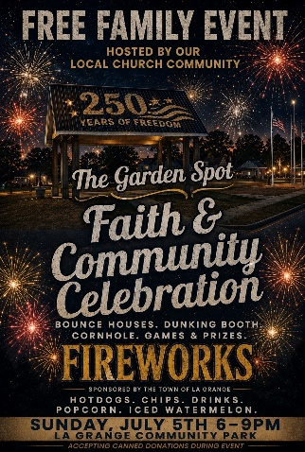

Join our church family and community on July 5th for a celebration of America and our faith. It will be held at La Grange Community Park, starting at 6 PM.

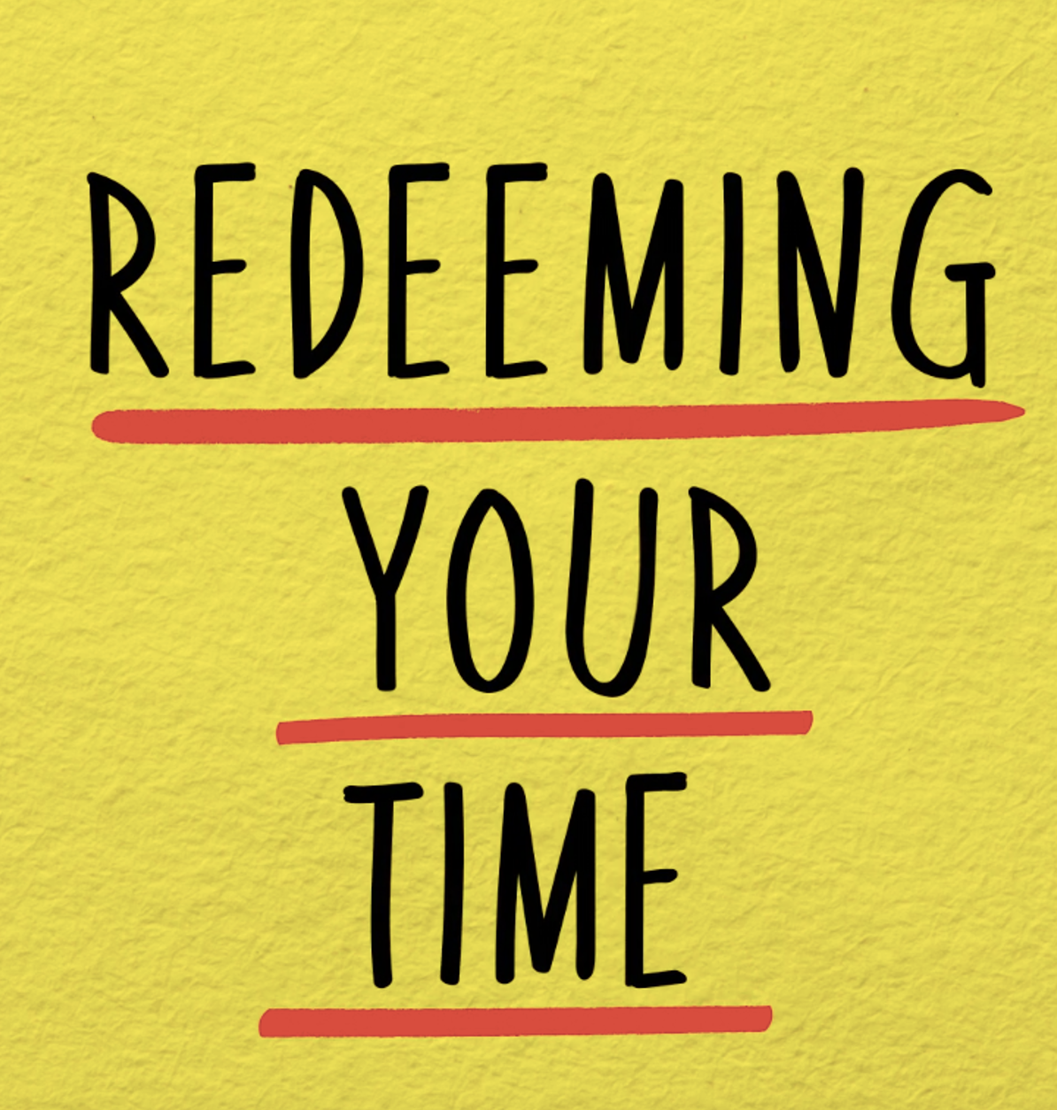



802 S. Caswell Street • La Grange, N.C.

Josh Hobgood - Pastor

