Worship & Celebration

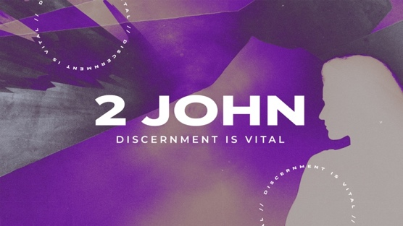
The Lord’s Day • June 7, 2026 • Eleven O’clock

Graduate Processional Musician

Welcome Pastor

Invocation Pastor

Call To Worship Psalm 119:105
"Your word is a lamp to my feet and a light to my path."

Worship “When I Survey The Wondrous Cross”
Hosting Jamie Ham
Welcome
Time of Fellowship
Announcements
Graduate Moment
Scripture Reading – Psalm 119:1-2
Giving Moment 2 Corinthians 9:7 NIV

"Each one must give as he has decided in his heart, not reluctantly or under compulsion, for God loves a cheerful giver."

Tithes and Offering Boxes – Back of Sanctuary

Kids Message Laity

Morning Prayer Lamentations 3:23-24 NIV
²² Because of the Lord’s great love we are not consumed, for his compassions never fail. ²³ They are new every morning; great is your faithfulness.
Special: “My Shepherd”
(Kids Dismissed To Kids Worship)

Message: “Walk In Obedience” 2 John 1

Altar Call: “Welcome The Healer”
Closing/Benediction: Jamie Ham
Postlude Musicians

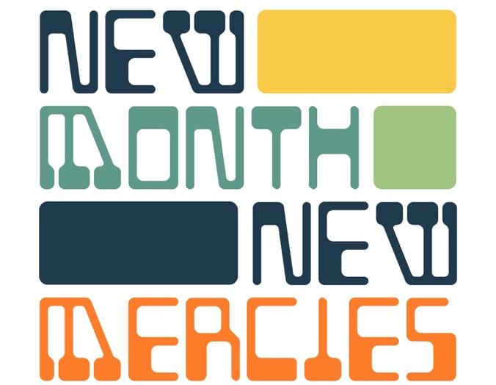

Church family, tucked near the back of your Bible is one of the shortest letters ever written — 13 verses, one page — and it is addressed to people just like us. John writes to a community of believers he loves deeply. He's not writing because they've failed. He's writing because he's overjoyed — he's heard that they are walking in truth, loving one another, and holding fast to what they've been taught. His first instinct is to celebrate them. That's worth receiving. If you have been showing up, loving your people, and staying rooted in Jesus — that brings joy to the heart of God and to every pastor and elder who walks with you. Don't underestimate the faithfulness of ordinary, consistent, unglamorous devotion. John noticed it. So does God.
The heart of John's letter is beautifully simple: love one another and stay close to Jesus. Not a new command — the oldest one. Love that has hands and feet. Love that shows up on hard days, forgives quickly, and serves without keeping score. That's the mark of this community, and John says: keep going.

Series Dates:
6.14.2026 – Do Some Good, 3 John 1
6.21.2026 – TBD
6.28.2026 - TBD




La Grange 1st FWB Church LaGrange1stFWB LaGrange1stFWB

www.lagrangefwb.org

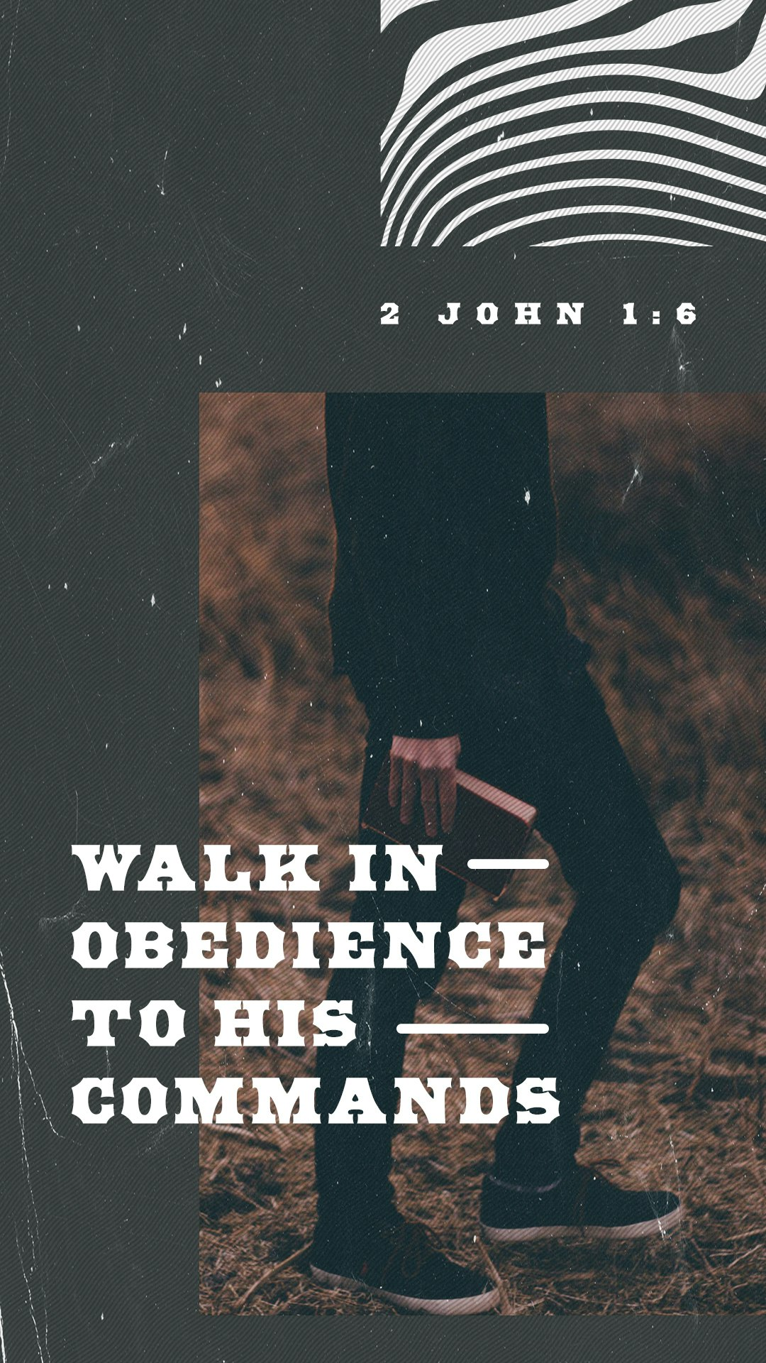



802 S. Caswell Street • La Grange, N.C.

Josh Hobgood - Pastor

