Worship & Celebration

The Lord’s Day • August 19, 2026 • Eleven O’clock


Preparation for Worship Musician

Welcome Pastor

Invocation Pastor

Call To Worship Psalm 8:3-4
When I consider your heavens, the work of your fingers, the moon and the stars, which you have set in place, ⁴ what is mankind that you are mindful of them, human beings that you care for them?

Worship Congregation
“God Of Wonders,” “God I’m Just Grateful,” “What A Mighty God”

Hosting Vicki Bannister
Welcome
Time of Fellowship
Announcements
Scripture Reading – Colossians 1:15-17
Giving Moment Psalm 96:8 NIV

Ascribe to the Lord the glory due his name; bring an offering and come into his courts.

Tithes and Offering Boxes – Back of Sanctuary

Kids Message Laity

Morning Prayer Matthew 6:9 NIV
"….Our Father in Heaven, Hallowed be Your name.”

Special: “How Great Is Our God/How Great Thou Art”

Message: “Awe of The Almighty”
Genesis 1:1-24

Altar Call: “How Great Thou Art”
Closing/Benediction: Vicki Bannister

Postlude Musicians

Think about the last time you were awestruck. It could be when you were at the beach this summer looking at the waves, when your child was born, the last time you looked at your spouse (hopefully!), at Cragmont looking at the mountains, or just sitting on your back porch listening to all of God's creation sing. These moments point us to God Almighty. The things we see and experience are not here by accident; properly viewed, they point us back to Jesus. Sometimes we just need a reminder of who it is that walks with us day in and day out in our lives: God.
Over these next few weeks, we pray that you are able to gaze upon God by seeing all He has created around us. If you are new to this Jesus/church thing, we hope you can be awestruck by God over these next few weeks. If you've been walking with Jesus for a while, we hope you can see Him again with fresh eyes. Even if you are somewhere in between, seeing God causes one response: worship. We say, "Great are You, Lord!"
Viewing God:
This week take time to notice things in creation that point you back to the creator. After noticing, thank Him!

Thank You from Hobgood’s:
Thank you to everyone who has helped us welcome Parker Vann Hobgood into the world. We have felt your prayers and needed them! For all those who fed us, Amen! We loved each meal and seeing those who brought them! We love each of you and are so glad to be back with you!




La Grange 1st FWB Church LaGrange1stFWB LaGrange1stFWB

www.lagrangefwb.org

Deacon of the Month – Bruce Bannister
August is The Convention of Original Free Will Baptist

Greeters/Ushers for Worship
 | Sanctuary | Gathering Hall
9 | Carolyn Massengill | Erin Dawson & Megan Wade
16 | Kendrick Harrison Jr. | Curtis & Flo Smith
23 | Laura Eason | Greg & Brent Herring
30 | Mary Gresham | Guy Hines Family
Candlelighters
9 | Benjamin Carrol | 16 | James & Alie Wooten
23 | Marley Daniels | 30 | Finn Bannister

Kid’s Church

9 | Laura Eason & Christie Westbrook | 16 | Bonnie Kornegay & DeeAnn Maready
23 | Sharon & Anna Baird | 30 | Megan Wade & Erin Dawson

Church Nursery
9 | Asa & Tiffany Creech | 16 | Rusty & Katie Wooten
23 | Brad & Morgan Hunter | 30 | Parker & Conner Harrison

Worship Host
9 | Jennifer Sutton | 16 | Vicki Bannister
23 | Kim Hipkiss | 30 | David Letchworth

CRIB Food
9 | NA | 16 | Ham Family
23 | Asa Creech & Carter Daniels | 30 | Hobgood Sr’s

Grass (Church & CRIB)
8 | Travis & Laura Eason | 15 | Jason Fields
22 | Brandon Cox & Curtis Smith | 29 | David Letchworth

Pro-Presenter Sanctuary
9 | Janet Hines | 16 | Heather Ham
23 | Olivia Sutton | 30 | Maura Ham

Pro-Presenter CRIB
9 | Heather Ham | 16 | Maura Ham
23 | Heather Ham | 30 | Maura Ham

Pro-Presenter Wednesday
5 | Marian Kennedy | 12 | Vicki Bannister
19 | Marian Kennedy | 26 | Vicki Bannister

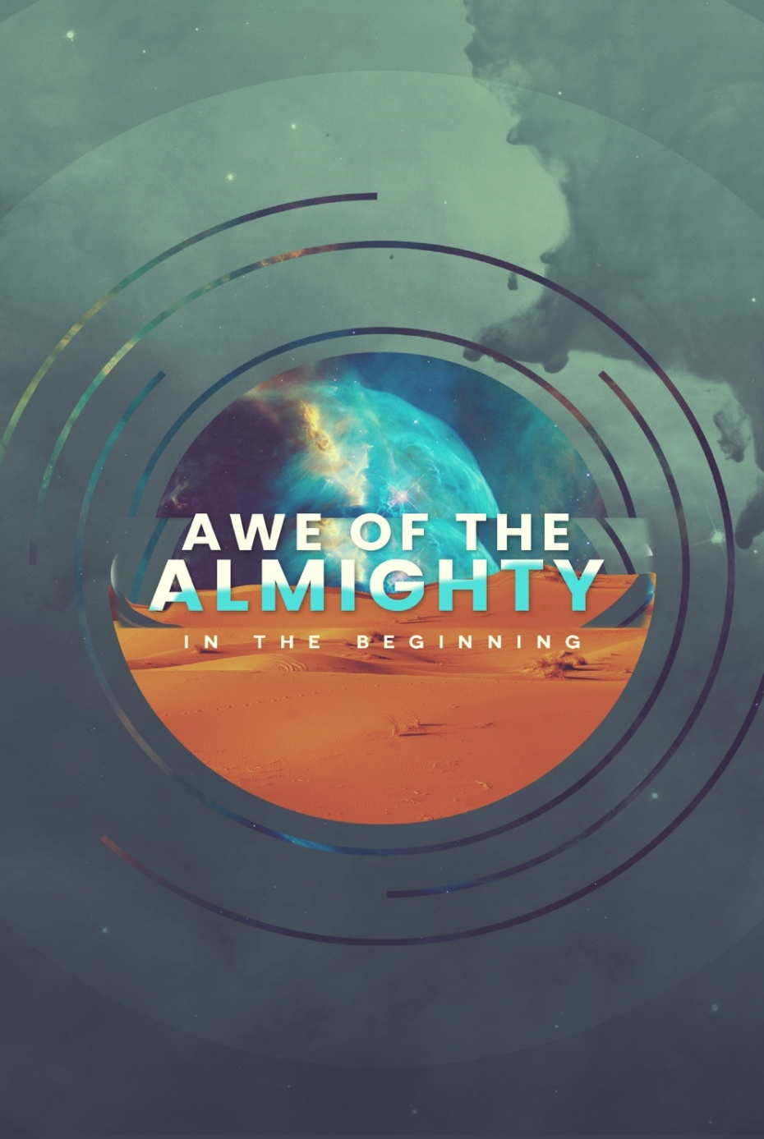

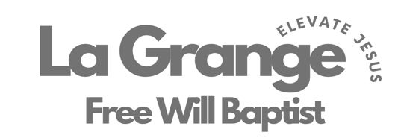

802 S. Caswell Street • La Grange, N.C.

Josh Hobgood – Pastor

Week at a Glance:

Tonight 16th:

4:45p // Choir Practice

5:30p // CRIB (6th – College)

6:00p // Kids Ministry (5th Grade & Down)

6:00p // Adult Bible Study (Prayer)

Monday 17th:

7:00p // Deacon’s Meeting

Tuesday 18th:

7:00p // Band Practice

Wednesday 19th:

6:00p // MIDWEEK (6th – College)

7:00p // Adult Bible Study (Joshua)

Sunday 23rd:

9:45a // Sunday School

11:00a // Worship

4:45p // Choir Practice

5:30p // CRIB (6th – College)

6:00p // Kids Ministry (5th Grade & Down)

6:00p // Adult Bible Study (Prayer)

6:00p // Proverbs31 Women

Upcoming Events:

9.15.26 – North Carolina Foundation for Christian Ministries Banquet

9.18.26 – God Is Love Conference (Contact David Ginn)

9.19.26 – God Is Love Conference (Contact David Ginn)

9.20.26 – Velocity (Contact David Ginn)

Love LA Serve Opportunities:

9.8.26 – Feeding OFWB ECU College Ministry (Contact Pastor Josh)

9.11.26 – Garden Spot (Contact Pastor Josh or Bruce Bannister)

9.12.26 – Garden Spot (Contact Pastor Josh or Bruce Bannister)

Week at a Glance:

Tonight 16th:

4:45p // Choir Practice

5:30p // CRIB (6th – College)

6:00p // Kids Ministry (5th Grade & Down)

6:00p // Adult Bible Study (Prayer)

Monday 17th:

7:00p // Deacon’s Meeting

Tuesday 18th:

7:00p // Band Practice

Wednesday 19th:

6:00p // MIDWEEK (6th – College)

7:00p // Adult Bible Study (Joshua)

Sunday 23rd:

9:45a // Sunday School

11:00a // Worship

4:45p // Choir Practice

5:30p // CRIB (6th – College)

6:00p // Kids Ministry (5th Grade & Down)

6:00p // Adult Bible Study (Prayer)

6:00p // Proverbs31 Women

Upcoming Events:

9.15.26 – North Carolina Foundation for Christian Ministries Banquet

9.18.26 – God Is Love Conference (Contact David Ginn)

9.19.26 – God Is Love Conference (Contact David Ginn)

9.20.26 – Velocity (Contact David Ginn)

Love LA Serve Opportunities:

9.8.26 – Feeding OFWB ECU College Ministry (Contact Pastor Josh)

9.11.26 – Garden Spot (Contact Pastor Josh or Bruce Bannister)

9.12.26 – Garden Spot (Contact Pastor Josh or Bruce Bannister)


August 30th will be our 2nd Beyond Sunday this year (Building Fund Sunday). We are so excited to celebrate what God has been doing through your faithfulness with your prayers, time and finances. We have 3 of these Sundays throughout each year. One is on Easter, one in August, and one at Homecoming (1st Sunday in November). These Sundays are set apart for us to give beyond what we normally would to further our ministry at La Grange Free Will Baptist Church both in our house and beyond our 4 walls. Thank YOU for praying and giving faithfully! God is calling us toward great things right now! Below are some of current efforts and future dreams.

CRIB Ministry
The Lord has done incredible things through our CRIB ministry. Students encounter Jesus week in and week out, and some for the very first time accept Him as Lord of their lives, which is nothing short of miraculous. We are still in the process of paying for this facility and are so thankful that we are all partnered together to make this happen. We hope everyone will take an opportunity to visit the CRIB to see the lives being changed through this ministry. Make this ministry an item of prayer, and prayerfully a place to give from your heart. Jesus is elevated one heart at the time through our CRIB ministry!

Amount Owed: $210,731.98 (As of 6/30/26)

Future Dreams
As we look to the future, we are excited to see God working in and through our congregation. He has brought us this far, and we believe He isn't finished yet. Would you join us in prayer as we seek what might be next for us to invest in — whether that's a new ministry, a relationship, or a step of faith we haven't taken yet? There are many opportunities in front of us, and we don't want to miss what God is doing. We say we want to go where Jesus is going! That means staying prayerful, staying open, and staying united as we discern His direction together. Pray that we would have clarity as a church family for what the future holds, and for the courage to follow wherever God leads.

August 30th will be our 2nd Beyond Sunday this year (Building Fund Sunday). We are so excited to celebrate what God has been doing through your faithfulness with your prayers, time and finances. We have 3 of these Sundays throughout each year. One is on Easter, one in August, and one at Homecoming (1st Sunday in November). These Sundays are set apart for us to give beyond what we normally would to further our ministry at La Grange Free Will Baptist Church both in our house and beyond our 4 walls. Thank YOU for praying and giving faithfully! God is calling us toward great things right now! Below are some of current efforts and future dreams.

CRIB Ministry
The Lord has done incredible things through our CRIB ministry. Students encounter Jesus week in and week out, and some for the very first time accept Him as Lord of their lives, which is nothing short of miraculous. We are still in the process of paying for this facility and are so thankful that we are all partnered together to make this happen. We hope everyone will take an opportunity to visit the CRIB to see the lives being changed through this ministry. Make this ministry an item of prayer, and prayerfully a place to give from your heart. Jesus is elevated one heart at the time through our CRIB ministry!

Amount Owed: $210,731.98 (As of 6/30/26)

Future Dreams
As we look to the future, we are excited to see God working in and through our congregation. He has brought us this far, and we believe He isn't finished yet. Would you join us in prayer as we seek what might be next for us to invest in — whether that's a new ministry, a relationship, or a step of faith we haven't taken yet? There are many opportunities in front of us, and we don't want to miss what God is doing. We say we want to go where Jesus is going! That means staying prayerful, staying open, and staying united as we discern His direction together. Pray that we would have clarity as a church family for what the future holds, and for the courage to follow wherever God leads.

