Worship & Celebration

The Lord’s Day • August 26, 2026 • Eleven O’clock


Preparation for Worship Musician

Welcome Pastor

Call To Worship Psalm 139:13-14
¹³For you created my inmost being; you knit me together in my mother’s womb. ¹⁴ I praise you because I am fearfully and wonderfully made; your works are wonderful, I know that full well.

Invocation Pastor

Worship Congregation
“Joyful, Joyful, We Adore Thee,” “All Creatures of our God and King”

Hosting Kim Hipkiss
Welcome
Time of Fellowship
Announcements
Scripture Reading – Matthew 10:29-31
Giving Moment Psalm 96:8 NIV

Ascribe to the Lord the glory due his name; bring an offering and come into his courts.

Tithes and Offering Boxes – Back of Sanctuary

Kids Message Laity

Kids Church Graduation Laity

Blessing of the Backpacks Laity

Morning Prayer Matthew 6:9 NIV
"….Our Father in Heaven, Hallowed be Your name.”

Special: Emma Moss

Message: “Awe of The Almighty: Our Creator”
Genesis 1:25-31

Altar Call: “Great Are You Lord”
Closing/Benediction: Kim Hipkiss

Postlude Musicians

God created YOU! He knows everything about you. He knows your going out, your lying down, your anxieties, your hopes, your dreams, your family drama, your goals, and your heart. Psalm 139 says it best: "You have searched me, Lord, and you know me... you perceive my thoughts from afar... before a word is on my tongue you, Lord, know it completely." There is nowhere we can go, nothing we can carry, that is hidden from Him.
It is so humbling that the God of the Universe knows us. He cares for us. We are His children, created in His image, formed with intention and love. Jesus went to the cross so that we would never be forgotten by our Heavenly Father — so that the distance sin created could be closed forever. That's not just theology, that's family. He didn't create us and walk away. He stayed close enough to know the number of hairs on our head, and He stays close enough to know the weight on our shoulders today.
Take time to realize this week the miracle that you are. You were created on purpose for a purpose. Jesus, we pray our lives at La Grange First Free Will Baptist Church would sing Your glory, that our purposes as individuals and as a group would be realized. Amen!
Take-Home Challenge: This week, read Psalm 139 slowly, one time each day. On the last day, write down one purpose or gift God has placed in you — and one step you'll take to use it for His glory.




La Grange 1st FWB Church LaGrange1stFWB LaGrange1stFWB

www.lagrangefwb.org

Deacon of the Month – Bruce Bannister
August is The Convention of Original Free Will Baptist

Greeters/Ushers for Worship
 | Sanctuary | Gathering Hall
9 | Carolyn Massengill | Erin Dawson & Megan Wade
16 | Kendrick Harrison Jr. | Curtis & Flo Smith
23 | Laura Eason | Greg & Brent Herring
30 | Mary Gresham | Guy Hines Family
Candlelighters
9 | Benjamin Carrol | 16 | James & Alie Wooten
23 | Marley Daniels | 30 | Finn Bannister

Kid’s Church

9 | Laura Eason & Christie Westbrook | 16 | Bonnie Kornegay & DeeAnn Maready
23 | Sharon & Anna Baird | 30 | Megan Wade & Erin Dawson

Church Nursery
9 | Asa & Tiffany Creech | 16 | Rusty & Katie Wooten
23 | Brad & Morgan Hunter | 30 | Parker & Conner Harrison

Worship Host
9 | Jennifer Sutton | 16 | Vicki Bannister
23 | Kim Hipkiss | 30 | David Letchworth

CRIB Food
9 | NA | 16 | Ham Family
23 | Asa Creech & Carter Daniels | 30 | Hobgood Sr’s

Grass (Church & CRIB)
8 | Travis & Laura Eason | 15 | Jason Fields
22 | Brandon Cox & Curtis Smith | 29 | David Letchworth

Pro-Presenter Sanctuary
9 | Janet Hines | 16 | Heather Ham
23 | Olivia Sutton | 30 | Maura Ham

Pro-Presenter CRIB
9 | Heather Ham | 16 | Maura Ham
23 | Heather Ham | 30 | Maura Ham

Pro-Presenter Wednesday
5 | Marian Kennedy | 12 | Vicki Bannister
19 | Marian Kennedy | 26 | Vicki Bannister

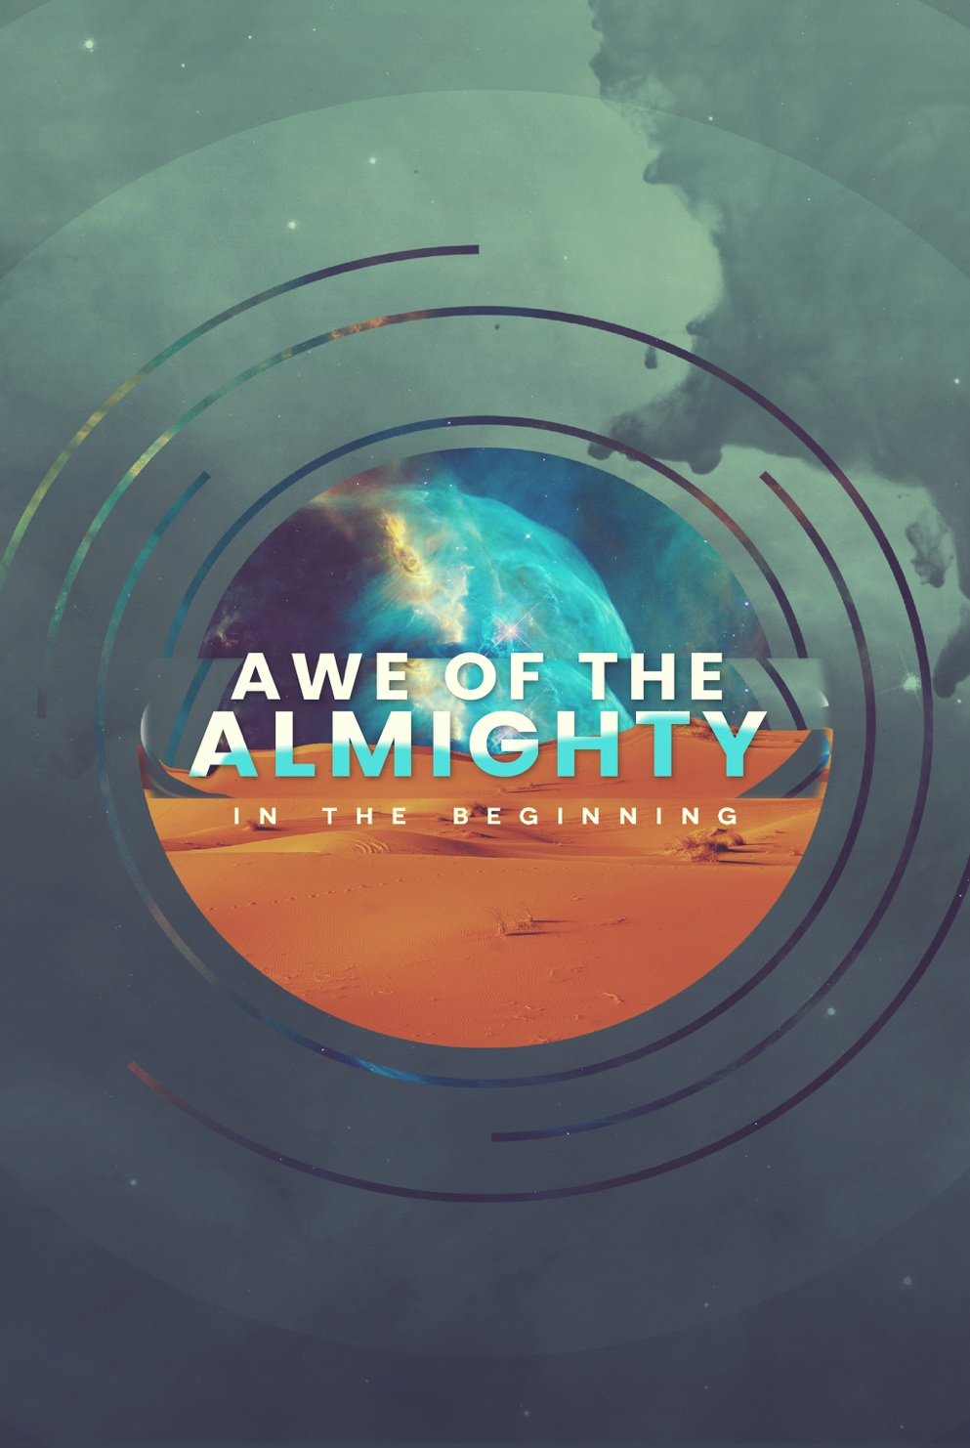

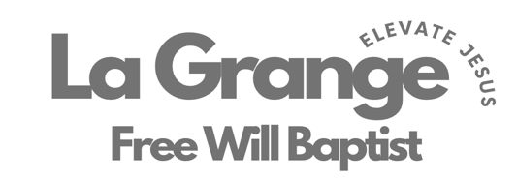

802 S. Caswell Street • La Grange, N.C.

Josh Hobgood – Pastor

Week at a Glance:

Tonight 23rd:

5:00p // Choir Practice

5:30p // CRIB (6th – College)

6:00p // Kids Ministry (5th Grade & Down)

6:00p // Adult Bible Study (Prayer)

Tuesday 25th:

7:00p // Band Practice

Wednesday 26th:

6:00p // MIDWEEK (6th – College)

7:00p // Adult Bible Study (Joshua)

Sunday 23rd:

9:45a // Sunday School

11:00a // Worship

5:00p // Choir Practice

5:30p // CRIB (6th – College)

6:00p // Kids Ministry (5th Grade & Down)

6:00p // Adult Bible Study (Prayer)

Upcoming Events:

9.15.26 – North Carolina Foundation for Christian Ministries Banquet

9.18.26 – God Is Love Conference (Contact David Ginn)

9.19.26 – God Is Love Conference (Contact David Ginn)

9.20.26 – Velocity (Contact David Ginn)

Love LA Serve Opportunities:

9.8.26 – Feeding OFWB ECU College Ministry (Contact Pastor Josh)

9.11.26 – Garden Spot (Contact Pastor Josh or Bruce Bannister)

9.12.26 – Garden Spot (Contact Pastor Josh or Bruce Bannister)

Week at a Glance:

Tonight 23rd:

5:00p // Choir Practice

5:30p // CRIB (6th – College)

6:00p // Kids Ministry (5th Grade & Down)

6:00p // Adult Bible Study (Prayer)

Tuesday 25th:

7:00p // Band Practice

Wednesday 26th:

6:00p // MIDWEEK (6th – College)

7:00p // Adult Bible Study (Joshua)

Sunday 23rd:

9:45a // Sunday School

11:00a // Worship

5:00p // Choir Practice

5:30p // CRIB (6th – College)

6:00p // Kids Ministry (5th Grade & Down)

6:00p // Adult Bible Study (Prayer)

Upcoming Events:

9.15.26 – North Carolina Foundation for Christian Ministries Banquet

9.18.26 – God Is Love Conference (Contact David Ginn)

9.19.26 – God Is Love Conference (Contact David Ginn)

9.20.26 – Velocity (Contact David Ginn)

Love LA Serve Opportunities:

9.8.26 – Feeding OFWB ECU College Ministry (Contact Pastor Josh)

9.11.26 – Garden Spot (Contact Pastor Josh or Bruce Bannister)

9.12.26 – Garden Spot (Contact Pastor Josh or Bruce Bannister)


August 30th will be our 2nd Beyond Sunday this year (Building Fund Sunday). We are so excited to celebrate what God has been doing through your faithfulness with your prayers, time and finances. We have 3 of these Sundays throughout each year. One is on Easter, one in August, and one at Homecoming (1st Sunday in November). These Sundays are set apart for us to give beyond what we normally would to further our ministry at La Grange Free Will Baptist Church both in our house and beyond our 4 walls. Thank YOU for praying and giving faithfully! God is calling us toward great things right now! Below are some of current efforts and future dreams.

CRIB Ministry
The Lord has done incredible things through our CRIB ministry. Students encounter Jesus week in and week out, and some for the very first time accept Him as Lord of their lives, which is nothing short of miraculous. We are still in the process of paying for this facility and are so thankful that we are all partnered together to make this happen. We hope everyone will take an opportunity to visit the CRIB to see the lives being changed through this ministry. Make this ministry an item of prayer, and prayerfully a place to give from your heart. Jesus is elevated one heart at the time through our CRIB ministry!

Amount Owed: $210,731.98 (As of 6/30/26)

Future Dreams
As we look to the future, we are excited to see God working in and through our congregation. He has brought us this far, and we believe He isn't finished yet. Would you join us in prayer as we seek what might be next for us to invest in — whether that's a new ministry, a relationship, or a step of faith we haven't taken yet? There are many opportunities in front of us, and we don't want to miss what God is doing. We say we want to go where Jesus is going! That means staying prayerful, staying open, and staying united as we discern His direction together. Pray that we would have clarity as a church family for what the future holds, and for the courage to follow wherever God leads.

August 30th will be our 2nd Beyond Sunday this year (Building Fund Sunday). We are so excited to celebrate what God has been doing through your faithfulness with your prayers, time and finances. We have 3 of these Sundays throughout each year. One is on Easter, one in August, and one at Homecoming (1st Sunday in November). These Sundays are set apart for us to give beyond what we normally would to further our ministry at La Grange Free Will Baptist Church both in our house and beyond our 4 walls. Thank YOU for praying and giving faithfully! God is calling us toward great things right now! Below are some of current efforts and future dreams.

CRIB Ministry
The Lord has done incredible things through our CRIB ministry. Students encounter Jesus week in and week out, and some for the very first time accept Him as Lord of their lives, which is nothing short of miraculous. We are still in the process of paying for this facility and are so thankful that we are all partnered together to make this happen. We hope everyone will take an opportunity to visit the CRIB to see the lives being changed through this ministry. Make this ministry an item of prayer, and prayerfully a place to give from your heart. Jesus is elevated one heart at the time through our CRIB ministry!

Amount Owed: $210,731.98 (As of 6/30/26)

Future Dreams
As we look to the future, we are excited to see God working in and through our congregation. He has brought us this far, and we believe He isn't finished yet. Would you join us in prayer as we seek what might be next for us to invest in — whether that's a new ministry, a relationship, or a step of faith we haven't taken yet? There are many opportunities in front of us, and we don't want to miss what God is doing. We say we want to go where Jesus is going! That means staying prayerful, staying open, and staying united as we discern His direction together. Pray that we would have clarity as a church family for what the future holds, and for the courage to follow wherever God leads.

