Worship & Celebration

The Lord’s Day • August 9, 2026 • Eleven O’clock



Preparation for Worship Musician

Welcome David Letchworth

Invocation David Letchworth

Call To Worship Laity

Worship "Send the Light"

Hosting Jennifer Sutton
Welcome
Time of Fellowship
Announcements
Scripture Reading - Matthew 28:19-20
Giving Moment Haggai 1:6 NIV

"You have planted much but harvested little. You eat but never have enough. You drink but never have your fill. You put on clothes but are not warm. You earn wages, only to put them in a purse with holes in it.”

Tithes and Offering Boxes – Back of Sanctuary

Kids Message Laity

Morning Prayer James 5:16 NIV

Special Music Andrew Alphin

Message Mark 6:7-12 - Andrew Alphin

Altar Call "Pass It On"

Closing/Benediction Jennifer Sutton
Postlude Musicians

Prepare to join us next week as we start our new series!



Series Dates:
8.16.26 - Sent I
8.23.26 - Sent II
8.30.26 - Sent III
9.6.26 - Sent IV




La Grange 1st FWB Church LaGrange1stFWB LaGrange1stFWB

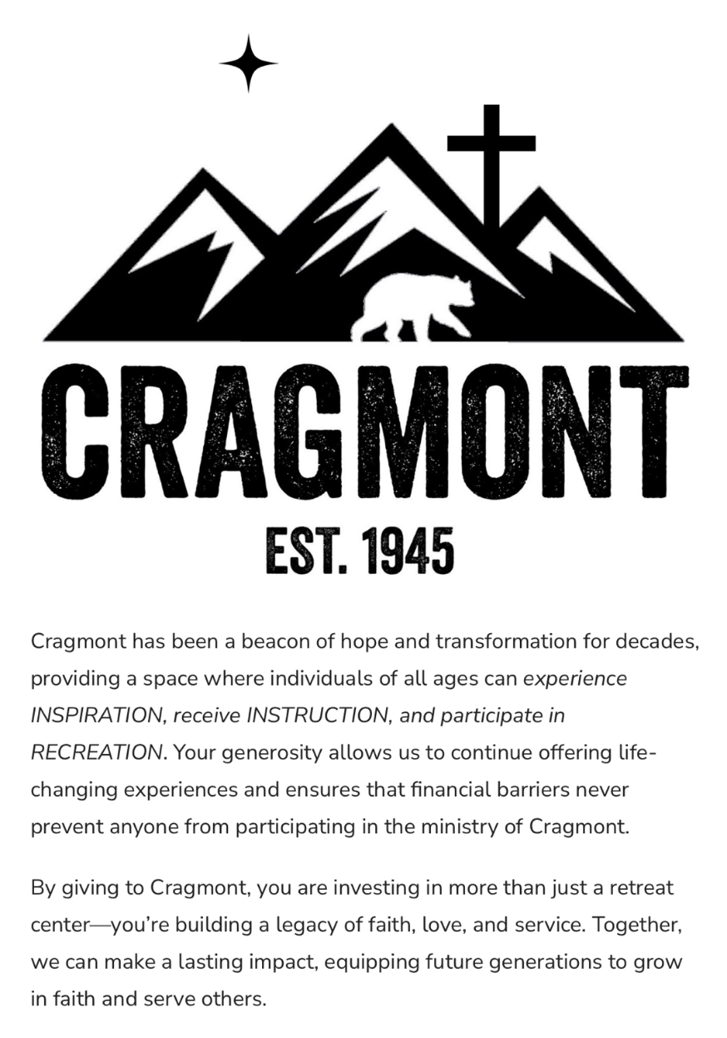
www.lagrangefwb.org


August 2026

Deacon of the Month – Bruce Bannister

Greeters for Worship
SANCTUARY | GATHERING HALL
9 - Carolyn Massengill | 9 - Erin Dawson & Megan Wade
16 - Kendrick Harrison, Jr. | 16 - Curtis & Flo Smith
23 - Laura Eason | 23 - Greg & Brent Herring
30 - Mary Gresham | 30 - Guy Hines Family

Candlelighters
9 - Benjamin Carroll | 16 - James & Allie Wooten
23 - Marley Daniels | 30 - Finn Bannister

Children’s Church
9 - Laura Eason & Christie Westbrook | 16 - Bonnie Kornegay/DeeAnn Maready
23 - Sharon Baird & Anna Baird | 30 - Megan Wade & Erin Dawson

Nursery
9 - Asa & Tiffany Creech | 16 - Rusty & Katie Wooten
23 - Brad & Morgan Hunter | 30 - Parker & Conner Harrison

Pro-Presenter Teams
9 - Janet Hines | 16 - Heather Ham
23 - Olivia Sutton | 30 - Maura Ham

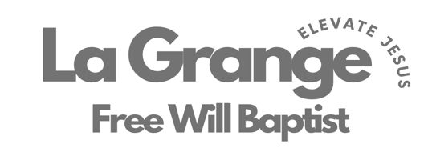


802 S. Caswell Street • La Grange, N.C.
Josh Hobgood - Pastor

