Worship & Celebration

The Lord’s Day • July 26, 2026 • Eleven O’clock


Preparation for Worship Musician

Welcome Laity

Invocation Laity

Call To Worship Psalm 24: 7-10

Worship Matthew Ham and Cragmont Campers
Hosting Brad Hunter
Welcome
Time of Fellowship
Announcements
Scripture Reading – Colossians 2: 6-7
Giving Moment Ephesians 5:15-16 NIV

" ¹⁵ Be very careful, then, how you live—not as unwise but as wise, ¹⁶ making the most of every opportunity, because the days are evil.”

Tithes and Offering Boxes – Back of Sanctuary

Kids Message Laity

Morning Prayer Psalm 31:15

Special Music Matthew Ham and Cragmont Campers

Message "Cragmont Testimonies" - Campers & Staff

Altar Call Matthew Ham & Cragmont Campers
Closing/Benediction Brad Hunter
Postlude Musicians
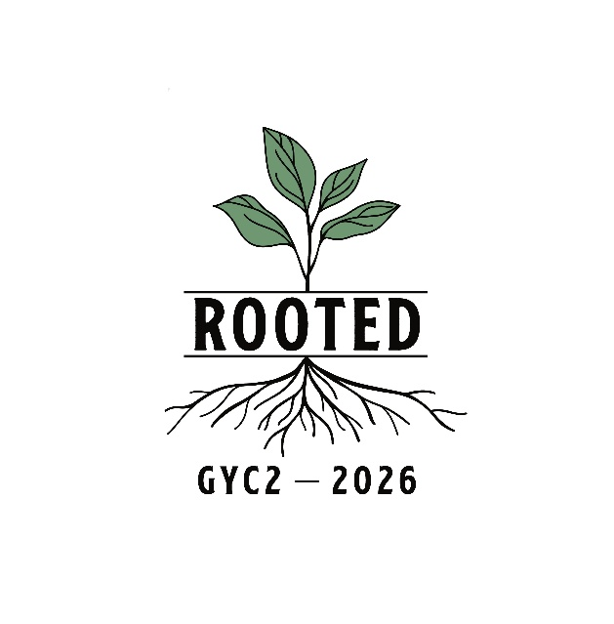
Next week we will resume our "Redeeming Your Time" series. Please join us and receive what God has prepared for our hearts on this subject.
Series Dates:
8.2.26 – Eliminate All Hurry

Series Dates:
8.2.26 – Ephesians 5:15-17, Luke 14:28-30, Mark 11:1-17, Matthew 14:1-14




La Grange 1st FWB Church LaGrange1stFWB LaGrange1stFWB

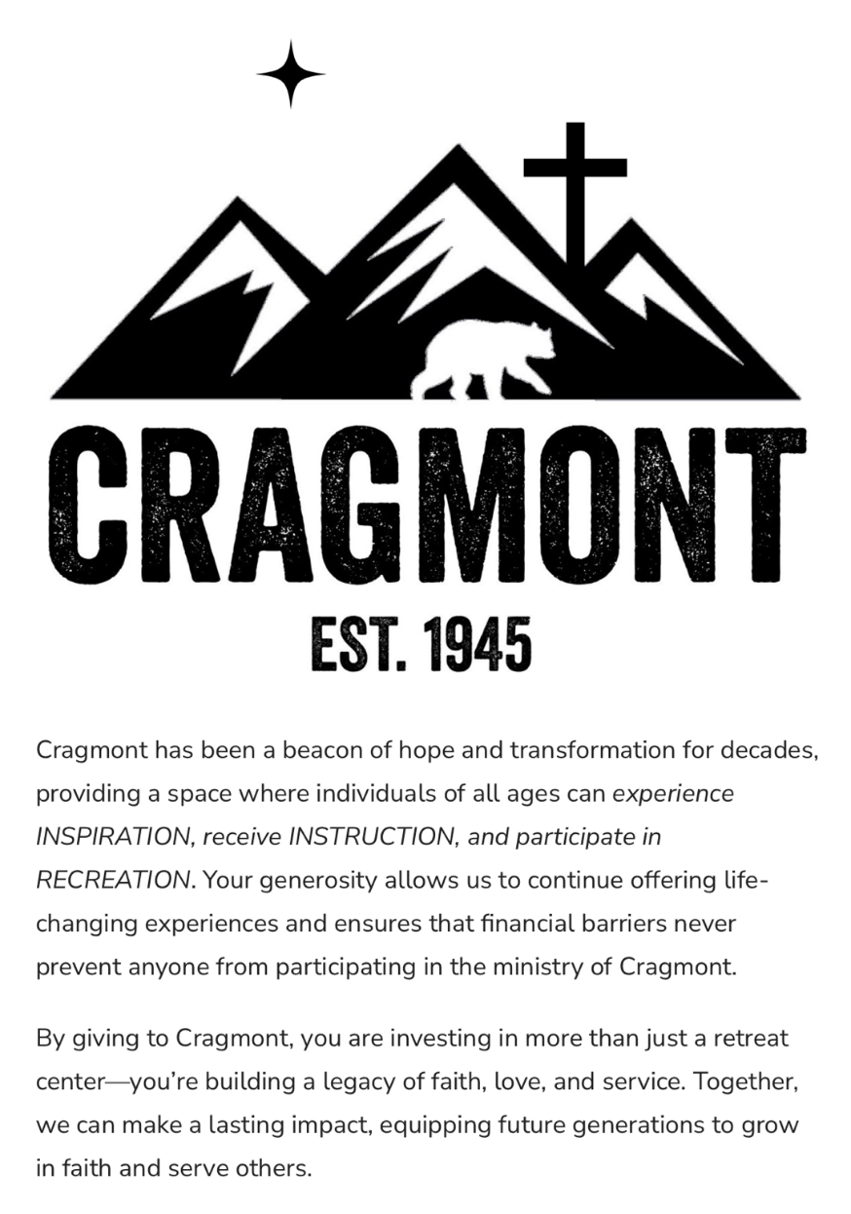
www.lagrangefwb.org


August 2026

Deacon of the Month – Bruce Bannister

Greeters for Worship
SANCTUARY | GATHERING HALL
2 - Bruce Bannister | 2 - Daughety Family
9 - Carolyn Massengill | 9 - Erin Dawson & Megan Wade
16 - Kendrick Harrison, Jr. | 16 - Curtis & Flo Smith
23 - Laura Eason | 23 - Greg & Brent Herring
30 - Mary Gresham | 30 - Guy Hines Family

Candlelighters
2 - Stella Killette | 9 - Benjamin Carroll
16 - James & Allie Wooten | 23 - Marley Daniels
30 - Finn Bannister

Children’s Church
2 - Carolyn Massengill/Christie Welheim | 9 - Laura Eason & Christie Westbrook
16 - Bonnie Kornegay/DeeAnn Maready | 23 - Sharon Baird & Anna Baird
30 - Megan Wade & Erin Dawson

Nursery
2 - Chris & Tracey Roddy | 9 - Asa & Tiffany Creech
16 - Rusty & Katie Wooten | 23 - Brad & Morgan Hunter
30 - Parker & Conner Harrison

Pro-Presenter Teams
2 - Maura Ham | 9 - Janet Hines
16 - Heather Ham | 23 - Olivia Sutton
30 - Maura Ham

CRAGMONT SUNDAY

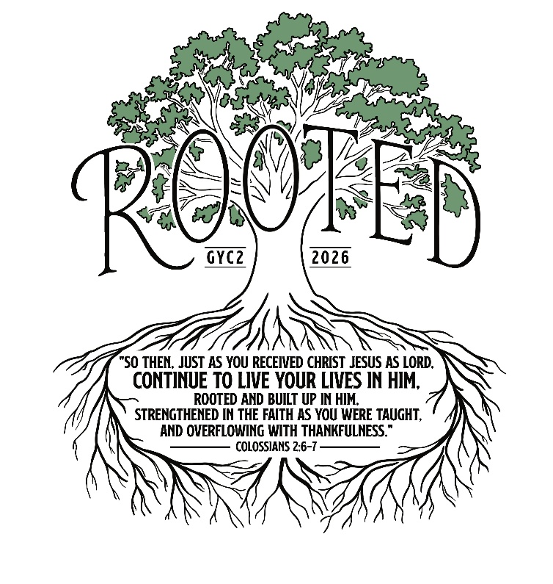



802 S. Caswell Street • La Grange, N.C.
Josh Hobgood - Pastor

