Foundational Truths - Integrity of the Word

Matthew 7:24-25 NKJV - ““Therefore whoever hears these sayings of Mine, and does them, I will liken him to a wise man who built his house on the rock: and the rain descended, the floods came, and the winds blew and beat on that house; and it did not fall, for it was founded on the rock.”

The Word of God is perfect, complete, and can be trusted as the complete truth. It is our life manual.

James 1:22 NKJV - “But be doers of the word, and not hearers only, deceiving yourselves.”

We are to be hearers of the Word and Doers of the Word. (Believe it, act on it)
This is our foundation as Christians.

Matthew 7:24 AMPC - “So everyone who hears these words of Mine and acts upon them [obeying them] will be like a sensible (prudent, practical, wise) man who built his house upon the rock.”

Matthew 7:26-27 NKJV - ““But everyone who hears these sayings of Mine, and does not do them, will be like a foolish man who built his house on the sand: and the rain descended, the floods came, and the winds blew and beat on that house; and it fell. And great was its fall.””

Jesus is now describing someone who hears it only, but doesn’t apply it to their life. Doesn’t act on it. He calls them foolish…..

Foolish mōrós - stupid, blockhead, absurd.

God’s Word should be final authority in your life! - That means whatever I read in the Bible, I am going to believe it, AND, I am going to act on it!

As Christians, our belief system should be based on the Word of God! Not what “experts” say, culture says, or what is politically correct.

I Peter 1:22-23 NKJV - “Since you have purified your souls in obeying the truth through the Spirit in sincere love of the brethren, love one another fervently with a pure heart, having been born again, not of corruptible seed but incorruptible, through the word of God which lives and abides forever,”

God’s Word is the incorruptible seed. It always works. It always produces!

1 Peter 1:23 AMPC - “You have been regenerated (born again), not from a mortal origin (seed, sperm), but from one that is immortal by the ever living and lasting Word of God.”

The Bible isn’t just a collection of books, it is the Word of God.

Hebrews 4:12 NKJV - “For the word of God is living and powerful, and sharper than any two-edged sword, piercing even to the division of soul and spirit, and of joints and marrow, and is a discerner of the thoughts and intents of the heart.”

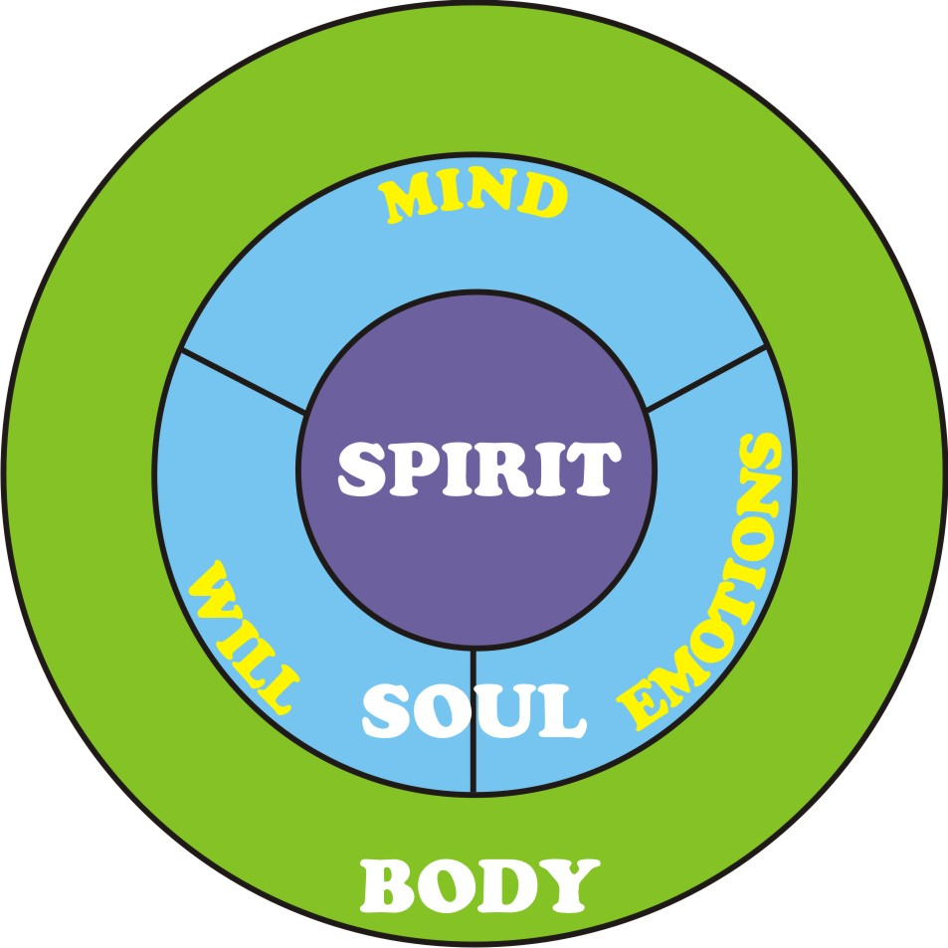

Remember that you are a spirit being, you have a soul, you live in this physical body. There are 3 parts to your being. All three are connected as you see in this diagram.

We live from the inside out, not the outside in. The Word of God will penetrate right down to the core of your being, and touch you in a way that nothing else can. Which can then impact the rest of your body.

John 1:1-3 NKJV - “In the beginning was the Word, and the Word was with God, and the Word was God. He was in the beginning with God. All things were made through Him, and without Him nothing was made that was made.”

The Word of God (Jesus) is perfect. He needs no improvements, He needs no additions. The Word is complete in itself and it is the foundation for every Christian.

John 1:14 NKJV - “And the Word became flesh and dwelt among us, and we beheld His glory, the glory as of the only begotten of the Father, full of grace and truth.”

Deuteronomy 12:32 NKJV - ““Whatever I command you, be careful to observe it; you shall not add to it nor take away from it.”

Proverbs 30:5-6 NKJV - “Every word of God is pure; He is a shield to those who put their trust in Him. Do not add to His words, Lest He rebuke you, and you be found a liar.”

Pure - that is in reference to refining metal. Like people refine gold.

There are no contradictions in the Bible. It is complete. Things that people would say are contradictions come from a lack of understanding.

God’s Word is perfect, complete, has no imperfections. We don’t add to His words.

The Book of Mormon, Apocrypha, or any other old writings from the Bible era that are not included in your Bible are NOT the Word of God.

