Healing Part 1
Redeemed from the Curse

Origin of Sickness and Disease

Genesis 1:10 NKJV - “And God called the dry land Earth, and the gathering together of the waters He called Seas. And God saw that it was good.”

Genesis 1:12 NKJV - “And the earth brought forth grass, the herb that yields seed according to its kind, and the tree that yields fruit, whose seed is in itself according to its kind. And God saw that it was good.”

Genesis 1:16 NKJV - “Then God made two great lights: the greater light to rule the day, and the lesser light to rule the night. He made the stars also.”

Genesis 1:17-18 NKJV - “God set them in the firmament of the heavens to give light on the earth, and to rule over the day and over the night, and to divide the light from the darkness. And God saw that it was good.”

Genesis 1:21 NKJV - “So God created great sea creatures and every living thing that moves, with which the waters abounded, according to their kind, and every winged bird according to its kind. And God saw that it was good.”

Genesis 1:25 NKJV - “And God made the beast of the earth according to its kind, cattle according to its kind, and everything that creeps on the earth according to its kind. And God saw that it was good.”

Everything God created was good!!!

Good - Tob - Excellent, pleasant, agreeable.

This does not define or describe sickness or disease.

On what day did God create sickness and diseases? He didn’t!!!

Genesis 3:17-19 NKJV - “Then to Adam He said, “Because you have heeded the voice of your wife, and have eaten from the tree of which I commanded you, saying, ‘You shall not eat of it’: “Cursed is the ground for your sake (Because of you) ; In toil you shall eat of it All the days of your life. Both thorns and thistles it shall bring forth for you, And you shall eat the herb of the field. In the sweat of your face you shall eat bread Till you return to the ground, For out of it you were taken; For dust you are, And to dust you shall return.””

The moment Adam and Eve sinned everything changed. This curse effected the ground, the animals, the atmosphere, and Adam and Eve themselves. It altered the natural course God had setup and introduced things that were anti-God.

Romans 5:12 NKJV - “Therefore, just as through one man sin entered the world, and death through sin, and thus death spread to all men, because all sinned—”

Death entered the world through one man’s sin - Adam.

Entered - eisérchomai - To come in, come into existence.

Death, and everything that causes death, came into existence when Adam and Eve sinned.

Adam and Eve would have never died if they would not have sinned. Your spirit is eternal, but Adam and Even were created with eternal bodies as well. Sin changed that.

(1 Corinthians 15:51-53 - Our glorified bodies)

Sickness, disease, death itself, was never in God’s plan. God is not the author of death, sickness, or disease

Numbers 21:7-8 NKJV - “Therefore the people came to Moses, and said, “We have sinned, for we have spoken against the Lord and against you; pray to the Lord that He take away the serpents from us.” So Moses prayed for the people. Then the Lord said to Moses, “Make a fiery serpent, and set it on a pole; and it shall be that everyone who is bitten, when he looks at it, shall live.””

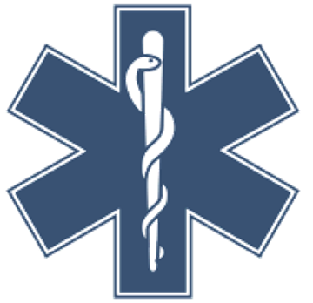
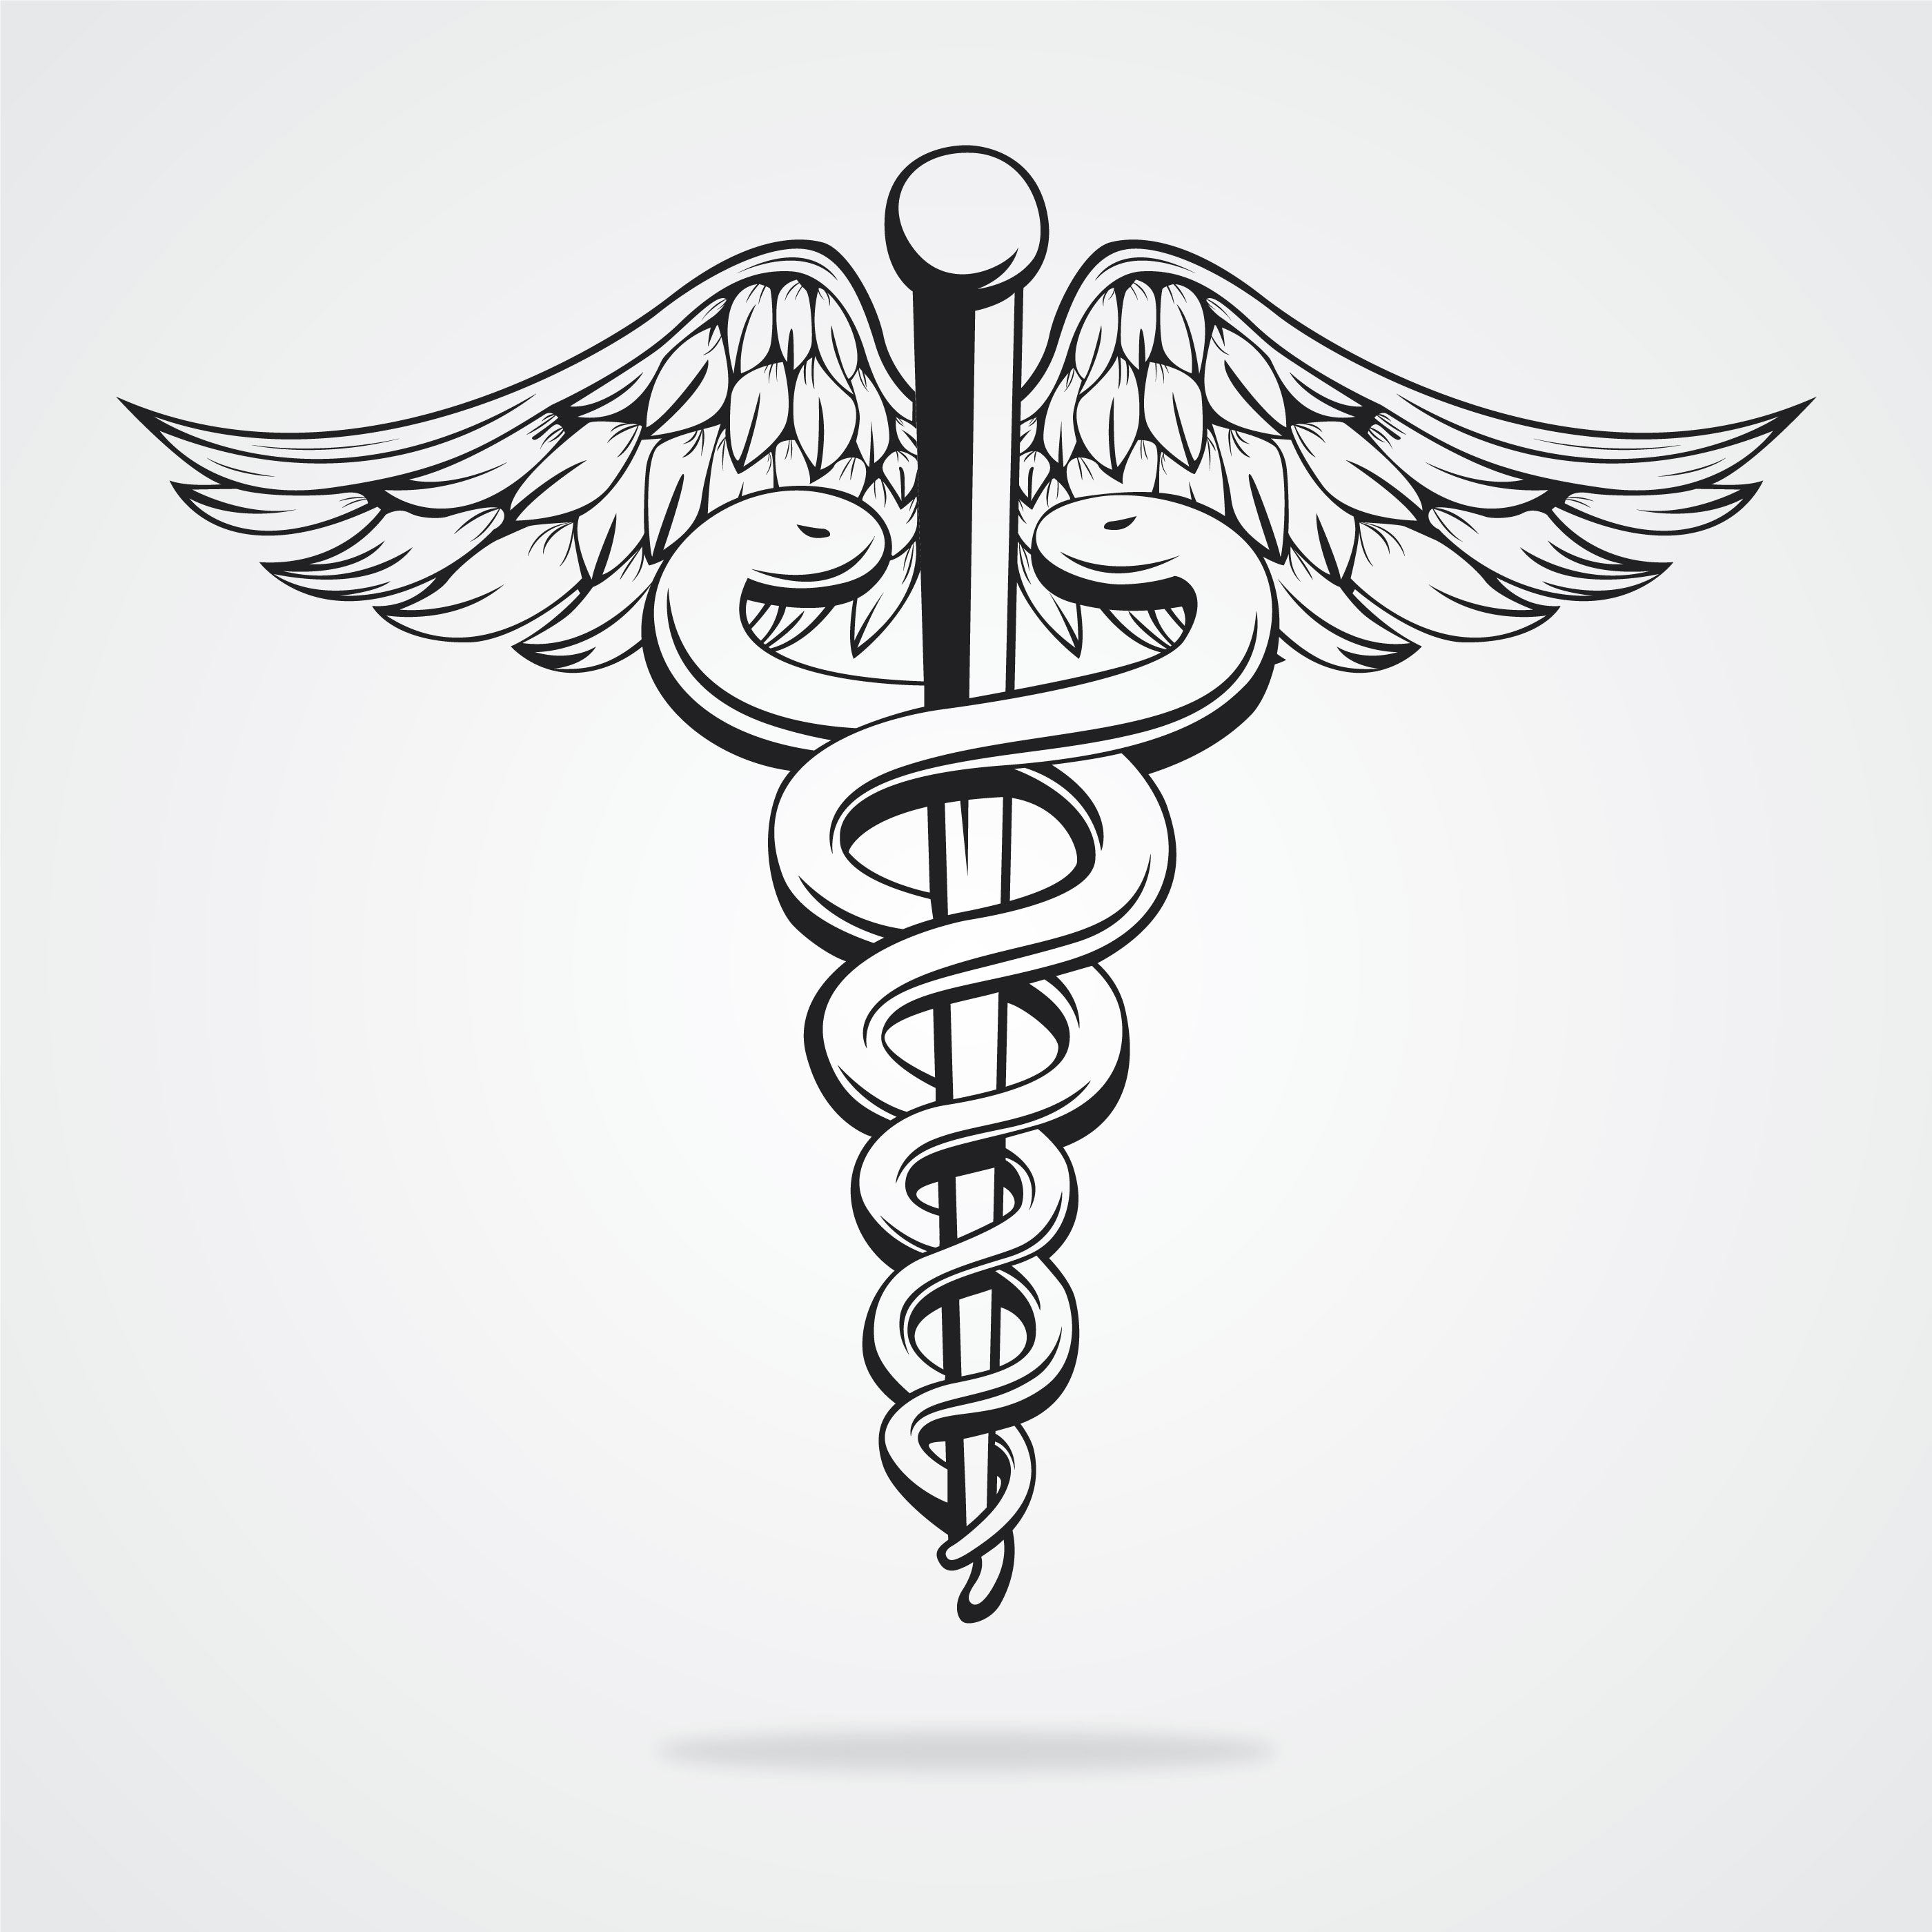

These have become the modern symbols for medicine, healing.

Numbers 21:9 NKJV - “So Moses made a bronze serpent, and put it on a pole; and so it was, if a serpent had bitten anyone, when he looked at the bronze serpent, he lived.”

Was it up to God whether or not they received their healing? NO!

Was it up to Moses whether or not they received their healing? NO!

The snake on the pole was a “type” of Jesus on the cross. This shows that God already had a plan for mankind to heal them permanently, and it was Jesus on that cross. He became sin for us, He took our sin upon Himself on the cross. This was a type of Jesus on the cross.

Galatians 3:13-14 NKJV - “Christ has redeemed us from the curse of the law, having become a curse for us (for it is written, “Cursed is everyone who hangs on a tree”), that the blessing of Abraham might come upon the Gentiles in Christ Jesus, that we might receive the promise of the Spirit through faith.”

We are not waiting on Christ to redeem us from the curse of the law. He has! Healing is a finished work.

Redeem - Purchase our freedom from. Paid a ransom.

Isaiah 53:4-5 NKJV - “Surely He has borne our griefs And carried our sorrows; Yet we esteemed Him stricken, Smitten by God, and afflicted. But He was wounded for our transgressions, He was bruised for our iniquities; The chastisement for our peace was upon Him, And by His stripes we are healed.”

Griefs - choliy - Sickness, Disease, Calamity.
Sorrows - makób - anguish, pain.

Matthew 8:16-17 NKJV - “When evening had come, they brought to Him many who were demon-possessed. And He cast out the spirits with a word, and healed all who were sick, that it might be fulfilled which was spoken by Isaiah the prophet, saying: “He Himself took our infirmities And bore our sicknesses.””

The objective of Jesus bearing our sins was that we would be free from sin.
The objective of Jesus bearing our sickness and diseases was that we would be free from sickness and disease.

I Peter 2:24 NKJV - “who Himself bore our sins in His own body on the tree, that we, having died to sins, might live for righteousness—by whose stripes you were healed.”

WERE is past tense. Isaiah was pointing to the future, Peter is looking to the cross at what Jesus has already done.

Healing has been paid for!!

This verse is not talking about spiritual healing.

If I was healed then I AM HEALED. You are not a sick person trying to be healed. You are a healed person, that sickness is trying to come upon.

Healing Belongs to Us

Matthew 15:21-23 NKJV - “Then Jesus went out from there and departed to the region of Tyre and Sidon. And behold, a woman of Canaan came from that region and cried out to Him, saying, “Have mercy on me, O Lord, Son of David! My daughter is severely demon-possessed.” But He answered her not a word. And His disciples came and urged Him, saying, “Send her away, for she cries out after us.””

Don’t you love the compassion the disciples were showing.

Matthew 15:24 NKJV - “But He answered and said, “I was not sent except to the lost sheep of the house of Israel.””

Jesus ministry wasn’t to the gentiles, it was to the Jewish people. She had no covenant rights as a non Jew. She couldn’t approach Jesus based on a covenant right like the Jewish people could.

Matthew 15:25-26 NKJV - “Then she came and worshiped Him, saying, “Lord, help me!” But He answered and said, “It is not good to take the children’s bread and throw it to the little dogs.””

Jesus just call her a dog? This was a reference to the fact she wasn’t a jew.

Matthew 15:27-28 NKJV “And she said, “Yes, Lord, yet even the little dogs eat the crumbs which fall from their masters’ table.” Then Jesus answered and said to her, “O woman, great is your faith! Let it be to you as you desire.” And her daughter was healed from that very hour.”

People have misunderstood this scripture and taught that you have to convince God to heal you, maybe He says yes and maybe He says no like to this lady.

Healing is the children’s bread. Healing belongs to us a children of God.

