Money Mastery 3

There are 3 different levels of income.

Level 1 - Money you work for.
Level 2 - Money that works for you.
Level 3 - Money that works without you.

Most people only stay at level 1. I’ve been a level 1 guy all my life up until now, work a job, get paid.

Level 2 income is where you invest money in an asset, and the asset makes money for you. Money is attracted not pursued.

Level 3 income is money that works without you. It’s money you don’t live off of, you’re comfortable, but you can put it in an account and accumulate it, and the goal is to give it all away.

Triple X Factor

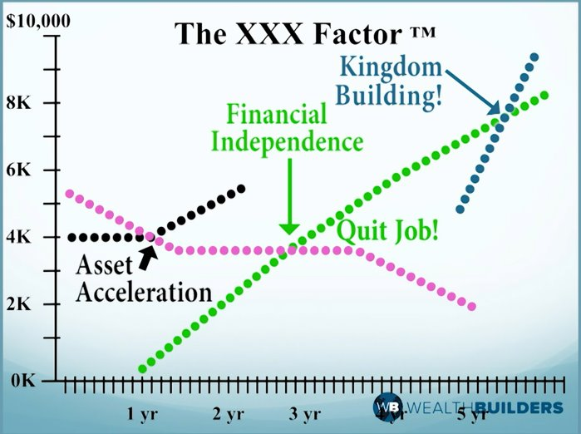

Only 3% of people get to the second X.

Deuteronomy 28:1-2 NKJV - ““Now it shall come to pass, if you diligently obey the voice of the Lord your God, to observe carefully all His commandments which I command you today, that the Lord your God will set you high above all nations of the earth. And all these blessings shall come upon you and overtake you, because you obey the voice of the Lord your God:”

We live in the new covenant, so ours is even better than this!
Deuteronomy 28:3 NKJV - ““Blessed shall you be in the city, and blessed shall you be in the country.”

Deuteronomy 28:4 NKJV - ““Blessed shall be the fruit of your body, the produce of your ground and the increase of your herds, the increase of your cattle and the offspring of your flocks.”

The work you do is blessed and notice it says INCREASING. If we are not increasing something is wrong!

Deuteronomy 28:5-6 NKJV - ““Blessed shall be your basket and your kneading bowl. “Blessed shall you be when you come in, and blessed shall you be when you go out.”

You’re blessed coming and going.

Deuteronomy 28:7-8 NKJV - ““The Lord will cause your enemies who rise against you to be defeated before your face; they shall come out against you one way and flee before you seven ways. “The Lord will command the blessing on you in your storehouses and in all to which you set your hand, and He will bless you in the land which the Lord your God is giving you.”

Your storehouse is where you keep your money, your wealth. There’s a blessing on your money! A blessing on it means that it’s not decreasing, it’s increasing! Not running out but running over!

Deuteronomy 28:9-12 NKJV - ““The Lord will establish you as a holy people to Himself, just as He has sworn to you, if you keep the commandments of the Lord your God and walk in His ways. Then all peoples of the earth shall see that you are called by the name of the Lord, and they shall be afraid of you. And the Lord will grant you plenty of goods, in the fruit of your body, in the increase of your livestock, and in the produce of your ground, in the land of which the Lord swore to your fathers to give you. The Lord will open to you His good treasure, the heavens, to give the rain to your land in its season, and to bless all the work of your hand. You shall lend to many nations, but you shall not borrow.”

How can you become the lender, and not the borrower?

A lender has something to lend. God gives us the ability to create and acquire wealth. (Deut 8:17-18) We need to start creating it and acquiring it.

In order for all of this to happen in our lives we have to change!

Example of what it looks like to become a Master of Money
II Samuel 17:27-29 NKJV - “Now it happened, when David had come to Mahanaim, that Shobi the son of Nahash from Rabbah of the people of Ammon, Machir the son of Ammiel from Lo Debar, and Barzillai the Gileadite from Rogelim, brought beds and basins, earthen vessels and wheat, barley and flour, parched grain and beans, lentils and parched seeds, honey and curds, sheep and cheese of the herd, for David and the people who were with him to eat. For they said, “The people are hungry and weary and thirsty in the wilderness.””

This giving did not come from people who only have level 1 income.

These people were giving out of their abundance.

II Samuel 19:31-32 NKJV - “And Barzillai the Gileadite came down from Rogelim and went across the Jordan with the king, to escort him across the Jordan. Now Barzillai was a very aged man, eighty years old. And he had provided the king with supplies while he stayed at Mahanaim, for he was a very rich man.”

Look what this man did with his wealth. Not only was he very wealthy, he was very giving.
He was 80, he wasn’t out there sowing in the field, plowing. He owned land, had servants doing the work. (Level 2 income).

7 Steps to Financial Freedom

1. Escalate - Increase your knowledge
You need to learn new things from people who do them (not people like you). Educate yourself, learn, invest in yourself so that you bring more to the marketplace.

2. Eliminate consumer debt
Consumer debt will be a hindrance for us to making progress. Wealthy people, when they buy things, they go pay for them. The only exception is when it’s an asset, then they may finance. Putting money in things that go down in value is not the path to financial freedom.

3. Accumulate
As you live off of 70 or 80%, take the 10% and save it to create a 3-6 month emergency fund. This will prevent you from going back into debt when the thief comes to steal from you.
Once you have your emergency fund start using that money to save for a home if you don’t already own one.

4. Participate
Get in the game. You need to start putting your money in things that go up in value. Acquire assets. Buy a house if you don’t already own one, invest in a Roth IRA.

5. Accelerate
The three ways to do this is invest in real estate, start a business, or invest in the stock market. You increased your knowledge in step one. Wealthy people typically own a business and also invest in some sort of real estate.

6. Emancipate
This means you get free. Reaching the second X will allow you to be free from your current level 1 job (if you want to be), you can start doing what you LOVE!!

7. Donate
Give 100% of your excess level 2 income to kingdom purpose and social causes. This is the third X.

1 Corinthians 3:9 AMPC - “For we are fellow workmen (joint promoters, laborers together) with and for God; you are God's garden and vineyard and field under cultivation, [you are] God's building. [Isa. 61:3.]”

Reflect and write down your 3-2-1

3 – Things you learned this lesson

2 – Questions you have from this lesson

1 – Idea you can implement from this lesson

Discussion Questions

- What are some ways you can escalate your knowledge to learn how to invest?

- Discuss your plan to save for emergencies.

- Are there any areas of investing you are currently comfortable?

- What concerns do you have about taking these 7 steps?

