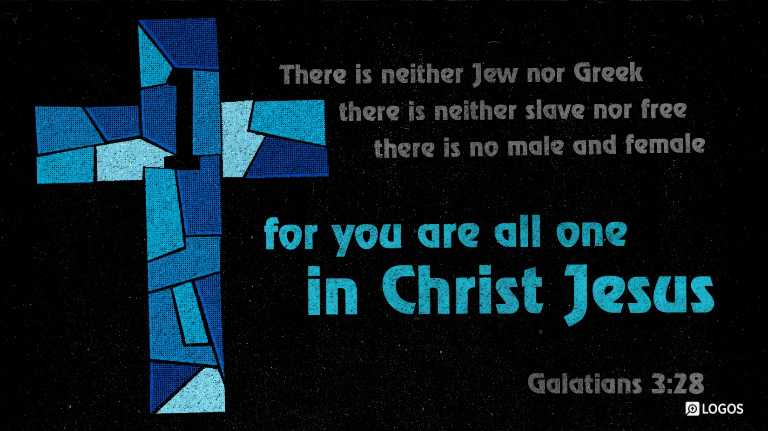
FRIDAY WORDS
March 27, 2026

Everyone is different.

We all have our own strengths and weaknesses. There are things we are great at, and things we aren’t so fantastic at.

Sometimes we can think to ourselves that other people, who have more strengths than we do, are loved more by God.

We think to ourselves, “If only I was like them…. then God could use me…. then He would love me.”

This is a lie that we too often believe. We need to remember what the Bible says. If you know Jesus as your Savior you are completely accepted by God. In Jesus all the categories that we often use to put people higher or lower disappear because no matter who we are or where we are from the solution for our sin is the same, and that solution is Jesus.

So, stop comparing yourself to others.
And start living in Christ.

