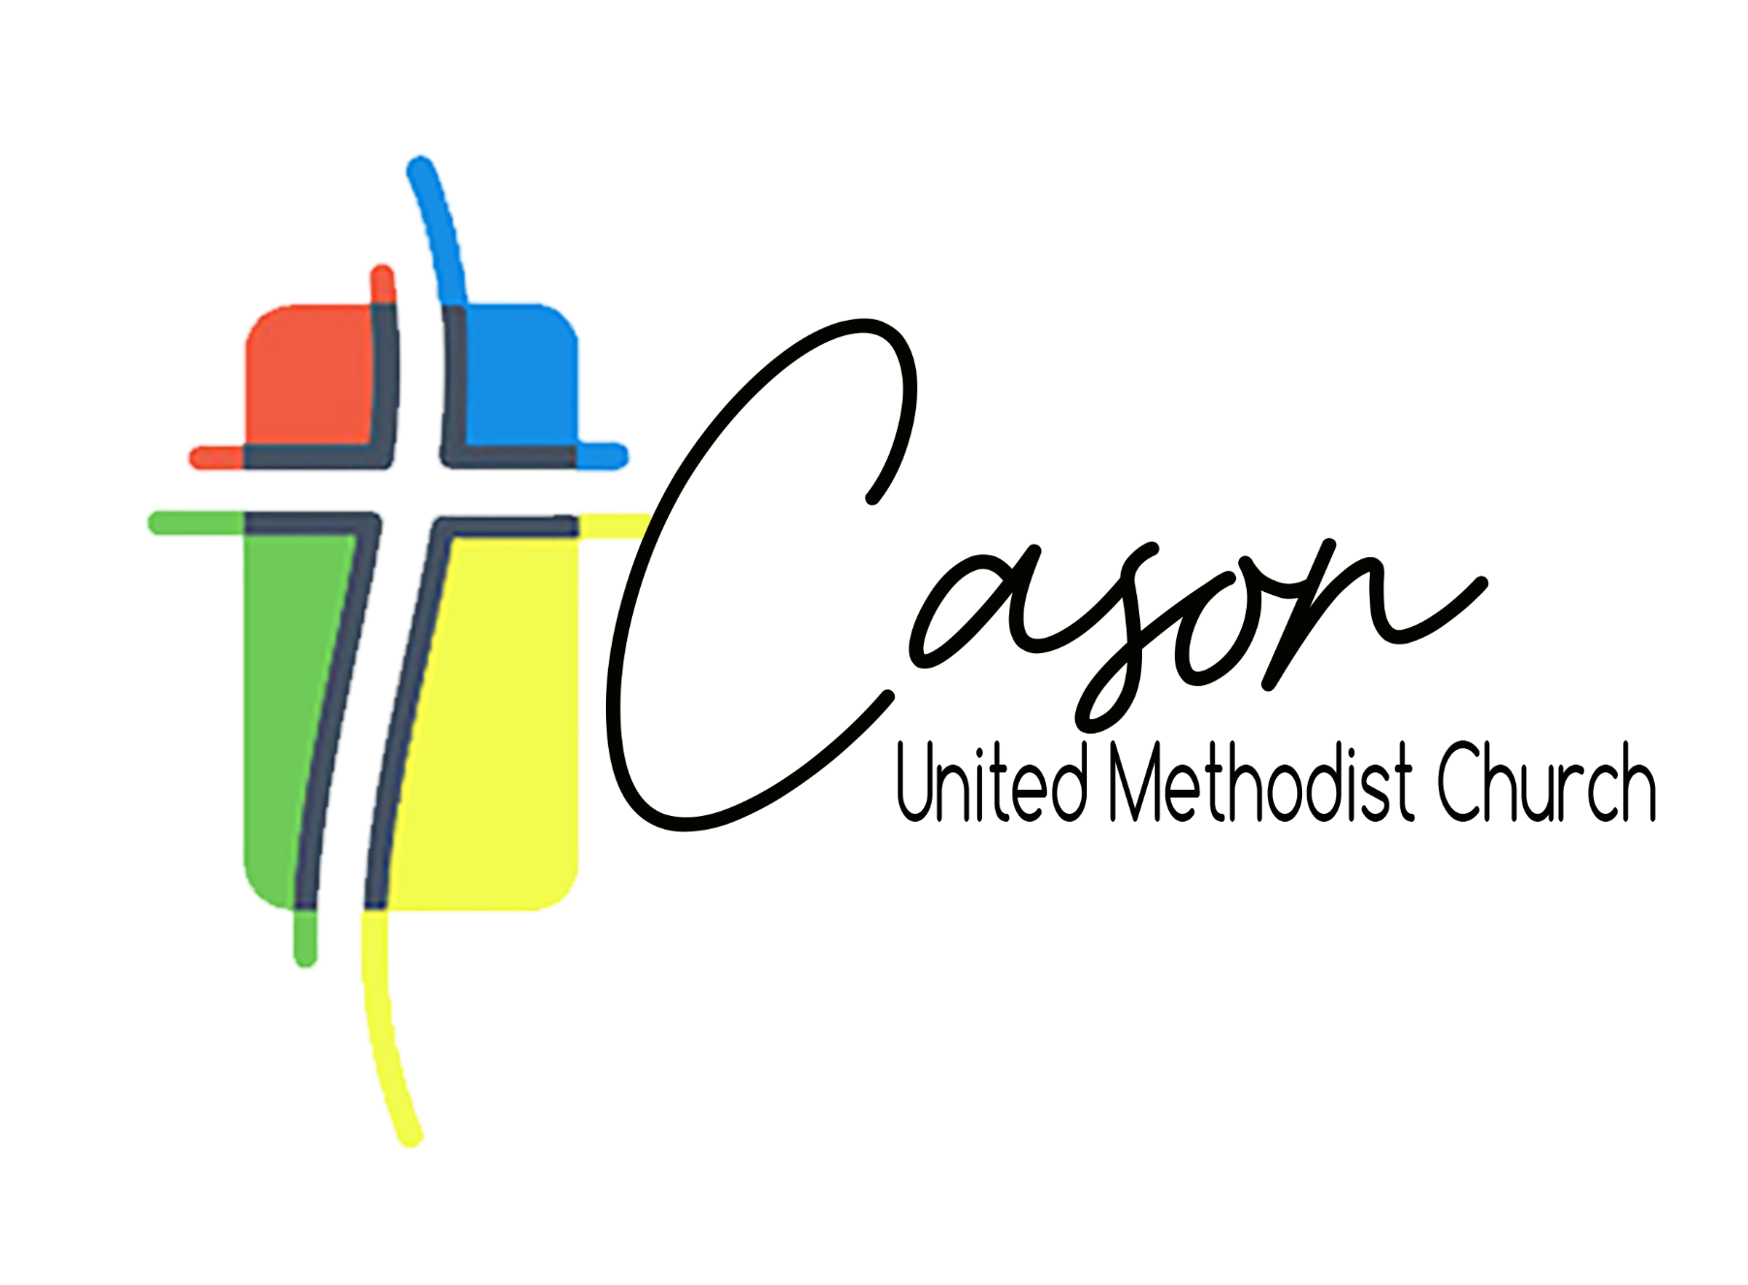
Leadership Team Agenda
February 7, 2026

Devotion
Approval & Questions of Agenda Packet
SPPRC Business
- Treasurer Compensation
- Rental Coordinator changes
Review and Approval of Revised Budget
Cocoplum Request Discussion
- Required Renovation
Church Maintenance Discussion and Approval
- Education Wing Roof Silicon Application
- Hurricane Shutters for Stained glass Windows
Caring Kitchen Review and Discussion
- Fellowship Hall and Kitchen Renovation
Front Lawn Activation Discussion
Leadership Chair Report
Pastoral Report
Prayer

