leader
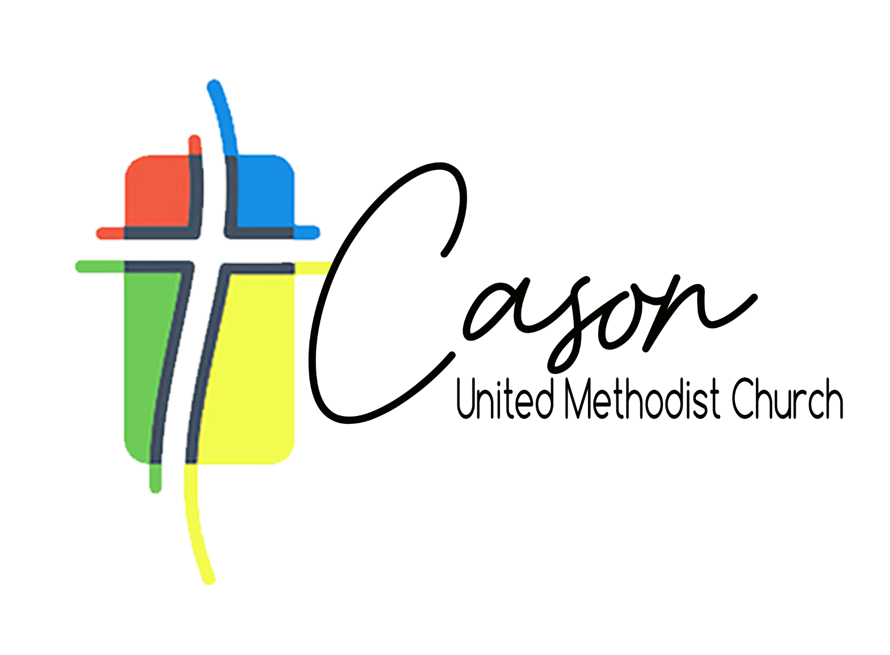
Leadership Team Agenda
May 31st, 2026

Devotion
Progress and Updates*
- Fellowship Hall
- Roof
- Choir Room
- Portable Classroom
- North & South Narthex Classrooms
- Caring Kitchen Update
- Reorganization of Administrative Wing
- Shutters
Things to Come (for discussion)*
- Parking Lot
- Kitchen
- Termite Treatment
Best Practices Committee Presentation
The Walkleader Presentation
Prayer

* Congregational comments and questions

