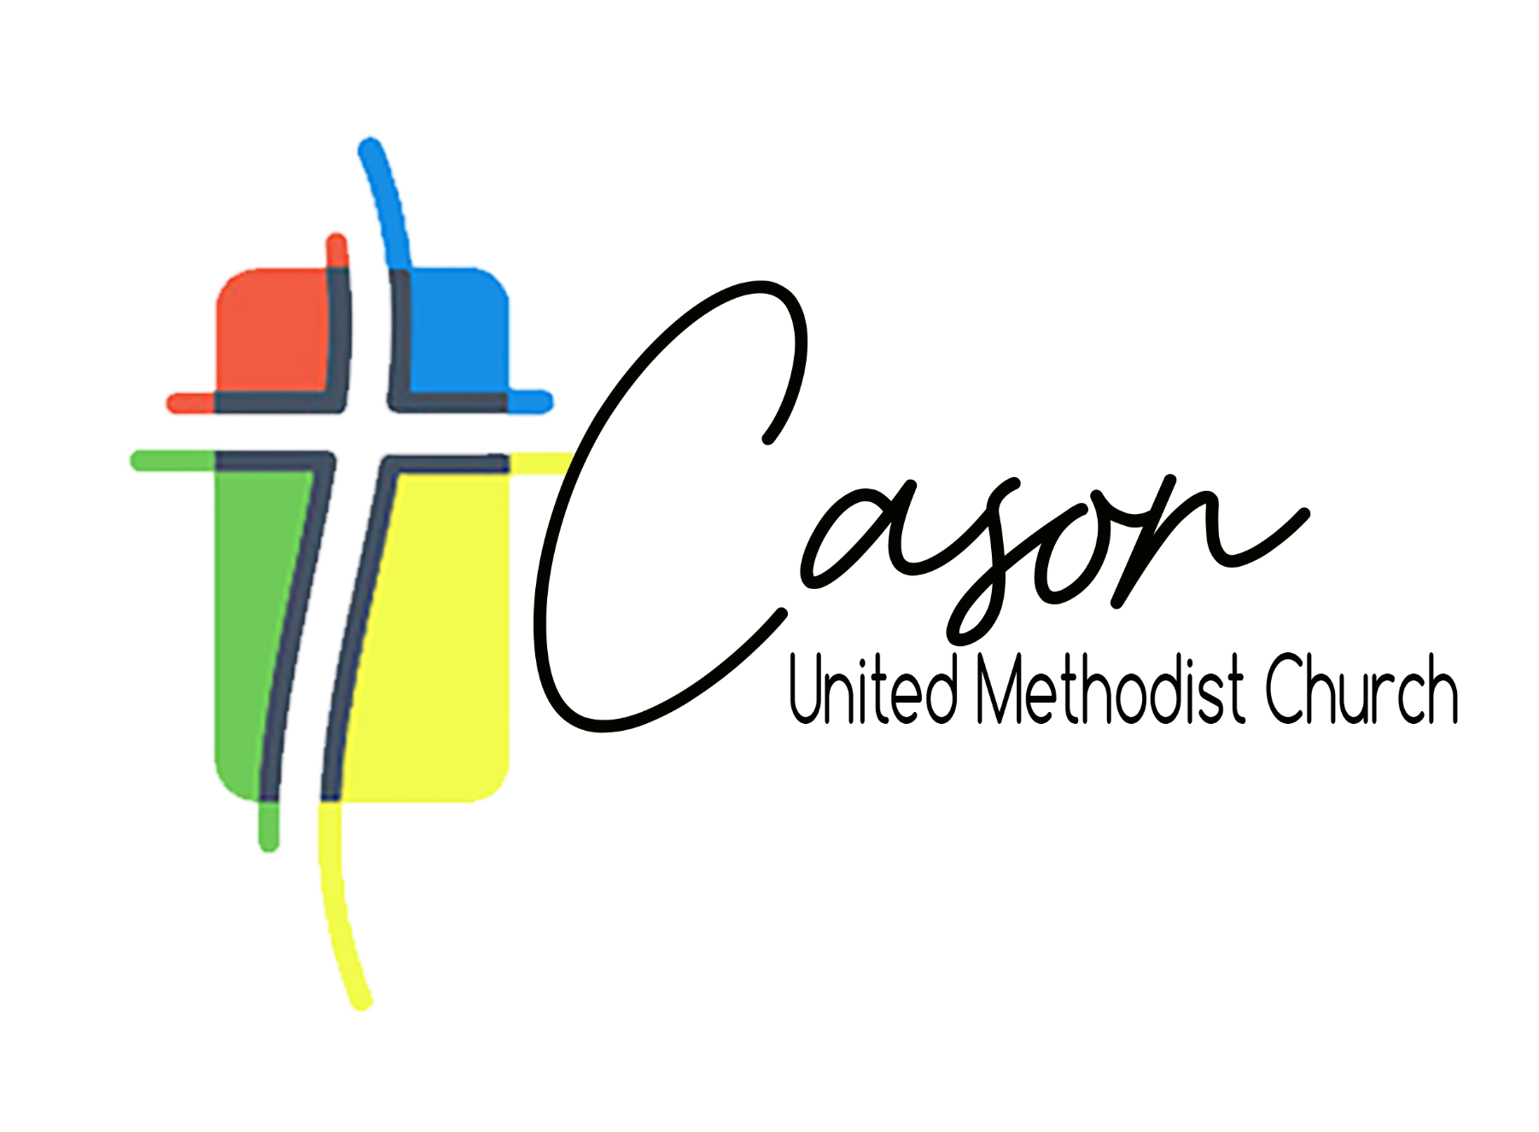
Called Church Conference
January 25th, 2026 – 3:00 pm

Call to Order and Opening Prayer Rev. Tim Barton
Election of Church Conference Secretary Rev. Tim Barton
Presentation of Leadership Slate Rev. David Schmidt
Discussion* Individuals wishing to speak
must use microphone/ Limit 2 mins
Vote All members of Cason are eligible to vote
Closing Prayer Dr. Rev. Mike Rynkiewich
Adjournment

Reminder: There will be a Potluck Lunch and Church Council Meeting on Sunday, February 15th at 12:45 in Fellowship Hall. We encourage everyone to attend.

