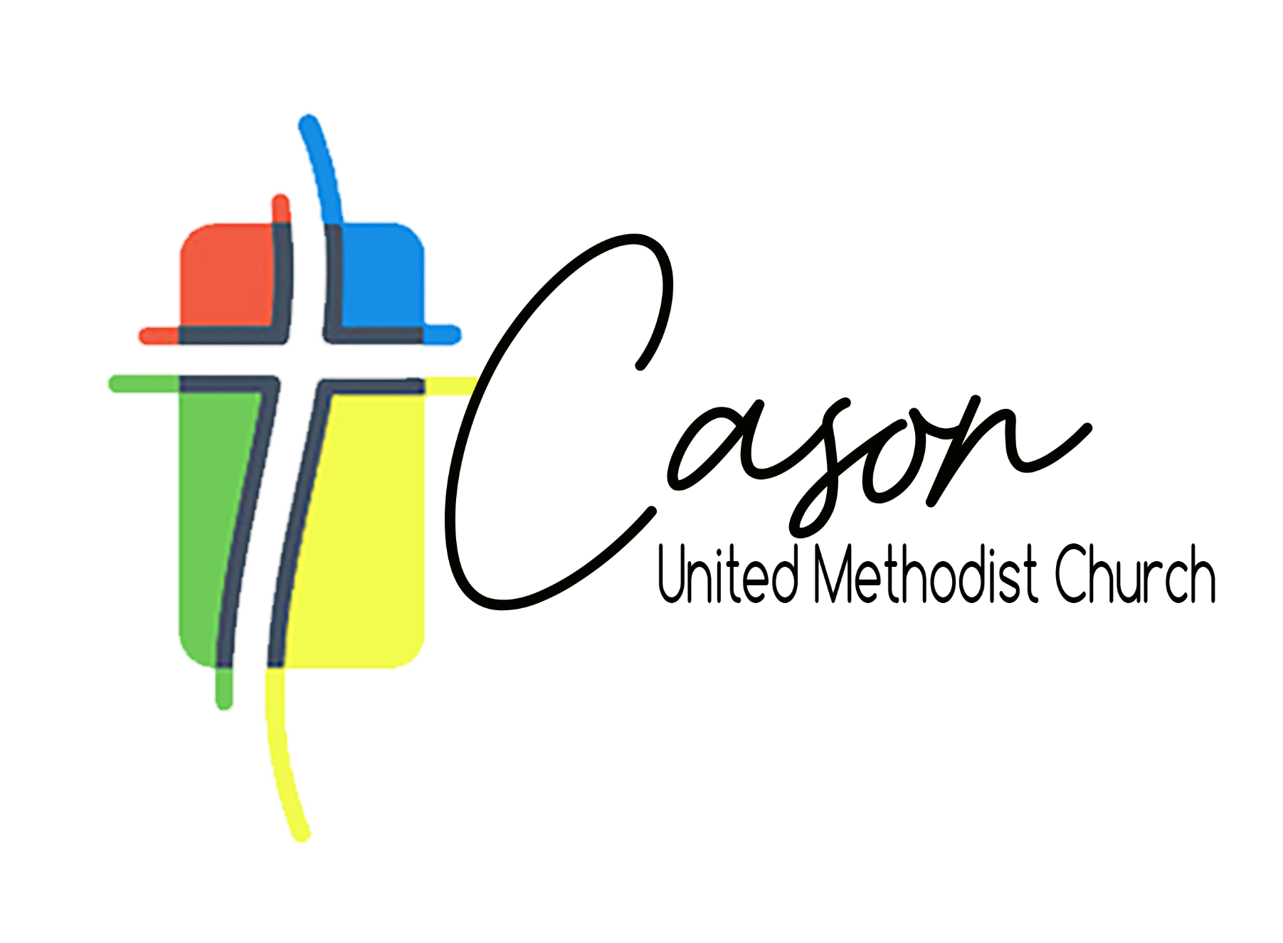
OC-15 Agenda
March 8, 2026
Prayer
SPPRC Business (Closed Meeting)
- Youth Assistant
- Maintenance Engineer
- Staff Liaisons
Spiritual Formation (Open Meeting)
Approval & Questions of Agenda Packet
Review/Reallocation of Finances
- Webmaster
  - Integrated Media Consultant vs. Social Media/Publicity
- Fellowship Hall Update
- Front Lawn Activation
  - Cross and Flame Statue & Prayer Labyrinth
- Parking Lot
Pressing Issues/Problem Solving
- Rental Committee
  - Wedding/ Funeral, Fellowship Hall, Etc
- Interior Design Team
  - Fellowship Hall, Narthex, etc.
- Redesign of storage
  - Shed/Barn
Help with Ministries
- Family Ministries
Prayer

