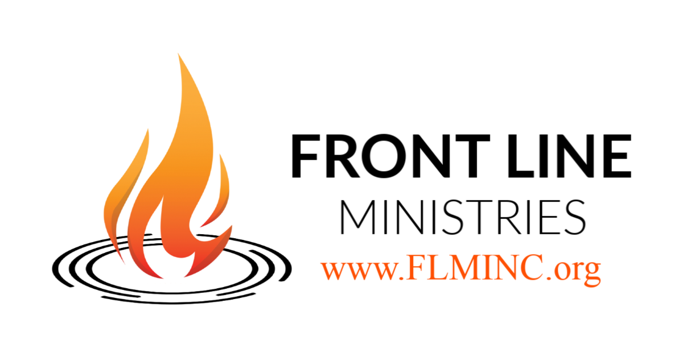
FINANCIAL INVESTMENT TEAM (FIT)
Believing in the proven calling and impact of Front Line Ministries (FLM), as a voice to the nations, I/we ________________________________________ desire to support FLM as a part of the Financial Investment Team (FIT). I/We understand that, while I am/we are not called to do what FLM does, or go where FLM goes, I/we CAN be a part of ensuring that the message of this ministry continues to go forward. As an expression of our on-going belief in the ministry, I/we hereby commit to offer our financial investment in the following manner …
your name/business name/church name

- Monthly investment in the amount of __________________

- Quarterly investment in the amount of __________________

- Bi-annual investment in the amount of __________________

- Annual investment in the amount of __________________

- “As able” investment in the amount of __________________

I/We agree that our investment is an expression of our unconditional support for the overall vision of FLM, and that the expenditure of my/our investment is at the discretion of the governing Board of Directors for the ministry.

Name/Contact: ___________________________ Email: __________________________________

CURRENT ONLINE GIVING PORTAL

ChurchAtThepicenter.org/give
[select “Front Line Ministries” from the funds scroll]

... declaring revival to the nations!

FINANCIAL INVESTMENT TEAM (FST)

Our Purpose

The purpose of the FINANCIAL INVESTMENT TEAM (FIT) is to assist Front Line Ministries (FLM) in its continued efforts to take the life-changing message of The Gospel of The Kingdom of God to people all across the nation, and around the world!

Our Method

True-to-the-definition of a “faith-based” ministry, FLM continues to impact the lives of individuals, families, and churches around the world, through our willingness to go whenever and wherever The Lord opens a door, regardless of the cost. Many times, it costs US money to fulfill the ministry invitations that we receive! The only way that we have continued to exist over the past 45 years, is through the generous and faithful investmnts of individuals, businesses, and churches from across the country that have experienced, thus believe in our ministry.

Our Plan

Recognizing the growing missional-mindedness of today’s church, we continue to offer a way for individuals, private businesses, and churches to get directly involved in helping us to reach the nations! Whether it is a weekly, monthly, twice-a-year, once-a-year, or an “as we are able” gift, the financial investment you offer will help to ensure that we continue to answer the call to spread The Gospel across the United States and around the world!

Our Promise

It is the commitment of FLM to honor your willingness to invest in our ministry by rightly investing your gift(s) into the ministry of spreading The Gospel. To keep all members of the FIT up-to-date on all that is happening as the result of their support, we will send E-Updates on a regular basis. Included will be words of encouragement and challenge from Kyle, Robin & other members of the FLM ministry team!

Your Benefit

Beyond the E-Updates, we offer FIT individuals and churches benefits on a wide variety of FLM future events such as conferences, training intensives, advances, resources, merchandise … and much more!

