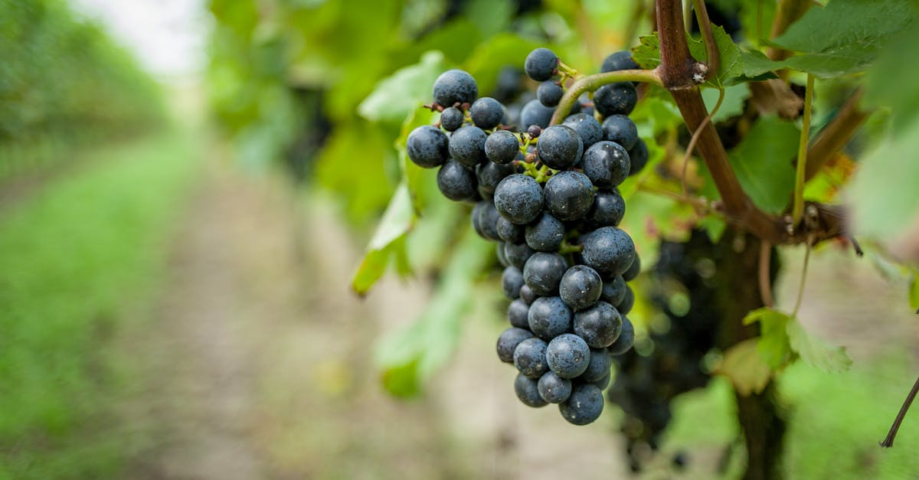
Rosh Chodesh Celebrations
5 7 8 6
First FruitsGatherings
“The New Wine is found
in the cluster.”
(Isaiah 65:8)
NISAN, 5786 (Sunday, March 15, 2026)
6:00PM – 8:00PM

IYAR, 5786 (Sunday, April 19, 2026)
6:00PM – 8:00PM

SIVAN, 5786 (Sunday, May 17, 2026)
6:00PM – 8:00PM

TAMUZ, 5786 (Sunday, June 14, 2026)
6:00PM – 8:00PM

AV, 5786 (Sunday, July 12, 2026)
6:00PM – 8:00PM

ELUL, 5786 (Sunday, August 16, 2026)
6:00PM – 8:00PM

TISHREI, 5786 (Wednesday, September 24, 2025)
HEAD OF THE YEAR 5786
6:00PM – 8:00PM

CHESHVAN, 5786 (Wednesday, October 22, 2025)
6:00PM – 8:00PM

KISLEV, 5786 (Wednesday, November 19, 2025)
6:00PM – 8:00PM

TEVET, 5786 (Wednesday, December 17, 2025)
6:00PM – 8:00PM

SHEVAT, 5786 (Sunday, January 18, 2026)
6:00PM – 8:00PM

ADAR, 5786 (Sunday, February 15, 2026)
6:00PM – 8:00PM

